SECURITIES AND EXCHANGE COMMISSION
WASHINGTON, D.C. 20549

SCHEDULE 13E-3
RULE 13E-3 TRANSACTION STATEMENT UNDER SECTION 13(e)
OF THE SECURITIES EXCHANGE ACT OF 1934

DISTRIBUTION SOLUTIONS GROUP, INC.
(Name of the Issuer)

Distribution Solutions Group, Inc.
Eclipse Parent Acquisitions, LLC
Eclipse Intermediate Acquisitions, LLC
Eclipse Acquisitions Merger Sub, Inc.
Luther King Capital Management Corporation
LKCM Headwater Investments II, L.P.
LKCM Headwater Investments IV, L.P.
LKCM Private Discipline Master Fund, LLC
PDLP Lawson, LLC
LKCM Investment Partnership, L.P.
LKCM Micro-Cap Partnership, L.P.
LKCM Core Discipline, L.P.
301 HW Opus Investors, LLC
LKCM TE Investors, LLC
Headwater Lawson Investors, LLC
J. Luther King, Jr.
J. Bryan King
(Names of Persons Filing Statement)
Common Stock, $1.00 par value per share
(Title of Class of Securities)
520776105
(CUSIP Number of Class of Securities)

Ronald Knutson  Distribution Solutions Group, Inc.  301 Commerce Street, Suite 1700  Fort Worth, Texas 76102  Tel: (888) 611-9888 |  | Jacob D. Smith  Eclipse Parent Acquisitions, LLC  Eclipse Intermediate Acquisitions, LLC  Eclipse Acquisitions Merger Sub, Inc.  Luther King Capital Management Corporation  LKCM Headwater Investments II, L.P.  LKCM Headwater Investments IV, L.P.  LKCM Private Discipline Master Fund, LLC  PDLP Lawson, LLC
LKCM Investment Partnership, L.P.
LKCM Micro-Cap Partnership, L.P.
LKCM Core Discipline, L.P.
301 HW Opus Investors, LLC
LKCM TE Investors, LLC
Headwater Lawson Investors, LLC
J. Luther King, Jr.
J. Bryan King
c/o Luther King Capital Management Corporation
301 Commerce Street, Suite 1600
Fort Worth, Texas 76102
Tel: (817) 332-3235
(Name, Address, and Telephone Number of Person Authorized to Receive Notices and Communications on Behalf of the Persons Filing Statement)

With copies to

Heidi J. Steele  Eric Orsic  McDermott Will & Schulte LLP  444 West Lake Street, Suite 4000  Chicago, Illinois 60606  Tel: (312) 372-2000 |  | Andrew J. Noreuil  Ryan H. Ferris  Mayer Brown LLP  71 South Wacker Drive  Chicago, Illinois 60606  Tel: (312) 782-0600

This statement is filed in connection with (check the appropriate box):

a. |  | ☒ |  | The filing of solicitation materials or an information statement subject to Regulation 14A, Regulation 14C or Rule 13e-3(c) under the Securities Exchange Act of 1934.
b. |  | ☐ |  | The filing of a registration statement under the Securities Act of 1933.
c. |  | ☐ |  | A tender offer.
d. |  | ☐ |  | None of the above.
Check the following box if the soliciting materials or information statement referred to in checking box (a) are preliminary copies: ☒
Check the following box if the filing is a final amendment reporting the results of the transaction: ☐
Neither the Securities and Exchange Commission nor any state securities commission has approved or disapproved of this transaction, passed upon the merits or fairness of this transaction, or passed upon the adequacy or accuracy of the disclosure in this transaction statement on Schedule 13E-3. Any representation to the contrary is a criminal offense.

INTRODUCTION
This Transaction Statement on Schedule 13E-3 (as amended, this “Transaction Statement”) is being filed with the Securities and Exchange Commission (the “SEC”) pursuant to Section 13(e) of the Securities Exchange Act of 1934, as amended (the “Exchange Act”), jointly by the following persons (each, a “Filing Person,” and collectively, the “Filing Persons”):

 |  |  | Distribution Solutions Group, Inc., a Delaware corporation (the “Company”);

 |  |  | Eclipse Parent Acquisitions, LLC, a Delaware limited liability company (“Parent”);

 |  |  | Eclipse Intermediate Acquisitions, LLC, a Delaware limited liability company and a wholly owned subsidiary of Parent (“Intermediate”);

 |  |  | Eclipse Acquisitions Merger Sub, Inc., a Delaware corporation and a wholly owned subsidiary of Intermediate (“Merger Sub”);

 |  |  | Luther King Capital Management Corporation, a Delaware corporation (“LKCM”);

 |  |  | LKCM Headwater Investments II, L.P., a Delaware limited partnership;

 |  |  | LKCM Headwater Investments IV, L.P., a Delaware limited partnership;

 |  |  | LKCM Private Discipline Master Fund, LLC, a Delaware limited liability company;

 |  |  | PDLP Lawson, LLC, a Texas limited liability company;

 |  |  | LKCM Investment Partnership, L.P., a Texas limited partnership;

 |  |  | LKCM Micro-Cap Partnership, L.P., a Delaware limited partnership;

 |  |  | LKCM Core Discipline, L.P., a Delaware limited partnership;

 |  |  | 301 HW Opus Investors, LLC, a Delaware limited liability company;

 |  |  | LKCM TE Investors, LLC, a Delaware limited liability company;

 |  |  | Headwater Lawson Investors, LLC, a Delaware limited liability company;

 |  |  | J. Luther King, Jr.; and

 |  |  | J. Bryan King, the Company’s Chief Executive Officer, President and Chairman of the Board and the Managing Partner of LKCM Headwater Investments, LLC (“LKCM Headwater”).
This Transaction Statement relates to the Agreement and Plan of Merger (the “Merger Agreement”), dated as of July 15, 2026, by and among Parent, Intermediate, Merger Sub and Company, pursuant to which, upon the terms and subject to the conditions set forth in the Merger Agreement, upon the closing of the transaction (the “Closing”), Merger Sub will merge with and into the Company (the “Merger” and, together with the other transactions contemplated by the Merger Agreement, collectively, the “Transactions”), with the Company surviving the Merger as a wholly owned subsidiary of Intermediate and an indirect wholly owned subsidiary of Parent. Parent, Intermediate and Merger Sub were formed by, and are affiliated with, LKCM Headwater, J. Bryan King and their respective affiliates. Mr. King is the Company’s Chief Executive Officer, President and Chairman of the Board and is also the Managing Partner of LKCM Headwater. LKCM Headwater and its affiliates beneficially own, in the aggregate, approximately 78.6% of the outstanding shares of the Company’s common stock, par value $1.00 per share (the “Company Common Stock”). Upon completion of the Merger, the Company will become a privately held company, and the Company Common Stock will no longer be listed on Nasdaq.
Concurrently with the filing of this Transaction Statement, the Company is filing a preliminary proxy statement (the “Proxy Statement”) under Regulation 14A of the Securities Exchange Act of 1934, as amended (the “Exchange Act”), with the SEC, pursuant to which the Company will be soliciting proxies from the Company’s stockholders in connection with the adoption of the Merger Agreement and certain other proposals contained therein. The Proxy Statement is attached hereto as Exhibit (a)(2)(i). A copy of the Merger Agreement is attached to the Proxy Statement as Annex A. Terms used but not defined in this Transaction Statement have the meanings assigned to them in the Proxy Statement.

1

Pursuant to General Instruction F to Schedule 13E-3, the information in the Proxy Statement, including all annexes thereto, is expressly incorporated by reference herein in its entirety, and responses to each item herein are qualified in their entirety by the information contained in the Proxy Statement. The cross-references below are being supplied pursuant to General Instruction G to Schedule 13E-3 and show the location in the Proxy Statement of the information required to be included in response to the items of Schedule 13E-3.
While each of the Filing Persons acknowledges that the Transactions are a “going private” transaction for purposes of Rule 13e-3 under the Exchange Act, the filing of this Transaction Statement shall not be construed as an admission by any Filing Person, or by any affiliate of a Filing Person, that the Company is “controlled” by any of the Filing Persons and/or their respective affiliates.
The information concerning the Company contained in, or incorporated by reference into, this Schedule 13E-3 and the Proxy Statement was supplied by the Company. Similarly, all information concerning each other Filing Person contained in, or incorporated by reference into, this Schedule 13E-3 and the Proxy Statement was supplied by such Filing Person. No Filing Person, including the Company, is responsible for the accuracy of any information supplied by any other Filing Person.

2

SCHEDULE 13E-3 ITEMS
Item 1. Summary Term Sheet
The information set forth in the Proxy Statement under the following captions is incorporated herein by reference:
“Summary Term Sheet”
“Questions and Answers About the Special Meeting and the Merger”
“Special Factors”
Item 2. Subject Company Information
(a) Name and address.
The name of the subject company is Distribution Solutions Group, Inc., a Delaware corporation (the “Company”). The address of the Company’s principal executive offices is 301 Commerce Street, Suite 1700, Fort Worth, Texas 76102, and the telephone number of its principal executive offices is (888) 611-9888.
(b) Securities.
The subject class of equity securities is the Company’s common stock, par value $1.00 per share (the “Company Common Stock”). As of August 27, 2026, the most recent practicable date for which information is currently available, 46,267,212 shares of Company Common Stock were issued and outstanding.
(c) Trading market and price.
The Company Common Stock is traded on the Nasdaq Global Select Market (“Nasdaq”) under the symbol “DSGR.” During the fiscal year ended December 31, 2024, the high and low sales prices per share of Company Common Stock on Nasdaq were $36.36 and $28.01, respectively, for the first quarter; $37.31 and $29.25, respectively, for the second quarter; $39.43 and $28.26, respectively, for the third quarter; and $41.47 and $33.80, respectively, for the fourth quarter. During the fiscal year ended December 31, 2025, the high and low sales prices per share of Company Common Stock on Nasdaq were $36.10 and $27.30, respectively, for the first quarter; $29.05 and $21.87, respectively, for the second quarter; $33.80 and $27.22, respectively, for the third quarter; and $31.49 and $25.33, respectively, for the fourth quarter. During the fiscal year ending December 31, 2026, the high and low sales prices per share of Company Common Stock on Nasdaq were $32.00 and $19.02, respectively, for the first quarter; $28.75 and $26.08, respectively, for the second quarter; and $35.06 and $26.60, respectively, for the third quarter through August 31, 2026.
On August 31, 2026, the most recent practicable date before the filing of this Transaction Statement, the closing price of the Company Common Stock on Nasdaq was $34.79 per share.
(d) Dividends.
During the past two years, the Company has not declared or paid any cash dividends with respect to the Company Common Stock. The Company does not currently intend to pay any cash dividends on the Company Common Stock. In addition, the Merger Agreement generally prohibits the Company from declaring, setting aside or paying dividends or making other distributions with respect to its capital stock before the effective time of the Merger without the prior written consent of Parent, subject to specified exceptions, including dividends paid by a direct or indirect wholly owned subsidiary of the Company to its parent.
(e) Prior public offerings.
During the past three years, none of the Filing Persons has made an underwritten public offering for cash of Company Common Stock or other Company securities that was registered under the Securities Act of 1933, as amended, or exempt from registration under Regulation A promulgated thereunder.

3

(f) Prior stock purchases.
Except for the purchases by the Company described below and certain activity relating to the Company’s equity compensation awards, none of the Filing Persons purchased any shares of Company Common Stock during the two years preceding August 31, 2026.
Under an existing stock repurchase program authorized by the board of directors of the Company (the “Board”), the Company may repurchase its Company Common Stock from time to time in open market transactions, privately negotiated transactions or by other methods. During the first quarter of 2025, the Company repurchased 320,638 shares of Company Common Stock at an average cost of $34.94 per share for a total cost of $11.2 million. During the second quarter of 2025, the Company repurchased 332,575 shares of Company Common Stock at an average cost of $26.59 per share for a total cost of $8.8 million. During the third and fourth quarters of 2025, the Company repurchased an additional 123,711 shares of Company Common Stock at an average cost of approximately $28.00 per share for a total cost of approximately $3.5 million. During the first six months of 2026, no repurchases were made. The remaining availability for stock repurchases under the program was $32.9 million at June 30, 2026. The stock repurchase program does not have an expiration date. The Merger Agreement generally prohibits the Company from repurchasing shares of Company Common Stock during the pendency of the Merger, subject to specified exceptions.
Item 3. Identity and Background of Filing Person
(a) – (c) Name and address; Business and background of entities; Business and background of natural persons. The information set forth in the Proxy Statement under the following captions is incorporated herein by reference:
“Summary Term Sheet”
“The Parties to the Merger”
“The Merger Agreement—Structure of the Merger”
“Important Information Regarding the Company—Directors and Executive Officers”
“Important Information Regarding the Company—Share Ownership of Certain Beneficial Owners and Management”
“Important Information Regarding the Affiliated Stockholders”
Item 4. Terms of the Transaction
(a)-(1) Material terms. Tender offers. Not applicable.
(a)-(2) Material terms. Mergers or similar transactions. The information set forth in the Proxy Statement under the following captions is incorporated herein by reference:
“Special Factors—Reasons for the Merger; Recommendations of the Special Committee and the Board”
“Special Factors—Certain Effects of the Merger”
“Special Factors—Anticipated Accounting Treatment”
“Special Factors—Certain Material U.S. Federal Income Tax Consequences of the Merger”
“The Merger Agreement”
(c) Different terms. The information set forth in the Proxy Statement under the following captions is incorporated herein by reference:
“Summary Term Sheet—Treatment of Shares”
“Special Factors—Certain Effects of the Merger”

4

“Special Factors—Interests of DSG’s Directors and Executive Officers in the Merger”
“The Merger Agreement—Merger Consideration”
“The Merger Agreement—Excluded Shares”
“The Merger Agreement—Appraisal Rights”
“The Merger Agreement—Treatment of Company Equity-Based Awards”
(d) Appraisal rights. The information set forth in the Proxy Statement under the following captions is incorporated herein by reference:
“Summary Term Sheet—Appraisal Rights”
“The Special Meeting—Appraisal Rights”
“The Merger Agreement—Appraisal Rights”
“Appraisal Rights”
“Annex C”
(e) Provisions for unaffiliated security holders. The information set forth in the Proxy Statement under the following captions is incorporated herein by reference:
“Summary Term Sheet—Introduction”
“Special Factors—Provisions for Unaffiliated Stockholders”
(f) Eligibility for listing or trading.
Not applicable. The shares of Company Common Stock will be delisted from Nasdaq and deregistered under the Exchange Act following the completion of the Merger. The information set forth in the Proxy Statement under the following caption is incorporated herein by reference: “Special Factors—Delisting and Deregistration of DSG’s Common Stock”.
Item 5. Past Contacts, Transactions, Negotiations and Agreements
(a)(1) – (2) Transactions. The information set forth in the Proxy Statement under the following captions is incorporated herein by reference:
“Important Information Regarding the Company—Transactions in DSG’s Securities”
“Important Information Regarding the Company—Past Contracts, Transactions, Negotiations and Agreements”
“Important Information Regarding the Affiliated Stockholders”
(b) – (c) Significant corporate events; Negotiations or contacts. The information set forth in the Proxy Statement under the following captions is incorporated herein by reference:
“Summary Term Sheet”
“Special Factors—Background of the Merger”
“Important Information Regarding the Company—Past Contracts, Transactions, Negotiations and Agreements”

5

“The Merger Agreement”
(e) Agreements involving the subject company’s securities. The information set forth in the Proxy Statement under the following captions is incorporated herein by reference:
“Summary Term Sheet”
“Special Factors—Interests of DSG’s Directors and Executive Officers in the Merger”
“Special Factors—Intent of DSG’s Directors and Executive Officers to Vote in Favor of the Merger and the Advisory Compensation Proposal and Certain Stockholders to Vote in Favor of the Merger”
“The Merger Agreement”
“Important Information Regarding the Company—Voting and Support Agreement”
“Important Information Regarding the Company—Share Ownership of Certain Beneficial Owners and Management”
Item 6. Purposes of the Transaction and Plans or Proposals
(b) Use of securities acquired. The information set forth in the Proxy Statement under the following captions is incorporated herein by reference:
“Special Factors—Certain Effects of the Merger”
“Special Factors—Plans for the Company After the Merger”
“Special Factors—Delisting and Deregistration of DSG’s Common Stock”
“The Merger Agreement—Merger Consideration”
“The Merger Agreement—Excluded Shares”
(c)(1) – (8) Plans. The information set forth in the Proxy Statement under the following captions is incorporated herein by reference:
“Summary Term Sheet”
“Special Factors—Plans for the Company After the Merger”
“Special Factors—Certain Effects of the Merger”
“Special Factors—Interests of DSG’s Directors and Executive Officers in the Merger”
“Special Factors—Interests of DSG’s Directors and Executive Officers in the Merger—Employment Arrangements Following the Merger”
“Special Factors—Financing of the Merger”
“Special Factors—Delisting and Deregistration of DSG’s Common Stock”
“The Merger Agreement—Structure of the Merger”
“The Merger Agreement—Directors and Officers; Charter and Bylaws of the Surviving Corporation”
“The Merger Agreement—Merger Consideration”

6

“The Merger Agreement—Excluded Shares”
“The Merger Agreement—Conduct of Business Pending the Merger”
“Important Information Regarding the Company—Dividends”
Item 7. Purposes, Alternatives, Reasons and Effects
(a) Purposes. The information set forth in the Proxy Statement under the following captions is incorporated herein by reference:
“Special Factors—Background of the Merger”
“Special Factors—Reasons for the Merger; Recommendations of the Special Committee and the Board”
“Special Factors—Positions of the Affiliated Stockholders as to the Fairness of the Merger”
“Special Factors—Plans for the Company After the Merger”
(b) Alternatives. The information set forth in the Proxy Statement under the following captions is incorporated herein by reference:
“Special Factors—Background of the Merger”
“Special Factors—Reasons for the Merger; Recommendations of the Special Committee and the Board”
(c) Reasons. The information set forth in the Proxy Statement under the following captions is incorporated herein by reference:
“Summary Term Sheet”
“Special Factors—Background of the Merger”
“Special Factors—Reasons for the Merger; Recommendations of the Special Committee and the Board”
“Special Factors—Summary of Discussion Materials of William Blair”
“Special Factors—Purposes and Reasons of the Affiliated Stockholders for the Merger”
“Special Factors—Positions of the Affiliated Stockholders as to the Fairness of the Merger”
(d) Effects. The information set forth in the Proxy Statement under the following captions is incorporated herein by reference:
“Special Factors—Certain Effects of the Merger”
“Special Factors—Certain Material U.S. Federal Income Tax Consequences of the Merger”
“Special Factors—Interests of DSG’s Directors and Executive Officers in the Merger”
“Special Factors—Financing of the Merger”
“Special Factors—Fees and Expenses”
Item 8. Fairness of the Transaction
(a) – (b) Fairness; Factors considered in determining fairness. The information set forth in the Proxy Statement under the following captions is incorporated herein by reference:

7

“Special Factors—Background of the Merger”
“Special Factors—Reasons for the Merger; Recommendations of the Special Committee and the Board”
“Special Factors—Certain Other Fairness Considerations”
“Special Factors—Opinion of William Blair”
“Special Factors—Purposes and Reasons of the Affiliated Stockholders for the Merger”
“Special Factors—Positions of the Affiliated Stockholders as to the Fairness of the Merger”
(c) Approval of security holders. The information set forth in the Proxy Statement under the following captions is incorporated herein by reference:
“Summary Term Sheet—Votes Required”
“Special Factors—Reasons for the Merger; Recommendations of the Special Committee and the Board—Potential Benefits and Other Favorable Factors”
“Special Factors—Reasons for the Merger; Recommendations of the Special Committee and the Board—Procedural Safeguards”
“The Special Meeting—Votes Required”
(d) Unaffiliated representative. The information set forth in the Proxy Statement under the following captions is incorporated herein by reference:
“Special Factors—Reasons for the Merger; Recommendations of the Special Committee and the Board”
(e) Approval of directors. The information set forth in the Proxy Statement under the following captions is incorporated herein by reference:
“Special Factors—Reasons for the Merger; Recommendations of the Special Committee and the Board”
(f) Other offers. The information set forth in the Proxy Statement under the following captions is incorporated herein by reference:
“Special Factors—Background of the Merger”
“Special Factors—Certain Other Fairness Considerations”
Item 9. Reports, Opinions, Appraisals and Negotiations
(a) – (b) Report, opinion or appraisal; Preparer and summary of the report, opinion or appraisal. The information set forth in the Proxy Statement under the following captions is incorporated herein by reference:
“Special Factors—Background of the Merger”
“Special Factors—Reasons for the Merger; Recommendations of the Special Committee and the Board”
“Special Factors—Certain Other Fairness Considerations”
“Special Factors—Opinion of William Blair”
“Special Factors—Summary of Discussion Materials of William Blair”
“Special Factors—Unaudited Prospective Financial Information”

8

(c) Availability of documents. The information set forth in the Proxy Statement under the following caption is incorporated herein by reference:
“Where You Can Find Additional Information”
The reports, opinions or appraisals referenced in this Item 9 will be made available for inspection and copying at the principal executive offices of the Company during its regular business hours by any interested equity holder of the Company common shares or by a representative who has been so designated in writing.
Item 10. Source and Amounts of Funds or Other Consideration
(a) Source of funds. The information set forth in the Proxy Statement under the following captions is incorporated herein by reference:
“Summary Term Sheet—Financing of the Merger”
“Special Factors—Financing of the Merger”
“The Merger Agreement—Financing”
(b) Conditions. The information set forth in the Proxy Statement under the following captions is incorporated herein by reference:
“Summary Term Sheet—Conditions to the Closing of the Merger”
“The Merger Agreement—Conditions to the Merger”
“Special Factors—Financing of the Merger”
(c) Expenses. The information set forth in the Proxy Statement under the following captions is incorporated herein by reference:
“Special Factors—Fees and Expenses”
(d) Borrowed funds. The information set forth in the Proxy Statement under the following captions is incorporated herein by reference:
“Special Factors—Financing of the Merger”
“The Merger Agreement—Financing”
Item 11. Interest in Securities of the Subject Company
(a) Securities ownership. The information set forth in the Proxy Statement under the following captions is incorporated herein by reference:
“Important Information Regarding the Company—Share Ownership of Certain Beneficial Owners and Management”
“Important Information Regarding the Affiliated Stockholders”
“Special Factors—Interests of DSG’s Directors and Executive Officers in the Merger”
(b) Securities transactions. The information set forth in the Proxy Statement under the following captions is incorporated herein by reference:
“Important Information Regarding the Company—Transactions in DSG’s Securities”
“Important Information Regarding the Affiliated Stockholders”

9

Item 12. The Solicitation or Recommendation
(d) Intent to tender or vote in a going-private transaction. The information set forth in the Proxy Statement under the following captions is incorporated herein by reference:
“Summary Term Sheet—Intent of DSG’s Directors and Executive Officers to Vote in Favor of the Merger and the Advisory Compensation Proposal and Certain Stockholders to Vote in Favor of the Merger”
“Special Factors—Intent of DSG’s Directors and Executive Officers to Vote in Favor of the Merger and the Advisory Compensation Proposal and Certain Stockholders to Vote in Favor of the Merger”
“Important Information Regarding the Company—Voting and Support Agreement”
(e) Recommendation of others. The information set forth in the Proxy Statement under the following captions is incorporated herein by reference:
“Summary Term Sheet—Reasons for the Merger; Recommendations of the Special Committee and the Board”
“Special Factors—Reasons for the Merger; Recommendations of the Special Committee and the Board”
Item 13. Financial Information
(a) Financial statements. The audited consolidated financial statements set forth in Item 8 of the Company’s Annual Report on Form 10-K for the fiscal year ended December 31, 2025 and unaudited consolidated financial statements set forth in Item 1 of the Company’s Quarterly Report on Form 10-Q for the quarterly period ended June 30, 2026 are incorporated herein by reference.
The information set forth in the Proxy Statement under the following captions is incorporated herein by reference:
“Important Information Regarding the Company—Book Value Per Share”
“Incorporation of Certain Documents by Reference”
(b) Pro forma information. Not applicable.
Item 14. Persons/Assets, Retained, Employed, Compensated or Used
(a) – (b) Solicitations or recommendations; Employees and corporate assets. The information set forth in the Proxy Statement under the following captions is incorporated herein by reference:
“Special Factors—Opinion of William Blair”
“Special Factors—Background of the Merger”
“The Special Meeting—Solicitation of Proxies”
Item 15. Additional Information
(b) Golden Parachute Compensation. The information set forth in the Proxy Statement under the following captions is incorporated herein by reference:
“Special Factors—Interests of DSG’s Directors and Executive Officers in the Merger—Change in Control and Severance Benefits”
“Special Factors—Interests of DSG’s Directors and Executive Officers in the Merger—Golden Parachute Compensation”
“Proposal 2: The Advisory Compensation Proposal”

10

(c) Other material information. The information set forth in the Proxy Statement, including all annexes thereto, is incorporated herein by reference.
Item 16. Exhibits
The following exhibits are filed herewith:

(a)(2)(i) |  | Preliminary Proxy Statement of the Company (the “Proxy Statement”) (included in the Schedule 14A filed on September 1, 2026 and incorporated herein by reference).
(a)(2)(ii) |  | Form of Proxy Card (included in the Proxy Statement and incorporated herein by reference).
(a)(2)(iii) |  | Letter to Stockholders (included in the Proxy Statement and incorporated herein by reference).
(a)(2)(iv) |  | Notice of Special Meeting of Stockholders (included in the Proxy Statement and incorporated herein by reference).
(a)(2)(vi) |  | Press release dated July 16, 2026 (included as Exhibit 99.1 to the Company’s Current Report on Form 8-K dated July 16, 2026 and incorporated herein by reference).
(b)(i) |  | Second Amended and Restated Credit Agreement, dated December 18, 2025, by and among Distribution Solutions Group, Inc., the subsidiary guarantors party thereto, the lenders party thereto and JPMorgan Chase Bank, N.A. (included as Exhibit 10.1 to the Company’s Current Report on Form 8-K dated December 22, 2025 and incorporated herein by reference).
(b)(ii) |  | First Amendment to Second Amended and Restated Credit Agreement, dated July 15, 2026, by and among Distribution Solutions Group, Inc., the subsidiary guarantors party thereto, the lenders party thereto and JPMorgan Chase Bank, N.A., as administrative agent (included as Exhibit 10.3 to the Company’s Current Report on Form 8-K dated July 16, 2026 and incorporated herein by reference).
(c)(i) |  | Opinion of William Blair (included as Annex B to the Proxy Statement and incorporated herein by reference).
(c)(ii) |  | Presentation by William Blair to the special committee of the Board (the “Special Committee”), dated April 21, 2026.
(c)(iii) |  | Presentation by William Blair to the Board, dated April 27, 2026.
(c)(iv) |  | Presentation by William Blair to the Special Committee, dated May 8, 2026.
(c)(v) |  | Presentation by William Blair to the Special Committee, dated June 5, 2026.
(c)(vi) |  | Presentation by William Blair to the Special Committee, dated June 9, 2026.
(c)(vii) |  | Presentation by William Blair to the Special Committee, dated June 18, 2026.
(c)(viii) |  | Presentation by William Blair to the Special Committee, dated July 15, 2026.
(c)(ix) |  | Presentation by J.P. Morgan Securities LLC to the Special Committee, dated May 28, 2026.
(d)(i) |  | Agreement and Plan of Merger, dated July 15, 2026, by and among Distribution Solutions Group, Inc., Eclipse Parent Acquisitions, LLC, Eclipse Intermediate Acquisitions, LLC and Eclipse Acquisitions Merger Sub, Inc. (included as Exhibit 2.1 to the Company’s Current Report on Form 8-K dated July 16, 2026 and incorporated herein by reference).
(d)(ii) |  | Equity Commitment Letter, dated July 15, 2026, delivered by LKCM Headwater Investments IV, L.P. to Eclipse Parent Acquisitions, LLC (included as Exhibit 2 to the Company’s Schedule 13D/A dated July 16, 2026 and incorporated herein by reference).
(d)(iii) |  | Limited Guarantee, dated July 15, 2026, by LKCM Headwater Investments IV, L.P. in favor of Distribution Solutions Group, Inc. (included as Exhibit 10.2 to the Company’s Current Report of Form 8-K dated July 16, 2026 and incorporated herein by reference).
(d)(iv) |  | Voting and Support Agreement, dated July 15, 2026, by and between Distribution Solutions Group, Inc. and Luther King Capital Management Corporation (included as Exhibit 10.1 to the Company’s Current Report on Form 8-K dated July 16, 2026 and incorporated herein by reference).
(f)(i) |  | Section 262 of the General Corporation Law of the State of Delaware (included as Annex C to the Proxy Statement and incorporated herein by reference).
107 |  | Filing Fee Table.

11

SIGNATURES
After due inquiry and to the best of the undersigned’s knowledge and belief, the undersigned certifies that the information set forth in this statement is true, complete and correct.
Dated: September 1, 2026

DISTRIBUTION SOLUTIONS GROUP, INC.
By: |  | /s/ Ronald Knutson
Name: |  | Ronald Knutson
Title: |  | Executive Vice President, Chief Financial Officer and Treasurer
After due inquiry and to the best of the undersigned’s knowledge and belief, the undersigned certifies that the information set forth in this statement is true, complete and correct.
Dated: September 1, 2026

ECLIPSE PARENT ACQUISITIONS, LLC
By: |  | /s/ Jacob D. Smith
Name: |  | Jacob D. Smith
Title: |  | Vice President, Secretary and General Counsel
ECLIPSE INTERMEDIATE ACQUISITIONS, LLC
By: |  | /s/ Jacob D. Smith
Name: |  | Jacob D. Smith
Title: |  | Vice President, Secretary and General Counsel
ECLIPSE ACQUISITIONS MERGER SUB, INC.
By: |  | /s/ Jacob D. Smith
Name: |  | Jacob D. Smith
Title: |  | Vice President, Secretary and General Counsel
LUTHER KING CAPITAL MANAGEMENT CORPORATION
By: |  | /s/ Jacob D. Smith
Name: |  | Jacob D. Smith
Title: |  | Principal and General Counsel
LKCM HEADWATER INVESTMENTS II, L.P.
By: |  | LKCM Headwater Investments II GP, L.P., its general partner
By: |  | /s/ Jacob D. Smith
Name: |  | Jacob D. Smith
Title: |  | Vice President and General Counsel
LKCM HEADWATER INVESTMENTS IV, L.P.
By: |  | LKCM Headwater Investments IV GP, L.P., its general partner
By: |  | /s/ Jacob D. Smith
Name: |  | Jacob D. Smith
Title: |  | Vice President and General Counsel

12

LKCM PRIVATE DISCIPLINE MASTER FUND, LLC
By: |  | LKCM Private Discipline Management, L.P., its manager
By: |  | LKCM Alternative Management, LLC, its general partner
By: |  | LKCM Capital Group, LLC, its sole member
By: |  | /s/ Jacob D. Smith
Name: |  | Jacob D. Smith
Title: |  | Vice President
PDLP LAWSON, LLC
By: |  | /s/ Jacob D. Smith
Name: |  | Jacob D. Smith
Title: |  | Vice President
LKCM INVESTMENT PARTNERSHIP, L.P.
By: |  | LKCM Investment Partnership GP, LLC, its general partner
By: |  | /s/ Jacob D. Smith
Name: |  | Jacob D. Smith
Title: |  | Vice President
LKCM MICRO-CAP PARTNERSHIP, L.P.
By: |  | LKCM Micro-Cap Management, L.P., its general partner
By: |  | LKCM Alternative Management, LLC, its general partner
By: |  | LKCM Capital Group, LLC, its sole member
By: |  | /s/ Jacob D. Smith
Name: |  | Jacob D. Smith
Title: |  | Vice President
LKCM CORE DISCIPLINE, L.P.
By: |  | LKCM Core Discipline Management, L.P., its general partner
By: |  | LKCM Alternative Management, LLC, its general partner
By: |  | LKCM Capital Group, LLC, its sole member
By: |  | /s/ Jacob D. Smith
Name: |  | Jacob D. Smith
Title: |  | Vice President
301 HW OPUS INVESTORS, LLC
By: |  | /s/ Jacob D. Smith
Name: |  | Jacob D. Smith
Title: |  | Vice President
LKCM TE INVESTORS, LLC
By: |  | /s/ Jacob D. Smith
Name: |  | Jacob D. Smith
Title: |  | Vice President

13

HEADWATER LAWSON INVESTORS, LLC
By: |  | /s/ Jacob D. Smith
Name: |  | Jacob D. Smith
Title: |  | Vice President
/s/ J. Luther King, Jr.
J. LUTHER KING, JR.
/s/ J. Bryan King
J. BRYAN KING

14
Exhibit (c)(ii)

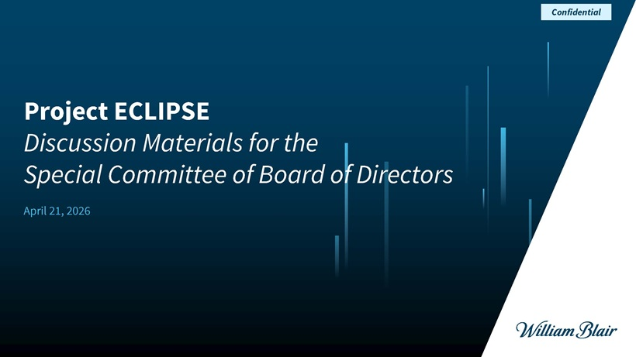
Project ECLIPSE Discussion Materials for the Special Committee of Board of Directors April 21, 2026 Confidential ECLIPSE

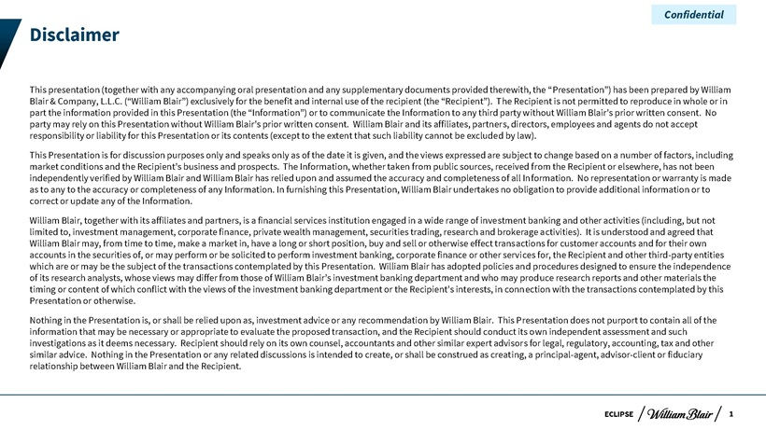
Disclaimer This presentation (together with any accompanying oral presentation and any supplementary documents provided therewith, the “Presentation”) has been prepared by William Blair & Company, L.L.C. (“William Blair”) exclusively for the benefit and internal use of the recipient (the “Recipient”). The Recipient is not permitted to reproduce in whole or in part the information provided in this Presentation (the “Information”) or to communicate the Information to any third party without William Blair’s prior written consent. No party may rely on this Presentation without William Blair’s prior written consent. William Blair and its affiliates, partners, directors, employees and agents do not accept responsibility or liability for this Presentation or its contents (except to the extent that such liability cannot be excluded by law). This Presentation is for discussion purposes only and speaks only as of the date it is given, and the views expressed are subject to change based on a number of factors, including market conditions and the Recipient’s business and prospects. The Information, whether taken from public sources, received from the Recipient or elsewhere, has not been independently verified by William Blair and William Blair has relied upon and assumed the accuracy and completeness of all Information. No representation or warranty is made as to any to the accuracy or completeness of any Information. In furnishing this Presentation, William Blair undertakes no obligation to provide additional information or to correct or update any of the Information. William Blair, together with its affiliates and partners, is a financial services institution engaged in a wide range of investment banking and other activities (including, but not limited to, investment management, corporate finance, private wealth management, securities trading, research and brokerage activities). It is understood and agreed that William Blair may, from time to time, make a market in, have a long or short position, buy and sell or otherwise effect transactions for customer accounts and for their own accounts in the securities of, or may perform or be solicited to perform investment banking, corporate finance or other services for, the Recipient and other third-party entities which are or may be the subject of the transactions contemplated by this Presentation. William Blair has adopted policies and procedures designed to ensure the independence of its research analysts, whose views may differ from those of William Blair’s investment banking department and who may produce research reports and other materials the timing or content of which conflict with the views of the investment banking department or the Recipient’s interests, in connection with the transactions contemplated by this Presentation or otherwise. Nothing in the Presentation is, or shall be relied upon as, investment advice or any recommendation by William Blair. This Presentation does not purport to contain all of the information that may be necessary or appropriate to evaluate the proposed transaction, and the Recipient should conduct its own independent assessment and such investigations as it deems necessary. Recipient should rely on its own counsel, accountants and other similar expert advisors for legal, regulatory, accounting, tax and other similar advice. Nothing in the Presentation or any related discussions is intended to create, or shall be construed as creating, a principal-agent, advisor-client or fiduciary relationship between William Blair and the Recipient. Confidential 1

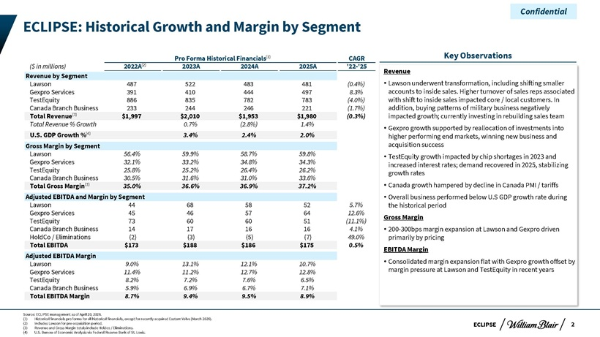
ECLIPSE Pro Forma Historical Financials CAGR ($ in millions) 2022A 2023A 2024A 2025A ‘22-’25 Revenue by Segment Lawson 487 522 483 481 (0.4%) Gexpro Services 391 410 444 497 8.3% TestEquity 886 835 782 783 (4.0%) Canada Branch Business 233 244 246 221 (1.7%) Total Revenue $1,997 $2,010 $1,953 $1,980 (0.3%) Total Revenue % Growth 0.7% (2.8%) 1.4% U.S. GDP Growth % 3.4% 2.4% 2.0% Gross Margin by Segment Lawson 56.4% 59.9% 58.7% 59.8% Gexpro Services 32.1% 33.2% 34.8% 34.3% TestEquity 25.8% 25.2% 26.4% 26.2% Canada Branch Business 30.5% 31.6% 31.0% 33.6% Total Gross Margin 35.0% 36.6% 36.9% 37.2% Adjusted EBITDA and Margin by Segment Lawson 44 68 58 52 5.7% Gexpro Services 45 46 57 64 12.6% TestEquity 73 60 60 51 (11.1%) Canada Branch Business 14 17 16 16 4.1% HoldCo / Eliminations (2) (3) (5) (7) 49.0% Total EBITDA $173 $188 $186 $175 0.5% Adjusted EBITDA Margin Lawson 9.0% 13.1% 12.1% 10.7% Gexpro Services 11.4% 11.2% 12.7% 12.8% TestEquity 8.2% 7.2% 7.6% 6.5% Canada Branch Business 5.9% 6.9% 6.7% 7.1% Total EBITDA Margin 8.7% 9.4% 9.5% 8.9% Key Observations Revenue Lawson underwent transformation, including shifting smaller accounts to inside sales. Higher turnover of sales reps associated with shift to inside sales impacted core / local customers. In addition, buying patterns of military business negatively impacted growth; currently investing in rebuilding sales team Gexpro growth supported by reallocation of investments into higher performing end markets, winning new business and acquisition success TestEquity growth impacted by chip shortages in 2023 and increased interest rates; demand recovered in 2025, stabilizing growth rates Canada growth hampered by decline in Canada PMI / tariffs Overall business performed below U.S GDP growth rate during the historical period Gross Margin 200-300bps margin expansion at Lawson and Gexpro driven primarily by pricing EBITDA Margin Consolidated margin expansion flat with Gexpro growth offset by margin pressure at Lawson and TestEquity in recent years (1) (4) Confidential ECLIPSE: Historical Growth and Margin by Segment (2) (3) (3)2 Source: ECLIPSE management as of April 20, 2026. (1) Historical financials pro forma for all historical financials, except for recently acquired Eastern Valve (March 2026). (2) Includes Lawson for pre-acquisition period. (3) Revenue and Gross Margin totals include Holdco / Eliminations. (4) U.S. Bureau of Economic Analysis via Federal Reserve Bank of St. Louis.

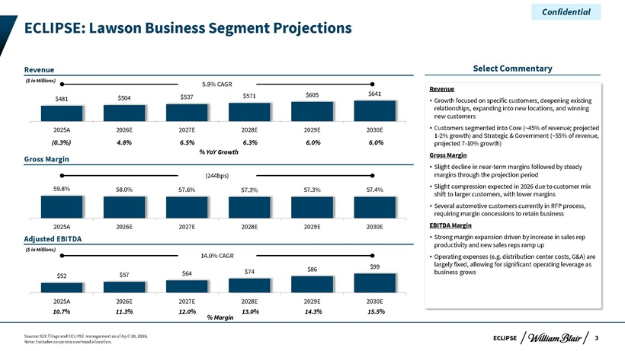
ECLIPSE $52 $57 $64 $74 $86 $99 2025A 2026E 2027E 2028E 2029E 2030E $481 $504 $537 $571 $605 $641 2025A 2026E 2027E 2028E 2029E 2030E ECLIPSE: Lawson Business Segment Projections Source: SEC filings and ECLIPSE management as of April 20, 2026. Note: Excludes corporate overhead allocation. Confidential 3 Revenue Adjusted EBITDA 59.8% 58.0% 57.6% 57.3% 57.3% 57.4% 2025A 2026E 2027E 2028E 2029E 2030E 5.9% CAGR 14.0% CAGR Gross Margin (244bps) Select Commentary Revenue  Growth focused on specific customers, deepening existing relationships, expanding into new locations, and winning new customers  Customers segmented into Core (~45% of revenue; projected 1-2% growth) and Strategic & Government (~55% of revenue, projected 7-10% growth) Gross Margin  Slight decline in near-term margins followed by steady margins through the projection period  Slight compression expected in 2026 due to customer mix shift to larger customers, with lower margins  Several automotive customers currently in RFP process, requiring margin concessions to retain business EBITDA Margin  Strong margin expansion driven by increase in sales rep productivity and new sales reps ramp up  Operating expenses (e.g. distribution center costs, G&A) are largely fixed, allowing for significant operating leverage as business grows (0.3%) 4.8% 6.5% 6.3% 6.0% 6.0% % YoY Growth ($ in Millions) 10.7% 11.3% 12.0% 13.0% 14.3% 15.5% % Margin ($ in Millions)

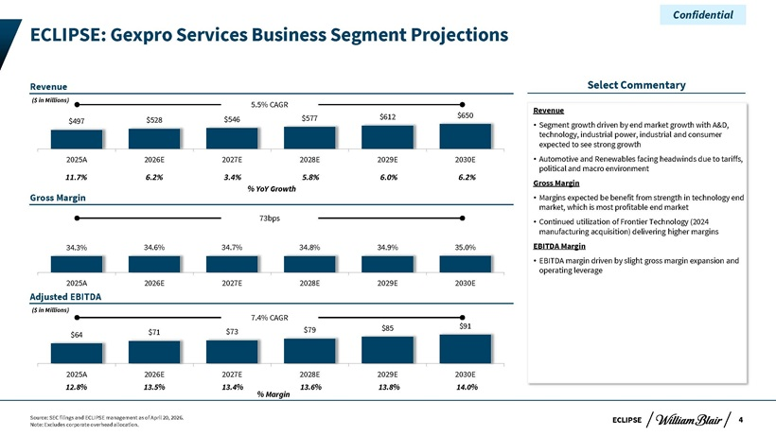
ECLIPSE $497 $528 $546 $577 $612 $650 2025A 2026E 2027E 2028E 2029E 2030E $64 $71 $73 $79 $85 $91 2025A 2026E 2027E 2028E 2029E 2030E Gross Margin Source: SEC filings and ECLIPSE management as of April 20, 2026. Note: Excludes corporate overhead allocation. Confidential 4 Revenue Select Commentary ECLIPSE: Gexpro Services Business Segment Projections Revenue  Segment growth driven by end market growth with A&D, technology, industrial power, industrial and consumer expected to see strong growth  Automotive and Renewables facing headwinds due to tariffs, political and macro environment Gross Margin  Margins expected be benefit from strength in technology end market, which is most profitable end market  Continued utilization of Frontier Technology (2024 manufacturing acquisition) delivering higher margins EBITDA Margin  EBITDA margin driven by slight gross margin expansion and operating leverage % YoY Growth 5.5% CAGR 7.4% CAGR 73bps 11.7% 6.2% 3.4% 5.8% 6.0% 6.2% 34.3% 34.6% 34.7% 34.8% 34.9% 35.0% 2025A 2026E 2027E 2028E 2029E 2030E 12.8% 13.5% 13.4% 13.6% 13.8% 14.0% % Margin Adjusted EBITDA ($ in Millions) ($ in Millions)

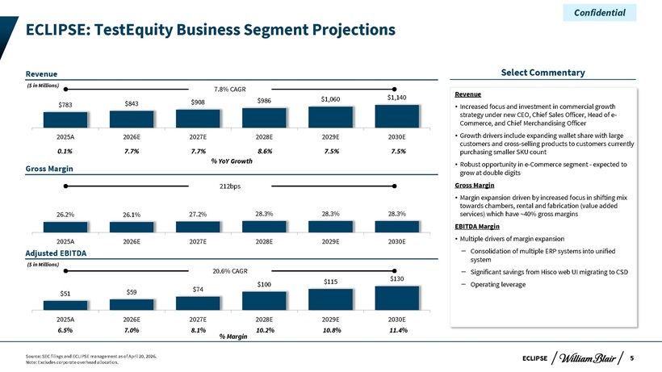
ECLIPSE $51 $59 $74 $100 $115 $130 2025A 2026E 2027E 2028E 2029E 2030E $783 $843 $908 $986 $1,060 $1,140 2025A 2026E 2027E 2028E 2029E 2030E Gross Margin Source: SEC filings and ECLIPSE management as of April 20, 2026. Note: Excludes corporate overhead allocation. Confidential 5 Revenue Select Commentary ECLIPSE: TestEquity Business Segment Projections Revenue  Increased focus and investment in commercial growth strategy under new CEO, Chief Sales Officer, Head of e- Commerce, and Chief Merchandising Officer  Growth drivers include expanding wallet share with large customers and cross-selling products to customers currently purchasing smaller SKU count  Robust opportunity in e-Commerce segment - expected to grow at double digits Gross Margin  Margin expansion driven by increased focus in shifting mix towards chambers, rental and fabrication (value added services) which have ~40% gross margins EBITDA Margin  Multiple drivers of margin expansion ‒ Consolidation of multiple ERP systems into unified system ‒ Significant savings from Hisco web UI migrating to CSD ‒ Operating leverage % YoY Growth 7.8% CAGR 20.6% CAGR 212bps 0.1% 7.7% 7.7% 8.6% 7.5% 7.5% 26.2% 26.1% 27.2% 28.3% 28.3% 28.3% 2025A 2026E 2027E 2028E 2029E 2030E 6.5% 7.0% 8.1% 10.2% 10.8% 11.4% % Margin Adjusted EBITDA ($ in Millions) ($ in Millions)

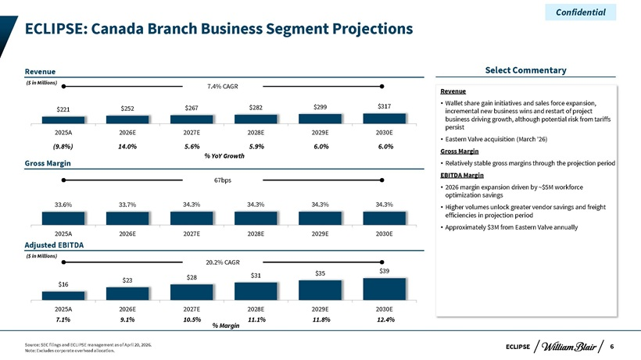
ECLIPSE Revenue $16 $23 $28 $31 $35 $39 2025A 2026E 2027E 2028E 2029E 2030E $221 $252 $267 $282 $299 $317 2025A 2026E 2027E 2028E 2029E 2030E Gross Margin Source: SEC filings and ECLIPSE management as of April 20, 2026. Note: Excludes corporate overhead allocation. Confidential 6 Select Commentary ECLIPSE: Canada Branch Business Segment Projections Revenue  Wallet share gain initiatives and sales force expansion, incremental new business wins and restart of project business driving growth, although potential risk from tariffs persist  Eastern Valve acquisition (March ‘26) Gross Margin  Relatively stable gross margins through the projection period EBITDA Margin  2026 margin expansion driven by ~$5M workforce optimization savings  Higher volumes unlock greater vendor savings and freight efficiencies in projection period  Approximately $3M from Eastern Valve annually % YoY Growth 7.4% CAGR 20.2% CAGR 67bps (9.8%) 14.0% 5.6% 5.9% 6.0% 6.0% 33.6% 33.7% 34.3% 34.3% 34.3% 34.3% 2025A 2026E 2027E 2028E 2029E 2030E 7.1% 9.1% 10.5% 11.1% 11.8% 12.4% % Margin Adjusted EBITDA ($ in Millions) ($ in Millions)

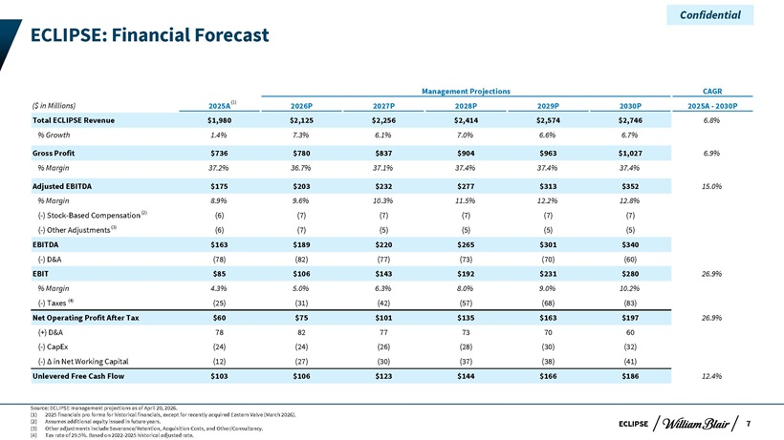
ECLIPSE Management Projections CAGR ($ in Millions) 2025A 2026P 2027P 2028P 2029P 2030P 2025A - 2030P Total ECLIPSE Revenue $1,980 $2,125 $2,256 $2,414 $2,574 $2,746 6.8% % Growth 1.4% 7.3% 6.1% 7.0% 6.6% 6.7% Gross Profit $736 $780 $837 $904 $963 $1,027 6.9% % Margin 37.2% 36.7% 37.1% 37.4% 37.4% 37.4% Adjusted EBITDA $175 $203 $232 $277 $313 $352 15.0% % Margin 8.9% 9.6% 10.3% 11.5% 12.2% 12.8% (-) Stock-Based Compensation (6) (7) (7) (7) (7) (7) (-) Other Adjustments (6) (7) (5) (5) (5) (5) EBITDA $163 $189 $220 $265 $301 $340 (-) D&A (78) (82) (77) (73) (70) (60) EBIT $85 $106 $143 $192 $231 $280 26.9% % Margin 4.3% 5.0% 6.3% 8.0% 9.0% 10.2% (-) Taxes (25) (31) (42) (57) (68) (83) Net Operating Profit After Tax $60 $75 $101 $135 $163 $197 26.9% (+) D&A 78 82 77 73 70 60 (-) CapEx (24) (24) (26) (28) (30) (32) (-) Ä in Net Working Capital (12) (27) (30) (37) (38) (41) Unlevered Free Cash Flow $103 $106 $123 $144 $166 $186 12.4% Source: ECLIPSE management projections as of April 20, 2026. (1) 2025 financials pro forma for historical financials, except for recently acquired Eastern Valve (March 2026). (2) Assumes additional equity issued in future years. (3) Other adjustments include Severance/Retention, Acquisition Costs, and Other/Consultancy. (4) Tax rate of 29.5%. Based on 2022-2025 historical adjusted rate. Confidential 7 (4) (3) (1) ECLIPSE: Financial Forecast (2)

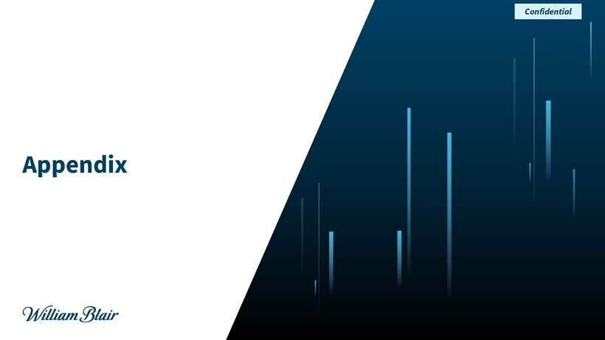
Appendix Confidential william Blair

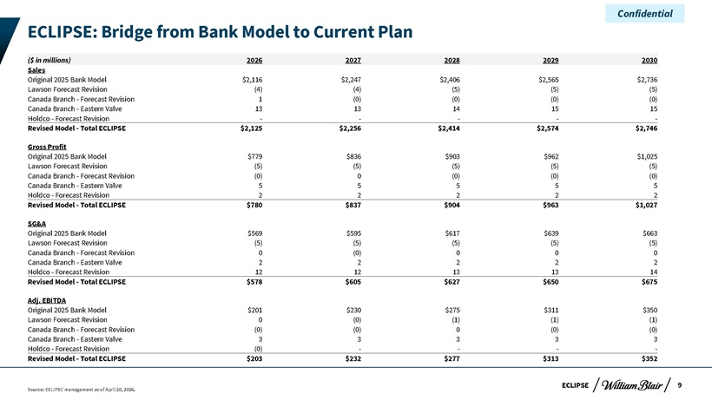
ECLIPSE ECLIPSE: Bridge from Bank Model to Current Plan Source: ECLIPSE management as of April 20, 2026. Confidential 9 ($ in millions) 2026 2027 2028 2029 2030 Sales Original 2025 Bank Model $2,116 $2,247 $2,406 $2,565 $2,736 Lawson Forecast Revision (4) (4) (5) (5) (5) Canada Branch—Forecast Revision 1 (0) (0) (0) (0) Canada Branch—Eastern Valve 13 13 14 15 15 Holdco—Forecast Revision ————— Revised Model—Total ECLIPSE $2,125 $2,256 $2,414 $2,574 $2,746 Gross Profit Original 2025 Bank Model $779 $836 $903 $962 $1,025 Lawson Forecast Revision (5) (5) (5) (5) (5) Canada Branch—Forecast Revision (0) 0 (0) (0) (0) Canada Branch—Eastern Valve 5 5 5 5 5 Holdco—Forecast Revision 2 2 2 2 2 Revised Model—Total ECLIPSE $780 $837 $904 $963 $1,027 SG&A Original 2025 Bank Model $569 $595 $617 $639 $663 Lawson Forecast Revision (5) (5) (5) (5) (5) Canada Branch—Forecast Revision 0 (0) 0 0 0 Canada Branch—Eastern Valve 2 2 2 2 2 Holdco—Forecast Revision 12 12 13 13 14 Revised Model—Total ECLIPSE $578 $605 $627 $650 $675 Adj. EBITDA Original 2025 Bank Model $201 $230 $275 $311 $350 Lawson Forecast Revision 0 (0) (1) (1) (1) Canada Branch—Forecast Revision (0) (0) 0 (0) (0) Canada Branch—Eastern Valve 3 3 3 3 3 Holdco—Forecast Revision (0) ———— Revised Model—Total ECLIPSE $203 $232 $277 $313 $352
Exhibit (c)(iii)

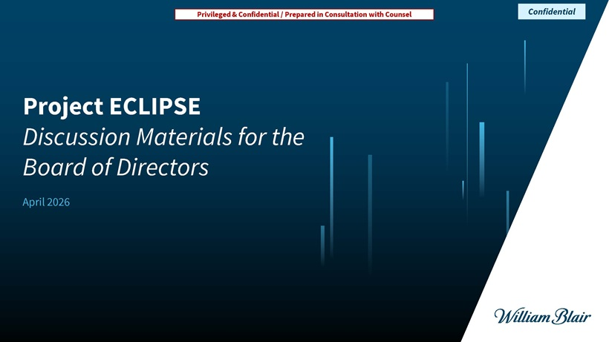
Project ECLIPSEDiscussion Materials for the Board of Directors April 2026 Privileged & Confidential / Prepared in Consultation with Counsel Confidential

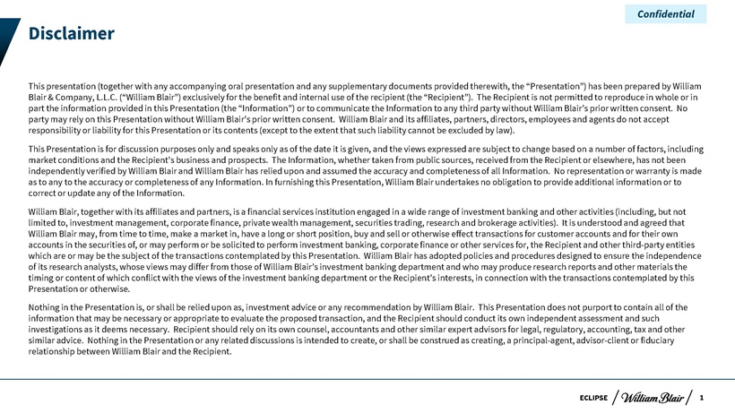
ECLIPSE Disclaimer This presentation (together with any accompanying oral presentation and any supplementary documents provided therewith, the “Presentation”) has been prepared by William Blair & Company, L.L.C. (“William Blair”) exclusively for the benefit and internal use of the recipient (the “Recipient”). The Recipient is not permitted to reproduce in whole or in part the information provided in this Presentation (the “Information”) or to communicate the Information to any third party without William Blair’s prior written consent. No party may rely on this Presentation without William Blair’s prior written consent. William Blair and its affiliates, partners, directors, employees and agents do not accept responsibility or liability for this Presentation or its contents (except to the extent that such liability cannot be excluded by law). This Presentation is for discussion purposes only and speaks only as of the date it is given, and the views expressed are subject to change based on a number of factors, including market conditions and the Recipient’s business and prospects. The Information, whether taken from public sources, received from the Recipient or elsewhere, has not been independently verified by William Blair and William Blair has relied upon and assumed the accuracy and completeness of all Information. No representation or warranty is made as to any to the accuracy or completeness of any Information. In furnishing this Presentation, William Blair undertakes no obligation to provide additional information or to correct or update any of the Information. William Blair, together with its affiliates and partners, is a financial services institution engaged in a wide range of investment banking and other activities (including, but not limited to, investment management, corporate finance, private wealth management, securities trading, research and brokerage activities). It is understood and agreed that William Blair may, from time to time, make a market in, have a long or short position, buy and sell or otherwise effect transactions for customer accounts and for their own accounts in the securities of, or may perform or be solicited to perform investment banking, corporate finance or other services for, the Recipient and other third-party entities which are or may be the subject of the transactions contemplated by this Presentation. William Blair has adopted policies and procedures designed to ensure the independence of its research analysts, whose views may differ from those of William Blair’s investment banking department and who may produce research reports and other materials the timing or content of which conflict with the views of the investment banking department or the Recipient’s interests, in connection with the transactions contemplated by this Presentation or otherwise. Nothing in the Presentation is, or shall be relied upon as, investment advice or any recommendation by William Blair. This Presentation does not purport to contain all of the information that may be necessary or appropriate to evaluate the proposed transaction, and the Recipient should conduct its own independent assessment and such investigations as it deems necessary. Recipient should rely on its own counsel, accountants and other similar expert advisors for legal, regulatory, accounting, tax and other similar advice. Nothing in the Presentation or any related discussions is intended to create, or shall be construed as creating, a principal-agent, advisor-client or fiduciary relationship between William Blair and the Recipient. Confidential 1

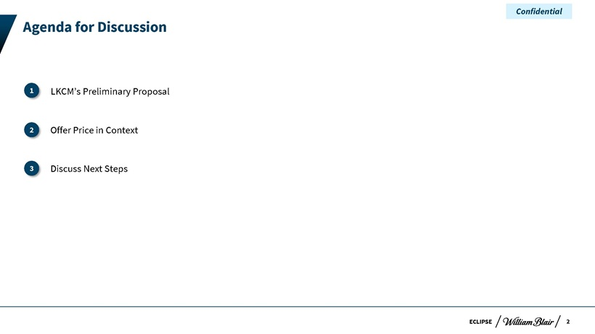
ECLIPSE Agenda for Discussion  LKCM’s Preliminary Proposal I. Offer Price in Context II. Discuss Next Steps 3 2 1 Confidential 2

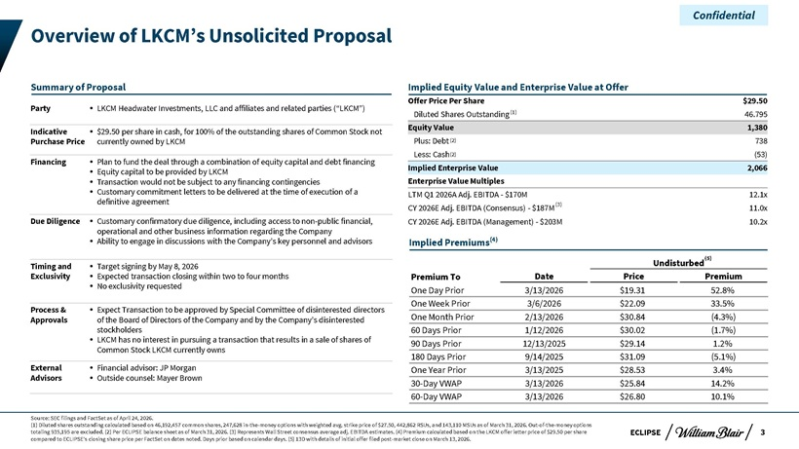
Overview of LKCM’s Unsolicited Proposal Summary of Proposal Party LKCM Headwater Investments, LLC and affiliates and related parties (“LKCM”) Indicative $29.50 per share in cash, for 100% of the outstanding shares of Common Stock not Purchase Price currently owned by LKCM Financing Plan to fund the deal through a combination of equity capital and debt financing Equity capital to be provided by LKCM Transaction would not be subject to any financing contingencies Customary commitment letters to be delivered at the time of execution of a definitive agreement Due Diligence Customary confirmatory due diligence, including access to non-public financial, operational and other business information regarding the Company Ability to engage in discussions with the Company’s key personnel and advisors Timing and Target signing by May 8, 2026 Exclusivity Expected transaction closing within two to four months No exclusivity requested Process & Expect Transaction to be approved by Special Committee of disinterested directors Approvals of the Board of Directors of the Company and by the Company’s disinterested stockholders LKCM has no interest in pursuing a transaction that results in a sale of shares of Common Stock LKCM currently owns External Financial advisor: JP Morgan Advisors Outside counsel: Mayer Brown Confidential Implied Equity Value and Enterprise Value at Offer Offer Price Per Share $29.50 Diluted Shares Outstanding (1) 46.795 Equity Value 1,380 Plus: Debt (2) 738 Less: Cash(2) (53) Implied Enterprise Value 2,066 Enterprise Value Multiples LTM Q1 2026A Adj. EBITDA—$170M 12.1x CY 2026E Adj. EBITDA (Consensus)—$187M(3) 11.0x CY 2026E Adj. EBITDA (Management)—$203M 10.2x Implied Premiums(4) Undisturbed(5) Premium To Date Price Premium One Day Prior 3/13/2026 $19.31 52.8% One Week Prior 3/6/2026 $22.09 33.5% One Month Prior 2/13/2026 $30.84 (4.3%) 60 Days Prior 1/12/2026 $30.02 (1.7%) 90 Days Prior 12/13/2025 $29.14 1.2% 180 Days Prior 9/14/2025 $31.09 (5.1%) One Year Prior 3/13/2025 $28.53 3.4% 30-Day VWAP 3/13/2026 $25.84 14.2% 60-Day VWAP 3/13/2026 $26.80 10.1% Source: SEC filings and FactSet as of April 24, 2026. (1) Diluted shares outstanding calculated based on 46,192,457 common shares, 247,628 in-the-money options with weighted avg. strike price of $27.50, 442,862 RSUs, and 143,110 MSUs as of March 31, 2026. Out-of-the-money options totaling 935,195 are excluded. (2) Per ECLIPSE balance sheet as of March 31, 2026. (3) Represents Wall Street consensus average adj. EBITDA estimates. (4) Premium calculated based on the LKCM offer letter price of $29.50 per share ECLIPSE 3 compared to ECLIPSE’s closing share price per FactSet on dates noted. Days prior based on calendar days. (5) 13D with details of initial offer filed post-market close on March 13, 2026.

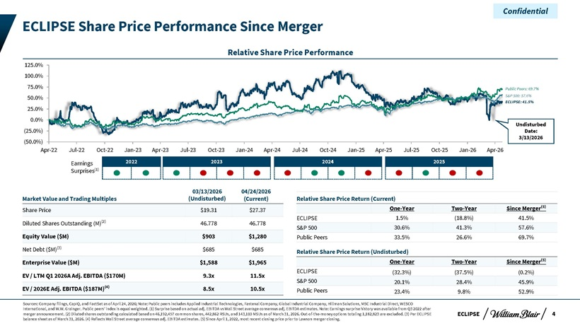
Confidential ECLIPSE Share Price Performance Since Merger Relative Share Price Performance 125.0% 100.0% 75.0% Public Peers: 69.7% 50.0% S&P 500: 57.6% ECLIPSE: 41.5% 25.0% 0.0% Undisturbed (25.0%) Date: 3/13/2026 (50.0%) Apr-22 Jul-22 Oct-22 Jan-23 Apr-23 Jul-23 Oct-23 Jan-24 Apr-24 Jul-24 Oct-24 Jan-25 Apr-25 Jul-25 Oct-25 Jan-26 Apr-26 Earnings 2022 2023 2024 2025 Surprises(1) 03/13/2026 04/24/2026 Market Value and Trading Multiples (Undisturbed) (Current) Share Price $19.31 $27.37 Diluted Shares Outstanding (M)(2) 46.778 46.778 Equity Value ($M) $903 $1,280 Net Debt ($M)(3) $685 $685 Enterprise Value ($M) $1,588 $1,965 EV / LTM Q1 2026A Adj. EBITDA ($170M) 9.3x 11.5x EV / 2026E Adj. EBITDA ($187M)(4) 8.5x 10.5x Relative Share Price Return (Current) One-Year Two-Year Since Merger(5) ECLIPSE 1.5% (18.8%) 41.5% S&P 500 30.6% 41.3% 57.6% Public Peers 33.5% 26.6% 69.7% Relative Share Price Return (Undisturbed) One-Year Two-Year Since Merger(5) ECLIPSE (32.3%) (37.5%) (0.2%) S&P 500 20.1% 28.4% 45.9% Public Peers 23.4% 9.8% 52.9% Sources: Company filings, CapIQ, and FactSet as of April 24, 2026; Note: Public peers includes Applied Industrial Technologies, Fastenal Company, Global Industrial Company, Hillman Solutions, MSC Industrial Direct, WESCO International, and W.W. Grainger. Public peers’ index is equal weighted. (1) Surprise based on actual adj. EBITDA vs Wall Street average consensus adj. EBITDA estimates. Note: Earnings surprise history was available from Q3 2022 after merger announcement. (2) Diluted shares outstanding calculated based on 46,192,457 common shares, 442,862 RSUs, and 143,110 MSUs as of March 31, 2026. Out-of-the-money options totaling 1,182,823 are excluded. (3) Per ECLIPSE ECLIPSE 4 balance sheet as of March 31, 2026. (4) Reflects Wall Street average consensus adj. EBITDA estimates. (5) Since April 1, 2022, most recent closing price prior to Lawson merger closing.

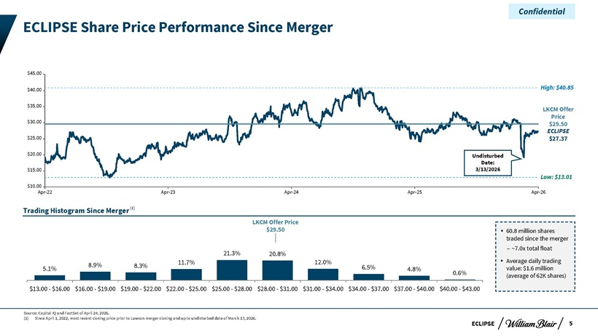
Confidential ECLIPSE Share Price Performance Since Merger $45.00 $40.00 High: $40.85 $35.00 LKCM Offer $30.00 Price $29.50 ECLIPSE $25.00 $27.37 $20.00 Undisturbed Date: $15.00 3/13/2026 Low: $13.01 $10.00 Apr-22 Apr-23 Apr-24 Apr-25 Apr-26 Trading Histogram Since Merger(1) LKCM Offer Price $29.50 60.8 million shares traded since the merger – ~7.0x total float 21.3% 20.8% 11.7% 12.0% Average daily trading 8.9% 8.3% 6.5% 5.1% 4.8% value: $1.6 million 0.6% (average of 62K shares) $13.00—$16.00 $16.00—$19.00 $19.00—$22.00 $22.00—$25.00 $25.00—$28.00 $28.00—$31.00 $31.00—$34.00 $34.00—$37.00 $37.00—$40.00 $40.00—$43.00 Source: Capital IQ and FactSet of April 24, 2026. (1) Since April 1, 2022, most recent closing price prior to Lawson merger closing and up to undisturbed date of March 13, 2026. ECLIPSE 5

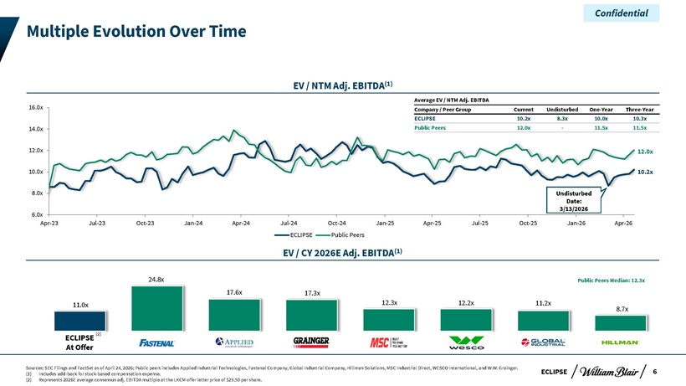
Confidential Multiple Evolution Over Time EV / NTM Adj. EBITDA(1) Average EV / NTM Adj. EBITDA 16.0x Company / Peer Group Current Undisturbed One-Year Three-Year ECLIPSE 10.2x 8.3x 10.0x 10.3x 14.0x Public Peers 12.0x—11.5x 11.5x 12.0x 12.0x 10.0x 10.2x 8.0x Undisturbed Date: 3/13/2026 6.0x Apr-23 Jul-23 Oct-23 Jan-24 Apr-24 Jul-24 Oct-24 Jan-25 Apr-25 Jul-25 Oct-25 Jan-26 Apr-26 ECLIPSE Public Peers EV / CY 2026E Adj. EBITDA(1) 24.8x Public Peers Median: 12.3x 17.6x 17.3x 11.0x 12.3x 12.2x 11.2x 8.7x ECLIPSE (2) At Offer Sources: SEC Filings and FactSet as of April 24, 2026; Public peers includes Applied Industrial Technologies, Fastenal Company, Global Industrial Company, Hillman Solutions, MSC Industrial Direct, WESCO International, and W.W. Grainger. ECLIPSE 6 (1) Includes add-back for stock-based compensation expense. (2) Represents 2026E average consensus adj. EBITDA multiple at the LKCM offer letter price of $29.50 per share.

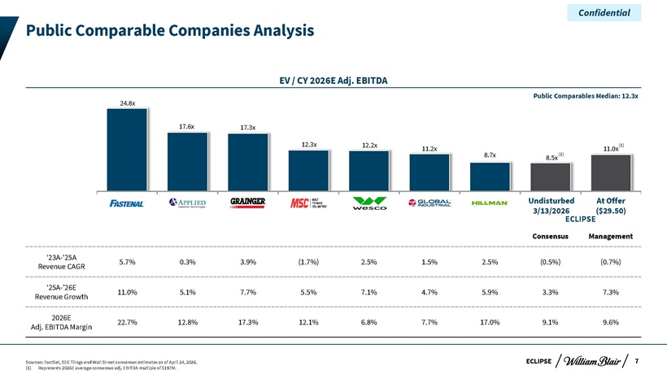
Confidential Public Comparable Companies Analysis EV / CY 2026E Adj. EBITDA Public Comparables Median: 12.3x 24.8x 17.6x 17.3x 12.3x 12.2x 11.0x (1) 11.2x (1) 8.7x 8.5x Undisturbed At Offer 3/13/2026 ECLIPSE($29.50) Consensus Management ‘23A-‘25A 5.7% 0.3% 3.9% (1.7%) 2.5% 1.5% 2.5% (0.5%) (0.7%) Revenue CAGR ‘25A-’26E 11.0% 5.1% 7.7% 5.5% 7.1% 4.7% 5.9% 3.3% 7.3% Revenue Growth 2026E 22.7% 12.8% 17.3% 12.1% 6.8% 7.7% 17.0% 9.1% 9.6% Adj. EBITDA Margin Sources: FactSet, SEC filings and Wall Street consensus estimates as of April 24, 2026. ECLIPSE 7 (1) Represents 2026E average consensus adj. EBITDA multiple of $187M.

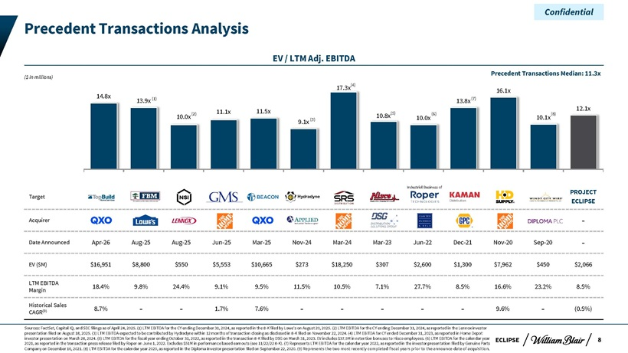
Confidential Precedent Transactions Analysis EV / LTM Adj. EBITDA Precedent Transactions Median: 11.3x ($ in millions) 17.3x(4) 16.1x 14.8x (1) (7) 13.9x 13.8x 11.5x 12.1x (2) 11.1x (5) (6) (8) 10.0x 10.8x 10.0x 10.1x 9.1x (3) Industrial Business of PROJECT Target ECLIPSE Acquirer—Date Announced Apr-26 Aug-25 Aug-25 Jun-25 Mar-25 Nov-24 Mar-24 Mar-23 Jun-22 Dec-21 Nov-20 Sep-20—EV ($M) $16,951 $8,800 $550 $5,553 $10,665 $273 $18,250 $307 $2,600 $1,300 $7,962 $450 $2,066 LTM EBITDA 18.4% 9.8% 24.4% 9.1% 9.5% 11.5% 10.5% 7.1% 27.7% 8.5% 16.6% 23.2% 8.5% Margin Historical Sales (9) 8.7% — 1.7% 7.6% — ——9.6%—(0.5%) CAGR Sources: FactSet, Capital IQ, and SEC filings as of April 24, 2025. (1) LTM EBITDA for the CY ending December 31, 2024, as reported in the 8-K filed by Lowe’s on August 20, 2025. (2) LTM EBITDA for the CY ending December 31, 2024, as reported in the Lennox investor presentation filed on August 18, 2025. (3) LTM EBITDA expected to be contributed by Hydradyne within 12 months of transaction closing as disclosed in 8-K filed on November 22, 2024. (4) LTM EBITDA for CY ended December 31, 2023, as reported in Home Depot investor presentation on March 28, 2024. (5) LTM EBITDA for the fiscal year ending October 31, 2022, as reported in the transaction 8-K filed by DSG on March 31, 2023. EV includes $37.5M in retention bonuses to Hisco employees. (6) LTM EBITDA for the calendar year ECLIPSE 8 2021, as reported in the transaction press release filed by Roper on June 1, 2022. Excludes $51M in performance based earnouts (see 11/22/22 8-K). (7) Represents LTM EBITDA for the calendar year 2022, as reported in the investor presentation filed by Genuine Parts Company on December 16, 2021. (8) LTM EBITDA for the calendar year 2020, as reported in the Diploma investor presentation filed on September 22, 2020. (9) Represents the two most recently completed fiscal years prior to the announce date of acquisition.

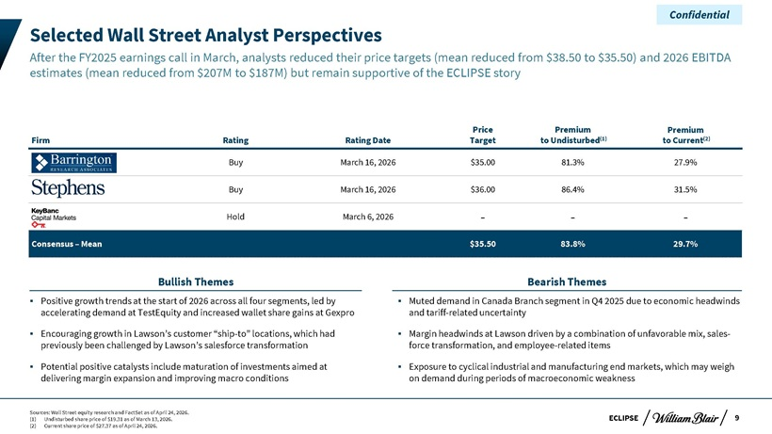
Confidential Selected Wall Street Analyst Perspectives After the FY2025 earnings call in March, analysts reduced their price targets (mean reduced from $38.50 to $35.50) and 2026 EBITDA estimates (mean reduced from $207M to $187M) but remain supportive of the ECLIPSE story Price Premium Premium Firm Rating Rating Date Target to Undisturbed(1) to Current(2) Buy March 16, 2026 $35.00 81.3% 27.9% Buy March 16, 2026 $36.00 86.4% 31.5% Hold March 6, 2026 ——Consensus – Mean $35.50 83.8% 29.7% Bullish Themes Bearish Themes Positive growth trends at the start of 2026 across all four segments, led by Muted demand in Canada Branch segment in Q4 2025 due to economic headwinds accelerating demand at TestEquity and increased wallet share gains at Gexpro and tariff-related uncertainty Encouraging growth in Lawson’s customer “ship-to” locations, which had Margin headwinds at Lawson driven by a combination of unfavorable mix, sales-previously been challenged by Lawson’s salesforce transformation force transformation, and employee-related items Potential positive catalysts include maturation of investments aimed at Exposure to cyclical industrial and manufacturing end markets, which may weigh delivering margin expansion and improving macro conditions on demand during periods of macroeconomic weakness Sources: Wall Street equity research and FactSet as of April 24, 2026. (1) Undisturbed share price of $19.31 as of March 13, 2026. ECLIPSE 9 (2) Current share price of $27.37 as of April 24, 2026.

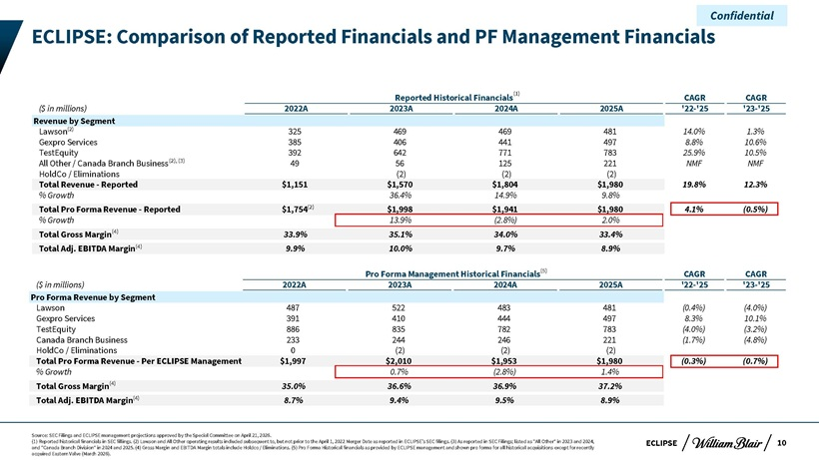
Confidential ECLIPSE: Comparison of Reported Financials and PF Management Financials Reported Historical Financials(1) CAGR CAGR ($ in millions) 2022A 2023A 2024A 2025A ‘22-‘25 ‘23-‘25 Revenue by Segment Lawson(2) 325 469 469 481 14.0% 1.3% Gexpro Services 385 406 441 497 8.8% 10.6% TestEquity 392 642 771 783 25.9% 10.5% All Other / Canada Branch Business(2), (3) 49 56 125 221 NMF NMF HoldCo / Eliminations (2) (2) (2) Total Revenue—Reported $1,151 $1,570 $1,804 $1,980 19.8% 12.3% % Growth 36.4% 14.9% 9.8% Total Pro Forma Revenue—Reported $1,754(2) $1,998 $1,941 $1,980 4.1% (0.5%) % Growth 13.9% (2.8%) 2.0% Total Gross Margin(4) 33.9% 35.1% 34.0% 33.4% Total Adj. EBITDA Margin(4) 9.9% 10.0% 9.7% 8.9% Pro Forma Management Historical Financials(5) CAGR CAGR ($ in millions) 2022A 2023A 2024A 2025A ‘22-‘25 ‘23-‘25 Pro Forma Revenue by Segment Lawson 487 522 483 481 (0.4%) (4.0%) Gexpro Services 391 410 444 497 8.3% 10.1% TestEquity 886 835 782 783 (4.0%) (3.2%) Canada Branch Business 233 244 246 221 (1.7%) (4.8%) HoldCo / Eliminations 0 (2) (2) (2) Total Pro Forma Revenue—Per ECLIPSE Management $1,997 $2,010 $1,953 $1,980 (0.3%) (0.7%) % Growth 0.7% (2.8%) 1.4% Total Gross Margin(4) 35.0% 36.6% 36.9% 37.2% Total Adj. EBITDA Margin(4) 8.7% 9.4% 9.5% 8.9% Source: SEC Filings and ECLIPSE management projections approved by the Special Committee on April 21, 2026. (1) Reported historical financials in SEC fillings. (2) Lawson and All Other operating results included subsequent to, but not prior to the April 1, 2022 Merger Date as reported in ECLIPSE’s SEC filings. (3) As reported in SEC Filings; listed as “All Other” in 2023 and 2024, ECLIPSE 10 and “Canada Branch Division” in 2024 and 2025. (4) Gross Margin and EBITDA Margin totals include Holdco / Eliminations. (5) Pro Forma Historical financials as provided by ECLIPSE management and shown pro forma for all historical acquisitions except for recently acquired Eastern Valve (March 2026).

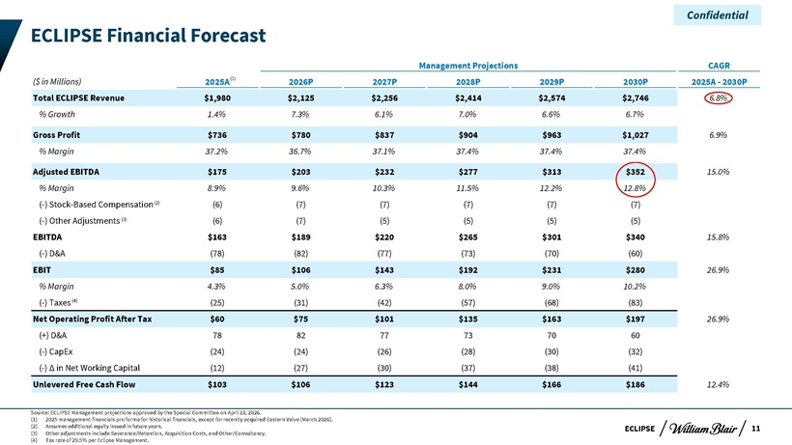
Confidential ECLIPSE Financial Forecast Management Projections CAGR ($ in Millions) 2025A(1) 2026P 2027P 2028P 2029P 2030P 2025A—2030P Total ECLIPSE Revenue $1,980 $2,125 $2,256 $2,414 $2,574 $2,746 6.8% % Growth 1.4% 7.3% 6.1% 7.0% 6.6% 6.7% Gross Profit $736 $780 $837 $904 $963 $1,027 6.9% % Margin 37.2% 36.7% 37.1% 37.4% 37.4% 37.4% Adjusted EBITDA $175 $203 $232 $277 $313 $352 15.0% % Margin 8.9% 9.6% 10.3% 11.5% 12.2% 12.8% (-) Stock-Based Compensation(2) (6) (7) (7) (7) (7) (7) (-) Other Adjustments (3) (6) (7) (5) (5) (5) (5) EBITDA $163 $189 $220 $265 $301 $340 15.8% (-) D&A (78) (82) (77) (73) (70) (60) EBIT $85 $106 $143 $192 $231 $280 26.9% % Margin 4.3% 5.0% 6.3% 8.0% 9.0% 10.2% (-) Taxes (4) (25) (31) (42) (57) (68) (83) Net Operating Profit After Tax $60 $75 $101 $135 $163 $197 26.9% (+) D&A 78 82 77 73 70 60 (-) CapEx (24) (24) (26) (28) (30) (32) (-) Ä in Net Working Capital (12) (27) (30) (37) (38) (41) Unlevered Free Cash Flow $103 $106 $123 $144 $166 $186 12.4% Source: ECLIPSE Management projections approved by the Special Committee on April 21, 2026. (1) 2025 management financials pro forma for historical financials, except for recently acquired Eastern Valve (March 2026). (2) Assumes additional equity issued in future years. ECLIPSE 11 (3) Other adjustments include Severance/Retention, Acquisition Costs, and Other/Consultancy. (4) Tax rate of 29.5% per Eclipse Management.

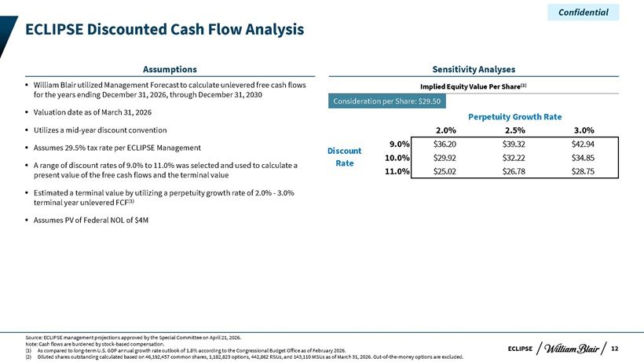
Confidential ECLIPSE Discounted Cash Flow Analysis Assumptions Sensitivity Analyses William Blair utilized Management Forecast to calculate unlevered free cash flows Implied Equity Value Per Share(2) for the years ending December 31, 2026, through December 31, 2030 Consideration per Share: $29.50 Valuation date as of March 31, 2026 Perpetuity Growth Rate Utilizes a mid-year discount convention 2.0% 2.5% 3.0% Assumes 29.5% tax rate per ECLIPSE Management 9.0% $36.20 $39.32 $42.94 Discount 10.0% $29.92 $32.22 $34.85 A range of discount rates of 9.0% to 11.0% was selected and used to calculate a Rate present value of the free cash flows and the terminal value 11.0% $25.02 $26.78 $28.75 Estimated a terminal value by utilizing a perpetuity growth rate of 2.0%—3.0% terminal year unlevered FCF(1) Assumes PV of Federal NOL of $4M Source: ECLIPSE management projections approved by the Special Committee on April 21, 2026. Note: Cash flows are burdened by stock-based compensation. (1) As compared to long-term U.S. GDP annual growth rate outlook of 1.8% according to the Congressional Budget Office as of February 2026. ECLIPSE 12 (2) Diluted shares outstanding calculated based on 46,192,457 common shares, 1,182,823 options, 442,862 RSUs, and 143,110 MSUs as of March 31, 2026. Out-of-the-money options are excluded.

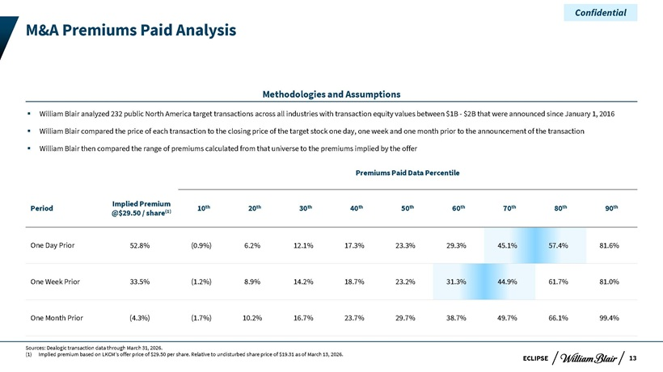
Confidential M&A Premiums Paid Analysis Methodologies and Assumptions William Blair analyzed 232 public North America target transactions across all industries with transaction equity values between $1B—$2B that were announced since January 1, 2016 William Blair compared the price of each transaction to the closing price of the target stock one day, one week and one month prior to the announcement of the transaction William Blair then compared the range of premiums calculated from that universe to the premiums implied by the offer Premiums Paid Data Percentile Implied Premium th th th th th th th th th Period (1) 10 20 30 40 50 60 70 80 90 @$29.50 / share One Day Prior 52.8% (0.9%) 6.2% 12.1% 17.3% 23.3% 29.3% 45.1% 57.4% 81.6% One Week Prior 33.5% (1.2%) 8.9% 14.2% 18.7% 23.2% 31.3% 44.9% 61.7% 81.0% One Month Prior (4.3%) (1.7%) 10.2% 16.7% 23.7% 29.7% 38.7% 49.7% 66.1% 99.4% Sources: Dealogic transaction data through March 31, 2026. (1) Implied premium based on LKCM’s offer price of $29.50 per share. Relative to undisturbed share price of $19.31 as of March 13, 2026. 13 ECLIPSE

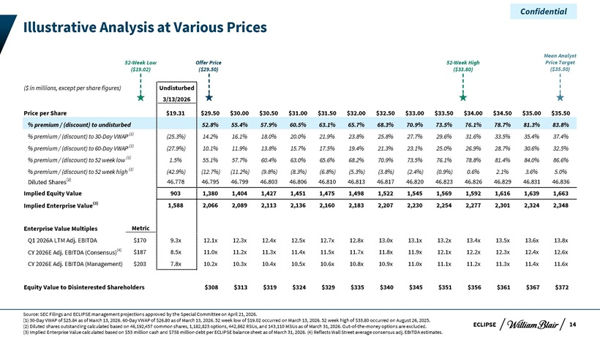
Confidential Illustrative Analysis at Various Prices Mean Analyst 52-Week Low Offer Price 52-Week High Price Target ($19.02) ($29.50) ($33.80) ($35.50) ($ in millions, except per share figures) Undisturbed 3/13/2026 Price per Share $19.31 $29.50 $30.00 $30.50 $31.00 $31.50 $32.00 $32.50 $33.00 $33.50 $34.00 $34.50 $35.00 $35.50 % premium / (discount) to undisturbed 52.8% 55.4% 57.9% 60.5% 63.1% 65.7% 68.3% 70.9% 73.5% 76.1% 78.7% 81.3% 83.8% % premium / (discount) to 30-Day VWAP (1) (25.3%) 14.2% 16.1% 18.0% 20.0% 21.9% 23.8% 25.8% 27.7% 29.6% 31.6% 33.5% 35.4% 37.4% % premium / (discount) to 60-Day VWAP (1) (27.9%) 10.1% 11.9% 13.8% 15.7% 17.5% 19.4% 21.3% 23.1% 25.0% 26.9% 28.7% 30.6% 32.5% % premium / (discount) to 52 week low (1) 1.5% 55.1% 57.7% 60.4% 63.0% 65.6% 68.2% 70.9% 73.5% 76.1% 78.8% 81.4% 84.0% 86.6% % premium / (discount) to 52 week high (1) (42.9%) (12.7%) (11.2%) (9.8%) (8.3%) (6.8%) (5.3%) (3.8%) (2.4%) (0.9%) 0.6% 2.1% 3.6% 5.0% Diluted Shares(2) 46.778 46.795 46.799 46.803 46.806 46.810 46.813 46.817 46.820 46.823 46.826 46.829 46.831 46.836 Implied Equity Value 903 1,380 1,404 1,427 1,451 1,475 1,498 1,522 1,545 1,569 1,592 1,616 1,639 1,663 Implied Enterprise Value(3) 1,588 2,066 2,089 2,113 2,136 2,160 2,183 2,207 2,230 2,254 2,277 2,301 2,324 2,348 Enterprise Value Multiples Metric Q1 2026A LTM Adj. EBITDA $170 9.3x 12.1x 12.3x 12.4x 12.5x 12.7x 12.8x 13.0x 13.1x 13.2x 13.4x 13.5x 13.6x 13.8x CY 2026E Adj. EBITDA (Consensus)(4) $187 8.5x 11.0x 11.2x 11.3x 11.4x 11.5x 11.7x 11.8x 11.9x 12.1x 12.2x 12.3x 12.4x 12.6x CY 2026E Adj. EBITDA (Management) $203 7.8x 10.2x 10.3x 10.4x 10.5x 10.6x 10.8x 10.9x 11.0x 11.1x 11.2x 11.3x 11.4x 11.6x Equity Value to Disinterested Shareholders $308 $313 $319 $324 $329 $335 $340 $345 $351 $356 $361 $367 $372 Source: SEC Filings and ECLIPSE management projections approved by the Special Committee on April 21, 2026. (1) 30-Day VWAP of $25.84 as of March 13, 2026. 60-Day VWAP of $26.80 as of March 13, 2026. 52 week low of $19.02 occurred on March 13, 2026. 52 week high of $33.80 occurred on August 26, 2025. (2) Diluted shares outstanding calculated based on 46,192,457 common shares, 1,182,823 options, 442,862 RSUs, and 143,110 MSUs as of March 31, 2026. Out-of-the-money options are excluded. ECLIPSE 14 (3) Implied Enterprise Value calculated based on $53 million cash and $738 million debt per ECLIPSE balance sheet as of March 31, 2026. (4) Reflects Wall Street average consensus adj. EBITDA estimates.

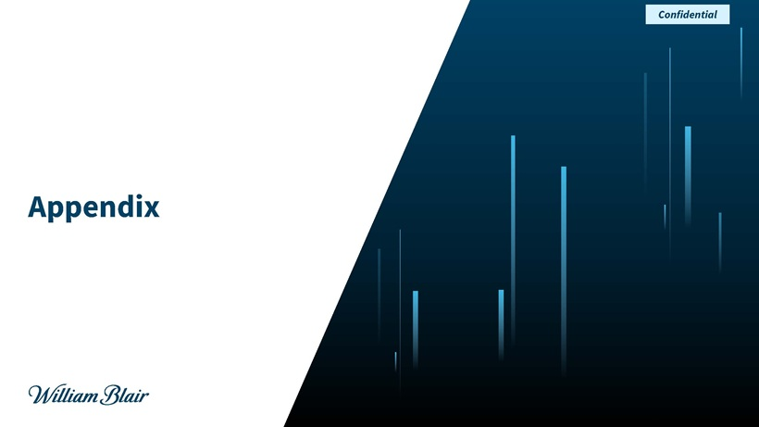
Confidential Appendix

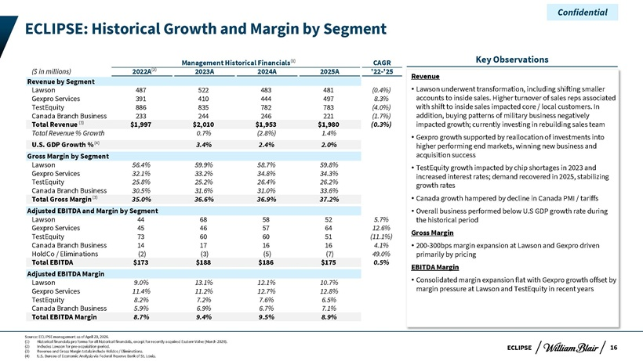
Confidential ECLIPSE: Historical Growth and Margin by Segment Management Historical Financials(1) CAGR Key Observations ($ in millions) 2022A(2) 2023A 2024A 2025A ‘22-‘25 Revenue Revenue by Segment Lawson 487 522 483 481 (0.4%)  Lawson underwent transformation, including shifting smaller Gexpro Services 391 410 444 497 8.3% accounts to inside sales. Higher turnover of sales reps associated TestEquity 886 835 782 783 (4.0%) with shift to inside sales impacted core / local customers. In Canada Branch Business 233 244 246 221 (1.7%) addition, buying patterns of military business negatively Total Revenue (3) $1,997 $2,010 $1,953 $1,980 (0.3%) impacted growth; currently investing in rebuilding sales team Total Revenue % Growth 0.7% (2.8%) 1.4% U.S. GDP Growth %(4) 3.4% 2.4% 2.0%  Gexpro growth supported by reallocation of investments into higher performing end markets, winning new business and Gross Margin by Segment acquisition success Lawson 56.4% 59.9% 58.7% 59.8%  TestEquity growth impacted by chip shortages in 2023 and Gexpro Services 32.1% 33.2% 34.8% 34.3% increased interest rates; demand recovered in 2025, stabilizing TestEquity 25.8% 25.2% 26.4% 26.2% growth rates Canada Branch Business 30.5% 31.6% 31.0% 33.6% Total Gross Margin(3) 35.0% 36.6% 36.9% 37.2%  Canada growth hampered by decline in Canada PMI / tariffs Adjusted EBITDA and Margin by Segment  Overall business performed below U.S GDP growth rate during Lawson 44 68 58 52 5.7% the historical period Gexpro Services 45 46 57 64 12.6% Gross Margin TestEquity 73 60 60 51 (11.1%) Canada Branch Business 14 17 16 16 4.1%  200-300bps margin expansion at Lawson and Gexpro driven HoldCo / Eliminations (2) (3) (5) (7) 49.0% primarily by pricing Total EBITDA $173 $188 $186 $175 0.5% EBITDA Margin Adjusted EBITDA Margin Lawson 9.0% 13.1% 12.1% 10.7%  Consolidated margin expansion flat with Gexpro growth offset by Gexpro Services 11.4% 11.2% 12.7% 12.8% margin pressure at Lawson and TestEquity in recent years TestEquity 8.2% 7.2% 7.6% 6.5% Canada Branch Business 5.9% 6.9% 6.7% 7.1% Total EBITDA Margin 8.7% 9.4% 9.5% 8.9% Source: ECLIPSE management as of April 20, 2026. (1) Historical financials pro forma for all historical financials, except for recently acquired Eastern Valve (March 2026). (2) Includes Lawson for pre-acquisition period. ECLIPSE 16 (3) Revenue and Gross Margin totals include Holdco / Eliminations. (4) U.S. Bureau of Economic Analysis via Federal Reserve Bank of St. Louis.

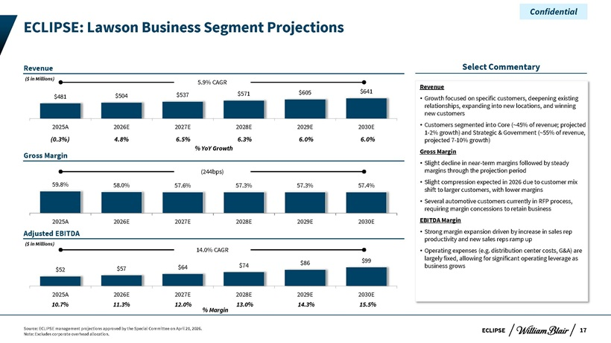
Confidential ECLIPSE: Lawson Business Segment Projections Revenue Select Commentary ($ in Millions) 5.9% CAGR Revenue $571 $605 $641 $481 $504 $537  Growth focused on specific customers, deepening existing relationships, expanding into new locations, and winning new customers 2025A 2026E 2027E 2028E 2029E 2030E  Customers segmented into Core (~45% of revenue; projected (0.3%) 4.8% 6.5% 6.3% 6.0% 6.0% 1-2% growth) and Strategic & Government (~55% of revenue, projected 7-10% growth) Gross Margin % YoY Growth Gross Margin  Slight decline in near-term margins followed by steady (244bps) margins through the projection period 59.8%  Slight compression expected in 2026 due to customer mix 58.0% 57.6% 57.3% 57.3% 57.4% shift to larger customers, with lower margins  Several automotive customers currently in RFP process, requiring margin concessions to retain business 2025A 2026E 2027E 2028E 2029E 2030E EBITDA Margin Adjusted EBITDA  Strong margin expansion driven by increase in sales rep productivity and new sales reps ramp up ($ in Millions) 14.0% CAGR  Operating expenses (e.g. distribution center costs, G&A) are $99 largely fixed, allowing for significant operating leverage as $74 $86 business grows $52 $57 $64 2025A 2026E 2027E 2028E 2029E 2030E 10.7% 11.3% 12.0% 13.0% 14.3% 15.5% % Margin Source: ECLIPSE management projections approved by the Special Committee on April 21, 2026. ECLIPSE 17 Note: Excludes corporate overhead allocation.

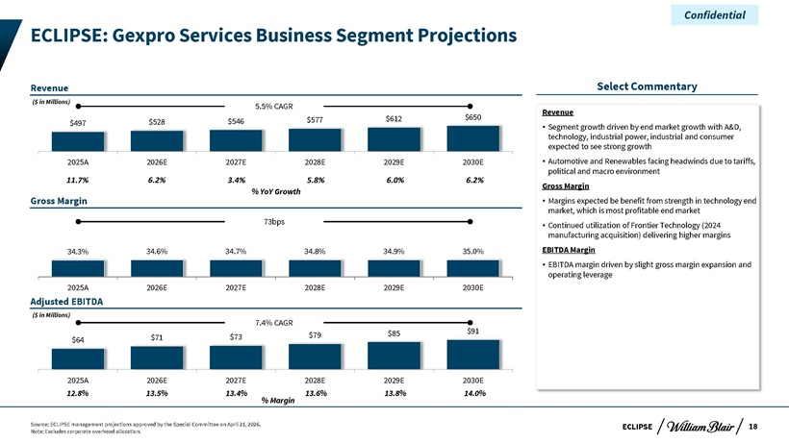
Confidential ECLIPSE: Gexpro Services Business Segment Projections Revenue Select Commentary ($ in Millions) 5.5% CAGR Revenue $577 $612 $650 $497 $528 $546  Segment growth driven by end market growth with A&D, technology, industrial power, industrial and consumer expected to see strong growth 2025A 2026E 2027E 2028E 2029E 2030E  Automotive and Renewables facing headwinds due to tariffs, 11.7% 6.2% 3.4% 5.8% 6.0% 6.2% political and macro environment Gross Margin % YoY Growth Gross Margin  Margins expected be benefit from strength in technology end market, which is most profitable end market 73bps  Continued utilization of Frontier Technology (2024 manufacturing acquisition) delivering higher margins 34.3% 34.6% 34.7% 34.8% 34.9% 35.0% EBITDA Margin  EBITDA margin driven by slight gross margin expansion and operating leverage 2025A 2026E 2027E 2028E 2029E 2030E Adjusted EBITDA ($ in Millions) 7.4% CAGR $85 $91 $71 $73 $79 $64 2025A 2026E 2027E 2028E 2029E 2030E 12.8% 13.5% 13.4% 13.6% 13.8% 14.0% % Margin Source: ECLIPSE management projections approved by the Special Committee on April 21, 2026. ECLIPSE 18 Note: Excludes corporate overhead allocation.

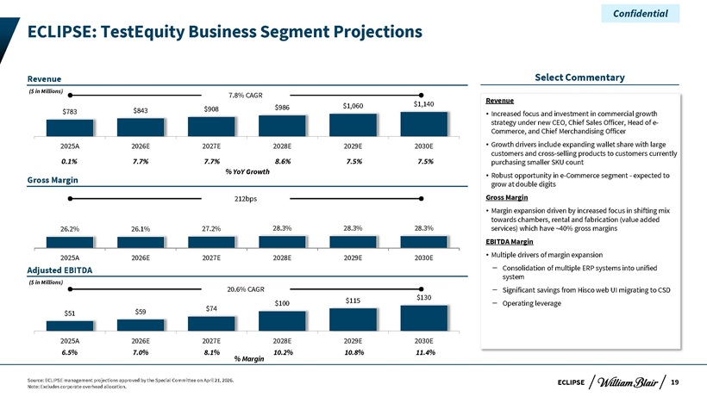
Confidential ECLIPSE: TestEquity Business Segment Projections Revenue Select Commentary ($ in Millions) 7.8% CAGR Revenue $986 $1,060 $1,140 $783 $843 $908  Increased focus and investment in commercial growth strategy under new CEO, Chief Sales Officer, Head of e-Commerce, and Chief Merchandising Officer 2025A 2026E 2027E 2028E 2029E 2030E  Growth drivers include expanding wallet share with large 0.1% 7.7% 7.7% 8.6% 7.5% 7.5% customers and cross-selling products to customers currently purchasing smaller SKU count % YoY Growth Gross Margin  Robust opportunity in e-Commerce segment—expected to grow at double digits 212bps Gross Margin  Margin expansion driven by increased focus in shifting mix towards chambers, rental and fabrication (value added 26.2% 26.1% 27.2% 28.3% 28.3% 28.3% services) which have ~40% gross margins EBITDA Margin 2025A 2026E 2027E 2028E 2029E 2030E  Multiple drivers of margin expansion Adjusted EBITDA – Consolidation of multiple ERP systems into unified system ($ in Millions) 20.6% CAGR $130 – Significant savings from Hisco web UI migrating to CSD $100 $115 – Operating leverage $59 $74 $51 2025A 2026E 2027E 2028E 2029E 2030E 6.5% 7.0% 8.1% 10.2% 10.8% 11.4% % Margin Source: ECLIPSE management projections approved by the Special Committee on April 21, 2026. ECLIPSE 19 Note: Excludes corporate overhead allocation.

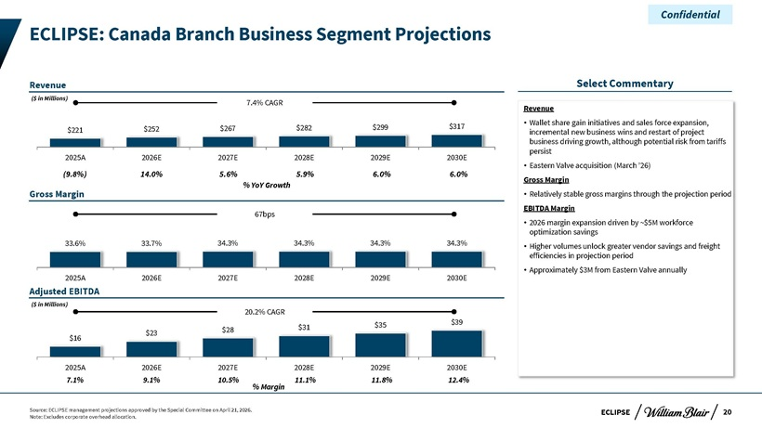
Confidential ECLIPSE: Canada Branch Business Segment Projections Revenue Select Commentary ($ in Millions) 7.4% CAGR Revenue  Wallet share gain initiatives and sales force expansion, $221 $252 $267 $282 $299 $317 incremental new business wins and restart of project business driving growth, although potential risk from tariffs persist 2025A 2026E 2027E 2028E 2029E 2030E  Eastern Valve acquisition (March ’26) (9.8%) 14.0% 5.6% 5.9% 6.0% 6.0% Gross Margin % YoY Growth Gross Margin  Relatively stable gross margins through the projection period EBITDA Margin 67bps  2026 margin expansion driven by ~$5M workforce optimization savings 33.6% 33.7% 34.3% 34.3% 34.3% 34.3%  Higher volumes unlock greater vendor savings and freight efficiencies in projection period 2025A 2026E 2027E 2028E 2029E 2030E  Approximately $3M from Eastern Valve annually Adjusted EBITDA ($ in Millions) 20.2% CAGR $35 $39 $28 $31 $23 $16 2025A 2026E 2027E 2028E 2029E 2030E 7.1% 9.1% 10.5% 11.1% 11.8% 12.4% % Margin Source: ECLIPSE management projections approved by the Special Committee on April 21, 2026. ECLIPSE 20 Note: Excludes corporate overhead allocation.

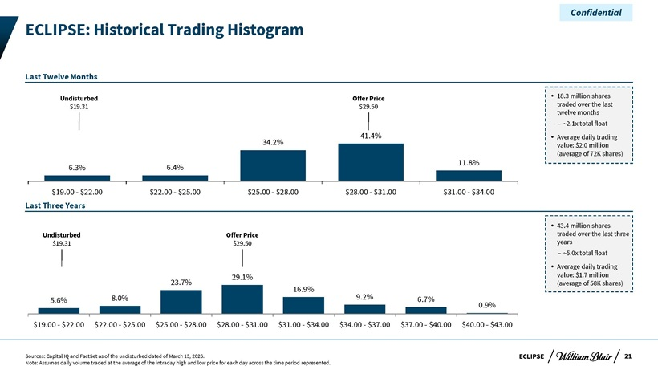
Confidential ECLIPSE: Historical Trading Histogram Last Twelve Months Undisturbed Offer Price 18.3 million shares $19.31 $29.50 traded over the last twelve – months ~2.1x total float 41.4% Average daily trading 34.2% value: $2.0 million (average of 72K shares) 11.8% 6.3% 6.4% $19.00—$22.00 $22.00—$25.00 $25.00—$28.00 $28.00—$31.00 $31.00—$34.00 Last Three Years 43.4 million shares Undisturbed Offer Price traded over the last three $19.31 $29.50 years – ~5.0x total float Average daily trading 23.7% 29.1% value: $1.7 million (average of 58K shares) 16.9% 9.2% 5.6% 8.0% 6.7% 0.9% $19.00—$22.00 $22.00—$25.00 $25.00—$28.00 $28.00—$31.00 $31.00—$34.00 $34.00—$37.00 $37.00—$40.00 $40.00—$43.00 Sources: Capital IQ and FactSet as of the undisturbed dated of March 13, 2026. ECLIPSE 21 Note: Assumes daily volume traded at the average of the intraday high and low price for each day across the time period represented.

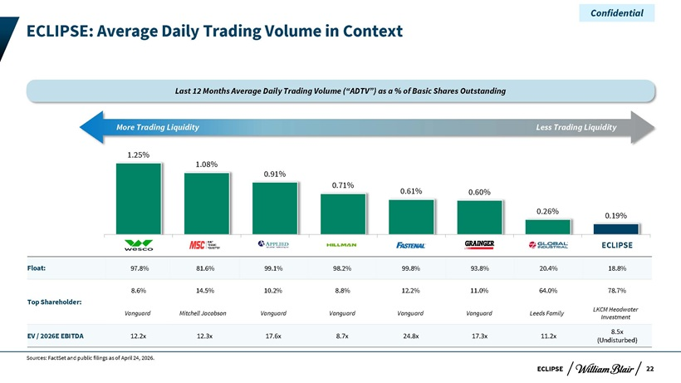
Confidential ECLIPSE: Average Daily Trading Volume in Context Last 12 Months Average Daily Trading Volume (“ADTV”) as a % of Basic Shares Outstanding More Trading Liquidity Less Trading Liquidity 1.25% 1.08% 0.91% 0.71% 0.61% 0.60% 0.26% 0.19% WCC-US MSM-US AIT-US HLMN-US FAST-US GWW-US GIC-US DSGR-US ECLIPSE Float: 97.8% 81.6% 99.1% 98.2% 99.8% 93.8% 20.4% 18.8% 8.6% 14.5% 10.2% 8.8% 12.2% 11.0% 64.0% 78.7% Top Shareholder: LKCM Headwater Vanguard Mitchell Jacobson Vanguard Vanguard Vanguard Vanguard Leeds Family Investment 8.5x EV / 2026E EBITDA 12.2x 12.3x 17.6x 8.7x 24.8x 17.3x 11.2x (Undisturbed) Sources: FactSet and public filings as of April 24, 2026. ECLIPSE 22

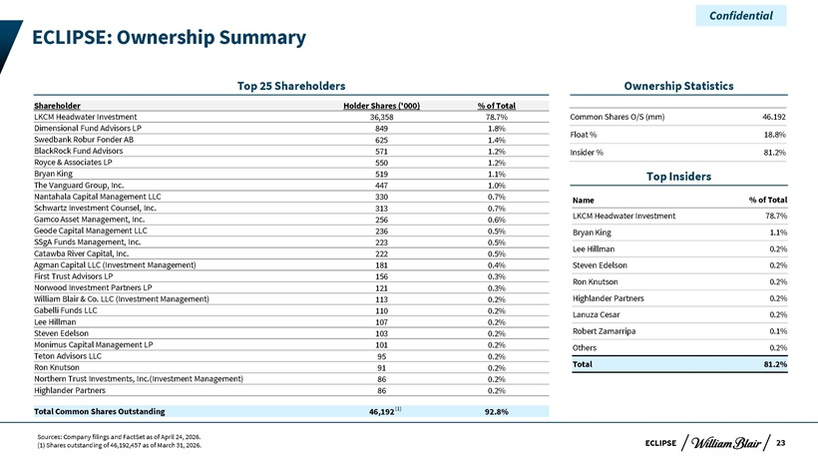
Confidential ECLIPSE: Ownership Summary Top 25 Shareholders Ownership Statistics Shareholder Holder Shares (‘000) % of Total LKCM Headwater Investment 36,358 78.7% Common Shares O/S (mm) 46.192 Dimensional Fund Advisors LP 849 1.8% Float % 18.8% Swedbank Robur Fonder AB 625 1.4% BlackRock Fund Advisors 571 1.2% Insider % 81.2% Royce & Associates LP 550 1.2% Bryan King 519 1.1% Top Insiders The Vanguard Group, Inc. 447 1.0% Nantahala Capital Management LLC 330 0.7% Name % of Total Schwartz Investment Counsel, Inc. 313 0.7% LKCM Headwater Investment 78.7% Gamco Asset Management, Inc. 256 0.6% Geode Capital Management LLC 236 0.5% Bryan King 1.1% SSgA Funds Management, Inc. 223 0.5% Lee Hillman 0.2% Catawba River Capital, Inc. 222 0.5% Agman Capital LLC (Investment Management) 181 0.4% Steven Edelson 0.2% First Trust Advisors LP 156 0.3% Ron Knutson 0.2% Norwood Investment Partners LP 121 0.3% William Blair & Co. LLC (Investment Management) 113 0.2% Highlander Partners 0.2% Gabelli Funds LLC 110 0.2% Lanuza Cesar 0.2% Lee Hillman 107 0.2% Steven Edelson 103 0.2% Robert Zamarripa 0.1% Monimus Capital Management LP 101 0.2% Others 0.2% Teton Advisors LLC 95 0.2% Ron Knutson 91 0.2% Total 81.2% Northern Trust Investments, Inc.(Investment Management) 86 0.2% Highlander Partners 86 0.2% Total Common Shares Outstanding 46,192 (1) 92.8% Sources: Company filings and FactSet as of April 24, 2026. (1) Shares outstanding of 46,192,457 as of March 31, 2026. ECLIPSE 23
Exhibit (c)(iv)

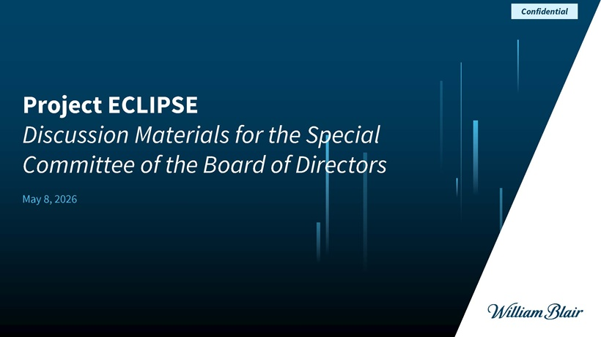
Project ECLIPSE Discussion Materials for the Special Committee of the Board of Directors May 8, 2026 Confidential

ECLIPSE Disclaimer This presentation (together with any accompanying oral presentation and any supplementary documents provided therewith, the “Presentation”) has been prepared by William Blair & Company, L.L.C. (“William Blair”) exclusively for the benefit and internal use of the recipient (the “Recipient”). The Recipient is not permitted to reproduce in whole or in part the information provided in this Presentation (the “Information”) or to communicate the Information to any third party without William Blair’s prior written consent. No party may rely on this Presentation without William Blair’s prior written consent. William Blair and its affiliates, partners, directors, employees and agents do not accept responsibility or liability for this Presentation or its contents (except to the extent that such liability cannot be excluded by law). This Presentation is for discussion purposes only and speaks only as of the date it is given, and the views expressed are subject to change based on a number of factors, including market conditions and the Recipient’s business and prospects. The Information, whether taken from public sources, received from the Recipient or elsewhere, has not been independently verified by William Blair and William Blair has relied upon and assumed the accuracy and completeness of all Information. No representation or warranty is made as to any to the accuracy or completeness of any Information. In furnishing this Presentation, William Blair undertakes no obligation to provide additional information or to correct or update any of the Information. William Blair, together with its affiliates and partners, is a financial services institution engaged in a wide range of investment banking and other activities (including, but not limited to, investment management, corporate finance, private wealth management, securities trading, research and brokerage activities). It is understood and agreed that William Blair may, from time to time, make a market in, have a long or short position, buy and sell or otherwise effect transactions for customer accounts and for their own accounts in the securities of, or may perform or be solicited to perform investment banking, corporate finance or other services for, the Recipient and other third-party entities which are or may be the subject of the transactions contemplated by this Presentation. William Blair has adopted policies and procedures designed to ensure the independence of its research analysts, whose views may differ from those of William Blair’s investment banking department and who may produce research reports and other materials the timing or content of which conflict with the views of the investment banking department or the Recipient’s interests, in connection with the transactions contemplated by this Presentation or otherwise. Nothing in the Presentation is, or shall be relied upon as, investment advice or any recommendation by William Blair. This Presentation does not purport to contain all of the information that may be necessary or appropriate to evaluate the proposed transaction, and the Recipient should conduct its own independent assessment and such investigations as it deems necessary. Recipient should rely on its own counsel, accountants and other similar expert advisors for legal, regulatory, accounting, tax and other similar advice. Nothing in the Presentation or any related discussions is intended to create, or shall be construed as creating, a principal-agent, advisor-client or fiduciary relationship between William Blair and the Recipient. Confidential 1

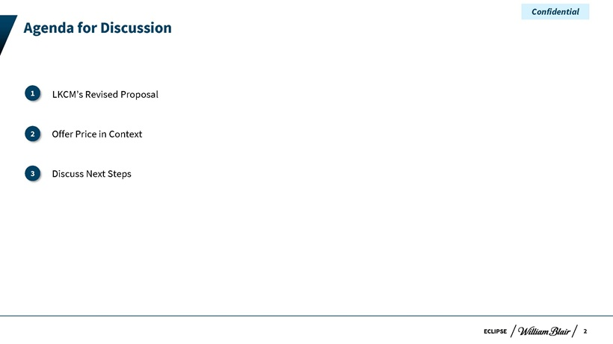
ECLIPSE Agenda for Discussion LKCM’s Revised Proposal I. Offer Price in Context II. Discuss Next Steps 3 2 1 Confidential 2

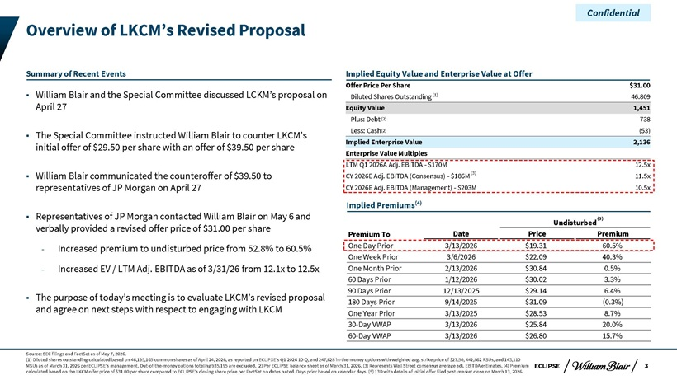
Confidential Overview of LKCM’s Revised Proposal Summary of Recent Events Implied Equity Value and Enterprise Value at Offer Offer Price Per Share $31.00 William Blair and the Special Committee discussed LCKM’s proposal on Diluted Shares Outstanding (1) 46.809 April 27 Equity Value 1,451 Plus: Debt(2) 738 Blair to Less: Cash(2) (53) The Special Committee instructed William counter LKCM’s initial offer of $29.50 per share with an offer of $39.50 per share Implied Enterprise Value 2,136 Enterprise Value Multiples LTM Q1 2026A Adj. EBITDA—$170M 12.5x William Blair communicated the counteroffer of $39.50 to CY 2026E Adj. EBITDA (Consensus)—$186M(3) 11.5x representatives of JP Morgan on April 27 CY 2026E Adj. EBITDA (Management)—$203M 10.5x Implied Premiums(4) Representatives of JP Morgan contacted William Blair on May 6 and Undisturbed(5) verbally provided a revised offer price of $31.00 per share Premium To Date Price Premium Increased premium to undisturbed price from 52.8% to 60.5% One Day Prior 3/13/2026 $19.31 60.5% One Week Prior 3/6/2026 $22.09 40.3% Increased EV / LTM Adj. EBITDA as of 3/31/26 from 12.1x to 12.5x One Month Prior 2/13/2026 $30.84 0.5% 60 Days Prior 1/12/2026 $30.02 3.3% 90 Days Prior 12/13/2025 $29.14 6.4% The purpose of today’s meeting is to evaluate LKCM’s revised proposal 180 Days Prior 9/14/2025 $31.09 (0.3%) and agree on next steps with respect to engaging with LKCM One Year Prior 3/13/2025 $28.53 8.7% 30-Day VWAP 3/13/2026 $25.84 20.0% 60-Day VWAP 3/13/2026 $26.80 15.7% Source: SEC filings and FactSet as of May 7, 2026. (1) Diluted shares outstanding calculated based on 46,195,165 common shares as of April 24, 2026, as reported on ECLIPSE’s Q1 2026 10-Q, and 247,628 in-the-money options with weighted avg. strike price of $27.50, 442,862 RSUs, and 143,110 MSUs as of March 31, 2026 per ECLIPSE’s management. Out-of-the-money options totaling 935,195 are excluded. (2) Per ECLIPSE balance sheet as of March 31, 2026. (3) Represents Wall Street consensus average adj. EBITDA estimates. (4) Premium ECLIPSE 3 calculated based on the LKCM offer price of $31.00 per share compared to ECLIPSE’s closing share price per FactSet on dates noted. Days prior based on calendar days. (5) 13D with details of initial offer filed post-market close on March 13, 2026.

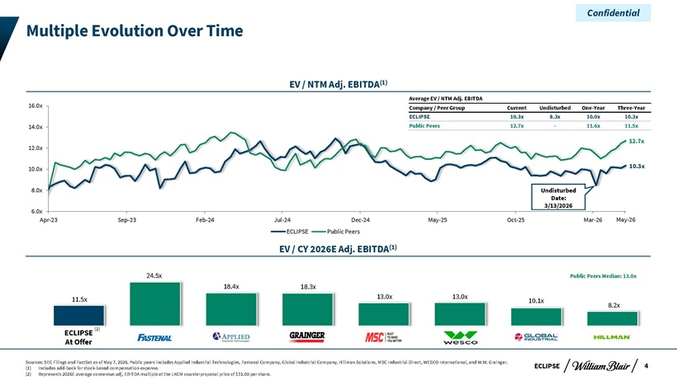
Confidential Multiple Evolution Over Time EV / NTM Adj. EBITDA(1) Average EV / NTM Adj. EBITDA 16.0x Company / Peer Group Current Undisturbed One-Year Three-Year ECLIPSE 10.3x 8.3x 10.0x 10.3x 14.0x Public Peers 12.7x—11.6x 11.5x 12.7x 12.0x 10.0x 10.3x 8.0x Undisturbed Date: 3/13/2026 6.0x Apr-23 Sep-23 Feb-24 Jul-24 Dec-24 May-25 Oct-25 Mar-26 May-26 ECLIPSE Public Peers EV / CY 2026E Adj. EBITDA(1) 24.5x Public Peers Median: 13.0x 18.4x 18.3x 11.5x 13.0x 13.0x 10.1x 8.2x ECLIPSE (2) At Offer Sources: SEC Filings and FactSet as of May 7, 2026. Public peers includes Applied Industrial Technologies, Fastenal Company, Global Industrial Company, Hillman Solutions, MSC Industrial Direct, WESCO International, and W.W. Grainger. 4 (1) Includes add-back for stock-based compensation expense. ECLIPSE (2) Represents 2026E average consensus adj. EBITDA multiple at the LKCM counterproposal price of $31.00 per share.

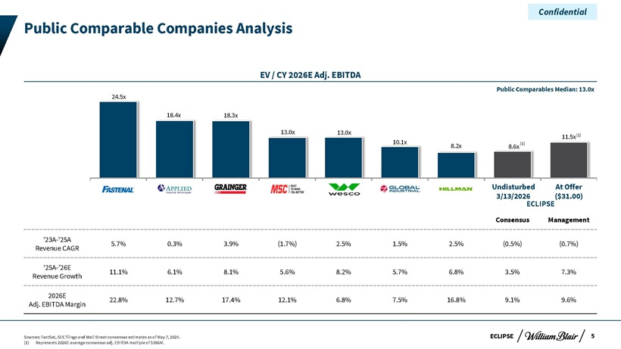
Confidential Public Comparable Companies Analysis EV / CY 2026E Adj. EBITDA Public Comparables Median: 13.0x 24.5x 18.4x 18.3x 13.0x 13.0x (1) 11.5x 10.1x (1) 8.2x 8.6x Undisturbed At Offer 3/13/2026 ECLIPSE($31.00) Consensus Management ‘23A-‘25A 5.7% 0.3% 3.9% (1.7%) 2.5% 1.5% 2.5% (0.5%) (0.7%) Revenue CAGR ‘25A-’26E 11.1% 6.1% 8.1% 5.6% 8.2% 5.7% 6.8% 3.5% 7.3% Revenue Growth 2026E 22.8% 12.7% 17.4% 12.1% 6.8% 7.5% 16.8% 9.1% 9.6% Adj. EBITDA Margin Sources: FactSet, SEC filings and Wall Street consensus estimates as of May 7, 2025. ECLIPSE 5 (1) Represents 2026E average consensus adj. EBITDA multiple of $186M.

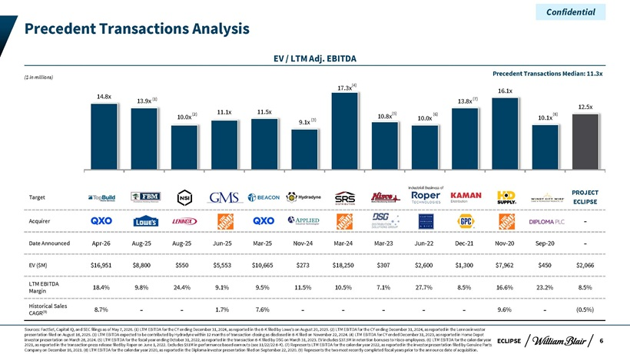
Confidential Precedent Transactions Analysis EV / LTM Adj. EBITDA Precedent Transactions Median: 11.3x ($ in millions) 17.3x(4) 16.1x 14.8x (1) (7) 13.9x 13.8x 12.5x (2) 11.1x 11.5x (5) (6) (8) 10.0x 10.8x 10.0x 10.1x 9.1x (3) Industrial Business of PROJECT Target ECLIPSE Acquirer—Date Announced Apr-26 Aug-25 Aug-25 Jun-25 Mar-25 Nov-24 Mar-24 Mar-23 Jun-22 Dec-21 Nov-20 Sep-20—EV ($M) $16,951 $8,800 $550 $5,553 $10,665 $273 $18,250 $307 $2,600 $1,300 $7,962 $450 $2,066 LTM EBITDA 18.4% 9.8% 24.4% 9.1% 9.5% 11.5% 10.5% 7.1% 27.7% 8.5% 16.6% 23.2% 8.5% Margin Historical Sales (9) 8.7% — 1.7% 7.6% — ——9.6%—(0.5%) CAGR Sources: FactSet, Capital IQ, and SEC filings as of May 7, 2026. (1) LTM EBITDA for the CY ending December 31, 2024, as reported in the 8-K filed by Lowe’s on August 20, 2025. (2) LTM EBITDA for the CY ending December 31, 2024, as reported in the Lennox investor presentation filed on August 18, 2025. (3) LTM EBITDA expected to be contributed by Hydradyne within 12 months of transaction closing as disclosed in 8-K filed on November 22, 2024. (4) LTM EBITDA for CY ended December 31, 2023, as reported in Home Depot investor presentation on March 28, 2024. (5) LTM EBITDA for the fiscal year ending October 31, 2022, as reported in the transaction 8-K filed by DSG on March 31, 2023. EV includes $37.5M in retention bonuses to Hisco employees. (6) LTM EBITDA for the calendar year ECLIPSE 6 2021, as reported in the transaction press release filed by Roper on June 1, 2022. Excludes $51M in performance based earnouts (see 11/22/22 8-K). (7) Represents LTM EBITDA for the calendar year 2022, as reported in the investor presentation filed by Genuine Parts Company on December 16, 2021. (8) LTM EBITDA for the calendar year 2020, as reported in the Diploma investor presentation filed on September 22, 2020. (9) Represents the two most recently completed fiscal years prior to the announce date of acquisition.

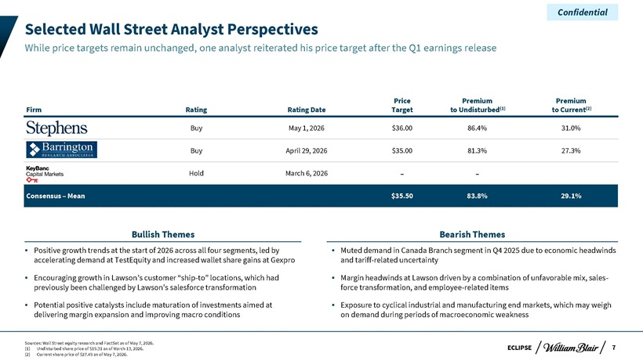
Confidential Selected Wall Street Analyst Perspectives While price targets remain unchanged, one analyst reiterated his price target after the Q1 earnings release Price Premium Premium Firm Rating Rating Date Target to Undisturbed(1) to Current(2) Buy May 1, 2026 $36.00 86.4% 31.0% Buy April 29, 2026 $35.00 81.3% 27.3% Hold March 6, 2026 — Consensus – Mean $35.50 83.8% 29.1% Bullish Themes Bearish Themes Positive growth trends at the start of 2026 across all four segments, led by Muted demand in Canada Branch segment in Q4 2025 due to economic headwinds accelerating demand at TestEquity and increased wallet share gains at Gexpro and tariff-related uncertainty Encouraging growth in Lawson’s customer “ship-to” locations, which had Margin headwinds at Lawson driven by a combination of unfavorable mix, sales-previously been challenged by Lawson’s salesforce transformation force transformation, and employee-related items Potential positive catalysts include maturation of investments aimed at Exposure to cyclical industrial and manufacturing end markets, which may weigh delivering margin expansion and improving macro conditions on demand during periods of macroeconomic weakness Sources: Wall Street equity research and FactSet as of May 7, 2026. (1) Undisturbed share price of $19.31 as of March 13, 2026. ECLIPSE 7 (2) Current share price of $27.49 as of May 7, 2026.

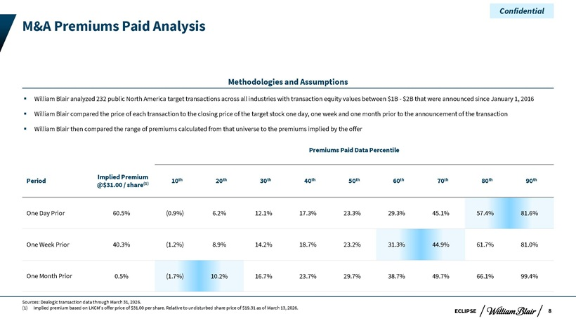
Confidential M&A Premiums Paid Analysis Methodologies and Assumptions William Blair analyzed 232 public North America target transactions across all industries with transaction equity values between $1B—$2B that were announced since January 1, 2016 William Blair compared the price of each transaction to the closing price of the target stock one day, one week and one month prior to the announcement of the transaction William Blair then compared the range of premiums calculated from that universe to the premiums implied by the offer Premiums Paid Data Percentile Implied Premium th th th th th th th th th Period (1) 10 20 30 40 50 60 70 80 90 @$31.00 / share One Day Prior 60.5% (0.9%) 6.2% 12.1% 17.3% 23.3% 29.3% 45.1% 57.4% 81.6% One Week Prior 40.3% (1.2%) 8.9% 14.2% 18.7% 23.2% 31.3% 44.9% 61.7% 81.0% One Month Prior 0.5% (1.7%) 10.2% 16.7% 23.7% 29.7% 38.7% 49.7% 66.1% 99.4% Sources: Dealogic transaction data through March 31, 2026. (1) Implied premium based on LKCM’s offer price of $31.00 per share. Relative to undisturbed share price of $19.31 as of March 13, 2026. ECLIPSE 8

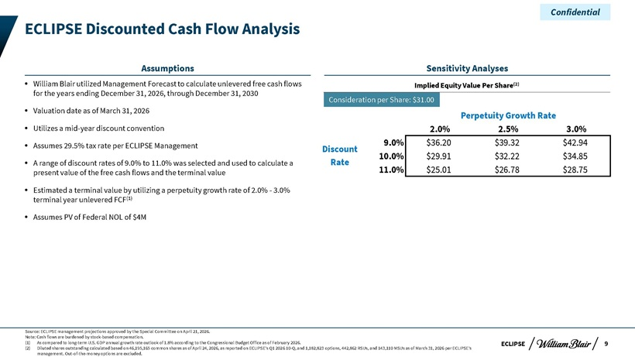
Confidential ECLIPSE Discounted Cash Flow Analysis Assumptions Sensitivity Analyses William Blair utilized Management Forecast to calculate unlevered free cash flows Implied Equity Value Per Share(2) for the years ending December 31, 2026, through December 31, 2030 Consideration per Share: $31.00 Valuation date as of March 31, 2026 Perpetuity Growth Rate Utilizes a mid-year discount convention 2.0% 2.5% 3.0% Assumes 29.5% tax rate per ECLIPSE Management 9.0% $36.20 $39.32 $42.94 Discount 10.0% $29.91 $32.22 $34.85 A range of discount rates of 9.0% to 11.0% was selected and used to calculate a Rate present value of the free cash flows and the terminal value 11.0% $25.01 $26.78 $28.75 Estimated a terminal value by utilizing a perpetuity growth rate of 2.0%—3.0% terminal year unlevered FCF(1) Assumes PV of Federal NOL of $4M Source: ECLIPSE management projections approved by the Special Committee on April 21, 2026. Note: Cash flows are burdened by stock-based compensation. (1) As compared to long-term U.S. GDP annual growth rate outlook of 1.8% according to the Congressional Budget Office as of February 2026. ECLIPSE 9 (2) Diluted shares outstanding calculated based on 46,195,165 common shares as of April 24, 2026, as reported on ECLIPSE’s Q1 2026 10-Q, and 1,182,823 options, 442,862 RSUs, and 143,110 MSUs as of March 31, 2026 per ECLIPSE’s management. Out-of-the-money options are excluded.

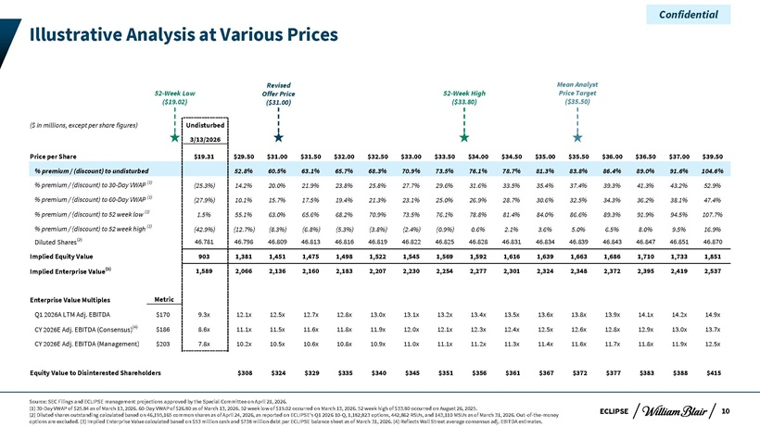
Confidential Illustrative Analysis at Various Prices Revised Mean Analyst 52-Week Low Offer Price 52-Week High Price Target ($19.02) ($31.00) ($33.80) ($35.50) ($ in millions, except per share figures) Undisturbed 3/13/2026 Price per Share $19.31 $29.50 $31.00 $31.50 $32.00 $32.50 $33.00 $33.50 $34.00 $34.50 $35.00 $35.50 $36.00 $36.50 $37.00 $39.50 % premium / (discount) to undisturbed 52.8% 60.5% 63.1% 65.7% 68.3% 70.9% 73.5% 76.1% 78.7% 81.3% 83.8% 86.4% 89.0% 91.6% 104.6% % premium / (discount) to 30-Day VWAP (1) (25.3%) 14.2% 20.0% 21.9% 23.8% 25.8% 27.7% 29.6% 31.6% 33.5% 35.4% 37.4% 39.3% 41.3% 43.2% 52.9% % premium / (discount) to 60-Day VWAP (1) (27.9%) 10.1% 15.7% 17.5% 19.4% 21.3% 23.1% 25.0% 26.9% 28.7% 30.6% 32.5% 34.3% 36.2% 38.1% 47.4% % premium / (discount) to 52 week low (1) 1.5% 55.1% 63.0% 65.6% 68.2% 70.9% 73.5% 76.1% 78.8% 81.4% 84.0% 86.6% 89.3% 91.9% 94.5% 107.7% % premium / (discount) to 52 week high (1) (42.9%) (12.7%) (8.3%) (6.8%) (5.3%) (3.8%) (2.4%) (0.9%) 0.6% 2.1% 3.6% 5.0% 6.5% 8.0% 9.5% 16.9% Diluted Shares(2) 46.781 46.798 46.809 46.813 46.816 46.819 46.822 46.825 46.828 46.831 46.834 46.839 46.843 46.847 46.851 46.870 Implied Equity Value 903 1,381 1,451 1,475 1,498 1,522 1,545 1,569 1,592 1,616 1,639 1,663 1,686 1,710 1,733 1,851 Implied Enterprise Value(3) 1,589 2,066 2,136 2,160 2,183 2,207 2,230 2,254 2,277 2,301 2,324 2,348 2,372 2,395 2,419 2,537 Enterprise Value Multiples Metric Q1 2026A LTM Adj. EBITDA $170 9.3x 12.1x 12.5x 12.7x 12.8x 13.0x 13.1x 13.2x 13.4x 13.5x 13.6x 13.8x 13.9x 14.1x 14.2x 14.9x CY 2026E Adj. EBITDA (Consensus)(4) $186 8.6x 11.1x 11.5x 11.6x 11.8x 11.9x 12.0x 12.1x 12.3x 12.4x 12.5x 12.6x 12.8x 12.9x 13.0x 13.7x CY 2026E Adj. EBITDA (Management) $203 7.8x 10.2x 10.5x 10.6x 10.8x 10.9x 11.0x 11.1x 11.2x 11.3x 11.4x 11.6x 11.7x 11.8x 11.9x 12.5x Equity Value to Disinterested Shareholders $308 $324 $329 $335 $340 $345 $351 $356 $361 $367 $372 $377 $383 $388 $415 Source: SEC Filings and ECLIPSE management projections approved by the Special Committee on April 21, 2026. (1) 30-Day VWAP of $25.84 as of March 13, 2026. 60-Day VWAP of $26.80 as of March 13, 2026. 52 week low of $19.02 occurred on March 13, 2026. 52 week high of $33.80 occurred on August 26, 2025. ECLIPSE 10 (2) Diluted shares outstanding calculated based on 46,195,165 common shares as of April 24, 2026, as reported on ECLIPSE’s Q1 2026 10-Q, 1,182,823 options, 442,862 RSUs, and 143,110 MSUs as of March 31, 2026. Out-of-the-money options are excluded. (3) Implied Enterprise Value calculated based on $53 million cash and $738 million debt per ECLIPSE balance sheet as of March 31, 2026. (4) Reflects Wall Street average consensus adj. EBITDA estimates.

Confidential Appendix

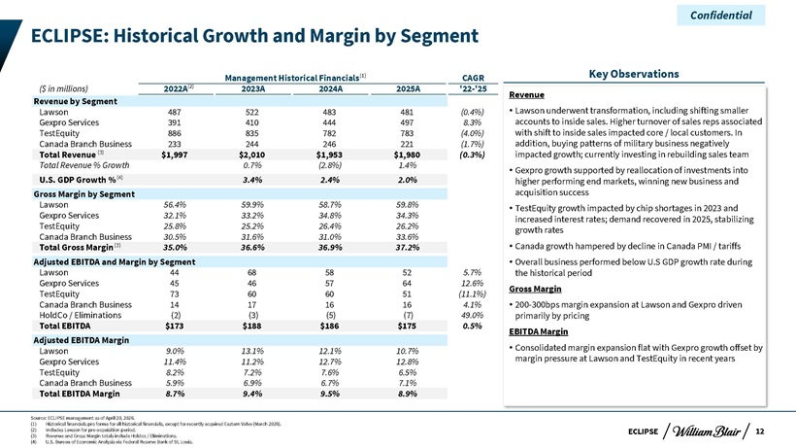
Confidential ECLIPSE: Historical Growth and Margin by Segment Management Historical Financials(1) CAGR Key Observations ($ in millions) 2022A(2) 2023A 2024A 2025A ‘22-‘25 Revenue Revenue by Segment Lawson underwent including smaller Lawson 487 522 483 481 (0.4%)  transformation, shifting Gexpro Services 391 410 444 497 8.3% accounts to inside sales. Higher turnover of sales reps associated TestEquity 886 835 782 783 (4.0%) with shift to inside sales impacted core / local customers. In Canada Branch Business 233 244 246 221 (1.7%) addition, buying patterns of military business negatively Total Revenue (3) $1,997 $2,010 $1,953 $1,980 (0.3%) impacted growth; currently investing in rebuilding sales team Total Revenue % Growth 0.7% (2.8%) 1.4% (4)  Gexpro growth supported by reallocation of investments into U.S. GDP Growth % 3.4% 2.4% 2.0% higher performing end markets, winning new business and Gross Margin by Segment acquisition success Lawson 56.4% 59.9% 58.7% 59.8%  TestEquity growth impacted by chip shortages in 2023 and Gexpro Services 32.1% 33.2% 34.8% 34.3% increased interest rates; demand recovered in 2025, stabilizing TestEquity 25.8% 25.2% 26.4% 26.2% growth rates Canada Branch Business 30.5% 31.6% 31.0% 33.6% Total Gross Margin(3) 35.0% 36.6% 36.9% 37.2%  Canada growth hampered by decline in Canada PMI / tariffs Adjusted EBITDA and Margin by Segment  Overall business performed below U.S GDP growth rate during Lawson 44 68 58 52 5.7% the historical period Gexpro Services 45 46 57 64 12.6% Gross Margin TestEquity 73 60 60 51 (11.1%) Canada Branch Business 14 17 16 16 4.1%  200-300bps margin expansion at Lawson and Gexpro driven HoldCo / Eliminations (2) (3) (5) (7) 49.0% primarily by pricing Total EBITDA $173 $188 $186 $175 0.5% Adjusted EBITDA Margin EBITDA Margin Lawson 9.0% 13.1% 12.1% 10.7%  Consolidated margin expansion flat with Gexpro growth offset by Gexpro Services 11.4% 11.2% 12.7% 12.8% margin pressure at Lawson and TestEquity in recent years TestEquity 8.2% 7.2% 7.6% 6.5% Canada Branch Business 5.9% 6.9% 6.7% 7.1% Total EBITDA Margin 8.7% 9.4% 9.5% 8.9% Source: ECLIPSE management as of April 20, 2026. (1) Historical financials pro forma for all historical financials, except for recently acquired Eastern Valve (March 2026). (2) Includes Lawson for pre-acquisition period. ECLIPSE 12 (3) Revenue and Gross Margin totals include Holdco / Eliminations. (4) U.S. Bureau of Economic Analysis via Federal Reserve Bank of St. Louis.

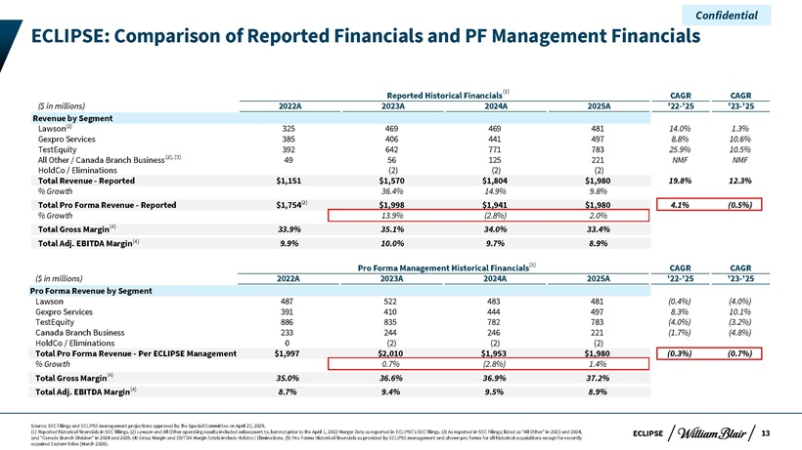
Confidential ECLIPSE: Comparison of Reported Financials and PF Management Financials Reported Historical Financials(1) CAGR CAGR ($ in millions) 2022A 2023A 2024A 2025A ‘22-‘25 ‘23-‘25 Revenue by Segment Lawson(2) 325 469 469 481 14.0% 1.3% Gexpro Services 385 406 441 497 8.8% 10.6% TestEquity 392 642 771 783 25.9% 10.5% All Other / Canada Branch Business(2), (3) 49 56 125 221 NMF NMF HoldCo / Eliminations (2) (2) (2) Total Revenue—Reported $1,151 $1,570 $1,804 $1,980 19.8% 12.3% % Growth 36.4% 14.9% 9.8% Total Pro Forma Revenue—Reported $1,754(2) $1,998 $1,941 $1,980 4.1% (0.5%) % Growth 13.9% (2.8%) 2.0% Total Gross Margin(4) 33.9% 35.1% 34.0% 33.4% Total Adj. EBITDA Margin(4) 9.9% 10.0% 9.7% 8.9% Pro Forma Management Historical Financials(5) CAGR CAGR ($ in millions) 2022A 2023A 2024A 2025A ‘22-‘25 ‘23-‘25 Pro Forma Revenue by Segment Lawson 487 522 483 481 (0.4%) (4.0%) Gexpro Services 391 410 444 497 8.3% 10.1% TestEquity 886 835 782 783 (4.0%) (3.2%) Canada Branch Business 233 244 246 221 (1.7%) (4.8%) HoldCo / Eliminations 0 (2) (2) (2) Total Pro Forma Revenue—Per ECLIPSE Management $1,997 $2,010 $1,953 $1,980 (0.3%) (0.7%) % Growth 0.7% (2.8%) 1.4% Total Gross Margin(4) 35.0% 36.6% 36.9% 37.2% Total Adj. EBITDA Margin(4) 8.7% 9.4% 9.5% 8.9% Source: SEC Filings and ECLIPSE management projections approved by the Special Committee on April 21, 2026. (1) Reported historical financials in SEC fillings. (2) Lawson and All Other operating results included subsequent to, but not prior to the April 1, 2022 Merger Date as reported in ECLIPSE’s SEC filings. (3) As reported in SEC Filings; listed as “All Other” in 2023 and 2024, ECLIPSE 13 and “Canada Branch Division” in 2024 and 2025. (4) Gross Margin and EBITDA Margin totals include Holdco / Eliminations. (5) Pro Forma Historical financials as provided by ECLIPSE management and shown pro forma for all historical acquisitions except for recently acquired Eastern Valve (March 2026).

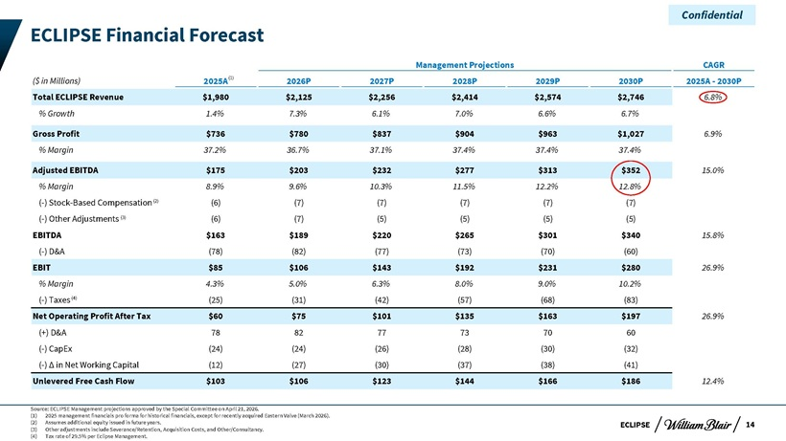
Confidential ECLIPSE Financial Forecast Management Projections CAGR ($ in Millions) 2025A(1) 2026P 2027P 2028P 2029P 2030P 2025A—2030P Total ECLIPSE Revenue $1,980 $2,125 $2,256 $2,414 $2,574 $2,746 6.8% % Growth 1.4% 7.3% 6.1% 7.0% 6.6% 6.7% Gross Profit $736 $780 $837 $904 $963 $1,027 6.9% % Margin 37.2% 36.7% 37.1% 37.4% 37.4% 37.4% Adjusted EBITDA $175 $203 $232 $277 $313 $352 15.0% % Margin 8.9% 9.6% 10.3% 11.5% 12.2% 12.8% (-) Stock-Based Compensation(2) (6) (7) (7) (7) (7) (7) (-) Other Adjustments (3) (6) (7) (5) (5) (5) (5) EBITDA $163 $189 $220 $265 $301 $340 15.8% (-) D&A (78) (82) (77) (73) (70) (60) EBIT $85 $106 $143 $192 $231 $280 26.9% % Margin 4.3% 5.0% 6.3% 8.0% 9.0% 10.2% (-) Taxes(4) (25) (31) (42) (57) (68) (83) Net Operating Profit After Tax $60 $75 $101 $135 $163 $197 26.9% (+) D&A 78 82 77 73 70 60 (-) CapEx (24) (24) (26) (28) (30) (32) (-) Ä in Net Working Capital (12) (27) (30) (37) (38) (41) Unlevered Free Cash Flow $103 $106 $123 $144 $166 $186 12.4% Source: ECLIPSE Management projections approved by the Special Committee on April 21, 2026. (1) 2025 management financials pro forma for historical financials, except for recently acquired Eastern Valve (March 2026). (2) Assumes additional equity issued in future years. ECLIPSE 14 (3) Other adjustments include Severance/Retention, Acquisition Costs, and Other/Consultancy. (4) Tax rate of 29.5% per Eclipse Management.

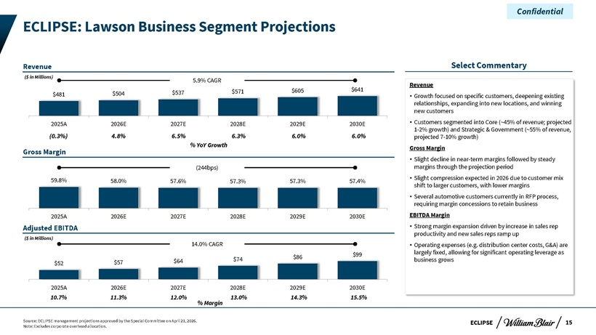
Confidential ECLIPSE: Lawson Business Segment Projections Revenue Select Commentary ($ in Millions) 5.9% CAGR Revenue $571 $605 $641 $481 $504 $537  Growth focused on specific customers, deepening existing relationships, expanding into new locations, and winning new customers 2025A 2026E 2027E 2028E 2029E 2030E  Customers segmented into Core (~45% of revenue; projected (0.3%) 4.8% 6.5% 6.3% 6.0% 6.0% 1-2% growth) and Strategic & Government (~55% of revenue, projected 7-10% growth) Gross Margin % YoY Growth Gross Margin  Slight decline in near-term margins followed by steady (244bps) margins through the projection period 59.8%  Slight compression expected in 2026 due to customer mix 58.0% 57.6% 57.3% 57.3% 57.4% shift to larger customers, with lower margins  Several automotive customers currently in RFP process, requiring margin concessions to retain business 2025A 2026E 2027E 2028E 2029E 2030E EBITDA Margin Adjusted EBITDA  Strong margin expansion driven by increase in sales rep productivity and new sales reps ramp up ($ in Millions) 14.0% CAGR  Operating expenses (e.g. distribution center costs, G&A) are $99 largely fixed, allowing for significant operating leverage as $74 $86 business grows $52 $57 $64 2025A 2026E 2027E 2028E 2029E 2030E 10.7% 11.3% 12.0% 13.0% 14.3% 15.5% % Margin Source: ECLIPSE management projections approved by the Special Committee on April 21, 2026. ECLIPSE 15 Note: Excludes corporate overhead allocation.

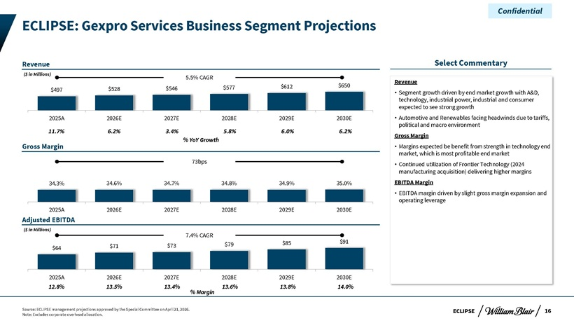
Confidential ECLIPSE: Gexpro Services Business Segment Projections Revenue Select Commentary ($ in Millions) 5.5% CAGR Revenue $577 $612 $650 $497 $528 $546  Segment growth driven by end market growth with A&D, technology, industrial power, industrial and consumer expected to see strong growth 2025A 2026E 2027E 2028E 2029E 2030E  Automotive and Renewables facing headwinds due to tariffs, political and macro environment 11.7% 6.2% 3.4% 5.8% 6.0% 6.2% Gross Margin % YoY Growth Gross Margin  Margins expected be benefit from strength in technology end market, which is most profitable end market 73bps Continued utilization of Frontier Technology (2024  manufacturing acquisition) delivering higher margins 34.3% 34.6% 34.7% 34.8% 34.9% 35.0% EBITDA Margin  EBITDA margin driven by slight gross margin expansion and operating leverage 2025A 2026E 2027E 2028E 2029E 2030E Adjusted EBITDA ($ in Millions) 7.4% CAGR $85 $91 $71 $73 $79 $64 2025A 2026E 2027E 2028E 2029E 2030E 12.8% 13.5% 13.4% 13.6% 13.8% 14.0% % Margin Source: ECLIPSE management projections approved by the Special Committee on April 21, 2026. ECLIPSE 16 Note: Excludes corporate overhead allocation.

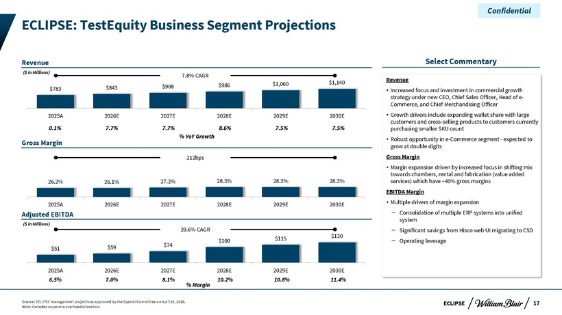
Confidential ECLIPSE: TestEquity Business Segment Projections Revenue Select Commentary ($ in Millions) 7.8% CAGR Revenue $986 $1,060 $1,140 $783 $843 $908  Increased focus and investment in commercial growth strategy under new CEO, Chief Sales Officer, Head of e-Commerce, and Chief Merchandising Officer 2025A 2026E 2027E 2028E 2029E 2030E  Growth drivers include expanding wallet share with large customers and cross-selling products to customers currently 0.1% 7.7% 7.7% 8.6% 7.5% 7.5% purchasing smaller SKU count % YoY Growth Robust opportunity—Gross Margin  in e-Commerce segment expected to grow at double digits 212bps Gross Margin  Margin expansion driven by increased focus in shifting mix towards chambers, rental and fabrication (value added 26.2% 26.1% 27.2% 28.3% 28.3% 28.3% services) which have ~40% gross margins EBITDA Margin 2025A 2026E 2027E 2028E 2029E 2030E  Multiple drivers of margin expansion Adjusted EBITDA – Consolidation of multiple ERP systems into unified system ($ in Millions) 20.6% CAGR $130 – Significant savings from Hisco web UI migrating to CSD $100 $115 – Operating leverage $59 $74 $51 2025A 2026E 2027E 2028E 2029E 2030E 6.5% 7.0% 8.1% 10.2% 10.8% 11.4% % Margin Source: ECLIPSE management projections approved by the Special Committee on April 21, 2026. ECLIPSE 17 Note: Excludes corporate overhead allocation.

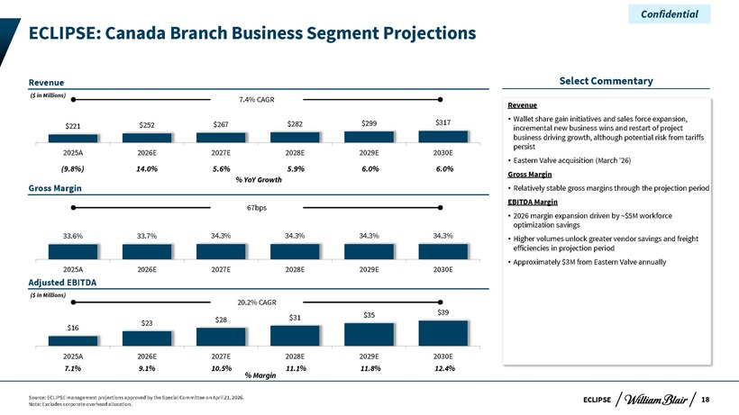
Confidential ECLIPSE: Canada Branch Business Segment Projections Revenue Select Commentary ($ in Millions) 7.4% CAGR Revenue $317  Wallet share gain initiatives and sales force expansion, $221 $252 $267 $282 $299 incremental new business wins and restart of project business driving growth, although potential risk from tariffs persist 2025A 2026E 2027E 2028E 2029E 2030E Eastern acquisition  Valve (March ’26) (9.8%) 14.0% 5.6% 5.9% 6.0% 6.0% Gross Margin % YoY Growth Gross Margin  Relatively stable gross margins through the projection period EBITDA Margin 67bps  2026 margin expansion driven by ~$5M workforce optimization savings 33.6% 33.7% 34.3% 34.3% 34.3% 34.3%  Higher volumes unlock greater vendor savings and freight efficiencies in projection period 2025A 2026E 2027E 2028E 2029E 2030E  Approximately $3M from Eastern Valve annually Adjusted EBITDA ($ in Millions) 20.2% CAGR $35 $39 $28 $31 $23 $16 2025A 2026E 2027E 2028E 2029E 2030E 7.1% 9.1% 10.5% 11.1% 11.8% 12.4% % Margin Source: ECLIPSE management projections approved by the Special Committee on April 21, 2026. ECLIPSE 18 Note: Excludes corporate overhead allocation.

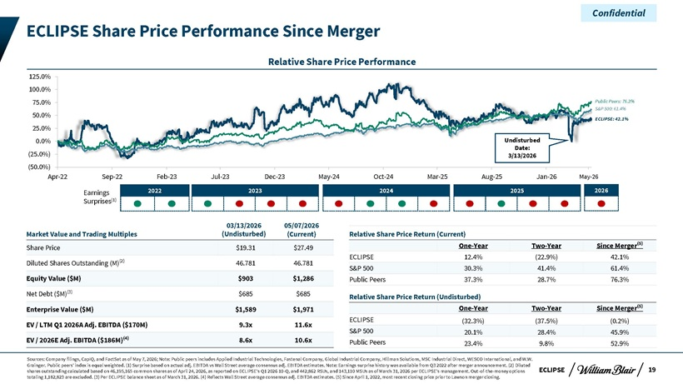
Confidential ECLIPSE Share Price Performance Since Merger Relative Share Price Performance 125.0% 100.0% 75.0% Public Peers: 76.3% 50.0% S&P 500: 61.4% ECLIPSE: 42.1% 25.0% 0.0% Undisturbed Date: (25.0%) 3/13/2026 (50.0%) Apr-22 Sep-22 Feb-23 Jul-23 Dec-23 May-24 Oct-24 Mar-25 Aug-25 Jan-26 May-26 Earnings 2022 2023 2024 2025 2026 Surprises(1) 03/13/2026 05/07/2026 Market Value and Trading Multiples (Undisturbed) (Current) Relative Share Price Return (Current) One-Year Two-Year Since Merger(5) Share Price $19.31 $27.49 ECLIPSE 12.4% (22.9%) 42.1% Diluted Shares Outstanding (M)(2) 46.781 46.781 S&P 500 30.3% 41.4% 61.4% Equity Value ($M) $903 $1,286 Public Peers 37.3% 28.7% 76.3% Net Debt ($M)(3) $685 $685 Relative Share Price Return (Undisturbed) Enterprise Value ($M) $1,589 $1,971 One-Year Two-Year Since Merger(5) ECLIPSE (32.3%) (37.5%) (0.2%) EV / LTM Q1 2026A Adj. EBITDA ($170M) 9.3x 11.6x S&P 500 20.1% 28.4% 45.9% EV / 2026E Adj. EBITDA ($186M)(4) 8.6x 10.6x Public Peers 23.4% 9.8% 52.9% Sources: Company filings, CapIQ, and FactSet as of May 7, 2026; Note: Public peers includes Applied Industrial Technologies, Fastenal Company, Global Industrial Company, Hillman Solutions, MSC Industrial Direct, WESCO International, and W.W. Grainger. Public peers’ index is equal weighted. (1) Surprise based on actual adj. EBITDA vs Wall Street average consensus adj. EBITDA estimates. Note: Earnings surprise history was available from Q3 2022 after merger announcement. (2) Diluted shares outstanding calculated based on 46,195,165 common shares as of April 24, 2026, as reported on ECLIPSE’s Q1 2026 10-Q, and 442,862 RSUs, and 143,110 MSUs as of March 31, 2026 per ECLIPSE’s management. Out-of-the-money options ECLIPSE 19 totaling 1,182,823 are excluded. (3) Per ECLIPSE balance sheet as of March 31, 2026. (4) Reflects Wall Street average consensus adj. EBITDA estimates. (5) Since April 1, 2022, most recent closing price prior to Lawson merger closing.

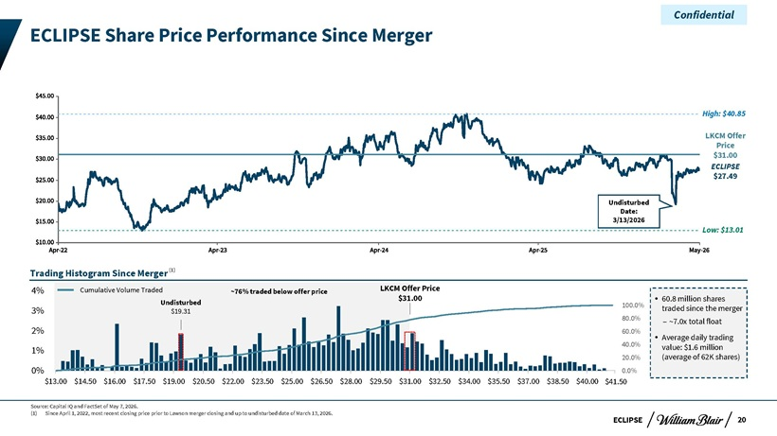
Confidential ECLIPSE Share Price Performance Since Merger High: $40.85 LKCM Offer Price $31.00 ECLIPSE $27.49 Undisturbed Date: 3/13/2026 Low: $13.01 Trading Histogram Since Merger(1) 4% Cumulative Volume Traded ~76% traded below offer price LKCM Offer Price $31.00 60.8 million shares Undisturbed 100.0% 3% $19.31 traded since the merger 80.0% – ~7.0x total float 2% 60.0% Average daily trading 40.0% value: $1.6 million 1% 20.0% (average of 62K shares) 0% 0.0% $13.00—$14.50—$16.00—$17.50—$19.00—$20.50—$22.00—$23.50—$25.00—$26.50—$28.00—$29.50—$31.00—$32.50—$34.00—$35.50—$37.00—$38.50—$40.00—$41.50 Source: Capital IQ and FactSet of May 7, 2026. (1) Since April 1, 2022, most recent closing price prior to Lawson merger closing and up to undisturbed date of March 13, 2026. ECLIPSE 20

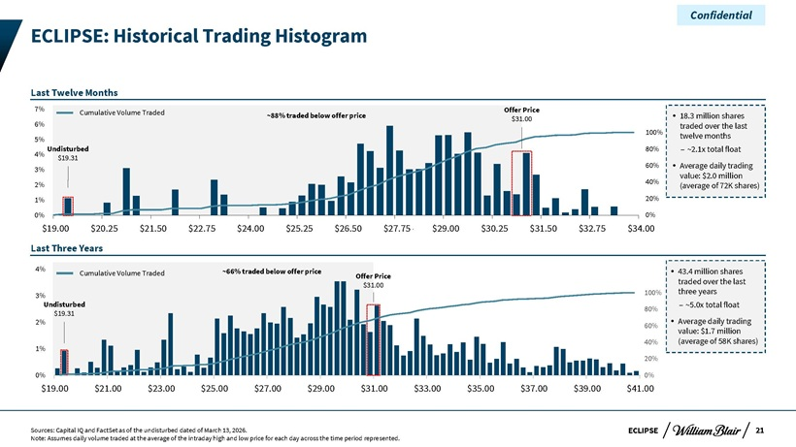
Confidential ECLIPSE: Historical Trading Histogram Last Twelve Months 7% Cumulative Volume Traded Offer Price ~88% traded below offer price $31.00 18.3 million shares 6% traded over the last 5% 100% twelve months Undisturbed 80% – ~2.1x total float 4% $19.31 60% Average daily trading 3% value: $2.0 million 2% 40% (average of 72K shares) 1% 20% 0% 0% $19.00 $20.25 $21.50 $22.75 $24.00 $25.25 $26.50 $27.75 $29.00 $30.25 $31.50 $32.75 $34. v00 Last Three Years 4% ~66% traded below offer price 43.4 million shares Cumulative Volume Traded Offer Price traded over the last $31.00 100% three years 3% Undisturbed – ~5.0x total float 80% $19.31 Average daily trading 2% 60% value: $1.7 million 1% 40% (average of 58K shares) 20% 0% 0% $19.00—$21.00—$23.00—$25.00—$27.00—$29.00—$31.00—$33.00—$35.00—$37.00—$39.00 $41.00—Sources: Capital IQ and FactSet as of the undisturbed dated of March 13, 2026. ECLIPSE 21 Note: Assumes daily volume traded at the average of the intraday high and low price for each day across the time period represented.

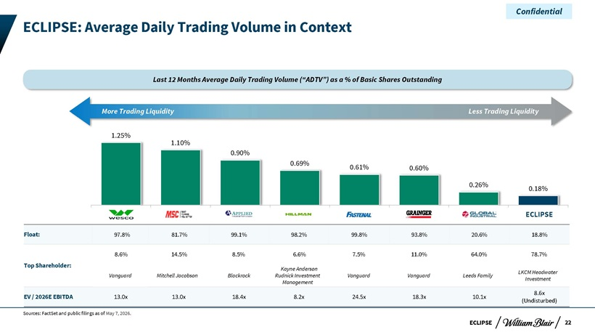
Confidential ECLIPSE: Average Daily Trading Volume in Context Last 12 Months Average Daily Trading Volume (“ADTV”) as a % of Basic Shares Outstanding More Trading Liquidity Less Trading Liquidity 1.25% 1.10% 0.90% 0.69% 0.61% 0.60% 0.26% 0.18% WCC-US MSM-US AIT-US HLMN-US FAST-US GWW-US GIC-US DSGR-US ECLIPSE Float: 97.8% 81.7% 99.1% 98.2% 99.8% 93.8% 20.6% 18.8% 8.6% 14.5% 8.5% 6.6% 7.5% 11.0% 64.0% 78.7% Top Shareholder: Kayne Anderson LKCM Headwater Vanguard Mitchell Jacobson Blackrock Rudnick Investment Vanguard Vanguard Leeds Family Investment Management 8.6x EV / 2026E EBITDA 13.0x 13.0x 18.4x 8.2x 24.5x 18.3x 10.1x (Undisturbed) Sources: FactSet and public filings as of May 7, 2026. ECLIPSE 22

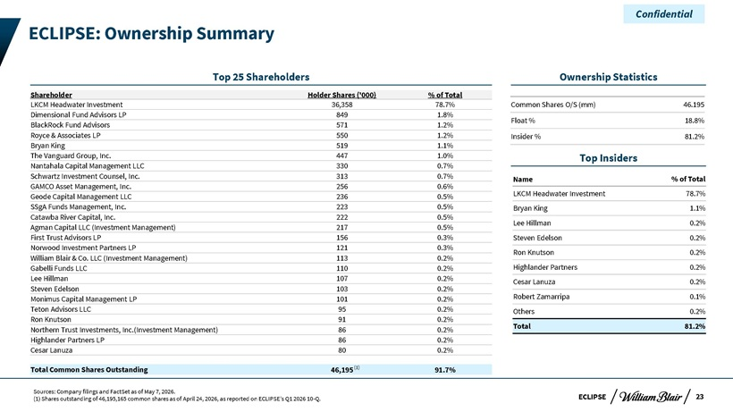
Confidential ECLIPSE: Ownership Summary Top 25 Shareholders Ownership Statistics Shareholder Holder Shares (‘000) % of Total LKCM Headwater Investment 36,358 78.7% Common Shares O/S (mm) 46.195 Dimensional Fund Advisors LP 849 1.8% Float % 18.8% BlackRock Fund Advisors 571 1.2% Royce & Associates LP 550 1.2% Insider % 81.2% Bryan King 519 1.1% The Vanguard Group, Inc. 447 1.0% Top Insiders Nantahala Capital Management LLC 330 0.7% Schwartz Investment Counsel, Inc. 313 0.7% Name % of Total GAMCO Asset Management, Inc. 256 0.6% Geode Capital Management LLC 236 0.5% LKCM Headwater Investment 78.7% SSgA Funds Management, Inc. 223 0.5% Bryan King 1.1% Catawba River Capital, Inc. 222 0.5% Lee Hillman 0.2% Agman Capital LLC (Investment Management) 217 0.5% First Trust Advisors LP 156 0.3% Steven Edelson 0.2% Norwood Investment Partners LP 121 0.3% Ron Knutson 0.2% William Blair & Co. LLC (Investment Management) 113 0.2% Gabelli Funds LLC 110 0.2% Highlander Partners 0.2% Lee Hillman 107 0.2% Cesar Lanuza 0.2% Steven Edelson 103 0.2% Robert Zamarripa 0.1% Monimus Capital Management LP 101 0.2% Teton Advisors LLC 95 0.2% Others 0.2% Ron Knutson 91 0.2% Northern Trust Investments, Inc.(Investment Management) 86 0.2% Total 81.2% Highlander Partners LP 86 0.2% Cesar Lanuza 80 0.2% Total Common Shares Outstanding 46,195 (1) 91.7% Sources: Company filings and FactSet as of May 7, 2026. (1) Shares outstanding of 46,195,165 common shares as of April 24, 2026, as reported on ECLIPSE’s Q1 2026 10-Q. ECLIPSE 23
Exhibit (c)(v)

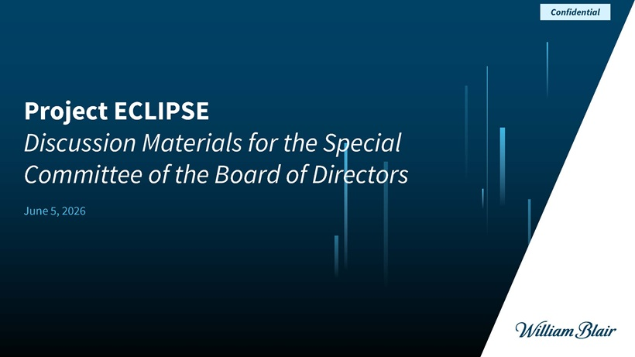
Project ECLIPSEDiscussion Materials for the Special Committee of the Board of Directors June 5, 2026 Confidential

ECLIPSE Disclaimer This presentation (together with any accompanying oral presentation and any supplementary documents provided therewith, the “Presentation”) has been prepared by William Blair & Company, L.L.C. (“William Blair”) exclusively for the benefit and internal use of the recipient (the “Recipient”). The Recipient is not permitted to reproduce in whole or in part the information provided in this Presentation (the “Information”) or to communicate the Information to any third party without William Blair’s prior written consent. No party may rely on this Presentation without William Blair’s prior written consent. William Blair and its affiliates, partners, directors, employees and agents do not accept responsibility or liability for this Presentation or its contents (except to the extent that such liability cannot be excluded by law). This Presentation is for discussion purposes only and speaks only as of the date it is given, and the views expressed are subject to change based on a number of factors, including market conditions and the Recipient’s business and prospects. The Information, whether taken from public sources, received from the Recipient or elsewhere, has not been independently verified by William Blair and William Blair has relied upon and assumed the accuracy and completeness of all Information. No representation or warranty is made as to any to the accuracy or completeness of any Information. In furnishing this Presentation, William Blair undertakes no obligation to provide additional information or to correct or update any of the Information. William Blair, together with its affiliates and partners, is a financial services institution engaged in a wide range of investment banking and other activities (including, but not limited to, investment management, corporate finance, private wealth management, securities trading, research and brokerage activities). It is understood and agreed that William Blair may, from time to time, make a market in, have a long or short position, buy and sell or otherwise effect transactions for customer accounts and for their own accounts in the securities of, or may perform or be solicited to perform investment banking, corporate finance or other services for, the Recipient and other third-party entities which are or may be the subject of the transactions contemplated by this Presentation. William Blair has adopted policies and procedures designed to ensure the independence of its research analysts, whose views may differ from those of William Blair’s investment banking department and who may produce research reports and other materials the timing or content of which conflict with the views of the investment banking department or the Recipient’s interests, in connection with the transactions contemplated by this Presentation or otherwise. Nothing in the Presentation is, or shall be relied upon as, investment advice or any recommendation by William Blair. This Presentation does not purport to contain all of the information that may be necessary or appropriate to evaluate the proposed transaction, and the Recipient should conduct its own independent assessment and such investigations as it deems necessary. Recipient should rely on its own counsel, accountants and other similar expert advisors for legal, regulatory, accounting, tax and other similar advice. Nothing in the Presentation or any related discussions is intended to create, or shall be construed as creating, a principal-agent, advisor-client or fiduciary relationship between William Blair and the Recipient. Confidential 1

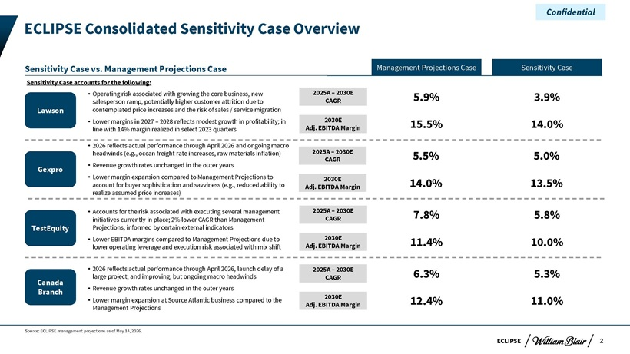
ECLIPSE ECLIPSE Consolidated Sensitivity Case Overview Source: ECLIPSE management projections as of May 14, 2026. Confidential Sensitivity Case vs. Management Projections Case Sensitivity Case accounts for the following: 2026 reflects actual performance through April 2026 and ongoing macro headwinds (e.g., ocean freight rate increases, raw materials inflation) Revenue growth rates unchanged in the outer years Lower margin expansion compared to Management Projections to account for buyer sophistication and savviness (e.g., reduced ability to realize assumed price increases) Accounts for the risk associated with executing several management initiatives currently in place; 2% lower CAGR than Management Projections, informed by certain external indicators Lower EBITDA margins compared to Management Projections due to lower operating leverage and execution risk associated with mix shift 2026 reflects actual performance through April 2026, launch delay of a large project, and improving, but ongoing macro headwinds Revenue growth rates unchanged in the outer years Lower margin expansion at Source Atlantic business compared to the Management Projections Operating risk associated with growing the core business, new salesperson ramp, potentially higher customer attrition due to contemplated price increases and the risk of sales / service migration Lower margins in 2027 – 2028 reflects modest growth in profitability; in line with 14% margin realized in select 2023 quarters Management Projections Case Sensitivity Case 2025A – 2030E CAGR 2030E Adj. EBITDA Margin 5.9% 3.9% 15.5% 14.0% 2025A – 2030E CAGR 2030E Adj. EBITDA Margin 5.5% 5.0% 14.0% 13.5% 2025A – 2030E CAGR 2030E Adj. EBITDA Margin 6.3% 5.3% 12.4% 11.0% 2025A – 2030E CAGR 2030E Adj. EBITDA Margin 7.8% 5.8% 11.4% 10.0% Lawson Gexpro TestEquity Canada Branch2

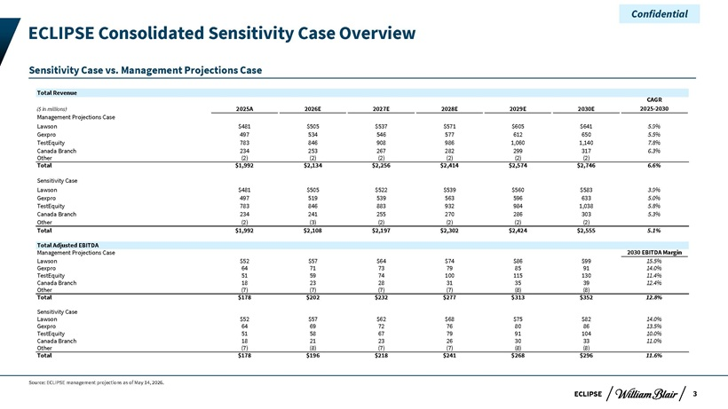
EConfidential ECLIPSE Consolidated Sensitivity Case Overview Sensitivity Case vs. Management Projections Case Total Revenue CAGR ($ in millions) 2025A 2026E 2027E 2028E 2029E 2030E 2025-2030 Management Projections Case Lawson $481 $505 $537 $571 $605 $641 5.9% Gexpro 497 534 546 577 612 650 5.5% TestEquity 783 846 908 986 1,060 1,140 7.8% Canada Branch 234 253 267 282 299 317 6.3% Other (2) (2) (2) (2) (2) (2) Total $1,992 $2,134 $2,256 $2,414 $2,574 $2,746 6.6% Sensitivity Case Lawson $481 $505 $522 $539 $560 $583 3.9% Gexpro 497 519 539 563 596 633 5.0% TestEquity 783 846 883 932 984 1,038 5.8% Canada Branch 234 241 255 270 286 303 5.3% Other (2) (3) (2) (2) (2) (2) Total $1,992 $2,108 $2,197 $2,302 $2,424 $2,555 5.1% Total Adjusted EBITDA Management Projections Case 2030 EBITDA Margin Lawson $52 $57 $64 $74 $86 $99 15.5% Gexpro 64 71 73 79 85 91 14.0% TestEquity 51 59 74 100 115 130 11.4% Canada Branch 18 23 28 31 35 39 12.4% Other (7) (7) (7) (7) (8) (8) Total $178 $202 $232 $277 $313 $352 12.8% Sensitivity Case Lawson $52 $57 $62 $68 $75 $82 14.0% Gexpro 64 69 72 76 80 86 13.5% TestEquity 51 58 67 79 91 104 10.0% Canada Branch 18 21 23 26 30 33 11.0% Other (7) (8) (7) (7) (8) (8) Total $178 $196 $218 $241 $268 $296 11.6% Source: ECLIPSE management projections as of May 14, 2026. ECLIPSE 3

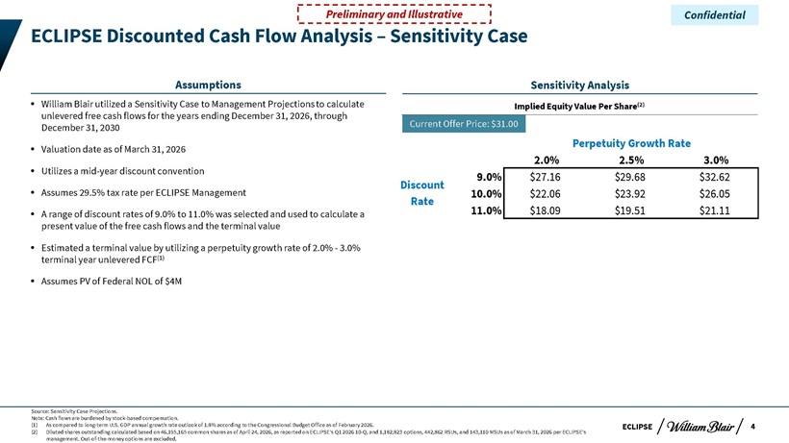
ECLIPSE ECLIPSE Discounted Cash Flow Analysis – Sensitivity Case William Blair utilized a Sensitivity Case to Management Projections to calculate unlevered free cash flows for the years ending December 31, 2026, through December 31, 2030 Valuation date as of March 31, 2026 Utilizes a mid-year discount convention Assumes 29.5% tax rate per ECLIPSE Management A range of discount rates of 9.0% to 11.0% was selected and used to calculate a present value of the free cash flows and the terminal value Estimated a terminal value by utilizing a perpetuity growth rate of 2.0%—3.0% terminal year unlevered FCF(1) Assumes PV of Federal NOL of $4M Assumptions Source: Sensitivity Case Projections. Note: Cash flows are burdened by stock-based compensation. (1) As compared to long-term U.S. GDP annual growth rate outlook of 1.8% according to the Congressional Budget Office as of February 2026. (2) Diluted shares outstanding calculated based on 46,195,165 common shares as of April 24, 2026, as reported on ECLIPSE’s Q1 2026 10-Q, and 1,182,823 options, 442,862 RSUs, and 143,110 MSUs as of March 31, 2026 per ECLIPSE’s management. Out-of-the-money options are excluded. Confidential 4 Current Offer Price: $31.00 Perpetuity Growth Rate 2.0% 2.5% 3.0% 9.0% $27.16 $29.68 $32.62 10.0% $22.06 $23.92 $26.05 11.0% $18.09 $19.51 $21.11 Discount Rate Sensitivity Analysis Implied Equity Value Per Share(2)

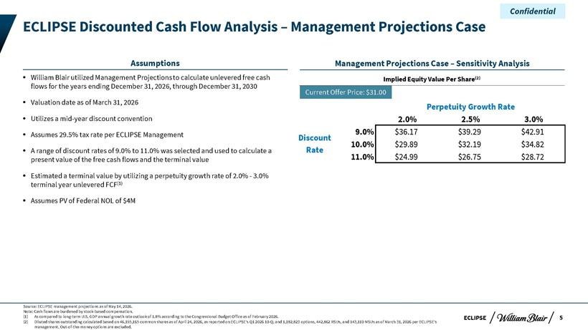
ECLIPSE ECLIPSE Discounted Cash Flow Analysis – Management Projections Case William Blair utilized Management Projections to calculate unlevered free cash flows for the years ending December 31, 2026, through December 31, 2030 Valuation date as of March 31, 2026 Utilizes a mid-year discount convention Assumes 29.5% tax rate per ECLIPSE Management A range of discount rates of 9.0% to 11.0% was selected and used to calculate a present value of the free cash flows and the terminal value Estimated a terminal value by utilizing a perpetuity growth rate of 2.0%—3.0% terminal year unlevered FCF(1) Assumes PV of Federal NOL of $4M Assumptions Source: ECLIPSE management projections as of May 14, 2026. Note: Cash flows are burdened by stock-based compensation. (1) As compared to long-term U.S. GDP annual growth rate outlook of 1.8% according to the Congressional Budget Office as of February 2026. (2) Diluted shares outstanding calculated based on 46,195,165 common shares as of April 24, 2026, as reported on ECLIPSE’s Q1 2026 10-Q, and 1,182,823 options, 442,862 RSUs, and 143,110 MSUs as of March 31, 2026 per ECLIPSE’s management. Out-of-the-money options are excluded. Confidential 5 Current Offer Price: $31.00 Perpetuity Growth Rate 2.0% 2.5% 3.0% 9.0% $36.17 $39.29 $42.91 10.0% $29.89 $32.19 $34.82 11.0% $24.99 $26.75 $28.72 Discount Rate Management Projections Case – Sensitivity Analysis Implied Equity Value Per Share(2)

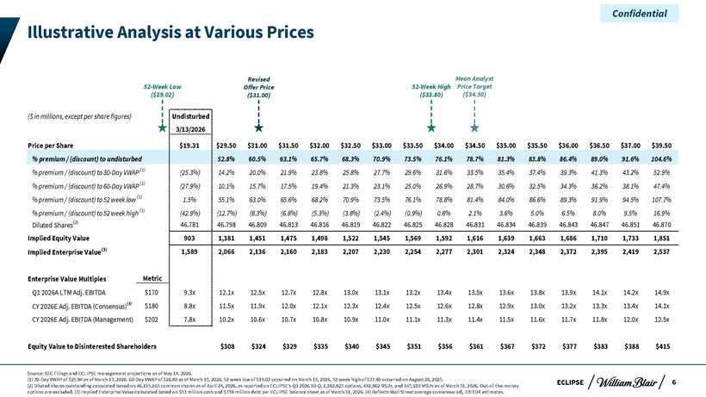
ECLIPSE Illustrative Analysis at Various Prices ($ in millions, except per share figures) Undisturbed 3/13/2026 Price per Share $19.31 $29.50 $31.00 $31.50 $32.00 $32.50 $33.00 $33.50 $34.00 $34.50 $35.00 $35.50 $36.00 $36.50 $37.00 $39.50 % premium / (discount) to undisturbed 52.8% 60.5% 63.1% 65.7% 68.3% 70.9% 73.5% 76.1% 78.7% 81.3% 83.8% 86.4% 89.0% 91.6% 104.6% % premium / (discount) to 30-Day VWAP (1) (25.3%) 14.2% 20.0% 21.9% 23.8% 25.8% 27.7% 29.6% 31.6% 33.5% 35.4% 37.4% 39.3% 41.3% 43.2% 52.9% % premium / (discount) to 60-Day VWAP (1) (27.9%) 10.1% 15.7% 17.5% 19.4% 21.3% 23.1% 25.0% 26.9% 28.7% 30.6% 32.5% 34.3% 36.2% 38.1% 47.4% % premium / (discount) to 52 week low (1) 1.5% 55.1% 63.0% 65.6% 68.2% 70.9% 73.5% 76.1% 78.8% 81.4% 84.0% 86.6% 89.3% 91.9% 94.5% 107.7% % premium / (discount) to 52 week high (1) (42.9%) (12.7%) (8.3%) (6.8%) (5.3%) (3.8%) (2.4%) (0.9%) 0.6% 2.1% 3.6% 5.0% 6.5% 8.0% 9.5% 16.9% Diluted Shares(2) 46.781 46.798 46.809 46.813 46.816 46.819 46.822 46.825 46.828 46.831 46.834 46.839 46.843 46.847 46.851 46.870 Implied Equity Value 903 1,381 1,451 1,475 1,498 1,522 1,545 1,569 1,592 1,616 1,639 1,663 1,686 1,710 1,733 1,851 Implied Enterprise Value(3) 1,589 2,066 2,136 2,160 2,183 2,207 2,230 2,254 2,277 2,301 2,324 2,348 2,372 2,395 2,419 2,537 Enterprise Value Multiples Metric Q1 2026A LTM Adj. EBITDA $170 9.3x 12.1x 12.5x 12.7x 12.8x 13.0x 13.1x 13.2x 13.4x 13.5x 13.6x 13.8x 13.9x 14.1x 14.2x 14.9x CY 2026E Adj. EBITDA (Consensus)(4) $180 8.8x 11.5x 11.9x 12.0x 12.1x 12.3x 12.4x 12.5x 12.6x 12.8x 12.9x 13.0x 13.2x 13.3x 13.4x 14.1x CY 2026E Adj. EBITDA (Management) $202 7.8x 10.2x 10.6x 10.7x 10.8x 10.9x 11.0x 11.1x 11.3x 11.4x 11.5x 11.6x 11.7x 11.8x 12.0x 12.5x Equity Value to Disinterested Shareholders $308 $324 $329 $335 $340 $345 $351 $356 $361 $367 $372 $377 $383 $388 $415 Source: SEC Filings and ECLIPSE management projections as of May 14, 2026. (1) 30-Day VWAP of $25.84 as of March 13, 2026. 60-Day VWAP of $26.80 as of March 13, 2026. 52 week low of $19.02 occurred on March 13, 2026. 52 week high of $33.80 occurred on August 26, 2025. (2) Diluted shares outstanding calculated based on 46,195,165 common shares as of April 24, 2026, as reported on ECLIPSE’s Q1 2026 10-Q, 1,182,823 options, 442,862 RSUs, and 143,110 MSUs as of March 31, 2026. Out-of-the-money options are excluded. (3) Implied Enterprise Value calculated based on $53 million cash and $738 million debt per ECLIPSE balance sheet as of March 31, 2026. (4) Reflects Wall Street average consensus adj. EBITDA estimates. Confidential 52-Week Low ($19.02) 52-Week High ($33.80) Mean Analyst Price Target ($34.50)6 Revised Offer Price ($31.00)

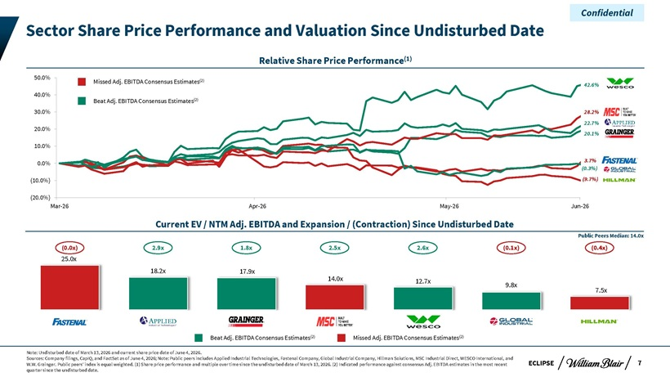
Confidential Sector Share Price Performance and Valuation Since Undisturbed Date Relative Share Price Performance(1) 50.0% Missed Adj. EBITDA Consensus Estimates(2) 42.6% 40.0% Beat Adj. EBITDA Consensus Estimates(2) 30.0% 28.2% 20.0% 22.7% 20.1% 10.0% 0.0% 3.7% (0.3%) (10.0%) (9.7%) (20.0%) Mar-26 Apr-26 May-26 Jun-26 Current EV / NTM Adj. EBITDA and Expansion / (Contraction) Since Undisturbed Date Public Peers Median: 14.0x (0.0x) 2.9x 1.8x 2.5x 2.6x (0.1x) (0.4x) 25.0x 18.2x 17.9x 14.0x 12.7x 9.8x 7.5x Beat Adj. EBITDA Consensus Estimates(2) Missed Adj. EBITDA Consensus Estimates(2) Note: Undisturbed date of March 13, 2026 and current share price date of June 4, 2026. Sources: Company filings, CapIQ, and FactSet as of June 4, 2026; Note: Public peers includes Applied Industrial Technologies, Fastenal Company, Global Industrial Company, Hillman Solutions, MSC Industrial Direct, WESCO International, and W.W. Grainger. Public peers’ index is equal weighted. (1) Share price performance and multiple over time since the undisturbed date of March 13, 2026. (2) Indicated performance against consensus Adj. EBITDA estimates in the most recent ECLIPSE 7 quarter since the undisturbed date.

Confidential Appendix

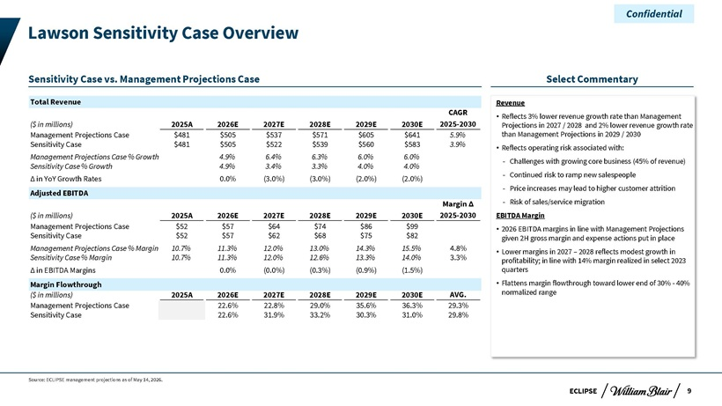
Confidential Lawson Sensitivity Case Overview Sensitivity Case vs. Management Projections Case Select Commentary Total Revenue Revenue CAGR  Reflects 3% lower revenue growth rate than Management ($ in millions) 2025A 2026E 2027E 2028E 2029E 2030E 2025-2030 Projections in 2027 / 2028 and 2% lower revenue growth rate Management Projections Case $481 $505 $537 $571 $605 $641 5.9% than Management Projections in 2029 / 2030 Sensitivity Case $481 $505 $522 $539 $560 $583 3.9%  Reflects operating risk associated with: Management Projections Case % Growth 4.9% 6.4% 6.3% 6.0% 6.0% ? Challenges with growing core business (45% of revenue) Sensitivity Case % Growth 4.9% 3.4% 3.3% 4.0% 4.0% ? Continued risk to ramp new salespeople Ä in YoY Growth Rates 0.0% (3.0%) (3.0%) (2.0%) (2.0%) ? Price increases may lead to higher customer attrition Adjusted EBITDA Margin Ä ? Risk of sales/service migration ($ in millions) 2025A 2026E 2027E 2028E 2029E 2030E 2025-2030 EBITDA Margin Management Projections Case $52 $57 $64 $74 $86 $99  2026 EBITDA margins in line with Management Projections Sensitivity Case $52 $57 $62 $68 $75 $82 given 2H gross margin and expense actions put in place Management Projections Case % Margin 10.7% 11.3% 12.0% 13.0% 14.3% 15.5% 4.8%  Lower margins in 2027 – 2028 reflects modest growth in Sensitivity Case % Margin 10.7% 11.3% 12.0% 12.6% 13.3% 14.0% 3.3% profitability; in line with 14% margin realized in select 2023 Ä in EBITDA Margins 0.0% (0.0%) (0.3%) (0.9%) (1.5%) quarters Margin Flowthrough  Flattens margin flowthrough toward lower end of 30%—40% ($ in millions) 2025A 2026E 2027E 2028E 2029E 2030E AVG. normalized range Management Projections Case 22.6% 22.8% 29.0% 35.6% 36.3% 29.3% Sensitivity Case 22.6% 31.9% 33.2% 30.3% 31.0% 29.8% Source: ECLIPSE management projections as of May 14, 2026. ECLIPSE 9

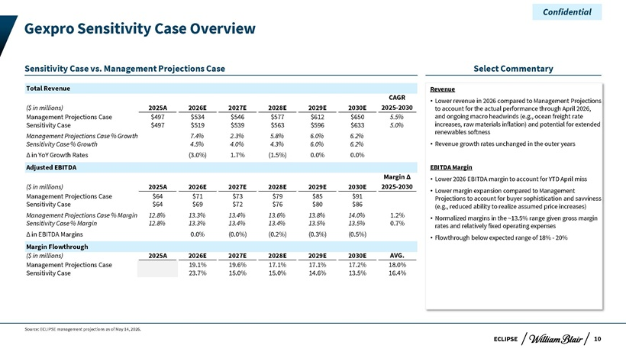
Confidential Gexpro Sensitivity Case Overview Sensitivity Case vs. Management Projections Case Select Commentary Total Revenue Revenue CAGR  Lower revenue in 2026 compared to Management Projections ($ in millions) 2025A 2026E 2027E 2028E 2029E 2030E 2025-2030 to account for the actual performance through April 2026, Management Projections Case $497 $534 $546 $577 $612 $650 5.5% and ongoing macro headwinds (e.g., ocean freight rate Sensitivity Case $497 $519 $539 $563 $596 $633 5.0% increases, raw materials inflation) and potential for extended renewables softness Management Projections Case % Growth 7.4% 2.3% 5.8% 6.0% 6.2% Sensitivity Case % Growth 4.5% 4.0% 4.3% 6.0% 6.2%  Revenue growth rates unchanged in the outer years Ä in YoY Growth Rates (3.0%) 1.7% (1.5%) 0.0% 0.0% Adjusted EBITDA EBITDA Margin Margin Ä  Lower 2026 EBITDA margin to account for YTD April miss ($ in millions) 2025A 2026E 2027E 2028E 2029E 2030E 2025-2030  Lower margin expansion compared to Management Management Projections Case $64 $71 $73 $79 $85 $91 Projections to account for buyer sophistication and savviness Sensitivity Case $64 $69 $72 $76 $80 $86 (e.g., reduced ability to realize assumed price increases) Management Projections Case % Margin 12.8% 13.3% 13.4% 13.6% 13.8% 14.0% 1.2%  Normalized margins in the ~13.5% range given gross margin Sensitivity Case % Margin 12.8% 13.3% 13.4% 13.4% 13.5% 13.5% 0.7% rates and relatively fixed operating expenses Ä in EBITDA Margins 0.0% (0.0%) (0.2%) (0.3%) (0.5%)  Flowthrough below expected range of 18%—20% Margin Flowthrough ($ in millions) 2025A 2026E 2027E 2028E 2029E 2030E AVG. Management Projections Case 19.1% 19.6% 17.1% 17.1% 17.2% 18.0% Sensitivity Case 23.7% 15.0% 15.0% 14.6% 13.5% 16.4% Source: ECLIPSE management projections as of May 14, 2026. ECLIPSE 10

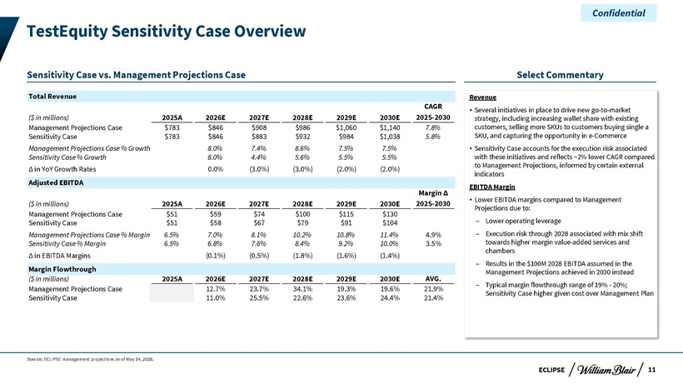
Confidential TestEquity Sensitivity Case Overview Sensitivity Case vs. Management Projections Case Select Commentary Total Revenue Revenue CAGR  Several initiatives in place to drive new go-to-market ($ in millions) 2025A 2026E 2027E 2028E 2029E 2030E 2025-2030 strategy, including increasing wallet share with existing Management Projections Case $783 $846 $908 $986 $1,060 $1,140 7.8% customers, selling more SKUs to customers buying single a Sensitivity Case $783 $846 $883 $932 $984 $1,038 5.8% SKU, and capturing the opportunity in e-Commerce Management Projections Case % Growth 8.0% 7.4% 8.6% 7.5% 7.5%  Sensitivity Case accounts for the execution risk associated Sensitivity Case % Growth 8.0% 4.4% 5.6% 5.5% 5.5% with these initiatives and reflects ~2% lower CAGR compared to Management Projections, informed by certain external in YoY Growth Rates 0.0% (3.0%) (3.0%) (2.0%) (2.0%) indicators Adjusted EBITDA EBITDA Margin Margin  Lower EBITDA margins compared to Management ($ in millions) 2025A 2026E 2027E 2028E 2029E 2030E 2025-2030 Projections due to: Management Projections Case $51 $59 $74 $100 $115 $130 Lower operating leverage Sensitivity Case $51 $58 $67 $79 $91 $104 Management Projections Case % Margin 6.5% 7.0% 8.1% 10.2% 10.8% 11.4% 4.9% Execution risk through 2028 associated with mix shift Sensitivity Case % Margin 6.5% 6.8% 7.6% 8.4% 9.2% 10.0% 3.5% towards higher margin value-added services and chambers in EBITDA Margins (0.1%) (0.5%) (1.8%) (1.6%) (1.4%) Results in the $100M 2028 EBITDA assumed in the Margin Flowthrough Management Projections achieved in 2030 instead ($ in millions) 2025A 2026E 2027E 2028E 2029E 2030E AVG. Typical margin flowthrough range of 19%—20%; Management Projections Case 12.7% 23.7% 34.1% 19.3% 19.6% 21.9% Sensitivity Case higher given cost over Management Plan Sensitivity Case 11.0% 25.5% 22.6% 23.6% 24.4% 21.4% Source: ECLIPSE management projections as of May 14, 2026. ECLIPSE 11

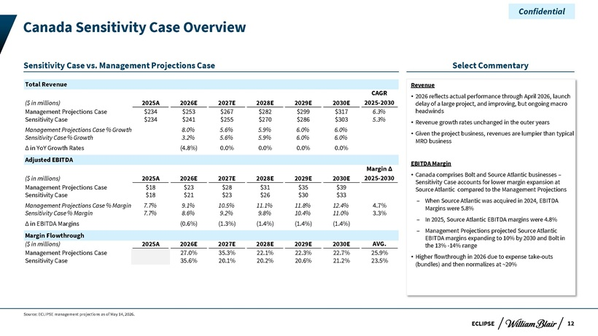
Confidential Canada Sensitivity Case Overview Sensitivity Case vs. Management Projections Case Select Commentary Total Revenue Revenue CAGR  2026 reflects actual performance through April 2026, launch ($ in millions) 2025A 2026E 2027E 2028E 2029E 2030E 2025-2030 delay of a large project, and improving, but ongoing macro Management Projections Case $234 $253 $267 $282 $299 $317 6.3% headwinds Sensitivity Case $234 $241 $255 $270 $286 $303 5.3%  Revenue growth rates unchanged in the outer years Management Projections Case % Growth 8.0% 5.6% 5.9% 6.0% 6.0%  Given the project business, revenues are lumpier than typical Sensitivity Case % Growth 3.2% 5.6% 5.9% 6.0% 6.0% MRO business Ä in YoY Growth Rates (4.8%) 0.0% 0.0% 0.0% 0.0% Adjusted EBITDA EBITDA Margin Margin Ä and Source Atlantic businesses – Canada comprises Bolt ($ in millions) 2025A 2026E 2027E 2028E 2029E 2030E 2025-2030 Sensitivity Case accounts for lower margin expansion at Management Projections Case $18 $23 $28 $31 $35 $39 Source Atlantic compared to the Management Projections Sensitivity Case $18 $21 $23 $26 $30 $33 ? When Source Atlantic was acquired in 2024, EBITDA Management Projections Case % Margin 7.7% 9.1% 10.5% 11.1% 11.8% 12.4% 4.7% Margins were 5.8% Sensitivity Case % Margin 7.7% 8.6% 9.2% 9.8% 10.4% 11.0% 3.3% ? In 2025, Source Atlantic EBITDA margins were 4.8% Ä in EBITDA Margins (0.6%) (1.3%) (1.4%) (1.4%) (1.4%) ? Management Projections projected Source Atlantic Margin Flowthrough EBITDA margins expanding to 10% by 2030 and Bolt in ($ in millions) 2025A 2026E 2027E 2028E 2029E 2030E AVG. the 13% -14% range Management Projections Case 27.0% 35.3% 22.1% 22.3% 22.7% 25.9%  Higher flowthrough in 2026 due to expense take-outs Sensitivity Case 35.6% 20.1% 20.2% 20.6% 21.2% 23.5% (bundles) and then normalizes at ~20% Source: ECLIPSE management projections as of May 14, 2026. ECLIPSE 12

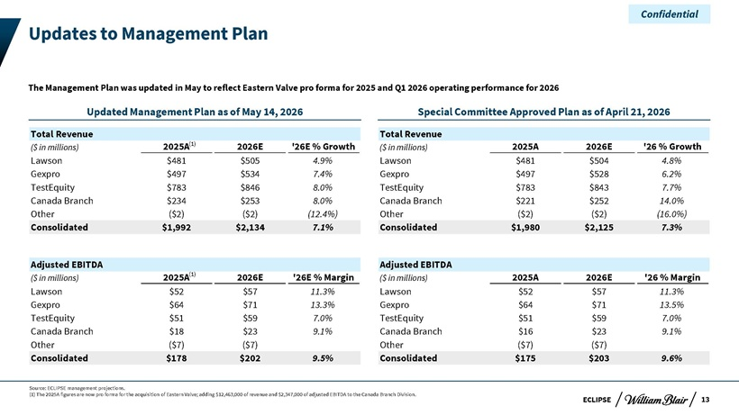
Confidential Updates to Management Plan The Management Plan was updated in May to reflect Eastern Valve pro forma for 2025 and Q1 2026 operating performance for 2026 Updated Management Plan as of May 14, 2026 Special Committee Approved Plan as of April 21, 2026 Total Revenue Total Revenue ($ in millions) 2025A(1) 2026E ‘26E % Growth ($ in millions) 2025A 2026E ‘26 % Growth Lawson $481 $505 4.9% Lawson $481 $504 4.8% Gexpro $497 $534 7.4% Gexpro $497 $528 6.2% TestEquity $783 $846 8.0% TestEquity $783 $843 7.7% Canada Branch $234 $253 8.0% Canada Branch $221 $252 14.0% Other ($2) ($2) (12.4%) Other ($2) ($2) (16.0%) Consolidated $1,992 $2,134 7.1% Consolidated $1,980 $2,125 7.3% Adjusted EBITDA Adjusted EBITDA ($ in millions) 2025A(1) 2026E ‘26E % Margin ($ in millions) 2025A 2026E ‘26 % Margin Lawson $52 $57 11.3% Lawson $52 $57 11.3% Gexpro $64 $71 13.3% Gexpro $64 $71 13.5% TestEquity $51 $59 7.0% TestEquity $51 $59 7.0% Canada Branch $18 $23 9.1% Canada Branch $16 $23 9.1% Other ($7) ($7) Other ($7) ($7) Consolidated $178 $202 9.5% Consolidated $175 $203 9.6% Source: ECLIPSE management projections. (1) The 2025A figures are now pro forma for the acquisition of Eastern Valve; adding $12,463,000 of revenue and $2,347,000 of adjusted EBITDA to the Canada Branch Division. ECLIPSE 13

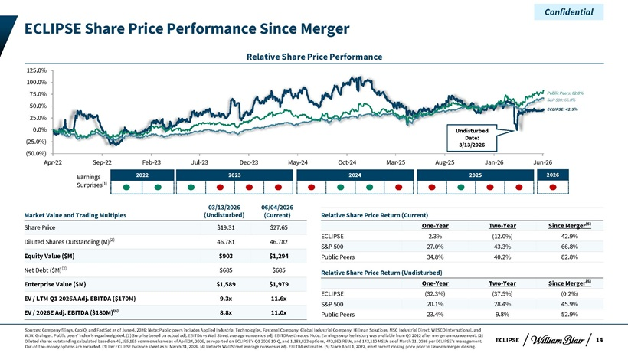
Confidential ECLIPSE Share Price Performance Since Merger Relative Share Price Performance 125.0% 100.0% 75.0% Public Peers: 82.8% 50.0% S&P 500: 66.8% ECLIPSE: 42.9% 25.0% 0.0% Undisturbed Date: (25.0%) 3/13/2026 (50.0%) Apr-22 Sep-22 Feb-23 Jul-23 Dec-23 May-24 Oct-24 Mar-25 Aug-25 Jan-26 Jun-26 Earnings 2022 2023 2024 2025 2026 Surprises(1) 03/13/2026 06/04/2026 Market Value and Trading Multiples (Undisturbed) (Current) Relative Share Price Return (Current) One-Year Two-Year Since Merger(5) Share Price $19.31 $27.65 ECLIPSE 2.3% (12.0%) 42.9% Diluted Shares Outstanding (M)(2) 46.781 46.782 S&P 500 27.0% 43.3% 66.8% Equity Value ($M) $903 $1,294 Public Peers 34.8% 40.2% 82.8% Net Debt ($M)(3) $685 $685 Relative Share Price Return (Undisturbed) Enterprise Value ($M) $1,589 $1,979 One-Year Two-Year Since Merger(5) ECLIPSE (32.3%) (37.5%) (0.2%) EV / LTM Q1 2026A Adj. EBITDA ($170M) 9.3x 11.6x S&P 500 20.1% 28.4% 45.9% EV / 2026E Adj. EBITDA ($180M)(4) 8.8x 11.0x Public Peers 23.4% 9.8% 52.9% Sources: Company filings, CapIQ, and FactSet as of June 4, 2026; Note: Public peers includes Applied Industrial Technologies, Fastenal Company, Global Industrial Company, Hillman Solutions, MSC Industrial Direct, WESCO International, and W.W. Grainger. Public peers’ index is equal weighted. (1) Surprise based on actual adj. EBITDA vs Wall Street average consensus adj. EBITDA estimates. Note: Earnings surprise history was available from Q3 2022 after merger announcement. (2) Diluted shares outstanding calculated based on 46,195,165 common shares as of April 24, 2026, as reported on ECLIPSE’s Q1 2026 10-Q, and 1,182,823 options, 442,862 RSUs, and 143,110 MSUs as of March 31, 2026 per ECLIPSE’s management. ECLIPSE 14 Out-of-the-money options are excluded. (3) Per ECLIPSE balance sheet as of March 31, 2026. (4) Reflects Wall Street average consensus adj. EBITDA estimates. (5) Since April 1, 2022, most recent closing price prior to Lawson merger closing.
Exhibit (c)(vi)

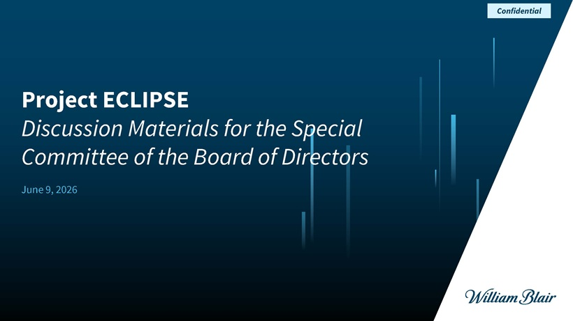
Project ECLIPSEDiscussion Materials for the Special Committee of the Board of Directors June 9, 2026 Confidential

ECLIPSE Disclaimer This presentation (together with any accompanying oral presentation and any supplementary documents provided therewith, the “Presentation”) has been prepared by William Blair & Company, L.L.C. (“William Blair”) exclusively for the benefit and internal use of the recipient (the “Recipient”). The Recipient is not permitted to reproduce in whole or in part the information provided in this Presentation (the “Information”) or to communicate the Information to any third party without William Blair’s prior written consent. No party may rely on this Presentation without William Blair’s prior written consent. William Blair and its affiliates, partners, directors, employees and agents do not accept responsibility or liability for this Presentation or its contents (except to the extent that such liability cannot be excluded by law). This Presentation is for discussion purposes only and speaks only as of the date it is given, and the views expressed are subject to change based on a number of factors, including market conditions and the Recipient’s business and prospects. The Information, whether taken from public sources, received from the Recipient or elsewhere, has not been independently verified by William Blair and William Blair has relied upon and assumed the accuracy and completeness of all Information. No representation or warranty is made as to any to the accuracy or completeness of any Information. In furnishing this Presentation, William Blair undertakes no obligation to provide additional information or to correct or update any of the Information. William Blair, together with its affiliates and partners, is a financial services institution engaged in a wide range of investment banking and other activities (including, but not limited to, investment management, corporate finance, private wealth management, securities trading, research and brokerage activities). It is understood and agreed that William Blair may, from time to time, make a market in, have a long or short position, buy and sell or otherwise effect transactions for customer accounts and for their own accounts in the securities of, or may perform or be solicited to perform investment banking, corporate finance or other services for, the Recipient and other third-party entities which are or may be the subject of the transactions contemplated by this Presentation. William Blair has adopted policies and procedures designed to ensure the independence of its research analysts, whose views may differ from those of William Blair’s investment banking department and who may produce research reports and other materials the timing or content of which conflict with the views of the investment banking department or the Recipient’s interests, in connection with the transactions contemplated by this Presentation or otherwise. Nothing in the Presentation is, or shall be relied upon as, investment advice or any recommendation by William Blair. This Presentation does not purport to contain all of the information that may be necessary or appropriate to evaluate the proposed transaction, and the Recipient should conduct its own independent assessment and such investigations as it deems necessary. Recipient should rely on its own counsel, accountants and other similar expert advisors for legal, regulatory, accounting, tax and other similar advice. Nothing in the Presentation or any related discussions is intended to create, or shall be construed as creating, a principal-agent, advisor-client or fiduciary relationship between William Blair and the Recipient. Confidential 1

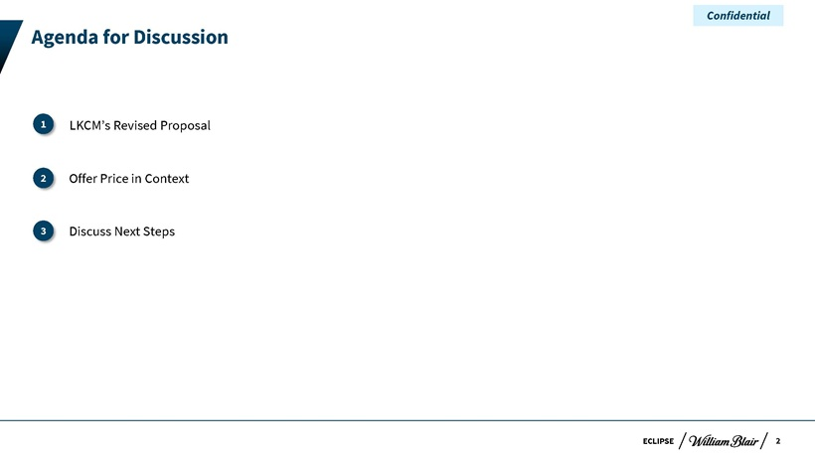
ECLIPSE Agenda for Discussion LKCM’s Revised Proposal I.Offer Price in Context II.Discuss Next Steps 3 2 1 Confidential 2

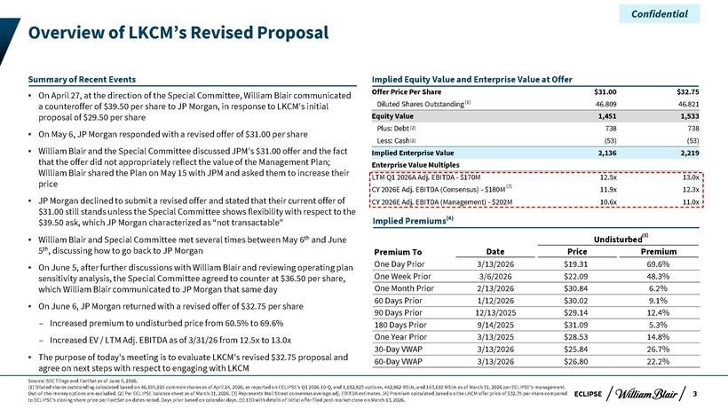
Confidential Overview of LKCM’s Revised Proposal Summary of Recent Events Implied Equity Value and Enterprise Value at Offer On April 27, at the direction of the Special Committee, William Blair communicated Offer Price Per Share $31.00 $32.75 a counteroffer of $39.50 per share to JP Morgan, in response to LKCM’s initial Diluted Shares Outstanding (1) 46.809 46.821 proposal of $29.50 per share Equity Value 1,451 1,533 Plus: Debt (2) 738 738 On May 6, JP Morgan responded with a revised offer of $31.00 per share (2) Less: Cash (53) (53) William Blair and the Special Committee discussed JPM’s $31.00 offer and the fact Implied Enterprise Value 2,136 2,219 that the offer did not appropriately reflect the value of the Management Plan; Enterprise Value Multiples William Blair shared the Plan on May 15 with JPM and asked them to increase their LTM Q1 2026A Adj. EBITDA—$170M 12.5x 13.0x price (3) CY 2026E Adj. EBITDA (Consensus)—$180M 11.9x 12.3x JP Morgan declined to submit a revised offer and stated that their current offer of CY 2026E Adj. EBITDA (Management)—$202M 10.6x 11.0x $31.00 still stands unless the Special Committee shows flexibility with respect to the $39.50 ask, which JP Morgan characterized as “not transactable” Implied Premiums(4) William Blair and Special Committee met several times between May 6th and June Undisturbed(5) 5th, discussing how to go back to JP Morgan Premium To Date Price Premium On June 5, after further discussions with William Blair and reviewing operating plan One Day Prior 3/13/2026 $19.31 69.6% sensitivity analysis, the Special Committee agreed to counter at $36.50 per share, One Week Prior 3/6/2026 $22.09 48.3% which William Blair communicated to JP Morgan that same day One Month Prior 2/13/2026 $30.84 6.2% 60 Days Prior 1/12/2026 $30.02 9.1% On June 6, JP Morgan returned with a revised offer of $32.75 per share 90 Days Prior 12/13/2025 $29.14 12.4% – Increased premium to undisturbed price from 60.5% to 69.6% 180 Days Prior 9/14/2025 $31.09 5.3% – Increased EV / LTM Adj. EBITDA as of 3/31/26 from 12.5x to 13.0x One Year Prior 3/13/2025 $28.53 14.8% 30-Day VWAP 3/13/2026 $25.84 26.7% The purpose of today’s meeting is to evaluate LKCM’s revised $32.75 proposal and 60-Day VWAP 3/13/2026 $26.80 22.2% agree on next steps with respect to engaging with LKCM Source: SEC filings and FactSet as of June 5, 2026. (1) Diluted shares outstanding calculated based on 46,195,165 common shares as of April 24, 2026, as reported on ECLIPSE’s Q1 2026 10-Q, and 1,182,823 options, 442,862 RSUs, and 143,110 MSUs as of March 31, 2026 per ECLIPSE’s management. Out-of-the-money options are excluded. (2) Per ECLIPSE balance sheet as of March 31, 2026. (3) Represents Wall Street consensus average adj. EBITDA estimates. (4) Premium calculated based on the LKCM offer price of $32.75 per share compared ECLIPSE 3 to ECLIPSE’s closing share price per FactSet on dates noted. Days prior based on calendar days. (5) 13D with details of initial offer filed post-market close on March 13, 2026.

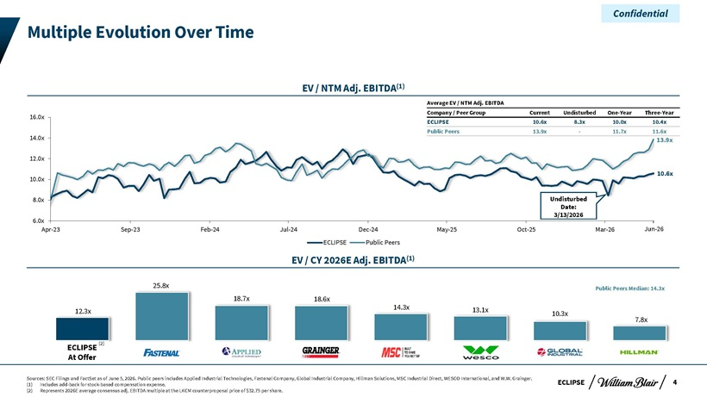
Confidential Multiple Evolution Over Time EV / NTM Adj. EBITDA(1) Average EV / NTM Adj. EBITDA Company / Peer Group Current Undisturbed One-Year Three-Year 16.0x ECLIPSE 10.6x 8.3x 10.0x 10.4x 14.0x Public Peers 13.9x—11.7x 11.6x 13.9x 12.0x 10.6x 10.0x 8.0x Undisturbed Date: 3/13/2026 6.0x Apr-23 Sep-23 Feb-24 Jul-24 Dec-24 May-25 Oct-25 Mar-26 Jun-26 ECLIPSE Public Peers EV / CY 2026E Adj. EBITDA(1) 25.8x Public Peers Median: 14.3x 18.7x 18.6x 14.3x 13.1x 12.3x 10.3x 7.8x ECLIPSE (2) At Offer Sources: SEC Filings and FactSet as of June 5, 2026. Public peers includes Applied Industrial Technologies, Fastenal Company, Global Industrial Company, Hillman Solutions, MSC Industrial Direct, WESCO International, and W.W. Grainger. ECLIPSE 4 (1) Includes add-back for stock-based compensation expense. (2) Represents 2026E average consensus adj. EBITDA multiple at the LKCM counterproposal price of $32.75 per share.

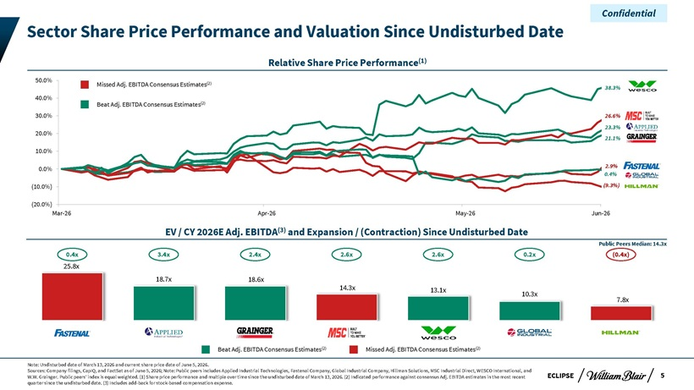
Confidential Sector Share Price Performance and Valuation Since Undisturbed Date Relative Share Price Performance(1) 50.0% Missed Adj. EBITDA Consensus Estimates(2) 38.3% 40.0% Beat Adj. EBITDA Consensus Estimates(2) 30.0% 26.6% 20.0% 23.3% 21.1% 10.0% 0.0% 2.9% 0.4% (10.0%) (9.3%) (20.0%) Mar-26 Apr-26 May-26 Jun-26 EV / CY 2026E Adj. EBITDA(3) and Expansion / (Contraction) Since Undisturbed Date Public Peers Median: 14.3x 0.4x 3.4x 2.4x 2.6x 2.6x 0.2x (0.4x) 25.8x 18.7x 18.6x 14.3x 13.1x 10.3x 7.8x Beat Adj. EBITDA Consensus Estimates(2) Missed Adj. EBITDA Consensus Estimates(2) Note: Undisturbed date of March 13, 2026 and current share price date of June 5, 2026. Sources: Company filings, CapIQ, and FactSet as of June 5, 2026; Note: Public peers includes Applied Industrial Technologies, Fastenal Company, Global Industrial Company, Hillman Solutions, MSC Industrial Direct, WESCO International, and W.W. Grainger. Public peers’ index is equal weighted. (1) Share price performance and multiple over time since the undisturbed date of March 13, 2026. (2) Indicated performance against consensus Adj. EBITDA estimates in the most recent ECLIPSE 5 quarter since the undisturbed date. (3) Includes add-back for stock-based compensation expense.

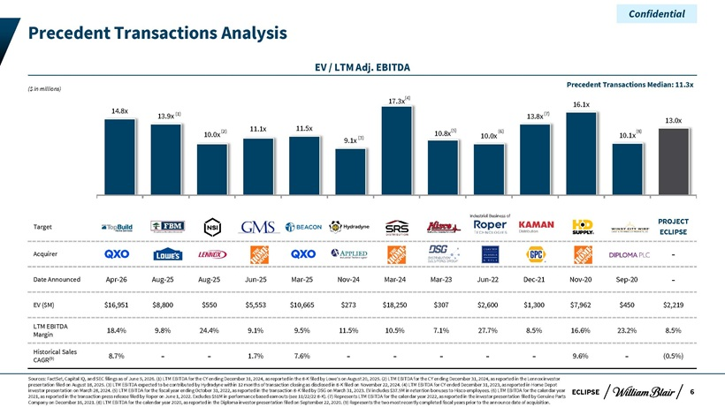
Confidential Precedent Transactions Analysis EV / LTM Adj. EBITDA Precedent Transactions Median: 11.3x ($ in millions) 17.3x(4) 16.1x 14.8x (1) (7) 13.9x 13.8x 13.0x (2) 11.1x 11.5x (5) (6) (8) 10.0x 10.8x 10.0x 10.1x 9.1x (3) Industrial Business of PROJECT Target ECLIPSE Acquirer—Date Announced Apr-26 Aug-25 Aug-25 Jun-25 Mar-25 Nov-24 Mar-24 Mar-23 Jun-22 Dec-21 Nov-20 Sep-20—EV ($M) $16,951 $8,800 $550 $5,553 $10,665 $273 $18,250 $307 $2,600 $1,300 $7,962 $450 $2,219 LTM EBITDA 18.4% 9.8% 24.4% 9.1% 9.5% 11.5% 10.5% 7.1% 27.7% 8.5% 16.6% 23.2% 8.5% Margin Historical Sales (9) 8.7% — 1.7% 7.6% — ——9.6%—(0.5%) CAGR Sources: FactSet, Capital IQ, and SEC filings as of June 5, 2026. (1) LTM EBITDA for the CY ending December 31, 2024, as reported in the 8-K filed by Lowe’s on August 20, 2025. (2) LTM EBITDA for the CY ending December 31, 2024, as reported in the Lennox investor presentation filed on August 18, 2025. (3) LTM EBITDA expected to be contributed by Hydradyne within 12 months of transaction closing as disclosed in 8-K filed on November 22, 2024. (4) LTM EBITDA for CY ended December 31, 2023, as reported in Home Depot investor presentation on March 28, 2024. (5) LTM EBITDA for the fiscal year ending October 31, 2022, as reported in the transaction 8-K filed by DSG on March 31, 2023. EV includes $37.5M in retention bonuses to Hisco employees. (6) LTM EBITDA for the calendar year ECLIPSE 6 2021, as reported in the transaction press release filed by Roper on June 1, 2022. Excludes $51M in performance based earnouts (see 11/22/22 8-K). (7) Represents LTM EBITDA for the calendar year 2022, as reported in the investor presentation filed by Genuine Parts Company on December 16, 2021. (8) LTM EBITDA for the calendar year 2020, as reported in the Diploma investor presentation filed on September 22, 2020. (9) Represents the two most recently completed fiscal years prior to the announce date of acquisition.

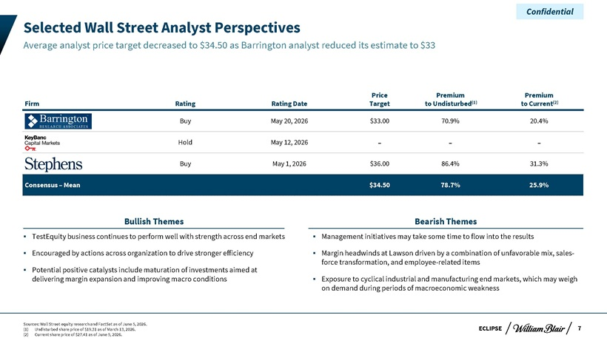
Confidential Selected Wall Street Analyst Perspectives Average analyst price target decreased to $34.50 as Barrington analyst reduced its estimate to $33 Price Premium Premium Firm Rating Rating Date Target to Undisturbed(1) to Current(2) Buy May 20, 2026 $33.00 70.9% 20.4% Hold May 12, 2026 — -Buy May 1, 2026 $36.00 86.4% 31.3% Consensus – Mean $34.50 78.7% 25.9% Bullish Themes Bearish Themes TestEquity business continues to perform well with strength across end markets Management initiatives may take some time to flow into the results Encouraged by actions across organization to drive stronger efficiency Margin headwinds at Lawson driven by a combination of unfavorable mix, sales- Potential positive catalysts include maturation of investments aimed at force transformation, and employee-related items delivering margin expansion and improving macro conditions Exposure to cyclical industrial and manufacturing end markets, which may weigh on demand during periods of macroeconomic weakness Sources: Wall Street equity research and FactSet as of June 5, 2026. (1) Undisturbed share price of $19.31 as of March 13, 2026. ECLIPSE 7 (2) Current share price of $27.41 as of June 5, 2026.

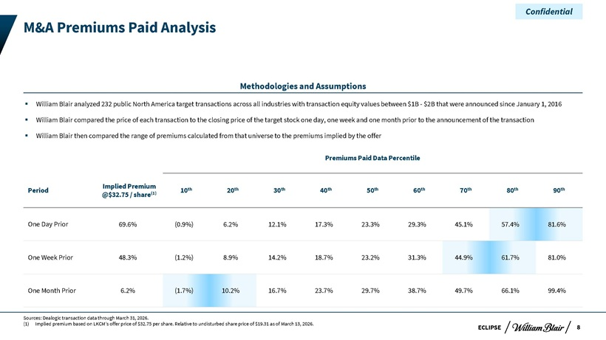
Confidential M&A Premiums Paid Analysis Methodologies and Assumptions William Blair analyzed 232 public North America target transactions across all industries with transaction equity values between $1B—$2B that were announced since January 1, 2016 William Blair compared the price of each transaction to the closing price of the target stock one day, one week and one month prior to the announcement of the transaction William Blair then compared the range of premiums calculated from that universe to the premiums implied by the offer Premiums Paid Data Percentile Implied Premium th th th th th th th th th Period (1) 10 20 30 40 50 60 70 80 90 @$32.75 / share One Day Prior 69.6% (0.9%) 6.2% 12.1% 17.3% 23.3% 29.3% 45.1% 57.4% 81.6% One Week Prior 48.3% (1.2%) 8.9% 14.2% 18.7% 23.2% 31.3% 44.9% 61.7% 81.0% One Month Prior 6.2% (1.7%) 10.2% 16.7% 23.7% 29.7% 38.7% 49.7% 66.1% 99.4% Sources: Dealogic transaction data through March 31, 2026. (1) Implied premium based on LKCM’s offer price of $32.75 per share. Relative to undisturbed share price of $19.31 as of March 13, 2026. 8 ECLIPSE

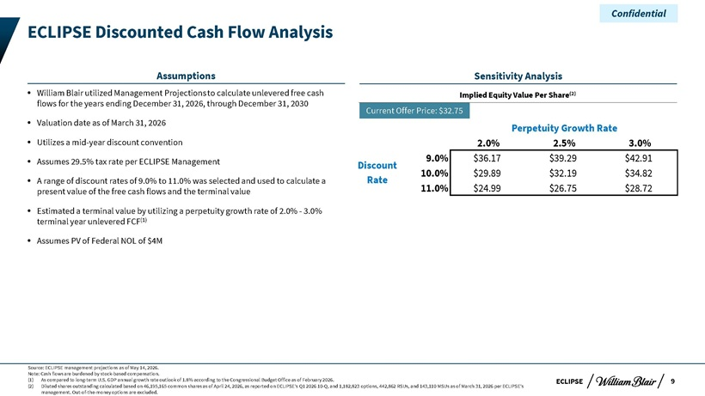
Confidential ECLIPSE Discounted Cash Flow Analysis Assumptions Sensitivity Analysis William Blair utilized Management Projections to calculate unlevered free cash Implied Equity Value Per Share(2) flows for the years ending December 31, 2026, through December 31, 2030 Current Offer Price: $32.75 Valuation date as of March 31, 2026 Perpetuity Growth Rate Utilizes a mid-year discount convention 2.0% 2.5% 3.0% Assumes 29.5% tax rate per ECLIPSE Management 9.0% $36.17 $39.29 $42.91 Discount 10.0% $29.89 $32.19 $34.82 A range of discount rates of 9.0% to 11.0% was selected and used to calculate a Rate present value of the free cash flows and the terminal value 11.0% $24.99 $26.75 $28.72 Estimated a terminal value by utilizing a perpetuity growth rate of 2.0%—3.0% terminal year unlevered FCF(1) Assumes PV of Federal NOL of $4M Source: ECLIPSE management projections as of May 14, 2026. Note: Cash flows are burdened by stock-based compensation. (1) As compared to long-term U.S. GDP annual growth rate outlook of 1.8% according to the Congressional Budget Office as of February 2026. ECLIPSE 9 (2) Diluted shares outstanding calculated based on 46,195,165 common shares as of April 24, 2026, as reported on ECLIPSE’s Q1 2026 10-Q, and 1,182,823 options, 442,862 RSUs, and 143,110 MSUs as of March 31, 2026 per ECLIPSE’s management. Out-of-the-money options are excluded.

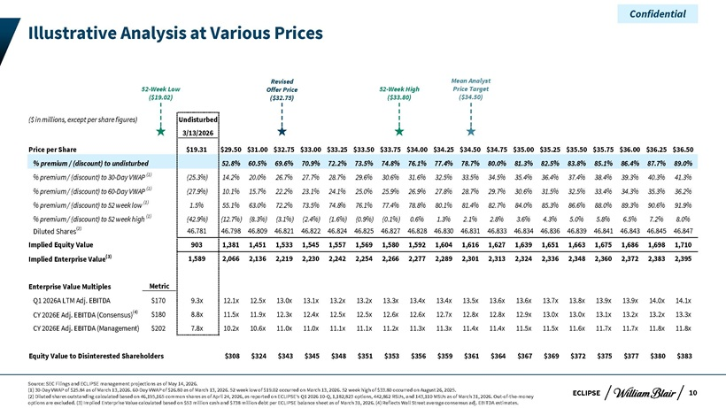
Confidential Illustrative Analysis at Various Prices Revised Mean Analyst 52-Week Low Offer Price 52-Week High Price Target ($19.02) ($32.75) ($33.80) ($34.50) ($ in millions, except per share figures) Undisturbed 3/13/2026 Price per Share $19.31 $29.50 $31.00 $32.75 $33.00 $33.25 $33.50 $33.75 $34.00 $34.25 $34.50 $34.75 $35.00 $35.25 $35.50 $35.75 $36.00 $36.25 $36.50 % premium / (discount) to undisturbed 52.8% 60.5% 69.6% 70.9% 72.2% 73.5% 74.8% 76.1% 77.4% 78.7% 80.0% 81.3% 82.5% 83.8% 85.1% 86.4% 87.7% 89.0% % premium / (discount) to 30-Day VWAP (1) (25.3%) 14.2% 20.0% 26.7% 27.7% 28.7% 29.6% 30.6% 31.6% 32.5% 33.5% 34.5% 35.4% 36.4% 37.4% 38.4% 39.3% 40.3% 41.3% % premium / (discount) to 60-Day VWAP (1) (27.9%) 10.1% 15.7% 22.2% 23.1% 24.1% 25.0% 25.9% 26.9% 27.8% 28.7% 29.7% 30.6% 31.5% 32.5% 33.4% 34.3% 35.3% 36.2% % premium / (discount) to 52 week low (1) 1.5% 55.1% 63.0% 72.2% 73.5% 74.8% 76.1% 77.4% 78.8% 80.1% 81.4% 82.7% 84.0% 85.3% 86.6% 88.0% 89.3% 90.6% 91.9% % premium / (discount) to 52 week high (1) (42.9%) (12.7%) (8.3%) (3.1%) (2.4%) (1.6%) (0.9%) (0.1%) 0.6% 1.3% 2.1% 2.8% 3.6% 4.3% 5.0% 5.8% 6.5% 7.2% 8.0% Diluted Shares(2) 46.781 46.798 46.809 46.821 46.822 46.824 46.825 46.827 46.828 46.830 46.831 46.833 46.834 46.836 46.839 46.841 46.843 46.845 46.847 Implied Equity Value 903 1,381 1,451 1,533 1,545 1,557 1,569 1,580 1,592 1,604 1,616 1,627 1,639 1,651 1,663 1,675 1,686 1,698 1,710 Implied Enterprise Value(3) 1,589 2,066 2,136 2,219 2,230 2,242 2,254 2,266 2,277 2,289 2,301 2,313 2,324 2,336 2,348 2,360 2,372 2,383 2,395 Enterprise Value Multiples Metric Q1 2026A LTM Adj. EBITDA $170 9.3x 12.1x 12.5x 13.0x 13.1x 13.2x 13.2x 13.3x 13.4x 13.4x 13.5x 13.6x 13.6x 13.7x 13.8x 13.9x 13.9x 14.0x 14.1x CY 2026E Adj. EBITDA (Consensus)(4) $180 8.8x 11.5x 11.9x 12.3x 12.4x 12.5x 12.5x 12.6x 12.6x 12.7x 12.8x 12.8x 12.9x 13.0x 13.0x 13.1x 13.2x 13.2x 13.3x CY 2026E Adj. EBITDA (Management) $202 7.8x 10.2x 10.6x 11.0x 11.0x 11.1x 11.1x 11.2x 11.3x 11.3x 11.4x 11.4x 11.5x 11.5x 11.6x 11.7x 11.7x 11.8x 11.8x Equity Value to Disinterested Shareholders $308 $324 $343 $345 $348 $351 $353 $356 $359 $361 $364 $367 $369 $372 $375 $377 $380 $383 Source: SEC Filings and ECLIPSE management projections as of May 14, 2026. (1) 30-Day VWAP of $25.84 as of March 13, 2026. 60-Day VWAP of $26.80 as of March 13, 2026. 52 week low of $19.02 occurred on March 13, 2026. 52 week high of $33.80 occurred on August 26, 2025. ECLIPSE 10 (2) Diluted shares outstanding calculated based on 46,195,165 common shares as of April 24, 2026, as reported on ECLIPSE’s Q1 2026 10-Q, 1,182,823 options, 442,862 RSUs, and 143,110 MSUs as of March 31, 2026. Out-of-the-money options are excluded. (3) Implied Enterprise Value calculated based on $53 million cash and $738 million debt per ECLIPSE balance sheet as of March 31, 2026. (4) Reflects Wall Street average consensus adj. EBITDA estimates.

Confidential Appendix

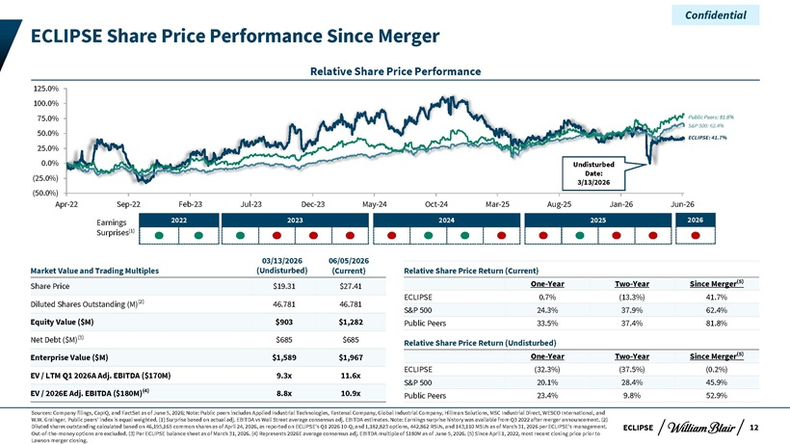
Confidential ECLIPSE Share Price Performance Since Merger Relative Share Price Performance 125.0% 100.0% 75.0% Public Peers: 81.8% 50.0% S&P 500: 62.4% ECLIPSE: 41.7% 25.0% 0.0% Undisturbed Date: (25.0%) 3/13/2026 (50.0%) Apr-22 Sep-22 Feb-23 Jul-23 Dec-23 May-24 Oct-24 Mar-25 Aug-25 Jan-26 Jun-26 Earnings 2022 2023 2024 2025 2026 Surprises(1) 03/13/2026 06/05/2026 Market Value and Trading Multiples (Undisturbed) (Current) Relative Share Price Return (Current) One-Year Two-Year Since Merger(5) Share Price $19.31 $27.41 ECLIPSE 0.7% (13.3%) 41.7% Diluted Shares Outstanding (M)(2) 46.781 46.781 S&P 500 24.3% 37.9% 62.4% Equity Value ($M) $903 $1,282 Public Peers 33.5% 37.4% 81.8% Net Debt ($M)(3) $685 $685 Relative Share Price Return (Undisturbed) Enterprise Value ($M) $1,589 $1,967 One-Year Two-Year Since Merger(5) ECLIPSE (32.3%) (37.5%) (0.2%) EV / LTM Q1 2026A Adj. EBITDA ($170M) 9.3x 11.6x S&P 500 20.1% 28.4% 45.9% EV / 2026E Adj. EBITDA ($180M)(4) 8.8x 10.9x Public Peers 23.4% 9.8% 52.9% Sources: Company filings, CapIQ, and FactSet as of June 5, 2026; Note: Public peers includes Applied Industrial Technologies, Fastenal Company, Global Industrial Company, Hillman Solutions, MSC Industrial Direct, WESCO International, and W.W. Grainger. Public peers’ index is equal weighted. (1) Surprise based on actual adj. EBITDA vs Wall Street average consensus adj. EBITDA estimates. Note: Earnings surprise history was available from Q3 2022 after merger announcement. (2) Diluted shares outstanding calculated based on 46,195,165 common shares as of April 24, 2026, as reported on ECLIPSE’s Q1 2026 10-Q, and 1,182,823 options, 442,862 RSUs, and 143,110 MSUs as of March 31, 2026 per ECLIPSE’s management. ECLIPSE 12 Out-of-the-money options are excluded. (3) Per ECLIPSE balance sheet as of March 31, 2026. (4) Represents 2026E average consensus adj. EBITDA multiple of $180M as of June 5, 2026. (5) Since April 1, 2022, most recent closing price prior to Lawson merger closing.

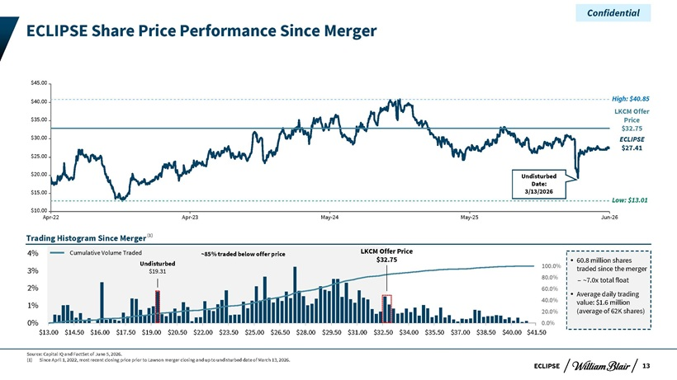
Confidential ECLIPSE Share Price Performance Since Merger $45.00 $40.00 High: $40.85 LKCM Offer $35.00 Price $32.75 $30.00 ECLIPSE $27.41 $25.00 $20.00 Undisturbed Date: $15.00 3/13/2026 Low: $13.01 $10.00 Apr-22 Apr-23 May-24 May-25 Jun-26 Trading Histogram Since Merger(1) Cumulative Volume Traded ~85% traded below offer price LKCM Offer Price $32.75 60.8 million shares Undisturbed 100.0% 3% $19.31 traded since the merger 80.0% – ~7.0x total float 2% 60.0% Average daily trading 40.0% value: $1.6 million 1% 20.0% (average of 62K shares) 0% 0.0% $13.00 $14.50 $16.00 $17.50 $19.00 $20.50 $22.00 $23.50 $25.00 $26.50 $28.00 $29.50 $31.00—$32.50—$34.00—$35.50—$37.00—$38.50—$40.00—$41.50 Source: Capital IQ and FactSet of June 5, 2026. (1) Since April 1, 2022, most recent closing price prior to Lawson merger closing and up to undisturbed date of March 13, 2026. ECLIPSE 13

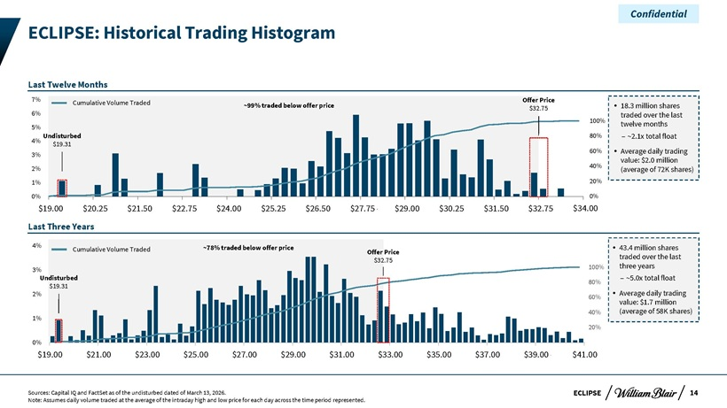
Confidential ECLIPSE: Historical Trading Histogram Last Twelve Months Cumulative Volume Traded Offer Price ~99% traded below offer price $32.75 18.3 million shares 6% traded over the last 5% 100% twelve months Undisturbed 80% – ~2.1x total float 4% $19.31 60% Average daily trading 3% value: $2.0 million 2% 40% (average of 72K shares) 1% 20% 0% 0% $19.00 $20.25 $21.50 $22.75 $24.00 $25.25 $26.50 $27.75 $29.00 $30.25 $31.50 $32.75 $34v .00 Last Three Years 4% ~78% traded below offer price 43.4 million shares Cumulative Volume Traded Offer Price $32.75 traded over the last 100% three years 3% Undisturbed – ~5.0x total float 80% $19.31 daily trading 2% Average 60% value: $1.7 million 1% 40% (average of 58K shares) 20% 0% $19.00—$21.00—$23.00—$25.00—$27.00—$29.00—$31.00—$33.00—$35.00—$37.00—$39.00 $41.00—Sources: Capital IQ and FactSet as of the undisturbed dated of March 13, 2026. ECLIPSE 14 Note: Assumes daily volume traded at the average of the intraday high and low price for each day across the time period represented.

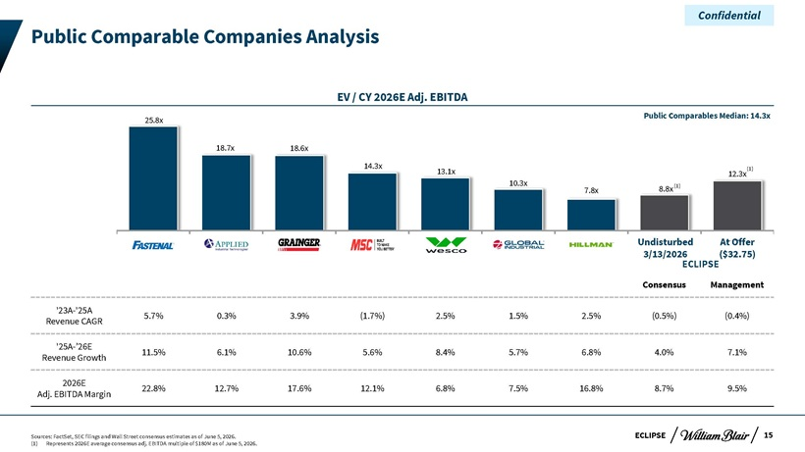
Confidential Public Comparable Companies Analysis EV / CY 2026E Adj. EBITDA Public Comparables Median: 14.3x 25.8x 18.7x 18.6x 14.3x (1) 13.1x 12.3x 10.3x (1) 7.8x 8.8x Undisturbed At Offer 3/13/2026 ECLIPSE($32.75) Consensus Management ‘23A-‘25A 5.7% 0.3% 3.9% (1.7%) 2.5% 1.5% 2.5% (0.5%) (0.4%) Revenue CAGR ‘25A-’26E 11.5% 6.1% 10.6% 5.6% 8.4% 5.7% 6.8% 4.0% 7.1% Revenue Growth 2026E 22.8% 12.7% 17.6% 12.1% 6.8% 7.5% 16.8% 8.7% 9.5% Adj. EBITDA Margin Sources: FactSet, SEC filings and Wall Street consensus estimates as of June 5, 2026. ECLIPSE 15 (1) Represents 2026E average consensus adj. EBITDA multiple of $180M as of June 5, 2026.

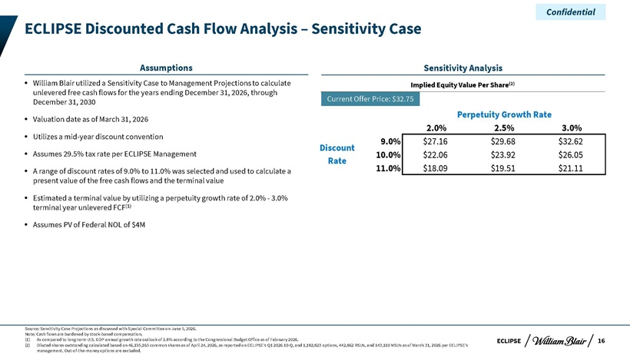
Confidential ECLIPSE Discounted Cash Flow Analysis – Sensitivity Case Assumptions Sensitivity Analysis William Blair utilized a Sensitivity Case to Management Projections to calculate Implied Equity Value Per Share(2) unlevered free cash flows for the years ending December 31, 2026, through December 31, 2030 Current Offer Price: $32.75 Perpetuity Growth Rate Valuation date as of March 31, 2026 2.0% 2.5% 3.0% Utilizes a mid-year discount convention 9.0% $27.16 $29.68 $32.62 Discount Assumes 29.5% tax rate per ECLIPSE Management 10.0% $22.06 $23.92 $26.05 Rate A range of discount rates of 9.0% to 11.0% was selected and used to calculate a 11.0% $18.09 $19.51 $21.11 present value of the free cash flows and the terminal value Estimated a terminal value by utilizing a perpetuity growth rate of 2.0%—3.0% terminal year unlevered FCF(1) Assumes PV of Federal NOL of $4M Source: Sensitivity Case Projections as discussed with Special Committee on June 5, 2026. Note: Cash flows are burdened by stock-based compensation. (1) As compared to long-term U.S. GDP annual growth rate outlook of 1.8% according to the Congressional Budget Office as of February 2026. ECLIPSE 16 (2) Diluted shares outstanding calculated based on 46,195,165 common shares as of April 24, 2026, as reported on ECLIPSE’s Q1 2026 10-Q, and 1,182,823 options, 442,862 RSUs, and 143,110 MSUs as of March 31, 2026 per ECLIPSE’s management. Out-of-the-money options are excluded.

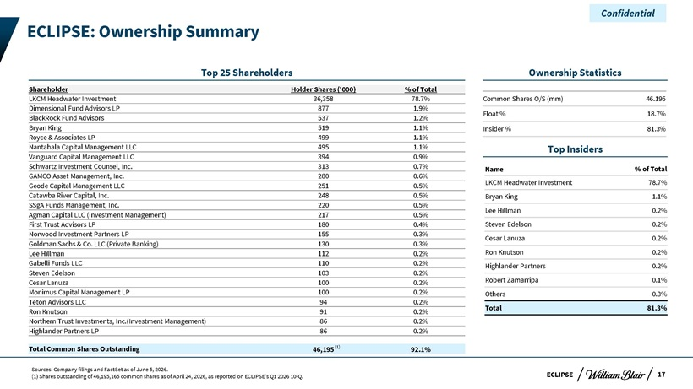
Confidential ECLIPSE: Ownership Summary Top 25 Shareholders Ownership Statistics Shareholder Holder Shares (‘000) % of Total LKCM Headwater Investment 36,358 78.7% Common Shares O/S (mm) 46.195 Dimensional Fund Advisors LP 877 1.9% Float % 18.7% BlackRock Fund Advisors 537 1.2% Bryan King 519 1.1% Insider % 81.3% Royce & Associates LP 499 1.1% Nantahala Capital Management LLC 495 1.1% Top Insiders Vanguard Capital Management LLC 394 0.9% Schwartz Investment Counsel, Inc. 313 0.7% Name % of Total GAMCO Asset Management, Inc. 280 0.6% Geode Capital Management LLC 251 0.5% LKCM Headwater Investment 78.7% Catawba River Capital, Inc. 248 0.5% Bryan King 1.1% SSgA Funds Management, Inc. 220 0.5% Lee Hillman 0.2% Agman Capital LLC (Investment Management) 217 0.5% First Trust Advisors LP 180 0.4% Steven Edelson 0.2% Norwood Investment Partners LP 155 0.3% Cesar Lanuza 0.2% Goldman Sachs & Co. LLC (Private Banking) 130 0.3% Lee Hillman 112 0.2% Ron Knutson 0.2% Gabelli Funds LLC 110 0.2% Highlander Partners 0.2% Steven Edelson 103 0.2% Robert Zamarripa 0.1% Cesar Lanuza 100 0.2% Monimus Capital Management LP 100 0.2% Others 0.3% Teton Advisors LLC 94 0.2% Total 81.3% Ron Knutson 91 0.2% Northern Trust Investments, Inc.(Investment Management) 86 0.2% Highlander Partners LP 86 0.2% Total Common Shares Outstanding 46,195 (1) 92.1% Sources: Company filings and FactSet as of June 5, 2026. (1) Shares outstanding of 46,195,165 common shares as of April 24, 2026, as reported on ECLIPSE’s Q1 2026 10-Q. ECLIPSE 17
Exhibit (c)(vii)

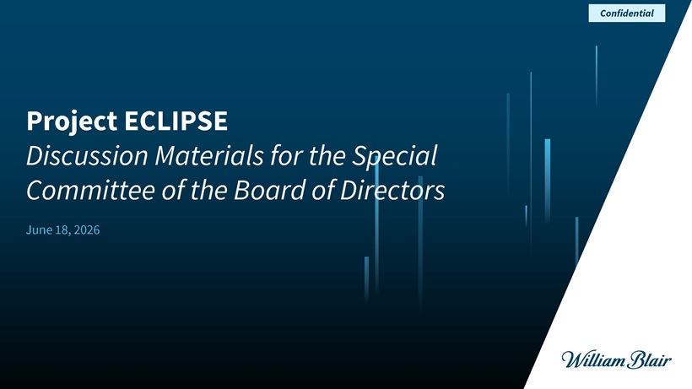
Confidential Project ECLIPSE Discussion Materials for the Special Committee of the Board of Directors June 18, 2026

Confidential Disclaimer This presentation (together with any accompanying oral presentation and any supplementary documents provided therewith, the “Presentation”) has been prepared by William Blair & Company, L.L.C. (“William Blair”) exclusively for the benefit and internal use of the recipient (the “Recipient”). The Recipient is not permitted to reproduce in whole or in part the information provided in this Presentation (the “Information”) or to communicate the Information to any third party without William Blair’s prior written consent. No party may rely on this Presentation without William Blair’s prior written consent. William Blair and its affiliates, partners, directors, employees and agents do not accept responsibility or liability for this Presentation or its contents (except to the extent that such liability cannot be excluded by law). This Presentation is for discussion purposes only and speaks only as of the date it is given, and the views expressed are subject to change based on a number of factors, including market conditions and the Recipient’s business and prospects. The Information, whether taken from public sources, received from the Recipient or elsewhere, has not been independently verified by William Blair and William Blair has relied upon and assumed the accuracy and completeness of all Information. No representation or warranty is made as to any to the accuracy or completeness of any Information. In furnishing this Presentation, William Blair undertakes no obligation to provide additional information or to correct or update any of the Information. William Blair, together with its affiliates and partners, is a financial services institution engaged in a wide range of investment banking and other activities (including, but not limited to, investment management, corporate finance, private wealth management, securities trading, research and brokerage activities). It is understood and agreed that William Blair may, from time to time, make a market in, have a long or short position, buy and sell or otherwise effect transactions for customer accounts and for their own accounts in the securities of, or may perform or be solicited to perform investment banking, corporate finance or other services for, the Recipient and other third-party entities which are or may be the subject of the transactions contemplated by this Presentation. William Blair has adopted policies and procedures designed to ensure the independence of its research analysts, whose views may differ from those of William Blair’s investment banking department and who may produce research reports and other materials the timing or content of which conflict with the views of the investment banking department or the Recipient’s interests, in connection with the transactions contemplated by this Presentation or otherwise. Nothing in the Presentation is, or shall be relied upon as, investment advice or any recommendation by William Blair. This Presentation does not purport to contain all of the information that may be necessary or appropriate to evaluate the proposed transaction, and the Recipient should conduct its own independent assessment and such investigations as it deems necessary. Recipient should rely on its own counsel, accountants and other similar expert advisors for legal, regulatory, accounting, tax and other similar advice. Nothing in the Presentation or any related discussions is intended to create, or shall be construed as creating, a principal-agent, advisor-client or fiduciary relationship between William Blair and the Recipient. ECLIPSE 1

Confidential Agenda for Discussion 1 LKCM’s Revised Proposal I2 . Offer Price in Context II 3. Discuss Next Steps ECLIPSE 2

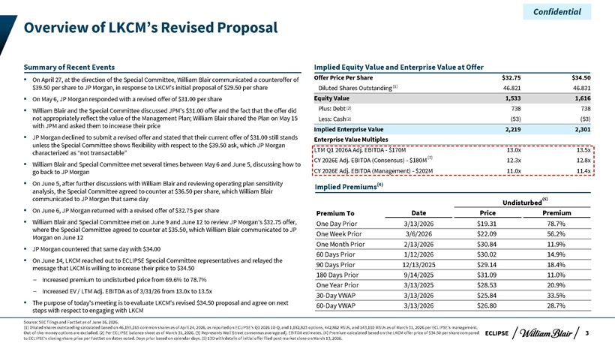
Confidential Overview of LKCM’s Revised Proposal Summary of Recent Events Implied Equity Value and Enterprise Value at Offer ? On April 27, at the direction of the Special Committee, William Blair communicated a counteroffer of Offer Price Per Share $32.75 $34.50 $39.50 per share to JP Morgan, in response to LKCM’s initial proposal of $29.50 per share Diluted Shares Outstanding (1) 46.821 46.831 ? On May 6, JP Morgan responded with a revised offer of $31.00 per share Equity Value 1,533 1,616 ? William Blair and the Special Committee discussed JPM’s $31.00 offer and the fact that the offer did Plus: Debt (2) 738 738 not appropriately reflect the value of the Management Plan; William Blair shared the Plan on May 15 Less: Cash(2) (53) (53) with JPM and asked them to increase their price Implied Enterprise Value 2,219 2,301 ? JP Morgan declined to submit a revised offer and stated that their current offer of $31.00 still stands Enterprise Value Multiples unless the Special Committee shows flexibility with respect to the $39.50 ask, which JP Morgan characterized as “not transactable” LTM Q1 2026A Adj. EBITDA—$170M 13.0x 13.5x CY 2026E Adj. EBITDA (Consensus)—$180M(3) 12.3x 12.8x ? William Blair and Special Committee met several times between May 6 and June 5, discussing how to go back to JP Morgan CY 2026E Adj. EBITDA (Management)—$202M 11.0x 11.4x ? On June 5, after further discussions with William Blair and reviewing operating plan sensitivity Implied Premiums(4) analysis, the Special Committee agreed to counter at $36.50 per share, which William Blair communicated to JP Morgan that same day Undisturbed(5) ? On June 6, JP Morgan returned with a revised offer of $32.75 per share Premium To Date Price Premium ? William Blair and Special Committee met on June 9 and June 12 to review JP Morgan’s $32.75 offer, One Day Prior 3/13/2026 $19.31 78.7% where the Special Committee agreed to counter at $35.50, which William Blair communicated to JP One Week Prior 3/6/2026 $22.09 56.2% Morgan on June 12 One Month Prior 2/13/2026 $30.84 11.9% ? JP Morgan countered that same day with $34.00 reached Committee representatives and relayed the 60 Days Prior 1/12/2026 $30.02 14.9% ? On June 14, LKCM out to ECLIPSE Special 90 Days Prior 12/13/2025 $29.14 18.4% message that LKCM is willing to increase their price to $34.50 180 Days Prior 9/14/2025 $31.09 11.0% ? Increased premium to undisturbed price from 69.6% to 78.7% EV / LTM Adj. EBITDA as of 3/31/26 from 13.0x to 13.5x One Year Prior 3/13/2025 $28.53 20.9% ? Increased 30-Day VWAP 3/13/2026 $25.84 33.5% ? The purpose of today’s meeting is to evaluate LKCM’s revised $34.50 proposal and agree on next 60-Day VWAP 3/13/2026 $26.80 28.7% steps with respect to engaging with LKCM Source: SEC filings and FactSet as of June 16, 2026. (1) Diluted shares outstanding calculated based on 46,195,165 common shares as of April 24, 2026, as reported on ECLIPSE’s Q1 2026 10-Q, and 1,182,823 options, 442,862 RSUs, and 143,110 MSUs as of March 31, 2026 per ECLIPSE’s management. Out-of-the-money options are excluded. (2) Per ECLIPSE balance sheet as of March 31, 2026. (3) Represents Wall Street consensus average adj. EBITDA estimates. (4) Premium calculated based on the LKCM offer price of $34.50 per share compared ECLIPSE 3 to ECLIPSE’s closing share price per FactSet on dates noted. Days prior based on calendar days. (5) 13D with details of initial offer filed post-market close on March 13, 2026.

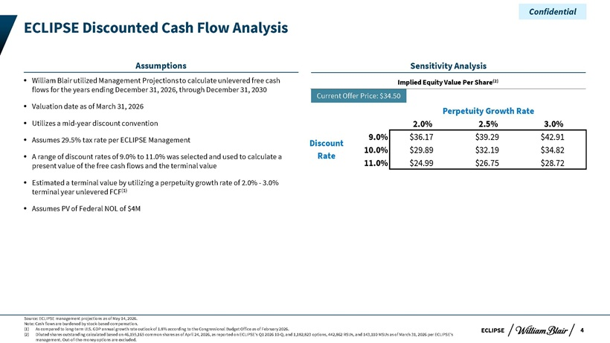
Confidential ECLIPSE Discounted Cash Flow Analysis Assumptions Sensitivity Analysis ? William Blair utilized Management Projections to calculate unlevered free cash Implied Equity Value Per Share(2) flows for the years ending December 31, 2026, through December 31, 2030 Current Offer Price: $34.50 ? Valuation date as of March 31, 2026 Perpetuity Growth Rate ? Utilizes a mid-year discount convention 2.0% 2.5% 3.0%? Assumes 29.5% tax rate per ECLIPSE Management 9.0% $36.17 $39.29 $42.91 Discount 10.0% $29.89 $32.19 $34.82 ? A range of discount rates of 9.0% to 11.0% was selected and used to calculate a Rate present value of the free cash flows and the terminal value 11.0% $24.99 $26.75 $28.72? Estimated a terminal value by utilizing a perpetuity growth rate of 2.0%—3.0% terminal year unlevered FCF(1) ? Assumes PV of Federal NOL of $4M Source: ECLIPSE management projections as of May 14, 2026. Note: Cash flows are burdened by stock-based compensation. (1) As compared to long-term U.S. GDP annual growth rate outlook of 1.8% according to the Congressional Budget Office as of February 2026. ECLIPSE 4 (2) Diluted shares outstanding calculated based on 46,195,165 common shares as of April 24, 2026, as reported on ECLIPSE’s Q1 2026 10-Q, and 1,182,823 options, 442,862 RSUs, and 143,110 MSUs as of March 31, 2026 per ECLIPSE’s management. Out-of-the-money options are excluded.

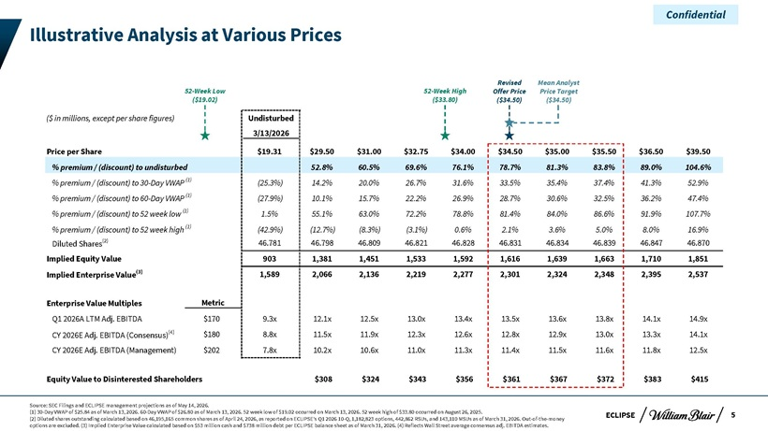
Confidential Illustrative Analysis at Various Prices Revised Mean Analyst 52-Week Low 52-Week High Offer Price Price Target ($19.02) ($33.80) ($34.50) ($34.50) ($ in millions, except per share figures) Undisturbed 3/13/2026 Price per Share $19.31 $29.50 $31.00 $32.75 $34.00 $34.50 $35.00 $35.50 $36.50 $39.50 % premium / (discount) to undisturbed 52.8% 60.5% 69.6% 76.1% 78.7% 81.3% 83.8% 89.0% 104.6% % premium / (discount) to 30-Day VWAP (1) (25.3%) 14.2% 20.0% 26.7% 31.6% 33.5% 35.4% 37.4% 41.3% 52.9% % premium / (discount) to 60-Day VWAP (1) (27.9%) 10.1% 15.7% 22.2% 26.9% 28.7% 30.6% 32.5% 36.2% 47.4% % premium / (discount) to 52 week low (1) 1.5% 55.1% 63.0% 72.2% 78.8% 81.4% 84.0% 86.6% 91.9% 107.7% % premium / (discount) to 52 week high (1) (42.9%) (12.7%) (8.3%) (3.1%) 0.6% 2.1% 3.6% 5.0% 8.0% 16.9% Diluted Shares(2) 46.781 46.798 46.809 46.821 46.828 46.831 46.834 46.839 46.847 46.870 Implied Equity Value 903 1,381 1,451 1,533 1,592 1,616 1,639 1,663 1,710 1,851 Implied Enterprise Value(3) 1,589 2,066 2,136 2,219 2,277 2,301 2,324 2,348 2,395 2,537 Enterprise Value Multiples Metric Q1 2026A LTM Adj. EBITDA $170 9.3x 12.1x 12.5x 13.0x 13.4x 13.5x 13.6x 13.8x 14.1x 14.9x CY 2026E Adj. EBITDA (Consensus)(4) $180 8.8x 11.5x 11.9x 12.3x 12.6x 12.8x 12.9x 13.0x 13.3x 14.1x CY 2026E Adj. EBITDA (Management) $202 7.8x 10.2x 10.6x 11.0x 11.3x 11.4x 11.5x 11.6x 11.8x 12.5x Equity Value to Disinterested Shareholders $308 $324 $343 $356 $361 $367 $372 $383 $415 Source: SEC Filings and ECLIPSE management projections as of May 14, 2026. (1) 30-Day VWAP of $25.84 as of March 13, 2026. 60-Day VWAP of $26.80 as of March 13, 2026. 52 week low of $19.02 occurred on March 13, 2026. 52 week high of $33.80 occurred on August 26, 2025. ECLIPSE 5 (2) Diluted shares outstanding calculated based on 46,195,165 common shares as of April 24, 2026, as reported on ECLIPSE’s Q1 2026 10-Q, 1,182,823 options, 442,862 RSUs, and 143,110 MSUs as of March 31, 2026. Out-of-the-money options are excluded. (3) Implied Enterprise Value calculated based on $53 million cash and $738 million debt per ECLIPSE balance sheet as of March 31, 2026. (4) Reflects Wall Street average consensus adj. EBITDA estimates.

Confidential Appendix

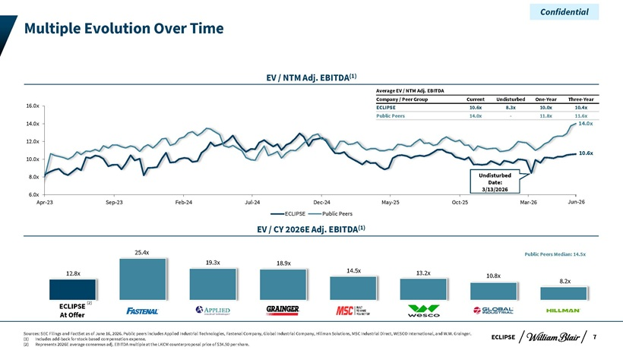
Confidential Multiple Evolution Over Time EV / NTM Adj. EBITDA(1) Average EV / NTM Adj. EBITDA Company / Peer Group Current Undisturbed One-Year Three-Year 16.0x ECLIPSE 10.6x 8.3x 10.0x 10.4x Public Peers 14.0x—11.8x 11.6x 14.0x 14.0x 12.0x 10.0x 10.6x 8.0x Undisturbed Date: 3/13/2026 6.0x Apr-23 Sep-23 Feb-24 Jul-24 Dec-24 May-25 Oct-25 Mar-26 Jun-26 ECLIPSE Public Peers EV / CY 2026E Adj. EBITDA(1) 25.4x Public Peers Median: 14.5x 19.3x 18.9x 12.8x 14.5x 13.2x 10.8x 8.2x ECLIPSE (2) At Offer Sources: SEC Filings and FactSet as of June 16, 2026. Public peers includes Applied Industrial Technologies, Fastenal Company, Global Industrial Company, Hillman Solutions, MSC Industrial Direct, WESCO International, and W.W. Grainger. ECLIPSE 7 (1) Includes add-back for stock-based compensation expense. (2) Represents 2026E average consensus adj. EBITDA multiple at the LKCM counterproposal price of $34.50 per share.

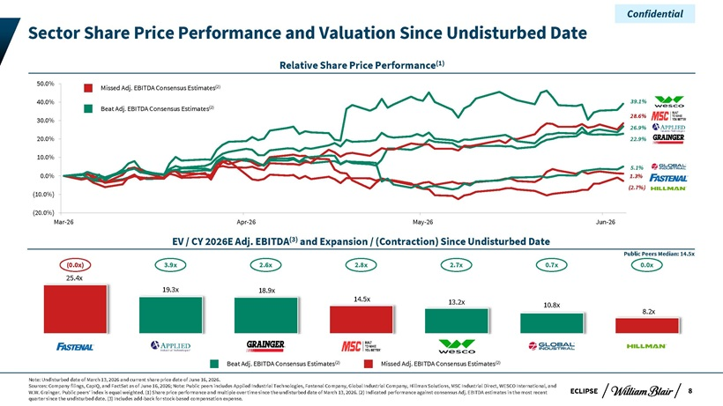
Confidential Sector Share Price Performance and Valuation Since Undisturbed Date Relative Share Price Performance(1) 50.0% Missed Adj. EBITDA Consensus Estimates(2) 40.0% 39.1% Beat Adj. EBITDA Consensus Estimates(2) 28.6% 30.0% 26.9% 20.0% 22.9% 10.0% 5.1% 0.0% 1.3% (10.0%) (2.7%) (20.0%) Mar-26 Apr-26 May-26 Jun-26 EV / CY 2026E Adj. EBITDA(3) and Expansion / (Contraction) Since Undisturbed Date Public Peers Median: 14.5x (0.0x) 3.9x 2.6x 2.8x 2.7x 0.7x 0.0x 25.4x 19.3x 18.9x 14.5x 13.2x 10.8x 8.2x Beat Adj. EBITDA Consensus Estimates(2) Missed Adj. EBITDA Consensus Estimates(2) Note: Undisturbed date of March 13, 2026 and current share price date of June 16, 2026. Sources: Company filings, CapIQ, and FactSet as of June 16, 2026; Note: Public peers includes Applied Industrial Technologies, Fastenal Company, Global Industrial Company, Hillman Solutions, MSC Industrial Direct, WESCO International, and W.W. Grainger. Public peers’ index is equal weighted. (1) Share price performance and multiple over time since the undisturbed date of March 13, 2026. (2) Indicated performance against consensus Adj. EBITDA estimates in the most recent ECLIPSE 8 quarter since the undisturbed date. (3) Includes add-back for stock-based compensation expense.

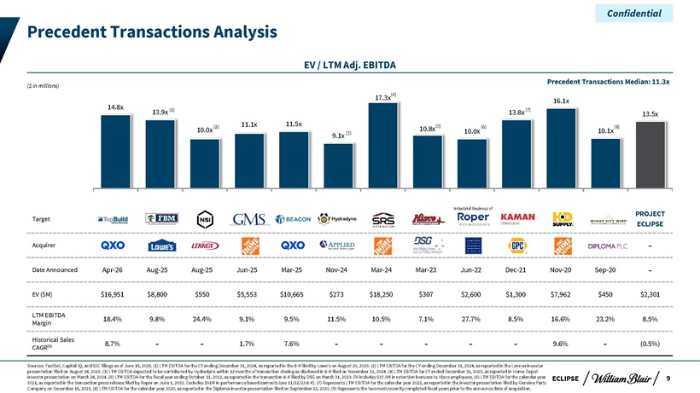
Confidential Precedent Transactions Analysis EV / LTM Adj. EBITDA Precedent Transactions Median: 11.3x ($ in millions) 17.3x(4) 16.1x 14.8x (1) (7) 13.9x 13.8x 13.5x (2) 11.1x 11.5x (5) (6) (8) 10.0x 10.8x 10.0x 10.1x 9.1x (3) Industrial Business of PROJECT Target ECLIPSE Acquirer—Date Announced Apr-26 Aug-25 Aug-25 Jun-25 Mar-25 Nov-24 Mar-24 Mar-23 Jun-22 Dec-21 Nov-20 Sep-20—EV ($M) $16,951 $8,800 $550 $5,553 $10,665 $273 $18,250 $307 $2,600 $1,300 $7,962 $450 $2,301 LTM EBITDA 18.4% 9.8% 24.4% 9.1% 9.5% 11.5% 10.5% 7.1% 27.7% 8.5% 16.6% 23.2% 8.5% Margin Historical Sales (9) 8.7% — 1.7% 7.6% — ——9.6%—(0.5%) CAGR Sources: FactSet, Capital IQ, and SEC filings as of June 16, 2026. (1) LTM EBITDA for the CY ending December 31, 2024, as reported in the 8-K filed by Lowe’s on August 20, 2025. (2) LTM EBITDA for the CY ending December 31, 2024, as reported in the Lennox investor presentation filed on August 18, 2025. (3) LTM EBITDA expected to be contributed by Hydradyne within 12 months of transaction closing as disclosed in 8-K filed on November 22, 2024. (4) LTM EBITDA for CY ended December 31, 2023, as reported in Home Depot investor presentation on March 28, 2024. (5) LTM EBITDA for the fiscal year ending October 31, 2022, as reported in the transaction 8-K filed by DSG on March 31, 2023. EV includes $37.5M in retention bonuses to Hisco employees. (6) LTM EBITDA for the calendar year ECLIPSE 9 2021, as reported in the transaction press release filed by Roper on June 1, 2022. Excludes $51M in performance based earnouts (see 11/22/22 8-K). (7) Represents LTM EBITDA for the calendar year 2022, as reported in the investor presentation filed by Genuine Parts Company on December 16, 2021. (8) LTM EBITDA for the calendar year 2020, as reported in the Diploma investor presentation filed on September 22, 2020. (9) Represents the two most recently completed fiscal years prior to the announce date of acquisition.

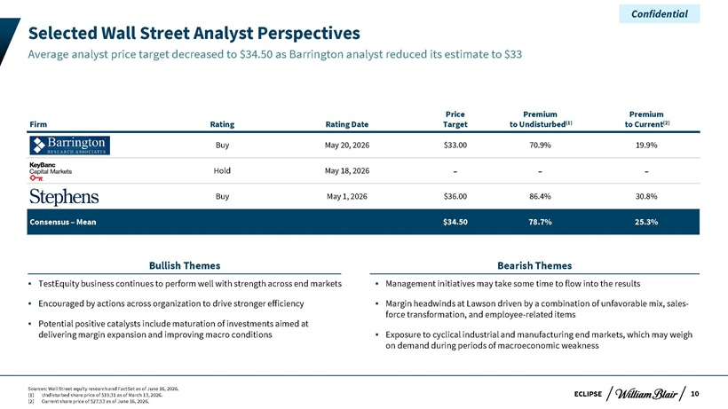
Confidential Selected Wall Street Analyst Perspectives Average analyst price target decreased to $34.50 as Barrington analyst reduced its estimate to $33 Price Premium Premium Firm Rating Rating Date Target to Undisturbed(1) to Current(2) Buy May 20, 2026 $33.00 70.9% 19.9% Hold May 18, 2026 — -Buy May 1, 2026 $36.00 86.4% 30.8% Consensus – Mean $34.50 78.7% 25.3% Bullish Themes Bearish Themes ? TestEquity business continues to perform well with strength across end markets ? Management initiatives may take some time to flow into the results ? Encouraged by actions across organization to drive stronger efficiency ? Margin headwinds at Lawson driven by a combination of unfavorable mix, sales- ? Potential positive catalysts include maturation of investments aimed at force transformation, and employee-related items delivering margin expansion and improving macro conditions ? Exposure to cyclical industrial and manufacturing end markets, which may weigh on demand during periods of macroeconomic weakness Sources: Wall Street equity research and FactSet as of June 16, 2026. (1) Undisturbed share price of $19.31 as of March 13, 2026. ECLIPSE 10 (2) Current share price of $27.53 as of June 16, 2026.

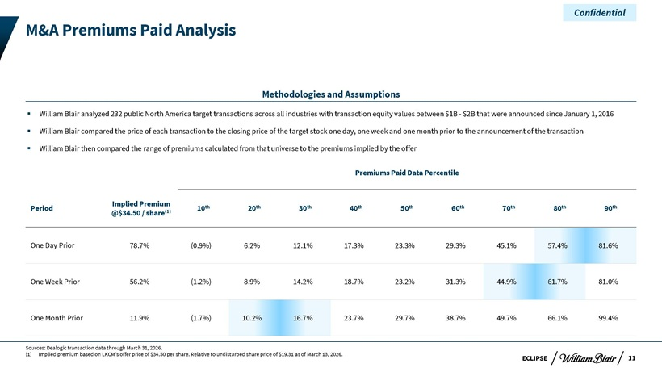
Confidential M&A Premiums Paid Analysis Methodologies and Assumptions ? William Blair analyzed 232 public North America target transactions across all industries with transaction equity values between $1B—$2B that were announced since January 1, 2016 ? William Blair compared the price of each transaction to the closing price of the target stock one day, one week and one month prior to the announcement of the transaction? William Blair then compared the range of premiums calculated from that universe to the premiums implied by the offer Premiums Paid Data Percentile Implied Premium th th th th th th th th th Period (1) 10 20 30 40 50 60 70 80 90 @$34.50 / share One Day Prior 78.7% (0.9%) 6.2% 12.1% 17.3% 23.3% 29.3% 45.1% 57.4% 81.6% One Week Prior 56.2% (1.2%) 8.9% 14.2% 18.7% 23.2% 31.3% 44.9% 61.7% 81.0% One Month Prior 11.9% (1.7%) 10.2% 16.7% 23.7% 29.7% 38.7% 49.7% 66.1% 99.4% Sources: Dealogic transaction data through March 31, 2026. (1) Implied premium based on LKCM’s offer price of $34.50 per share. Relative to undisturbed share price of $19.31 as of March 13, 2026. 11 ECLIPSE

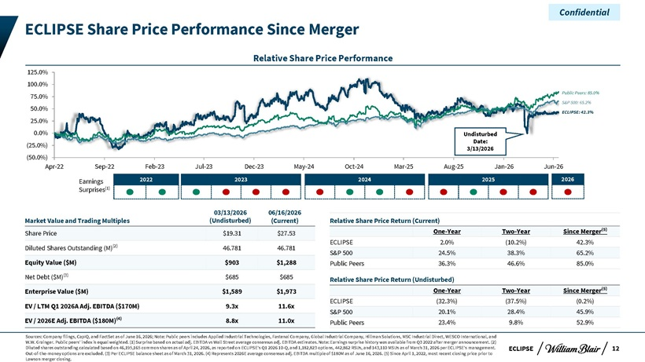
Confidential ECLIPSE Share Price Performance Since Merger Relative Share Price Performance 125.0% 100.0% Public Peers: 85.0% 75.0% 50.0% S&P 500: 65.2% ECLIPSE: 42.3% 25.0% 0.0% Undisturbed Date: (25.0%) 3/13/2026 (50.0%) Apr-22 Sep-22 Feb-23 Jul-23 Dec-23 May-24 Oct-24 Mar-25 Aug-25 Jan-26 Jun-26 Earnings 2022 2023 2024 2025 2026 Surprises(1) 03/13/2026 06/16/2026 Market Value and Trading Multiples (Undisturbed) (Current) Relative Share Price Return (Current) One-Year Two-Year Since Merger(5) Share Price $19.31 $27.53 ECLIPSE 2.0% (10.2%) 42.3% Diluted Shares Outstanding (M)(2) 46.781 46.781 S&P 500 24.5% 38.3% 65.2% Equity Value ($M) $903 $1,288 Public Peers 36.3% 46.6% 85.0% Net Debt ($M)(3) $685 $685 Relative Share Price Return (Undisturbed) Enterprise Value ($M) $1,589 $1,973 One-Year Two-Year Since Merger(5) ECLIPSE (32.3%) (37.5%) (0.2%) EV / LTM Q1 2026A Adj. EBITDA ($170M) 9.3x 11.6x S&P 500 20.1% 28.4% 45.9% EV / 2026E Adj. EBITDA ($180M)(4) 8.8x 11.0x Public Peers 23.4% 9.8% 52.9% Sources: Company filings, CapIQ, and FactSet as of June 16, 2026; Note: Public peers includes Applied Industrial Technologies, Fastenal Company, Global Industrial Company, Hillman Solutions, MSC Industrial Direct, WESCO International, and W.W. Grainger. Public peers’ index is equal weighted. (1) Surprise based on actual adj. EBITDA vs Wall Street average consensus adj. EBITDA estimates. Note: Earnings surprise history was available from Q3 2022 after merger announcement. (2) Diluted shares outstanding calculated based on 46,195,165 common shares as of April 24, 2026, as reported on ECLIPSE’s Q1 2026 10-Q, and 1,182,823 options, 442,862 RSUs, and 143,110 MSUs as of March 31, 2026 per ECLIPSE’s management. ECLIPSE 12 Out-of-the-money options are excluded. (3) Per ECLIPSE balance sheet as of March 31, 2026. (4) Represents 2026E average consensus adj. EBITDA multiple of $180M as of June 16, 2026. (5) Since April 1, 2022, most recent closing price prior to Lawson merger closing.

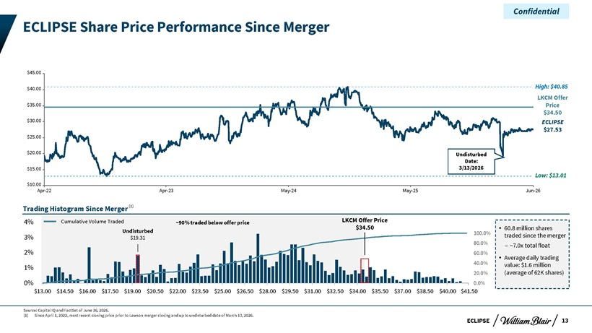
Confidential ECLIPSE Share Price Performance Since Merger $45.00 $40.00 High: $40.85 LKCM Offer $35.00 Price $34.50 $30.00 ECLIPSE $27.53 $25.00 $20.00 Undisturbed Date: $15.00 3/13/2026 Low: $13.01 $10.00 Apr-22 Apr-23 May-24 May-25 Jun-26 Trading Histogram Since Merger(1) Cumulative Volume Traded ~90% traded below offer price LKCM Offer Price $34.50? 60.8 million shares Undisturbed 100.0% 3% $19.31 traded since the merger 80.0% – ~7.0x total float 2% 60.0% ? Average daily trading 40.0% value: $1.6 million 1% 20.0% (average of 62K shares) 0% 0.0% $13.00—$14.50—$16.00—$17.50—$19.00—$20.50—$22.00—$23.50—$25.00—$26.50—$28.00—$29.50—$31.00—$32.50—$34.00—$35.50—$37.00—$38.50—$40.00—$41.50 Source: Capital IQ and FactSet of June 16, 2026. (1) Since April 1, 2022, most recent closing price prior to Lawson merger closing and up to undisturbed date of March 13, 2026. ECLIPSE 13

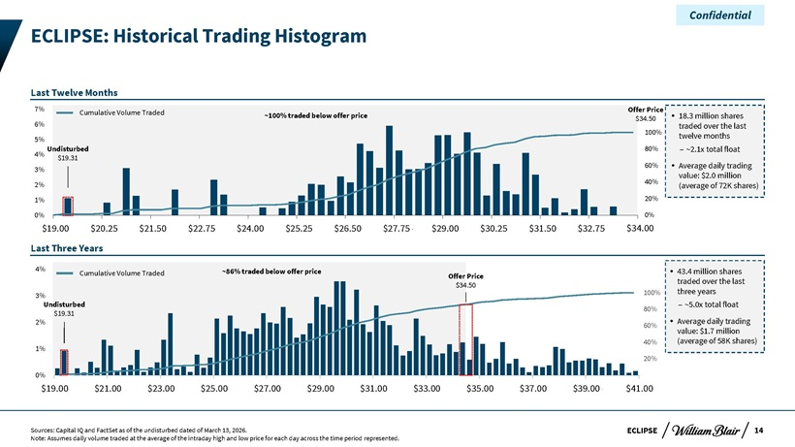
Confidential ECLIPSE: Historical Trading Histogram Last Twelve Months Cumulative Volume Traded Offer Price ~100% traded below offer price $34.50? 18.3 million shares 6% traded over the last 5% 100% twelve months Undisturbed 80% – ~2.1x total float 4% $19.31 60%? Average daily trading 3% value: $2.0 million 2% 40% (average of 72K shares) 1% 20% 0% 0% $19.00 $20.25 $21.50 $22.75 $24.00 $25.25 $26.50 $27.75 $29.00 $30.25 $31.50 $32.75 $34v .00 Last Three Years 4% ~86% traded below offer price? 43.4 million shares Cumulative Volume Traded Offer Price $34.50 traded over the last 100% three years 3% Undisturbed – ~5.0x total float 80% $19.31 Average daily trading 2%? 60% value: $1.7 million 1% 40% (average of 58K shares) 20% 0% $19.00—$21.00—$23.00—$25.00—$27.00—$29.00—$31.00—$33.00—$35.00—$37.00—$39.00 $41.00—Sources: Capital IQ and FactSet as of the undisturbed dated of March 13, 2026. ECLIPSE 14 Note: Assumes daily volume traded at the average of the intraday high and low price for each day across the time period represented.

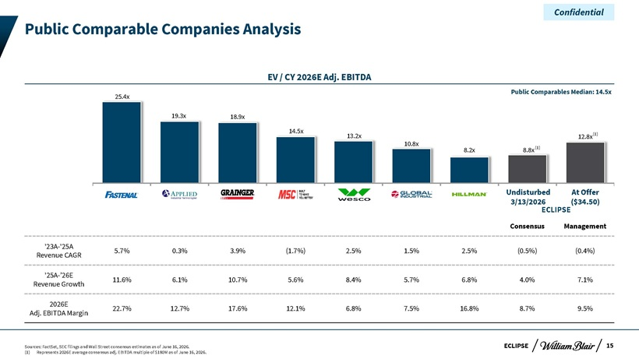
Confidential Public Comparable Companies Analysis EV / CY 2026E Adj. EBITDA Public Comparables Median: 14.5x 25.4x 19.3x 18.9x 14.5x (1) 13.2x 12.8x 10.8x 8.2x 8.8x (1) Undisturbed At Offer 3/13/2026 ECLIPSE($34.50) Consensus Management ‘23A-‘25A 5.7% 0.3% 3.9% (1.7%) 2.5% 1.5% 2.5% (0.5%) (0.4%) Revenue CAGR ‘25A-’26E 11.6% 6.1% 10.7% 5.6% 8.4% 5.7% 6.8% 4.0% 7.1% Revenue Growth 2026E 22.7% 12.7% 17.6% 12.1% 6.8% 7.5% 16.8% 8.7% 9.5% Adj. EBITDA Margin Sources: FactSet, SEC filings and Wall Street consensus estimates as of June 16, 2026. ECLIPSE 15 (1) Represents 2026E average consensus adj. EBITDA multiple of $180M as of June 16, 2026.

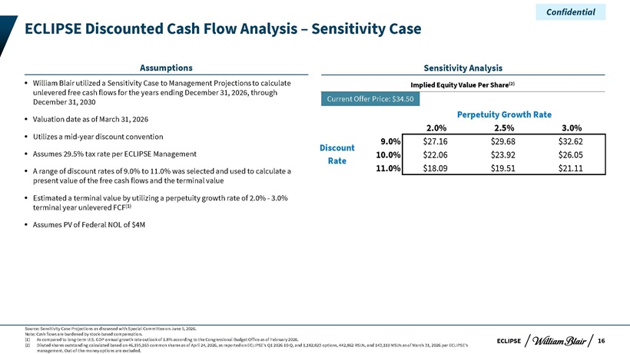
Confidential ECLIPSE Discounted Cash Flow Analysis – Sensitivity Case Assumptions Sensitivity Analysis ? William Blair utilized a Sensitivity Case to Management Projections to calculate Implied Equity Value Per Share(2) unlevered free cash flows for the years ending December 31, 2026, through December 31, 2030 Current Offer Price: $34.50 Perpetuity Growth Rate ? Valuation date as of March 31, 2026 2.0% 2.5% 3.0% ? Utilizes a mid-year discount convention 9.0% $27.16 $29.68 $32.62 Discount ? Assumes 29.5% tax rate per ECLIPSE Management 10.0% $22.06 $23.92 $26.05 Rate ? A range of discount rates of 9.0% to 11.0% was selected and used to calculate a 11.0% $18.09 $19.51 $21.11 present value of the free cash flows and the terminal value ? Estimated a terminal value by utilizing a perpetuity growth rate of 2.0%—3.0% terminal year unlevered FCF(1) ? Assumes PV of Federal NOL of $4M Source: Sensitivity Case Projections as discussed with Special Committee on June 5, 2026. Note: Cash flows are burdened by stock-based compensation. (1) As compared to long-term U.S. GDP annual growth rate outlook of 1.8% according to the Congressional Budget Office as of February 2026. ECLIPSE 16 (2) Diluted shares outstanding calculated based on 46,195,165 common shares as of April 24, 2026, as reported on ECLIPSE’s Q1 2026 10-Q, and 1,182,823 options, 442,862 RSUs, and 143,110 MSUs as of March 31, 2026 per ECLIPSE’s management. Out-of-the-money options are excluded.

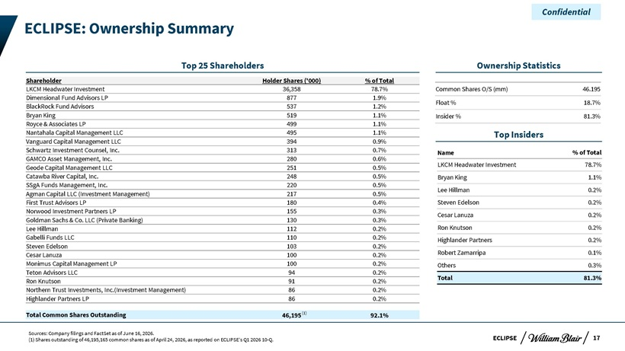
Confidential ECLIPSE: Ownership Summary Top 25 Shareholders Ownership Statistics Shareholder Holder Shares (‘000) % of Total LKCM Headwater Investment 36,358 78.7% Common Shares O/S (mm) 46.195 Dimensional Fund Advisors LP 877 1.9% Float % 18.7% BlackRock Fund Advisors 537 1.2% Bryan King 519 1.1% Insider % 81.3% Royce & Associates LP 499 1.1% Nantahala Capital Management LLC 495 1.1% Top Insiders Vanguard Capital Management LLC 394 0.9% Schwartz Investment Counsel, Inc. 313 0.7% Name % of Total GAMCO Asset Management, Inc. 280 0.6% Geode Capital Management LLC 251 0.5% LKCM Headwater Investment 78.7% Catawba River Capital, Inc. 248 0.5% Bryan King 1.1% SSgA Funds Management, Inc. 220 0.5% Lee Hillman 0.2% Agman Capital LLC (Investment Management) 217 0.5% First Trust Advisors LP 180 0.4% Steven Edelson 0.2% Norwood Investment Partners LP 155 0.3% Cesar Lanuza 0.2% Goldman Sachs & Co. LLC (Private Banking) 130 0.3% Lee Hillman 112 0.2% Ron Knutson 0.2% Gabelli Funds LLC 110 0.2% Highlander Partners 0.2% Steven Edelson 103 0.2% Robert Zamarripa 0.1% Cesar Lanuza 100 0.2% Monimus Capital Management LP 100 0.2% Others 0.3% Teton Advisors LLC 94 0.2% Total 81.3% Ron Knutson 91 0.2% Northern Trust Investments, Inc.(Investment Management) 86 0.2% Highlander Partners LP 86 0.2% Total Common Shares Outstanding 46,195 (1) 92.1% Sources: Company filings and FactSet as of June 16, 2026. (1) Shares outstanding of 46,195,165 common shares as of April 24, 2026, as reported on ECLIPSE’s Q1 2026 10-Q. ECLIPSE 17
Exhibit (c)(viii)

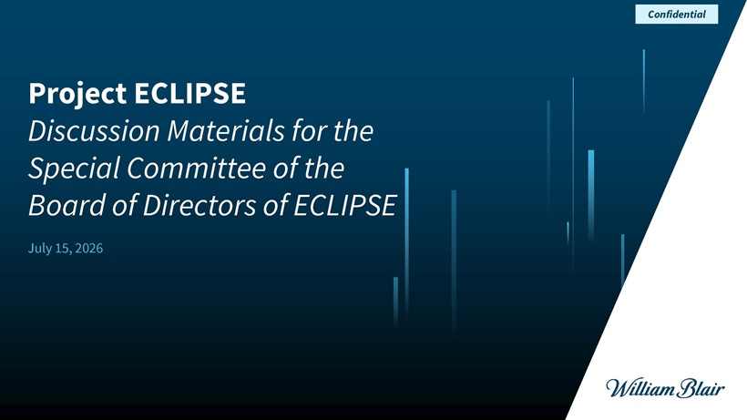
Confidential Project ECLIPSE Discussion Materials for the Special Committee of the Board of Directors of ECLIPSE July 15, 2026

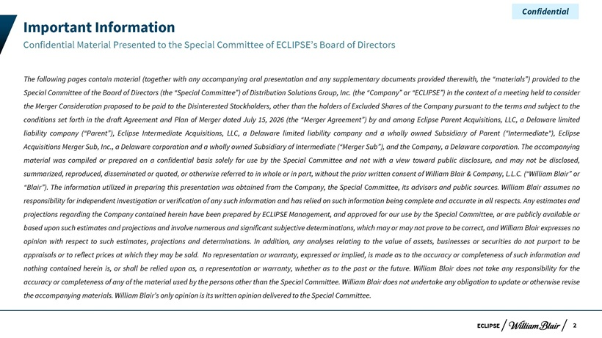
Confidential Important Information Confidential Material Presented to the Special Committee of ECLIPSE’s Board of Directors The following pages contain material (together with any accompanying oral presentation and any supplementary documents provided therewith, the “materials”) provided to the Special Committee of the Board of Directors (the “Special Committee”) of Distribution Solutions Group, Inc. (the “Company” or “ECLIPSE”) in the context of a meeting held to consider the Merger Consideration proposed to be paid to the Disinterested Stockholders, other than the holders of Excluded Shares of the Company pursuant to the terms and subject to the conditions set forth in the draft Agreement and Plan of Merger dated July 15, 2026 (the “Merger Agreement”) by and among Eclipse Parent Acquisitions, LLC, a Delaware limited liability company (“Parent”), Eclipse Intermediate Acquisitions, LLC, a Delaware limited liability company and a wholly owned Subsidiary of Parent (“Intermediate”), Eclipse Acquisitions Merger Sub, Inc., a Delaware corporation and a wholly owned Subsidiary of Intermediate (“Merger Sub”), and the Company, a Delaware corporation. The accompanying material was compiled or prepared on a confidential basis solely for use by the Special Committee and not with a view toward public disclosure, and may not be disclosed, summarized, reproduced, disseminated or quoted, or otherwise referred to in whole or in part, without the prior written consent of William Blair & Company, L.L.C. (“William Blair” or “Blair”). The information utilized in preparing this presentation was obtained from the Company, the Special Committee, its advisors and public sources. William Blair assumes no responsibility for independent investigation or verification of any such information and has relied on such information being complete and accurate in all respects. Any estimates and projections regarding the Company contained herein have been prepared by ECLIPSE Management, and approved for our use by the Special Committee, or are publicly available or based upon such estimates and projections and involve numerous and significant subjective determinations, which may or may not prove to be correct, and William Blair expresses no opinion with respect to such estimates, projections and determinations. In addition, any analyses relating to the value of assets, businesses or securities do not purport to be appraisals or to reflect prices at which they may be sold. No representation or warranty, expressed or implied, is made as to the accuracy or completeness of such information and nothing contained herein is, or shall be relied upon as, a representation or warranty, whether as to the past or the future. William Blair does not take any responsibility for the accuracy or completeness of any of the material used by the persons other than the Special Committee. William Blair does not undertake any obligation to update or otherwise revise the accompanying materials. William Blair’s only opinion is its written opinion delivered to the Special Committee. ECLIPSE 2

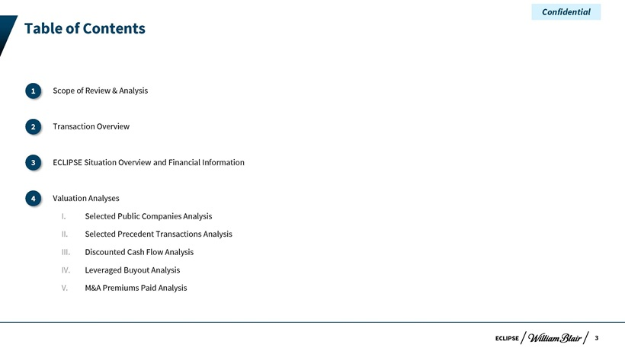
Confidential Table of Contents I1 . Scope of Review & Analysis II 2. Transaction Overview I3 . ECLIPSE Situation Overview and Financial Information II 4. Valuation Analyses I. Selected Public Companies Analysis II. Selected Precedent Transactions Analysis III. Discounted Cash Flow Analysis IV. Leveraged Buyout Analysis V. M&A Premiums Paid Analysis ECLIPSE 3


Confidential Scope of Review & Analysis

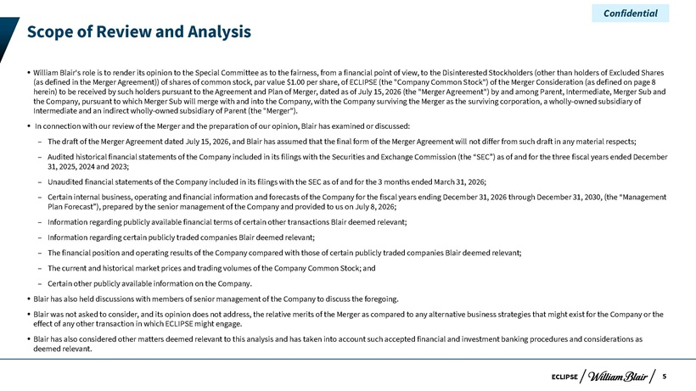
Confidential Scope of Review and Analysis ? William Blair’s role is to render its opinion to the Special Committee as to the fairness, from a financial point of view, to the Disinterested Stockholders (other than holders of Excluded Shares (as defined in the Merger Agreement)) of shares of common stock, par value $1.00 per share, of ECLIPSE (the “Company Common Stock”) of the Merger Consideration (as defined on page 8 herein) to be received by such holders pursuant to the Agreement and Plan of Merger, dated as of July 15, 2026 (the “Merger Agreement”) by and among Parent, Intermediate, Merger Sub and the Company, pursuant to which Merger Sub will merge with and into the Company, with the Company surviving the Merger as the surviving corporation, a wholly-owned subsidiary of Intermediate and an indirect wholly-owned subsidiary of Parent (the “Merger”). ? In connection with our review of the Merger and the preparation of our opinion, Blair has examined or discussed: ? The draft of the Merger Agreement dated July 15, 2026, and Blair has assumed that the final form of the Merger Agreement will not differ from such draft in any material respects; ? Audited historical financial statements of the Company included in its filings with the Securities and Exchange Commission (the “SEC”) as of and for the three fiscal years ended December 31, 2025, 2024 and 2023; ? Unaudited financial statements of the Company included in its filings with the SEC as of and for the 3 months ended March 31, 2026; ? Certain internal business, operating and financial information and forecasts of the Company for the fiscal years ending December 31, 2026 through December 31, 2030, (the “Management Plan Forecast”), prepared by the senior management of the Company and provided to us on July 8, 2026; ? Information regarding publicly available financial terms of certain other transactions Blair deemed relevant; ? Information regarding certain publicly traded companies Blair deemed relevant; ? The financial position and operating results of the Company compared with those of certain publicly traded companies Blair deemed relevant; ? The current and historical market prices and trading volumes of the Company Common Stock; and ? Certain other publicly available information on the Company. ? Blair has also held discussions with members of senior management of the Company to discuss the foregoing. ? Blair was not asked to consider, and its opinion does not address, the relative merits of the Merger as compared to any alternative business strategies that might exist for the Company or the effect of any other transaction in which ECLIPSE might engage. ? Blair has also considered other matters deemed relevant to this analysis and has taken into account such accepted financial and investment banking procedures and considerations as deemed relevant. ECLIPSE 5

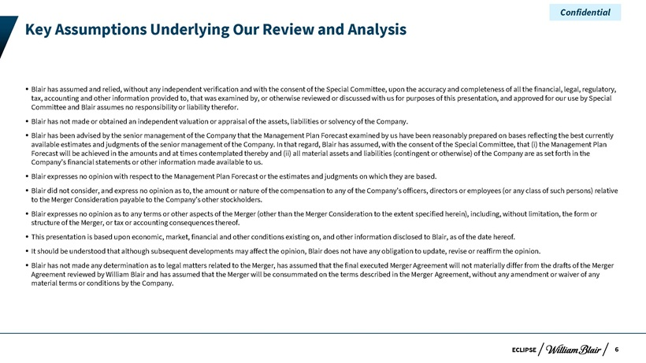
Confidential Key Assumptions Underlying Our Review and Analysis ? Blair has assumed and relied, without any independent verification and with the consent of the Special Committee, upon the accuracy and completeness of all the financial, legal, regulatory, tax, accounting and other information provided to, that was examined by, or otherwise reviewed or discussed with us for purposes of this presentation, and approved for our use by Special Committee and Blair assumes no responsibility or liability therefor. ? Blair has not made or obtained an independent valuation or appraisal of the assets, liabilities or solvency of the Company. ? Blair has been advised by the senior management of the Company that the Management Plan Forecast examined by us have been reasonably prepared on bases reflecting the best currently available estimates and judgments of the senior management of the Company. In that regard, Blair has assumed, with the consent of the Special Committee, that (i) the Management Plan Forecast will be achieved in the amounts and at times contemplated thereby and (ii) all material assets and liabilities (contingent or otherwise) of the Company are as set forth in the Company’s financial statements or other information made available to us. ? Blair expresses no opinion with respect to the Management Plan Forecast or the estimates and judgments on which they are based. ? Blair did not consider, and express no opinion as to, the amount or nature of the compensation to any of the Company’s officers, directors or employees (or any class of such persons) relative to the Merger Consideration payable to the Company’s other stockholders. ? Blair expresses no opinion as to any terms or other aspects of the Merger (other than the Merger Consideration to the extent specified herein), including, without limitation, the form or structure of the Merger, or tax or accounting consequences thereof. ? This presentation is based upon economic, market, financial and other conditions existing on, and other information disclosed to Blair, as of the date hereof.? It should be understood that although subsequent developments may affect the opinion, Blair does not have any obligation to update, revise or reaffirm the opinion. ? Blair has not made any determination as to legal matters related to the Merger, has assumed that the final executed Merger Agreement will not materially differ from the drafts of the Merger Agreement reviewed by William Blair and has assumed that the Merger will be consummated on the terms described in the Merger Agreement, without any amendment or waiver of any material terms or conditions by the Company. ECLIPSE 6

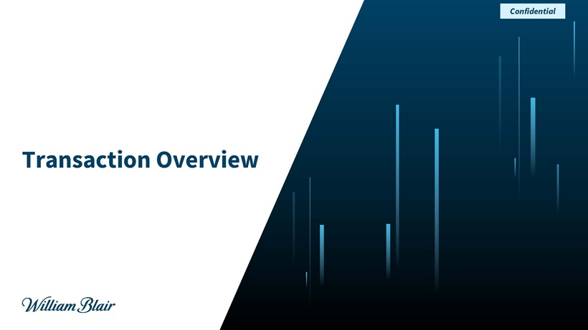
Confidential Transaction Overview

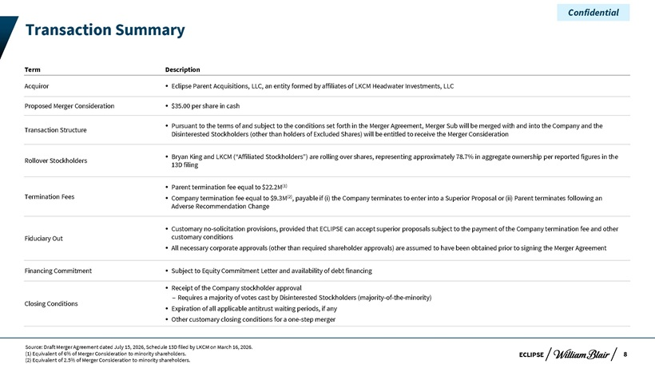
Confidential Transaction Summary Term Description Acquiror? Eclipse Parent Acquisitions, LLC, an entity formed by affiliates of LKCM Headwater Investments, LLC Proposed Merger Consideration? $35.00 per share in cash ? Pursuant to the terms of and subject to the conditions set forth in the Merger Agreement, Merger Sub will be merged with and into the Company and the Transaction Structure Disinterested Stockholders (other than holders of Excluded Shares) will be entitled to receive the Merger Consideration ? Bryan King and LKCM (“Affiliated Stockholders”) are rolling over shares, representing approximately 78.7% in aggregate ownership per reported figures in the Rollover Stockholders 13D filing ? Parent termination fee equal to $22.2M(1) Termination Fees? Company termination fee equal to $9.3M(2), payable if (i) the Company terminates to enter into a Superior Proposal or (ii) Parent terminates following an Adverse Recommendation Change ? Customary no-solicitation provisions, provided that ECLIPSE can accept superior proposals subject to the payment of the Company termination fee and other Fiduciary Out customary conditions? All necessary corporate approvals (other than required shareholder approvals) are assumed to have been obtained prior to signing the Merger Agreement Financing Commitment? Subject to Equity Commitment Letter and availability of debt financing ? Receipt of the Company stockholder approval – Requires a majority of votes cast by Disinterested Stockholders (majority-of-the-minority) Closing Conditions? Expiration of all applicable antitrust waiting periods, if any? Other customary closing conditions for a one-step merger Source: Draft Merger Agreement dated July 15, 2026, Schedule 13D filed by LKCM on March 16, 2026. (1) Equivalent of 6% of Merger Consideration to minority shareholders. ECLIPSE 8 (2) Equivalent of 2.5% of Merger Consideration to minority shareholders.

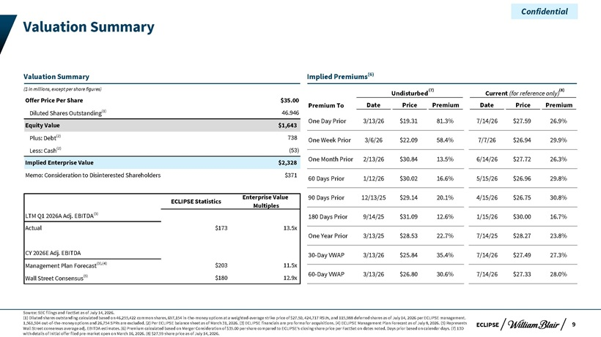
Confidential Valuation Summary Valuation Summary Implied Premiums(6) ($ in millions, except per share figures) (7) (8) Undisturbed Current (for reference only) Offer Price Per Share $35.00 Premium To Date Price Premium Date Price Premium Diluted Shares Outstanding(1) 46.946 One Day Prior 3/13/26 $19.31 81.3% 7/14/26 $27.59 26.9% Equity Value $1,643 Plus: Debt(2) 738 One Week Prior 3/6/26 $22.09 58.4% 7/7/26 $26.94 29.9% Less: Cash(2) (53) One Month Prior 2/13/26 $30.84 13.5% 6/14/26 $27.72 26.3% Implied Enterprise Value $2,328 Memo: Consideration to Disinterested Shareholders $371 60 Days Prior 1/12/26 $30.02 16.6% 5/15/26 $26.96 29.8% Enterprise Value 90 Days Prior 12/13/25 $29.14 20.1% 4/15/26 $26.75 30.8% ECLIPSE Statistics Multiples LTM Q1 2026A Adj. EBITDA(3) 180 Days Prior 9/14/25 $31.09 12.6% 1/15/26 $30.00 16.7% Actual $173 13.5x One Year Prior 3/13/25 $28.53 22.7% 7/14/25 $28.27 23.8% CY 2026E Adj. EBITDA 30-Day VWAP 3/13/26 $25.84 35.4% 7/14/26 $27.49 27.3% Management Plan Forecast(3),(4) $203 11.5x (5) 60-Day VWAP 3/13/26 $26.80 30.6% 7/14/26 $27.33 28.0% Wall Street Consensus $180 12.9x Source: SEC filings and FactSet as of July 14, 2026. (1) Diluted shares outstanding calculated based on 46,255,422 common shares, 697,154 in-the-money options at a weighted-average strike price of $27.50, 424,717 RSUs, and 115,988 deferred shares as of July 14, 2026 per ECLIPSE management. 1,561,504 out-of-the-money options and 26,754 SPRs are excluded. (2) Per ECLIPSE balance sheet as of March 31, 2026. (3) ECLIPSE financials are pro forma for acquisitions. (4) ECLIPSE Management Plan Forecast as of July 8, 2026. (5) Represents ECLIPSE 9 Wall Street consensus average adj. EBITDA estimates. (6) Premium calculated based on Merger Consideration of $35.00 per share compared to ECLIPSE’s closing share price per FactSet on dates noted. Days prior based on calendar days. (7) 13D with details of initial offer filed pre-market open on March 16, 2026. (8) $27.59 share price as of July 14, 2026.

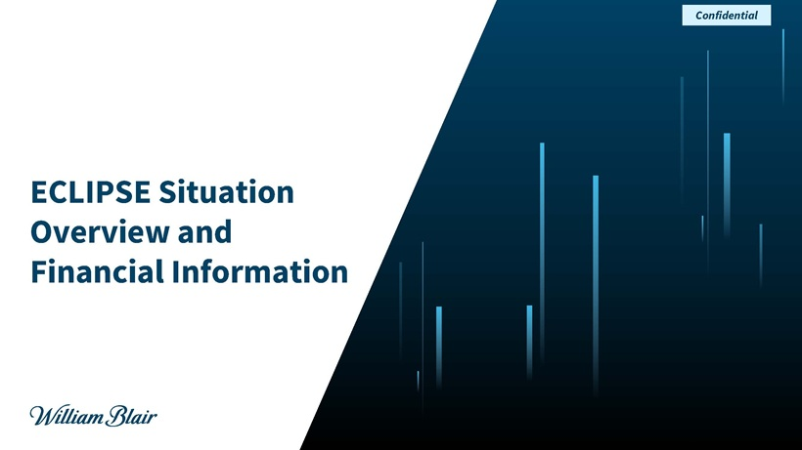
Confidential ECLIPSE Situation Overview and Financial Information

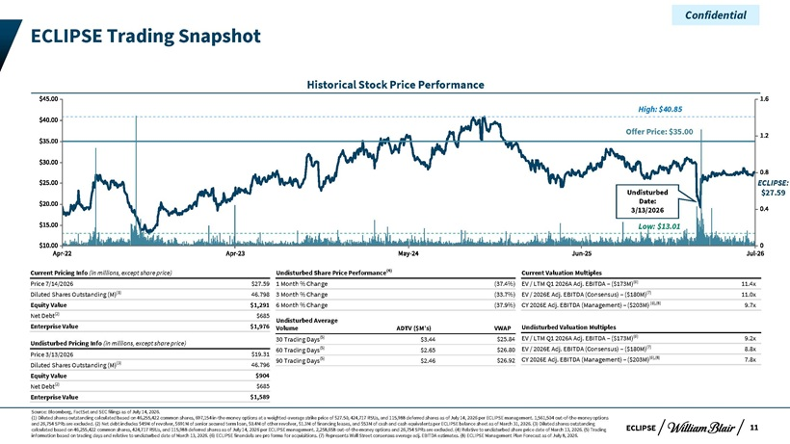
Confidential ECLIPSE Trading Snapshot Historical Stock Price Performance High: $40.85 Offer Price: $35.00 ECLIPSE: Undisturbed $27.59 Date: 3/13/2026 Low: $13.01 Current Pricing Info (in millions, except share price) Undisturbed Share Price Performance(4) Current Valuation Multiples Price 7/14/2026 $27.59 1 Month % Change (37.4%) EV / LTM Q1 2026A Adj. EBITDA – ($173M)(6) 11.4x Diluted Shares Outstanding (M)(1) 46.798 3 Month % Change (33.7%) EV / 2026E Adj. EBITDA (Consensus) – ($180M)(7) 11.0x Equity Value $1,291 6 Month % Change (37.9%) CY 2026E Adj. EBITDA (Management) – ($203M) (6),(8) 9.7x Net Debt(2) $685 Undisturbed Average Enterprise Value $1,976 Volume ADTV ($M’s) VWAP Undisturbed Valuation Multiples 30 Trading Days(5) $3.44 $25.84 EV / LTM Q1 2026A Adj. EBITDA – ($173M)(6) 9.2x Undisturbed Pricing Info (in millions, except share price) 60 Trading Days(5) $2.65 $26.80 EV / 2026E Adj. EBITDA (Consensus) – ($180M)(7) 8.8x Price 3/13/2026 $19.31 90 Trading Days(5) $2.46 $26.92 CY 2026E Adj. EBITDA (Management) – ($203M)(6),(8) 7.8x Diluted Shares Outstanding (M)(3) 46.796 Equity Value $904 Net Debt(2) $685 Enterprise Value $1,589 Source: Bloomberg, FactSet and SEC filings as of July 14, 2026. (1) Diluted shares outstanding calculated based on 46,255,422 common shares, 697,154 in-the-money options at a weighted-average strike price of $27.50, 424,717 RSUs, and 115,988 deferred shares as of July 14, 2026 per ECLIPSE management. 1,561,504 out-of-the-money options and 26,754 SPRs are excluded. (2) Net debt includes $45M of revolver, $691M of senior secured term loan, $0.4M of other revolver, $1.3M of financing leases, and $53M of cash and cash equivalents per ECLIPSE balance sheet as of March 31, 2026. (3) Diluted shares outstanding ECLIPSE 11 calculated based on 46,255,422 common shares, 424,717 RSUs, and 115,988 deferred shares as of July 14, 2026 per ECLIPSE management. 2,258,658 out-of-the-money options and 26,754 SPRs are excluded. (4) Relative to undisturbed share price date of March 13, 2026. (5) Trading information based on trading days and relative to undisturbed date of March 13, 2026. (6) ECLIPSE financials are pro forma for acquisitions. (7) Represents Wall Street consensus average adj. EBITDA estimates. (8) ECLIPSE Management Plan Forecast as of July 8, 2026.

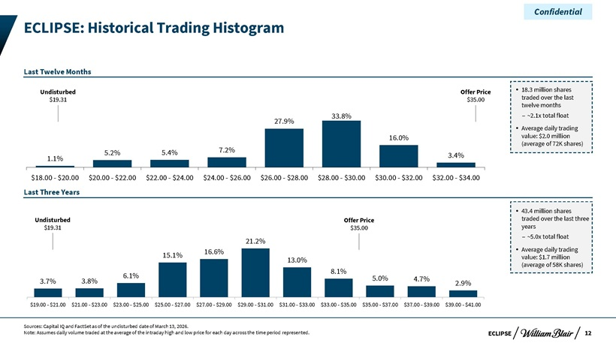
Confidential ECLIPSE: Historical Trading Histogram Last Twelve Months Undisturbed Offer Price? 18.3 million shares $19.31 $35.00 traded over the last twelve months 33.8% – ~2.1x total float 27.9% ? Average daily trading 16.0% value: $2.0 million (average of 72K shares) 5.2% 5.4% 7.2% 1.1% 3.4% $18.00—$20.00 $20.00—$22.00 $22.00—$24.00 $24.00—$26.00 $26.00—$28.00 $28.00—$30.00 $30.00—$32.00 $32.00—$34.00 Last Three Years ? 43.4 million shares Undisturbed Offer Price traded over the last three $19.31 $35.00 years – ~5.0x total float 21.2% 16.6%? Average daily trading 15.1% value: $1.7 million 13.0% (average of 58K shares) 8.1% 6.1% 5.0% 4.7% 3.7% 3.8% 2.9% $19.00—$21.00 $21.00—$23.00 $23.00—$25.00 $25.00—$27.00 $27.00—$29.00 $29.00—$31.00 $31.00—$33.00 $33.00—$35.00 $35.00—$37.00 $37.00—$39.00 $39.00—$41.00 Sources: Capital IQ and FactSet as of the undisturbed date of March 13, 2026. Note: Assumes daily volume traded at the average of the intraday high and low price for each day across the time period represented. ECLIPSE 12

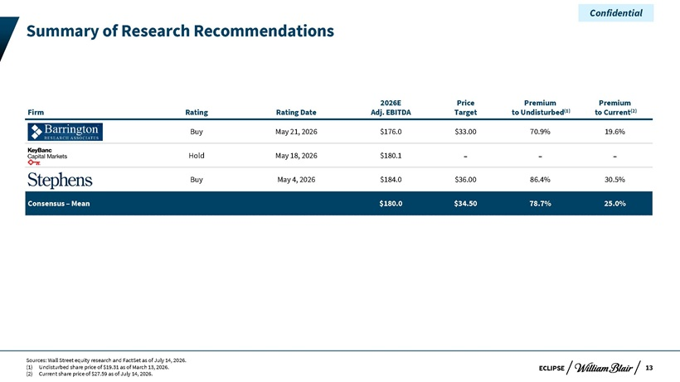
Confidential Summary of Research Recommendations 2026E Price Premium Premium Firm Rating Rating Date Adj. EBITDA Target to Undisturbed(1) to Current(2) Buy May 21, 2026 $176.0 $33.00 70.9% 19.6% Hold May 18, 2026 $180.1 — -Buy May 4, 2026 $184.0 $36.00 86.4% 30.5% Consensus – Mean $180.0 $34.50 78.7% 25.0% Sources: Wall Street equity research and FactSet as of July 14, 2026. (1) Undisturbed share price of $19.31 as of March 13, 2026. ECLIPSE 13 (2) Current share price of $27.59 as of July 14, 2026.

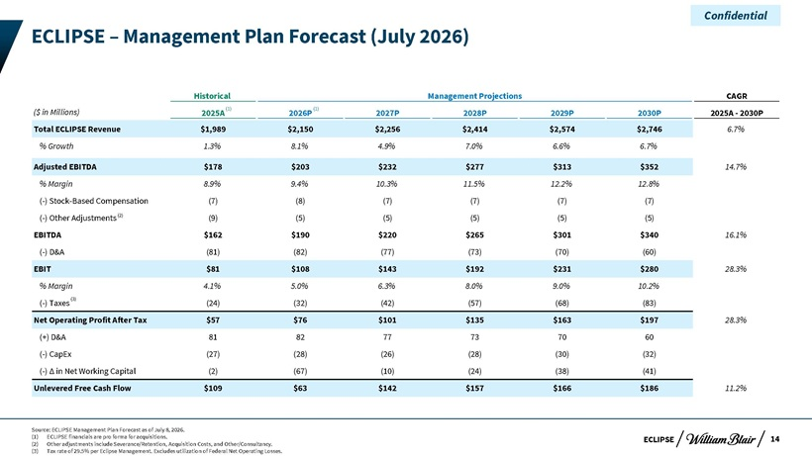
Confidential ECLIPSE – Management Plan Forecast (July 2026) Historical Management Projections CAGR ($ in Millions) 2025A(1) 2026P(1) 2027P 2028P 2029P 2030P 2025A—2030P Total ECLIPSE Revenue $1,989 $2,150 $2,256 $2,414 $2,574 $2,746 6.7% % Growth 1.3% 8.1% 4.9% 7.0% 6.6% 6.7% Adjusted EBITDA $178 $203 $232 $277 $313 $352 14.7% % Margin 8.9% 9.4% 10.3% 11.5% 12.2% 12.8% (-) Stock-Based Compensation (7) (8) (7) (7) (7) (7) (-) Other Adjustments(2) (9) (5) (5) (5) (5) (5) EBITDA $162 $190 $220 $265 $301 $340 16.1% (-) D&A (81) (82) (77) (73) (70) (60) EBIT $81 $108 $143 $192 $231 $280 28.3% % Margin 4.1% 5.0% 6.3% 8.0% 9.0% 10.2% (-) Taxes(3) (24) (32) (42) (57) (68) (83) Net Operating Profit After Tax $57 $76 $101 $135 $163 $197 28.3% (+) D&A 81 82 77 73 70 60 (-) CapEx (27) (28) (26) (28) (30) (32) (-) Ä in Net Working Capital (2) (67) (10) (24) (38) (41) Unlevered Free Cash Flow $109 $63 $142 $157 $166 $186 11.2% Source: ECLIPSE Management Plan Forecast as of July 8, 2026. (1) ECLIPSE financials are pro forma for acquisitions. ECLIPSE 14 (2) Other adjustments include Severance/Retention, Acquisition Costs, and Other/Consultancy. (3) Tax rate of 29.5% per Eclipse Management. Excludes utilization of Federal Net Operating Losses.

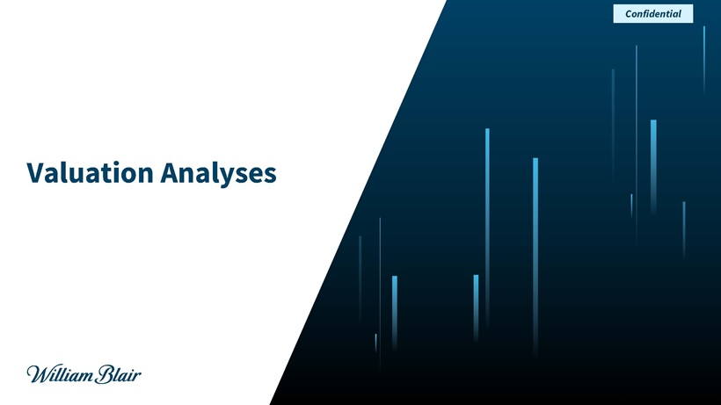
Confidential Valuation Analyses

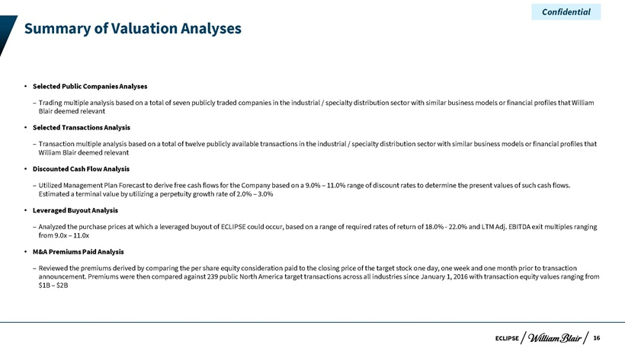
Confidential Summary of Valuation Analyses  Selected Public Companies Analyses – Trading multiple analysis based on a total of seven publicly traded companies in the industrial / specialty distribution sector with similar business models or financial profiles that William Blair deemed relevant  Selected Transactions Analysis – Transaction multiple analysis based on a total of twelve publicly available transactions in the industrial / specialty distribution sector with similar business models or financial profiles that William Blair deemed relevant  Discounted Cash Flow Analysis – Utilized Management Plan Forecast to derive free cash flows for the Company based on a 9.0% – 11.0% range of discount rates to determine the present values of such cash flows. Estimated a terminal value by utilizing a perpetuity growth rate of 2.0% – 3.0%  Leveraged Buyout Analysis – Analyzed the purchase prices at which a leveraged buyout of ECLIPSE could occur, based on a range of required rates of return of 18.0%—22.0% and LTM Adj. EBITDA exit multiples ranging from 9.0x – 11.0x  M&A Premiums Paid Analysis – Reviewed the premiums derived by comparing the per share equity consideration paid to the closing price of the target stock one day, one week and one month prior to transaction announcement. Premiums were then compared against 239 public North America target transactions across all industries since January 1, 2016 with transaction equity values ranging from $1B – $2B ECLIPSE 16

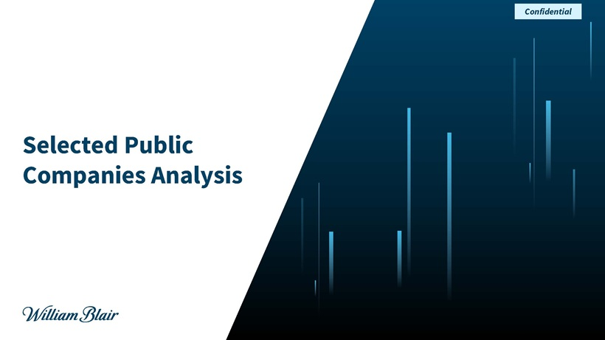
Confidential Selected Public Companies Analysis

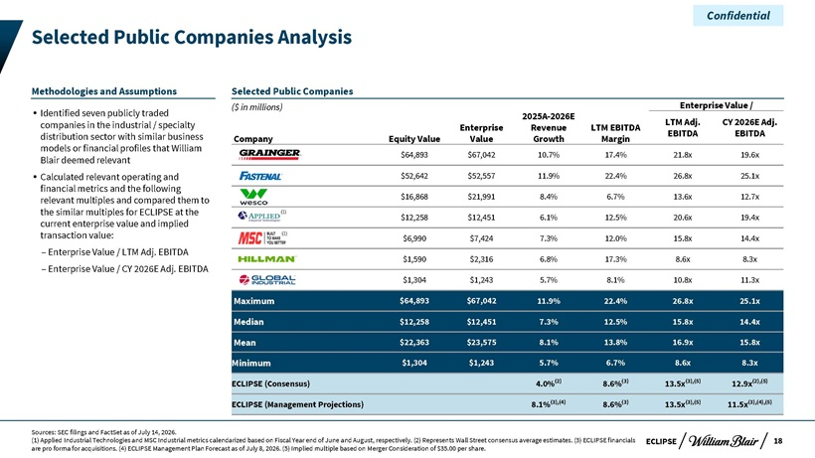
Confidential Selected Public Companies Analysis Methodologies and Assumptions Selected Public Companies ($ in millions) Enterprise Value / ? Identified seven publicly traded 2025A-2026E LTM Adj. CY 2026E Adj. companies in the industrial / specialty Enterprise Revenue LTM EBITDA distribution sector with similar business EBITDA EBITDA models or financial profiles that William Company Equity Value Value Growth Margin $64,893 $67,042 10.7% 17.4% 21.8x 19.6x Blair deemed relevant ? Calculated relevant operating and $52,642 $52,557 11.9% 22.4% 26.8x 25.1x financial metrics and the following relevant multiples and compared them to $16,868 $21,991 8.4% 6.7% 13.6x 12.7x the similar multiples for ECLIPSE at the (1) $12,258 $12,451 6.1% 12.5% 20.6x 19.4x current enterprise value and implied transaction value: (1) $6,990 $7,424 7.3% 12.0% 15.8x 14.4x – Enterprise Value / LTM Adj. EBITDA $1,590 $2,316 6.8% 17.3% 8.6x 8.3x – Enterprise Value / CY 2026E Adj. EBITDA $1,304 $1,243 5.7% 8.1% 10.8x 11.3x Maximum $64,893 $67,042 11.9% 22.4% 26.8x 25.1x Median $12,258 $12,451 7.3% 12.5% 15.8x 14.4x Mean $22,363 $23,575 8.1% 13.8% 16.9x 15.8x Minimum $1,304 $1,243 5.7% 6.7% 8.6x 8.3x ECLIPSE (Consensus) 4.0%(2) 8.6%(3) 13.5x(3),(5) 12.9x(2),(5) ECLIPSE (Management Projections) 8.1%(3),(4) 8.6%(3) 13.5x(3),(5) 11.5x(3),(4),(5) Sources: SEC filings and FactSet as of July 14, 2026. (1) Applied Industrial Technologies and MSC Industrial metrics calendarized based on Fiscal Year end of June and August, respectively. (2) Represents Wall Street consensus average estimates. (3) ECLIPSE financials ECLIPSE 18 are pro forma for acquisitions. (4) ECLIPSE Management Plan Forecast as of July 8, 2026. (5) Implied multiple based on Merger Consideration of $35.00 per share.

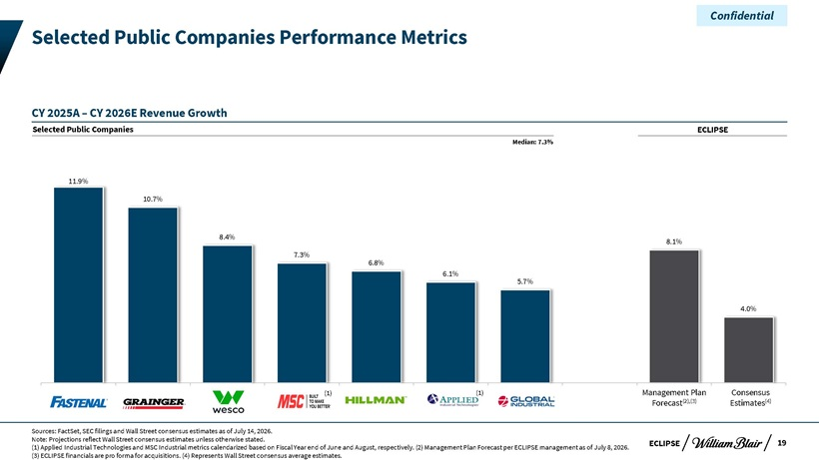
Confidential Selected Public Companies Performance Metrics CY 2025A – CY 2026E Revenue Growth Selected Public Companies ECLIPSE Median: 7.3% 11.9% 10.7% 8.4% 8.1% 7.3% 6.8% 6.1% 5.7% 4.0% (1) (1) Management Plan Consensus Forecast(2),(3) Estimates(4) Sources: FactSet, SEC filings and Wall Street consensus estimates as of July 14, 2026. Note: Projections reflect Wall Street consensus estimates unless otherwise stated. ECLIPSE 19 (1) Applied Industrial Technologies and MSC Industrial metrics calendarized based on Fiscal Year end of June and August, respectively. (2) Management Plan Forecast per ECLIPSE management as of July 8, 2026. (3) ECLIPSE financials are pro forma for acquisitions. (4) Represents Wall Street consensus average estimates.

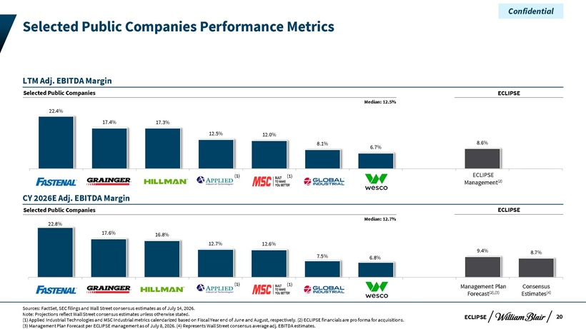
Confidential Selected Public Companies Performance Metrics LTM Adj. EBITDA Margin Selected Public Companies ECLIPSE Median: 12.5% 22.4% 17.4% 17.3% 12.5% 12.0% 8.1% 8.6% 6.7% (1) (1) ECLIPSE Management(2) CY 2026E Adj. EBITDA Margin Selected Public Companies ECLIPSE Median: 12.7% 22.8% 17.6% 16.8% 12.7% 12.6% 7.5% 9.4% 8.7% 6.8% (1) (1) Management Plan Consensus Forecast(2),(3) Estimates(4) Sources: FactSet, SEC filings and Wall Street consensus estimates as of July 14, 2026. Note: Projections reflect Wall Street consensus estimates unless otherwise stated. ECLIPSE 20 (1) Applied Industrial Technologies and MSC Industrial metrics calendarized based on Fiscal Year end of June and August, respectively. (2) ECLIPSE financials are pro forma for acquisitions. (3) Management Plan Forecast per ECLIPSE management as of July 8, 2026. (4) Represents Wall Street consensus average adj. EBITDA estimates.

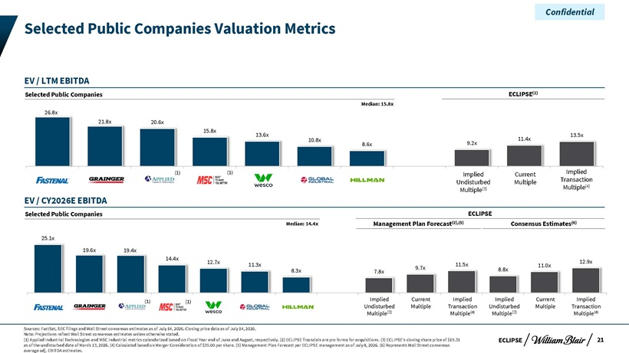
Confidential Selected Public Companies Valuation Metrics EV / LTM EBITDA Selected Public Companies ECLIPSE(2) Median: 15.8x 26.8x 21.8x 20.6x 15.8x 13.6x 13.5x 10.8x 11.4x 8.6x 9.2x (1) (1) Implied Current Implied Undisturbed Multiple Transaction Multiple(4) Multiple(3) EV / CY2026E EBITDA Selected Public Companies ECLIPSE Median: 14.4x Management Plan Forecast(2),(5) Consensus Estimates(6) 25.1x 19.6x 19.4x 14.4x 12.7x 11.5x 12.9x 11.3x 11.0x 8.3x 9.7x 8.8x 7.8x (1) (1) Implied Current Implied Implied Current Implied Undisturbed Multiple Transaction Undisturbed Multiple Transaction Multiple(3) Multiple(4) Multiple(3) Multiple(4) Sources: FactSet, SEC filings and Wall Street consensus estimates as of July 14, 2026. Closing price data as of July 14, 2026. Note: Projections reflect Wall Street consensus estimates unless otherwise stated. (1) Applied Industrial Technologies and MSC Industrial metrics calendarized based on Fiscal Year end of June and August, respectively. (2) ECLIPSE financials are pro forma for acquisitions. (3) ECLIPSE’s closing share price of $19.31 ECLIPSE 21 as of the undisturbed date of March 13, 2026. (4) Calculated based on Merger Consideration of $35.00 per share. (5) Management Plan Forecast per ECLIPSE management as of July 8, 2026. (6) Represents Wall Street consensus average adj. EBITDA estimates.

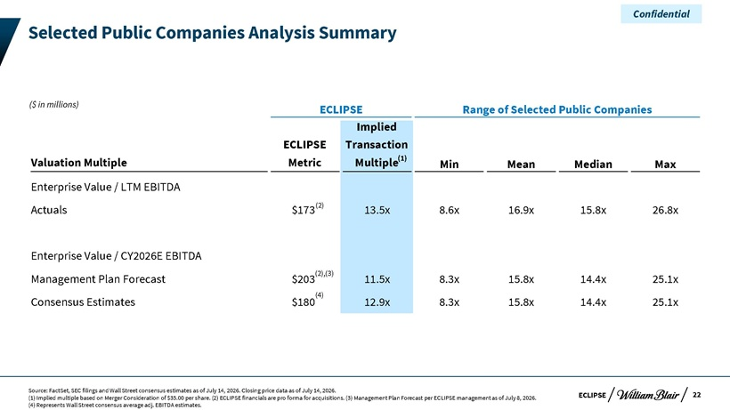
Confidential Selected Public Companies Analysis Summary ($ in millions) ECLIPSE Range of Selected Public Companies Implied ECLIPSE Transaction Valuation Multiple Metric Multiple(1) Min Mean Median Max Enterprise Value / LTM EBITDA Actuals $173(2) 13.5x 8.6x 16.9x 15.8x 26.8x Enterprise Value / CY2026E EBITDA Management Plan Forecast $203(2),(3) 11.5x 8.3x 15.8x 14.4x 25.1x (4) Consensus Estimates $180 12.9x 8.3x 15.8x 14.4x 25.1x Source: FactSet, SEC filings and Wall Street consensus estimates as of July 14, 2026. Closing price data as of July 14, 2026. (1) Implied multiple based on Merger Consideration of $35.00 per share. (2) ECLIPSE financials are pro forma for acquisitions. (3) Management Plan Forecast per ECLIPSE management as of July 8, 2026. ECLIPSE 22 (4) Represents Wall Street consensus average adj. EBITDA estimates.

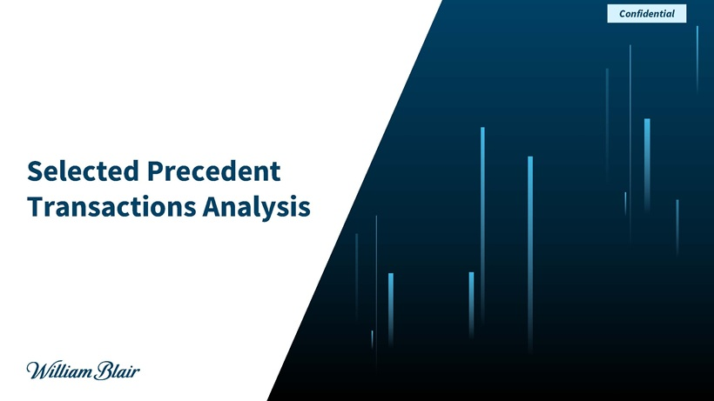
Confidential Selected Precedent Transactions Analysis

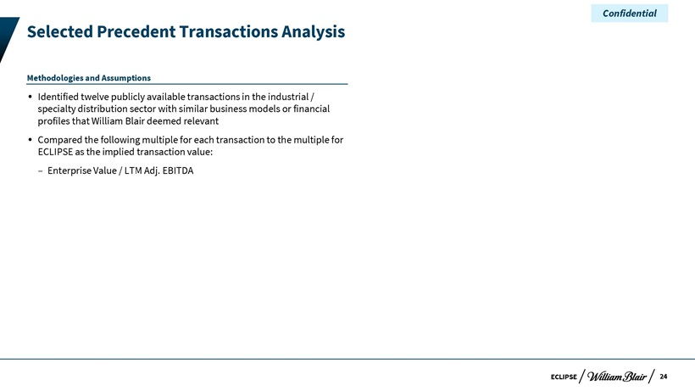
Confidential Selected Precedent Transactions Analysis Methodologies and Assumptions ? Identified twelve publicly available transactions in the industrial / specialty distribution sector with similar business models or financial profiles that William Blair deemed relevant? Compared the following multiple for each transaction to the multiple for ECLIPSE as the implied transaction value: – Enterprise Value / LTM Adj. EBITDA ECLIPSE 24

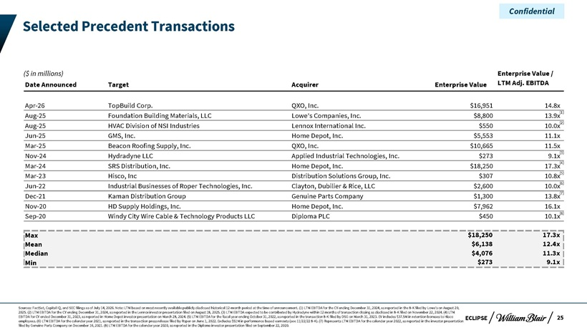
Confidential Selected Precedent Transactions ($ in millions) Enterprise Value / Date Announced Target Acquirer Enterprise Value LTM Adj. EBITDA Apr-26 TopBuild Corp. QXO, Inc. $16,951 14.8x Aug-25 Foundation Building Materials, LLC Lowe’s Companies, Inc. $8,800 13.9x(1) Aug-25 HVAC Division of NSI Industries Lennox International Inc. $550 10.0x(2) Jun-25 GMS, Inc. Home Depot, Inc. $5,553 11.1x Mar-25 Beacon Roofing Supply, Inc. QXO, Inc. $10,665 11.5x Nov-24 Hydradyne LLC Applied Industrial Technologies, Inc. $273 9.1x(3) Mar-24 SRS Distribution, Inc. Home Depot, Inc. $18,250 17.3x(4) Mar-23 Hisco, Inc Distribution Solutions Group, Inc. $307 10.8x(5) Jun-22 Industrial Businesses of Roper Technologies, Inc. Clayton, Dubilier & Rice, LLC $2,600 10.0x(6) Dec-21 Kaman Distribution Group Genuine Parts Company $1,300 13.8x(7) Nov-20 HD Supply Holdings, Inc. Home Depot, Inc. $7,962 16.1x Sep-20 Windy City Wire Cable & Technology Products LLC Diploma PLC $450 10.1x(8) Max $18,250 17.3x Mean $6,138 12.4x Median $4,076 11.3x Min $273 9.1x Sources: FactSet, Capital IQ, and SEC filings as of July 14, 2026. Note: LTM based on most recently available publicly disclosed historical 12-month period at the time of announcement. (1) LTM EBITDA for the CY ending December 31, 2024, as reported in the 8-K filed by Lowe’s on August 20, 2025. (2) LTM EBITDA for the CY ending December 31, 2024, as reported in the Lennox investor presentation filed on August 18, 2025. (3) LTM EBITDA expected to be contributed by Hydradyne within 12 months of transaction closing as disclosed in 8-K filed on November 22, 2024. (4) LTM EBITDA for CY ended December 31, 2023, as reported in Home Depot investor presentation on March 28, 2024. (5) LTM EBITDA for the fiscal year ending October 31, 2022, as reported in the transaction 8-K filed by DSG on March 31, 2023. EV includes $37.5M in retention bonuses to Hisco ECLIPSE 25 employees. (6) LTM EBITDA for the calendar year 2021, as reported in the transaction press release filed by Roper on June 1, 2022. Excludes $51M in performance based earnouts (see 11/22/22 8-K). (7) Represents LTM EBITDA for the calendar year 2022, as reported in the investor presentation filed by Genuine Parts Company on December 16, 2021. (8) LTM EBITDA for the calendar year 2020, as reported in the Diploma investor presentation filed on September 22, 2020.

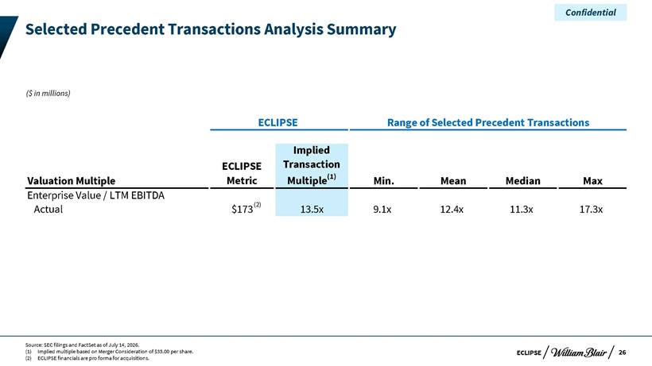
Confidential Selected Precedent Transactions Analysis Summary ($ in millions) ECLIPSE Range of Selected Precedent Transactions Implied ECLIPSE Transaction Valuation Multiple Metric Multiple(1) Min. Mean Median Max Enterprise Value / LTM EBITDA Actual $173(2) 13.5x 9.1x 12.4x 11.3x 17.3x Source: SEC filings and FactSet as of July 14, 2026. (1) Implied multiple based on Merger Consideration of $35.00 per share. ECLIPSE 26 (2) ECLIPSE financials are pro forma for acquisitions.

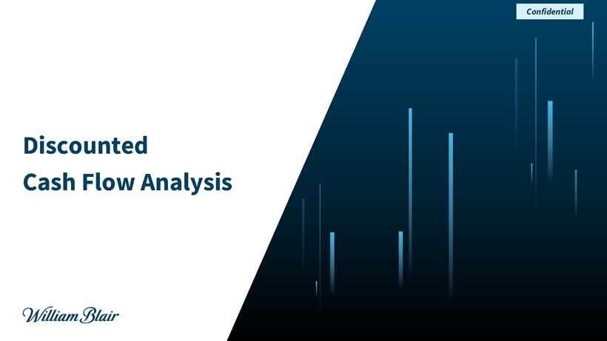
Confidential Discounted Cash Flow Analysis

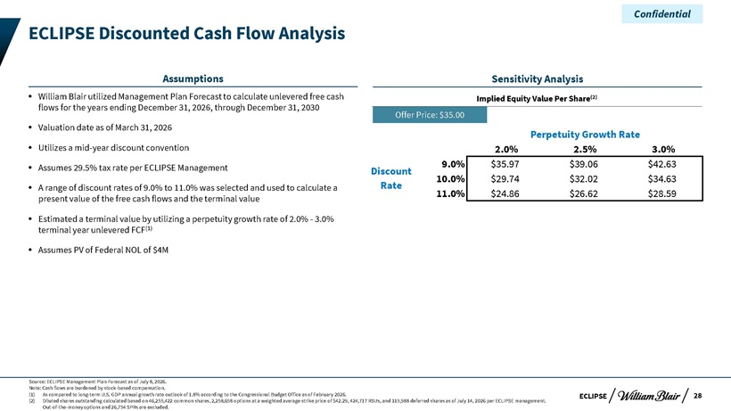
Confidential ECLIPSE Discounted Cash Flow Analysis Assumptions Sensitivity Analysis ? William Blair utilized Management Plan Forecast to calculate unlevered free cash Implied Equity Value Per Share(2) flows for the years ending December 31, 2026, through December 31, 2030 Offer Price: $35.00? Valuation date as of March 31, 2026 Perpetuity Growth Rate ? Utilizes a mid-year discount convention 2.0% 2.5% 3.0%? Assumes 29.5% tax rate per ECLIPSE Management 9.0% $35.97 $39.06 $42.63 Discount 10.0% $29.74 $32.02 $34.63 ? A range of discount rates of 9.0% to 11.0% was selected and used to calculate a Rate 11.0% $24.86 $26.62 $28.59 present value of the free cash flows and the terminal value? Estimated a terminal value by utilizing a perpetuity growth rate of 2.0%—3.0% terminal year unlevered FCF(1)? Assumes PV of Federal NOL of $4M Source: ECLIPSE Management Plan Forecast as of July 8, 2026. Note: Cash flows are burdened by stock-based compensation. (1) As compared to long-term U.S. GDP annual growth rate outlook of 1.8% according to the Congressional Budget Office as of February 2026. ECLIPSE 28 (2) Diluted shares outstanding calculated based on 46,255,422 common shares, 2,258,658 options at a weighted average strike price of $42.29, 424,717 RSUs, and 115,988 deferred shares as of July 14, 2026 per ECLIPSE management. Out-of-the-money options and 26,754 SPRs are excluded.

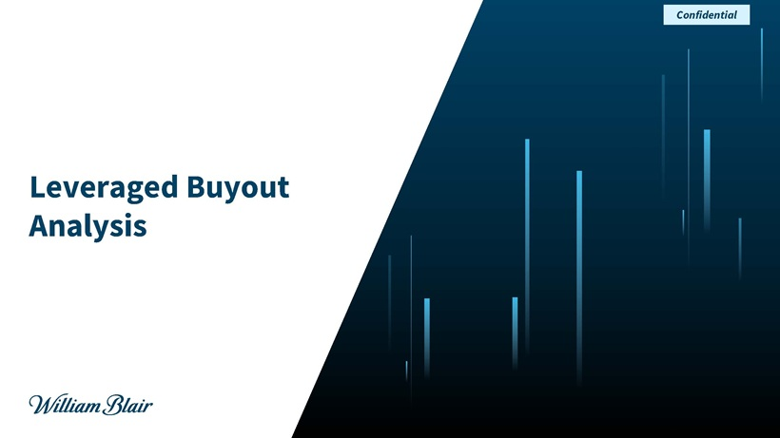
Confidential Leveraged Buyout Analysis

7 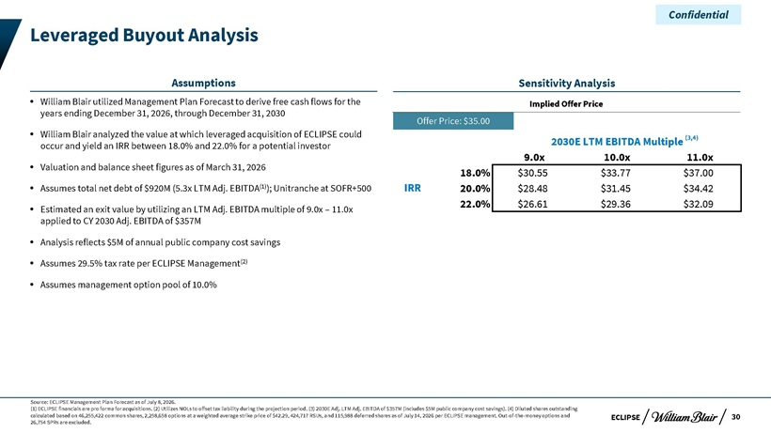
Confidential Leveraged Buyout Analysis Assumptions Sensitivity Analysis ? William Blair utilized Management Plan Forecast to derive free cash flows for the Implied Offer Price years ending December 31, 2026, through December 31, 2030 Offer Price: $35.00 ? William Blair analyzed the value at which leveraged acquisition of ECLIPSE could (3,4) occur and yield an IRR between 18.0% and 22.0% for a potential investor 2030E LTM EBITDA Multiple Valuation and sheet figures as 9.0x 10.0x 11.0x? balance of March 31, 2026 18.0% $30.55 $33.77 $37.00? Assumes total net debt of $920M (5.3x LTM Adj. EBITDA(1)); Unitranche at SOFR+500 IRR 20.0% $28.48 $31.45 $34.42 22.0% $26.61 $29.36 $32.09 ? Estimated an exit value by utilizing an LTM Adj. EBITDA multiple of 9.0x – 11.0x applied to CY 2030 Adj. EBITDA of $357M ? Analysis reflects $5M of annual public company cost savings? Assumes 29.5% tax rate per ECLIPSE Management(2)? Assumes management option pool of 10.0% Source: ECLIPSE Management Plan Forecast as of July 8, 2026. (1) ECLIPSE financials are pro forma for acquisitions. (2) Utilizes NOLs to offset tax liability during the projection period. (3) 2030E Adj. LTM Adj. EBITDA of $357M (includes $5M public company cost savings). (4) Diluted shares outstanding calculated based on 46,255,422 common shares, 2,258,658 options at a weighted average strike price of $42.29, 424,717 RSUs, and 115,988 deferred shares as of July 14, 2026 per ECLIPSE management. Out-of-the-money options and ECLIPSE 30 26,754 SPRs are excluded.

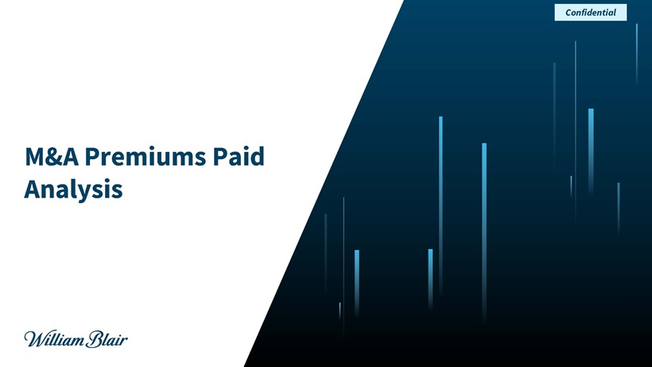
Confidential M&A Premiums Paid Analysis

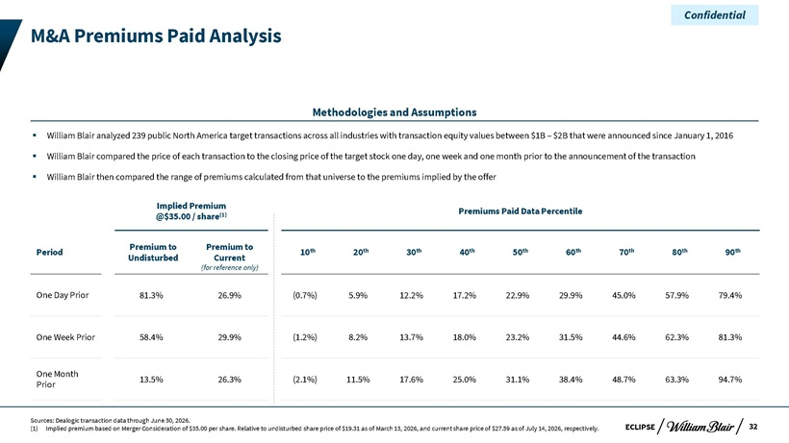
Confidential M&A Premiums Paid Analysis Methodologies and Assumptions ? William Blair analyzed 239 public North America target transactions across all industries with transaction equity values between $1B – $2B that were announced since January 1, 2016 ? William Blair compared the price of each transaction to the closing price of the target stock one day, one week and one month prior to the announcement of the transaction ? William Blair then compared the range of premiums calculated from that universe to the premiums implied by the offer Implied Premium (1) Premiums Paid Data Percentile @$35.00 / share Premium to Premium to th th th th th th th th th Period 10 20 30 40 50 60 70 80 90 Undisturbed Current (for reference only) One Day Prior 81.3% 26.9% (0.7%) 5.9% 12.2% 17.2% 22.9% 29.9% 45.0% 57.9% 79.4% One Week Prior 58.4% 29.9% (1.2%) 8.2% 13.7% 18.0% 23.2% 31.5% 44.6% 62.3% 81.3% One Month 13.5% 26.3% (2.1%) 11.5% 17.6% 25.0% 31.1% 38.4% 48.7% 63.3% 94.7% Prior Sources: Dealogic transaction data through June 30, 2026. (1) Implied premium based on Merger Consideration of $35.00 per share. Relative to undisturbed share price of $19.31 as of March 13, 2026, and current share price of $27.59 as of July 14, 2026, respectively. ECLIPSE 32
Exhibit (c)(ix)

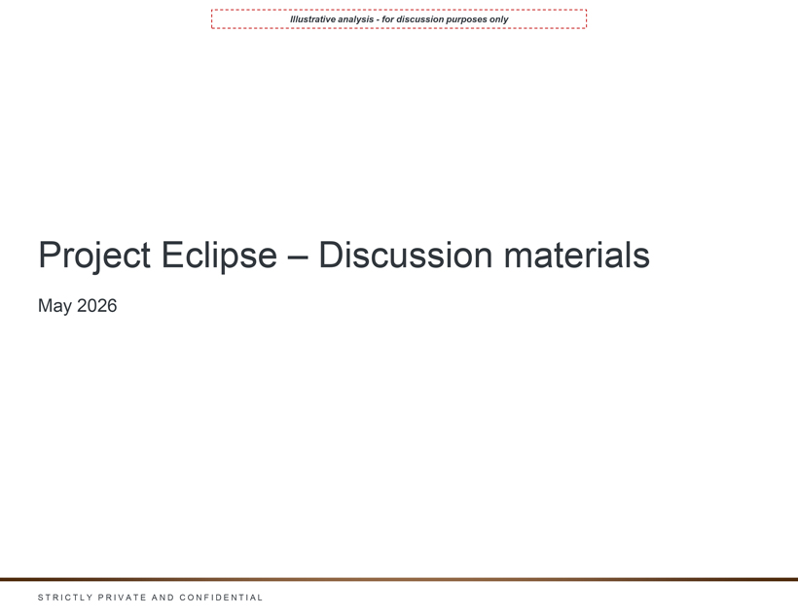
Illustrative analysis—for discussion purposes only Project Eclipse – Discussion materials May 2026

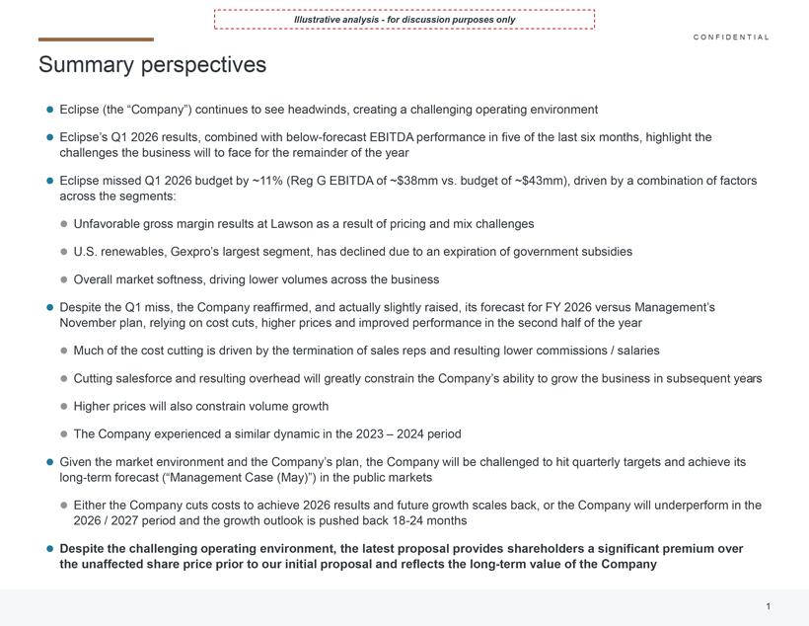
Illustrative analysis—for discussion purposes only Summary perspectives Eclipse (the “Company”) continues to see headwinds, creating a challenging operating environment CONFIDENTIAL Eclipse’s Q1 2026 results, combined with below-forecast EBITDA performance in five of the last six months, highlight the challenges the business will to face for the remainder of the year Eclipse missed Q1 2026 budget by ~11% (Reg G EBITDA of ~$38mm vs. budget of ~$43mm), driven by a combination of factors across the segments: Unfavorable gross margin results at Lawson as a result of pricing and mix challenges U.S. renewables, Gexpro’s largest segment, has declined due to an expiration of government subsidies Overall market softness, driving lower volumes across the business Despite the Q1 miss, the Company reaffirmed, and actually slightly raised, its forecast for FY 2026 versus Management’s November plan, relying on cost cuts, higher prices and improved performance in the second half of the year Much of the cost cutting is driven by the termination of sales reps and resulting lower commissions / salaries Cutting salesforce and resulting overhead will greatly constrain the Company’s ability to grow the business in subsequent years Higher prices will also constrain volume growth The Company experienced a similar dynamic in the 2023 – 2024 period Given the market environment and the Company’s plan, the Company will be challenged to hit quarterly targets and achieve its long-term forecast (“Management Case (May)”) in the public markets Either the Company cuts costs to achieve 2026 results and future growth scales back, or the Company will underperform in the 2026 / 2027 period and the growth outlook is pushed back 18-24 months Despite the challenging operating environment, the latest proposal provides shareholders a significant premium over the unaffected share price prior to our initial proposal and reflects the long-term value of the Company

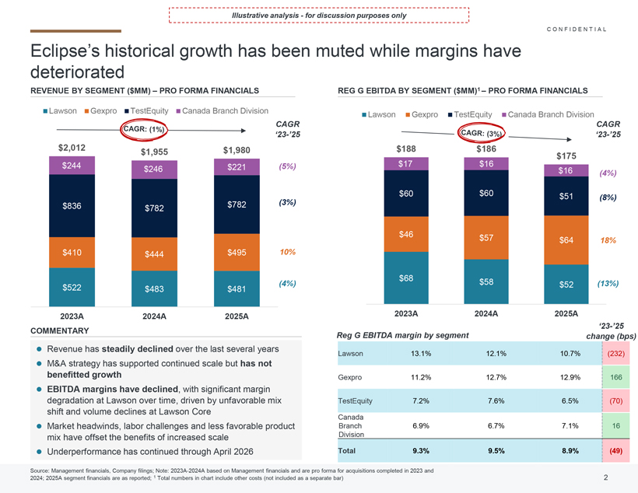
Illustrative analysis—for discussion purposes only Eclipse’s historical growth has been muted while margins have deteriorated REVENUE BY SEGMENT ($MM) –PRO FORMA FINANCIALS REG G EBITDA BY SEGMENT ($MM)1 –PRO FORMA FINANCIALSRevenue has steadily declinedover the last several years M&A strategy has supported continued scale but has not benefitted growth EBITDA margins have declined, with significant margin degradation at Lawson over time, driven by unfavorable mix shift and volume declines at Lawson Core Market headwinds, labor challenges and less favorable product mix have offset the benefits of increased scale Underperformance has continued through April 2026 Source: Management financials, Company filings; Note: 2023A-2024A based on Management financials and are pro forma for acquisitions completed in 2023 and 2024; 2025A segment financials are as reported; 1Total numbers in chart include other costs (not included as a separate bar) CONFIDENTIAL

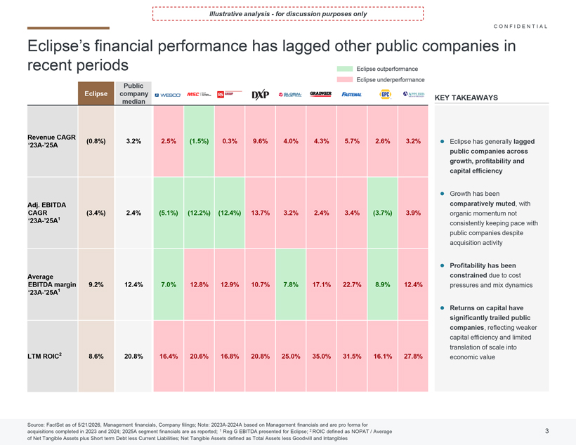
Illustrative analysis—for discussion purposes only Eclipse’s financial performance has lagged other public companies in recent periods Eclipse has generally lagged public companies across growth, profitability and capital efficiency Growth has been comparatively muted, with organic momentum not consistently keeping pace with public companies despite acquisition activity Profitability has been constraineddue tocost pressures and mix dynamics Returns on capital have significantly trailed public companies, reflecting weaker capital efficiency and limited translation of scale into economic value CONFIDENTIAL

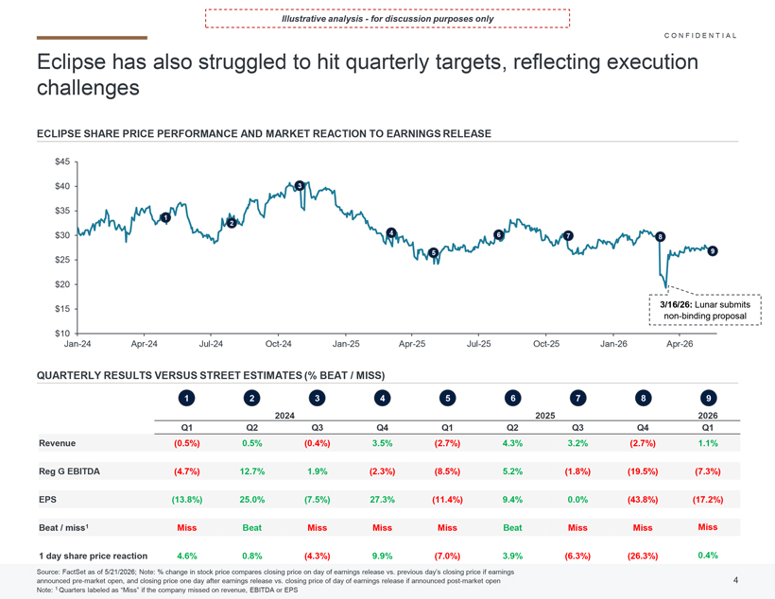
Illustrative analysis—for discussion purposes only Eclipse has also struggled to hit quarterly targets, reflecting execution challenges ECLIPSE SHARE PRICE PERFORMANCE AND MARKET REACTION TO EARNINGS RELEASE CONFIDENTIAL

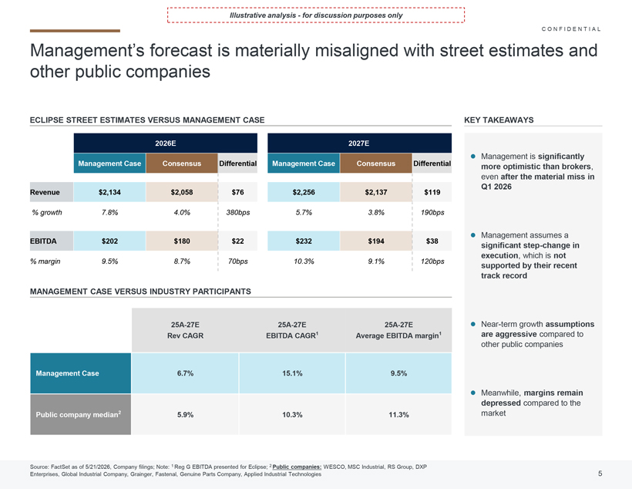
Illustrative analysis—for discussion purposes only Management’s forecast is materially misaligned with street estimates and other public companies Management is significantly more optimistic than brokers, even after the material miss in Q1 2026 Management assumes a significant step-change in execution, which is not supported by their recent track record Near-term growth assumptions are aggressivecompared to other public companies Meanwhile, margins remain depressed compared to the market Source: FactSet as of 5/21/2026, Company filings; Note: 1 Reg G EBITDA presented for Eclipse; 2 Public companies:WESCO, MSC Industrial, RS Group, DXP Enterprises, Global Industrial Company, Grainger, Fastenal, Genuine Parts Company, Applied Industrial Technologies 25A-27E Rev CAGR 25A-27E EBITDA CAGR1 25A-27E Average EBITDA margin1 Management Case 6.7% 15.1% 9.5% Public company median2 5.9% 10.3% 11.3% ECLIPSE STREET ESTIMATES VERSUS MANAGEMENT CASE MANAGEMENT CASE VERSUS INDUSTRY PARTICIPANTS 2026E 2027E Management Case Consensus Differential Management Case Consensus Differential Revenue $2,134 $2,058 $76 $2,256 $2,137 $119 % growth 7.8% 4.0% 380bps 5.7% 3.8% 190bps EBITDA $202 $180 $22 $232 $194 $38 % margin 9.5% 8.7% 70bps 10.3% 9.1% 120bps KEY TAKEAWAYS CONFIDENTIAL

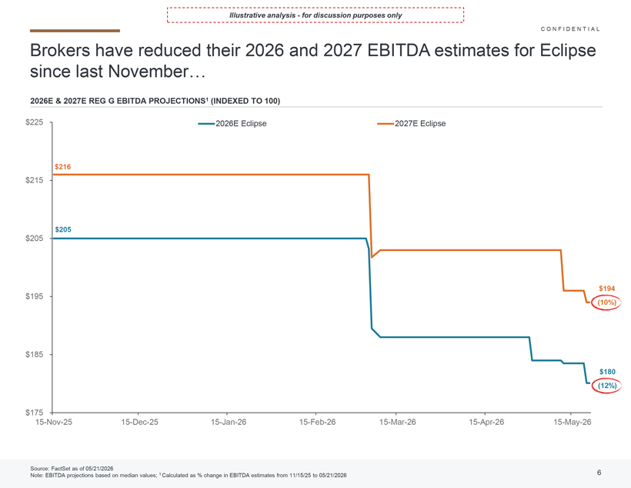
Illustrative analysis—for discussion purposes only Brokers have reduced their 2026 and 2027 EBITDA estimates for Eclipse since last November 2026E & 2027E REG G EBITDA PROJECTIONS1 (INDEXED TO 100 CONFIDENTIAL

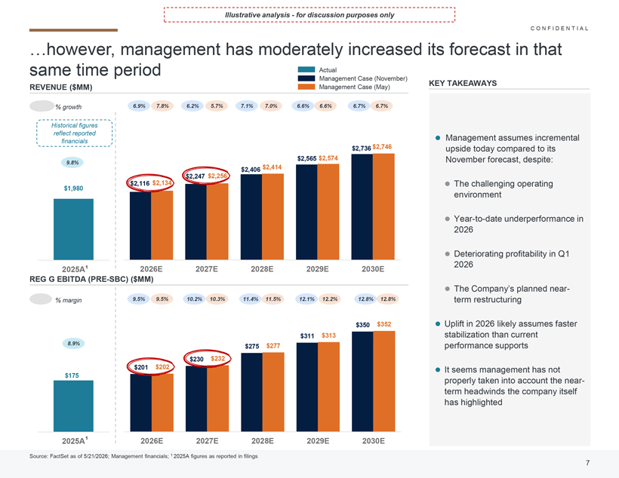
Illustrative analysis—for discussion purposes only however, management has moderately increased its forecast in that same time period Actual Management Case (November) REVENUE ($MM) % growth Historical figures reflect reported financials 9.8% $1,980 2025A 1 REG G EBITDA (PRE-SBC) ($MM) % margin 8.9% $175 2025A 1 Management Case (May) 6.9% $2,116 7.8% $2,134 6.2% $2,247 5.7% $2,256 7.1% 7.0% $2,406 $2,414 6.6% 6.6% $2,565 6.7% 6.7% $2,736 $2,574 $2,746 2026E 9.5% $201 9.5% $202 2027E 10.2% $230 10.3% $232 2028E 11.4% $275 11.5% $277 2029E 12.1% $311 2030E 12.2% $313 12.8% $350 12.8% $352 2026E 2027E 75849-007 31Aug26 14:52 Page 9 2028E Source: FactSet as of 5/21/2026; Management financials; 1 2025A figures as reported in filings 2029E 2030E KEY TAKEAWAYS Management assumes incremental upside today compared to its November forecast, despite: The challenging operating environment Year-to-date underperformance in 2026 Deteriorating profitability in Q1 2026 The Company’s planned near term restructuring Uplift in 2026 likely assumes faster stabilization than current performance supports It seems management has not properly taken into account the near term headwinds the company itself has highlighted CONFIDENTIAL

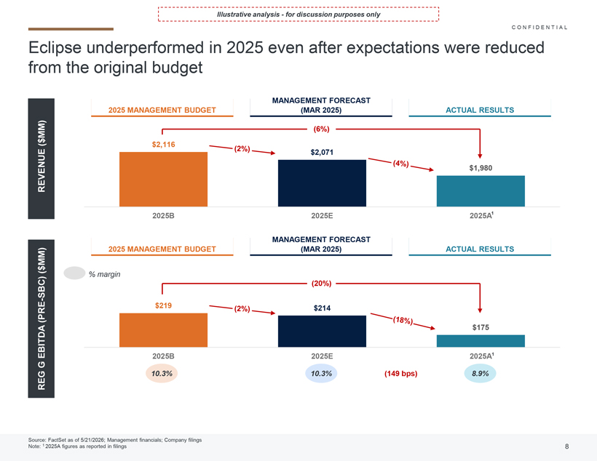
Illustrative analysis—for discussion purposes only Eclipse underperformed in 2025 even after expectations were reduced from the original budget REVENUE ($MM) REG G EBITDA (PRE-SBC) ($MM) 2025 MANAGEMENT BUDGET MANAGEMENT FORECAST (MAR 2025) ACTUAL RESULTS CONFIDENTIAL

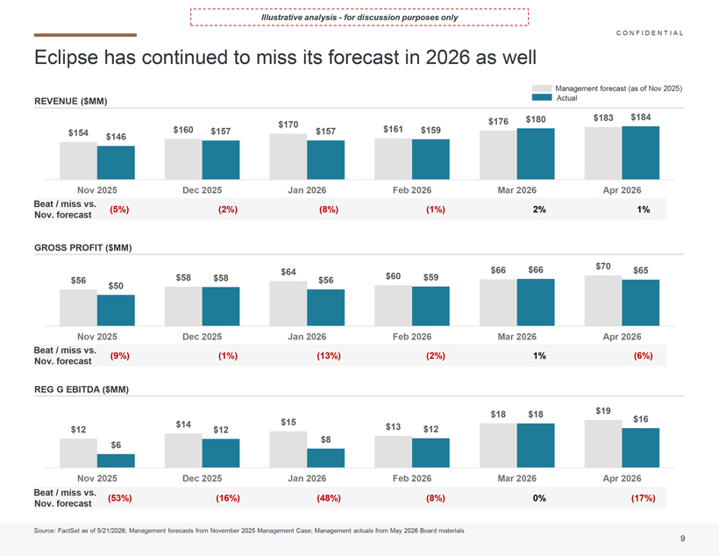
Illustrative analysis—for discussion purposes only Eclipse has continued to miss its forecast in 2026 as well REVENUE ($MM) Source: FactSet as of 5/21/2026; Management forecasts from November 2025 Management Case; Management actuals from May 2026 Board materials M CONFIDENTIAL

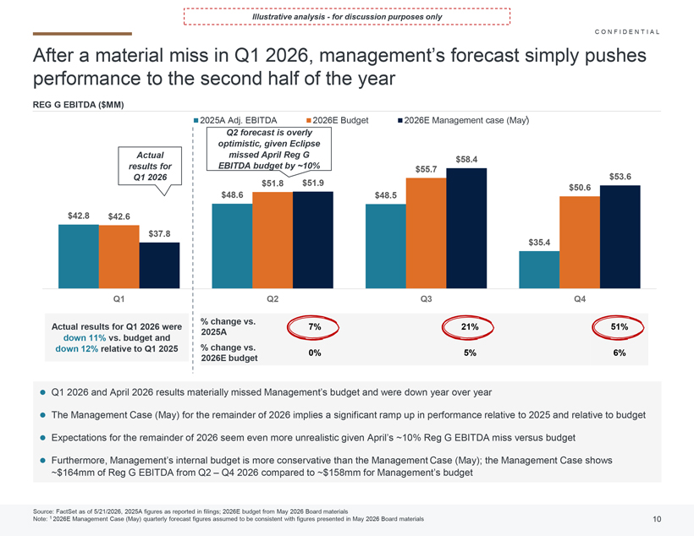
Illustrative analysis—for discussion purposes only After a material miss in Q1 2026, management’s forecast simply pushes performance to the second half of the year Q1 2026 and April 2026 results materially missed Management’s budget and were down year over year The Management Case (May) for the remainder of 2026 implies a significant ramp up in performance relative to 2025 and relative to budget Expectations for the remainder of 2026 seem even more unrealistic given April’s ~10% Reg G EBITDA miss versus budget Furthermore, Management’s internal budget is more conservative than the Management Case (May); the Management Case shows ~$164mm of Reg G EBITDA from Q2 –Q4 2026 compared to ~$158mm for Management’s budget Source: FactSet as of 5/21/2026, 2025A figures as reported in filings; 2026E budget from May 2026 Board materials Note: 1 2026E Management Case (May) quarterly forecast figures assumed to be consistent with figures presented in May 2026 Board materials CONFIDENTIAL

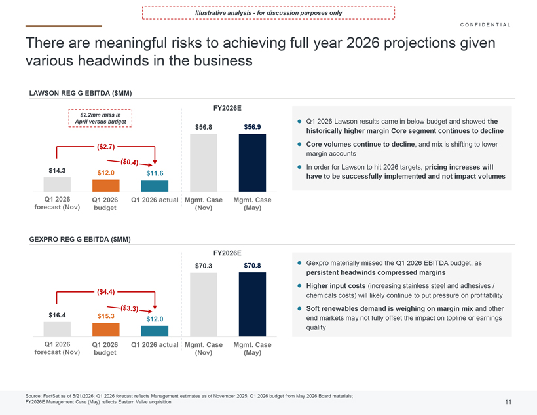
Illustrative analysis—for discussion purposes only There are meaningful risks to achieving full year 2026 projections given various headwinds in the business LAWSON REG G EBITDA ($MM) $14.3 $12.0 $11.6 $56.8 $56.9 Q1 2026 forecast Q1 2026 budget Q1 2026 actual Mgmt. Case (Nov) Mgmt. Case (May) Source: FactSet as of 5/21/2026; Q1 2026 forecast reflects Management estimates as of November 2025; Q1 2026 budget from May 2026 Board materials; FY2026E Management Case (May) reflects EasternValve acquisition GEXPRO REG G EBITDA ($MM) $16.4 $15.3 $12.0 $70.3 $70.8 Q1 2026 forecast Q1 2026 budget Q1 2026 actual Mgmt. Case (Nov) Mgmt. Case (May) Gexpro materially missed the Q1 2026 EBITDA budget, as persistent headwinds compressed margins Higher input costs (increasing stainless steel and adhesives / chemicals costs) will likely continue to put pressure on profitability Soft renewables demand is weighing on margin mixand other end markets may not fully offset the impact on topline or earnings quality Q1 2026 Lawson results came in below budget and showed the historically higher margin Core segment continues to decline Core volumes continue to decline, and mix is shifting to lower margin accounts In order forLawson to hit 2026 targets, pricing increases will have to be successfully implemented and not impact volumes CONFIDENTIAL

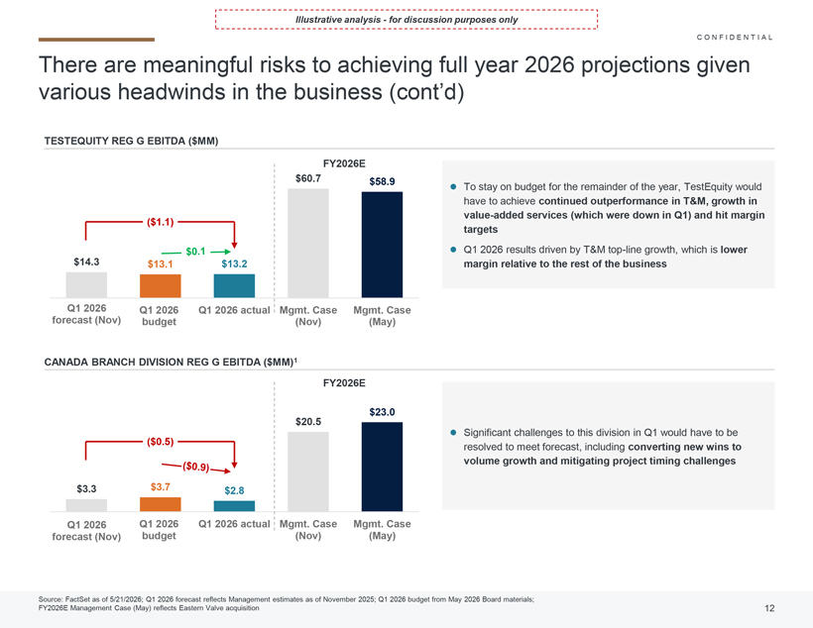
Illustrative analysis—for discussion purposes only There are meaningful risks to achieving full year 2026 projections given various headwinds in the business (cont’d) Significant challenges to this division in Q1 would have to be resolved to meet forecast, including converting new wins to volume growth and mitigating project timing challenges Source: FactSet as of 5/21/2026; Q1 2026 forecast reflects Management estimates as of November 2025; Q1 2026 budget from May 2026 Board materials; FY2026E Management Case (May) reflects EasternValve acquisition TESTEQUITY REG G EBITDA ($MM) CANADA BRANCH DIVISION REG G EBITDA ($MM)1 To stay on budget for the remainder of the year, TestEquitywould have to achieve continued outperformance in T&M, growth in value-added services (which were down in Q1) and hit margin targets Q1 2026 results driven by T&M top-line growth, which is lower margin relative to the rest of the business CONFIDENTIAL

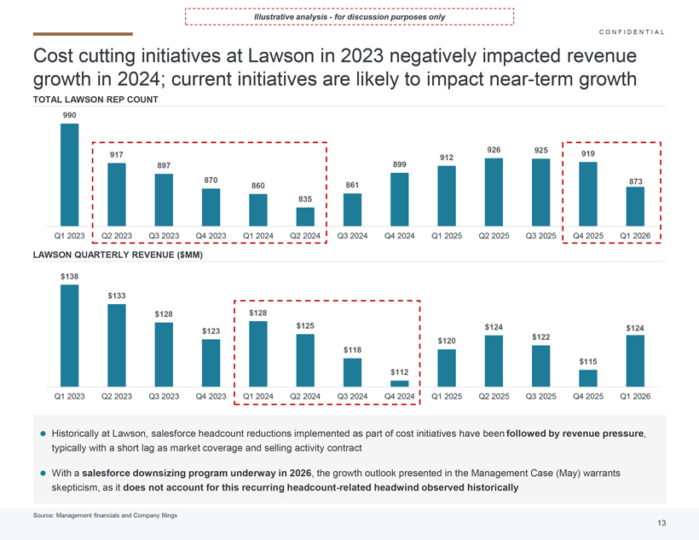
Illustrative analysis—for discussion purposes only Cost cutting initiatives at Lawson in 2023 negatively impacted revenue growth in 2024; current initiatives are likely to impact near-term growth TOTAL LAWSON REP COUNT $138 $133 $128 $123 $128 $125 $118 $112 $120 $124 $122 $115 $124 Q1 2023 Q2 2023 Q3 2023 Q4 2023 Q1 2024 Q2 2024 Q3 2024 Q4 2024 Q1 2025 Q2 2025 Q3 2025 Q4 2025 Q1 2026 LAWSON QUARTERLY REVENUE($MM) Historically at Lawson, salesforce headcount reductions implemented as part of cost initiatives have been followed by revenue pressure, typically with a short lag as market coverage and selling activity contract With a salesforce downsizing program underway in 2026, the growth outlook presented in the Management Case (May) warrants skepticism, as it does not account for this recurring headcount-related headwind observed historically CONFIDENTIAL

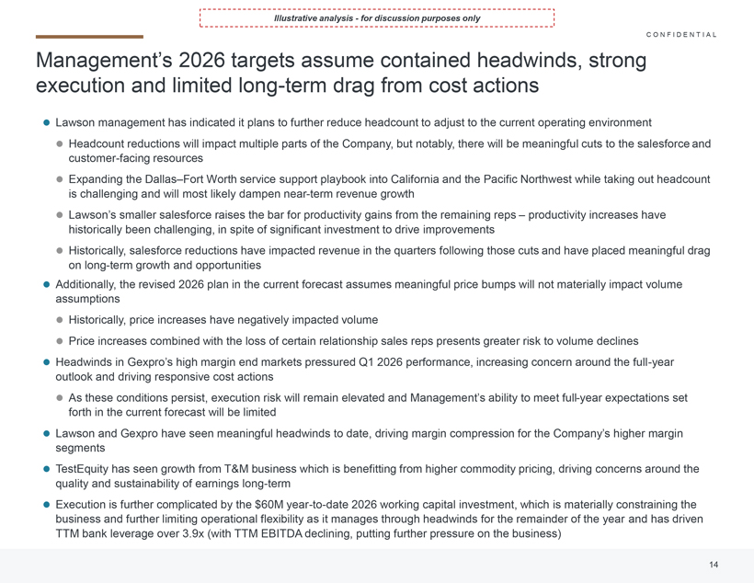
Illustrative analysis—for discussion purposes only Management’s 2026 targets assume contained headwinds, strong execution and limited long-term drag from cost actions Lawson management has indicated it plans to further reduce headcount to adjust to the current operating environment Headcount reductions will impact multiple parts of the Company, but notably, there will be meaningful cuts to the salesforceand customer-facing resources Expanding the Dallas–Fort Worth service support playbook into California and the Pacific Northwest while taking out headcount is challenging and will most likely dampen near-term revenue growth Lawson’s smaller salesforce raises the bar for productivity gains from the remaining reps– productivity increases have historically been challenging, in spite of significant investment to drive improvements Historically, salesforce reductions have impacted revenue in the quarters following those cuts and have placed meaningful drag on long-term growth and opportunities Additionally, the revised 2026 plan in the current forecast assumes meaningful price bumps will not materially impact volume assumptions Historically, price increases have negatively impacted volume Price increases combined with the loss of certain relationship sales reps presents greater risk to volume declines Headwinds in Gexpro’s high margin end markets pressured Q1 2026 performance, increasing concern around the full-year outlook and driving responsive cost actions As these conditions persist, execution risk will remain elevated and Management’s ability to meet full-year expectations set forth in the current forecast will be limited Lawson and Gexpro have seen meaningful headwinds to date, driving margin compression for the Company’s higher margin segments TestEquity has seen growth from T&M business which is benefitting from higher commodity pricing, driving concerns around the quality and sustainability of earnings long-term Execution is further complicated by the $60M year-to-date 2026 working capital investment, which is materially constraining the business and further limiting operational flexibility as it manages through headwinds for the remainder of the year and has driven TTM bank leverage over 3.9x (with TTM EBITDA declining, putting further pressure on the business) CONFIDENTIAL

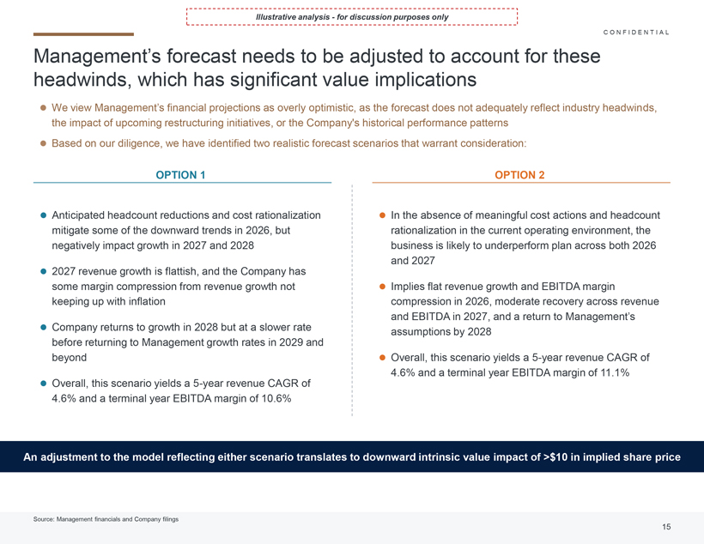
Illustrative analysis—for discussion purposes only Management’s forecast needs to be adjusted to account for these headwinds, which has significant value implications C ONFIDENTIAL We view Management’s financial projections as overly optimistic, as the forecast does not adequately reflect industry headwinds, the impact of upcoming restructuring initiatives, or the Company’s historical performance patterns Based on our diligence, we have identified two realistic forecast scenarios that warrant consideration: OPTION 1 Anticipated headcount reductions and cost rationalization mitigate some of the downward trends in 2026, but negatively impact growth in 2027 and 2028 2027 revenue growth is flattish, and the Company has some margin compression from revenue growth not keeping up with inflation Company returns to growth in 2028 but at a slower rate before returning to Management growth rates in 2029 and beyond Overall, this scenario yields a 5-year revenue CAGR of 4.6% and a terminal year EBITDA margin of 10.6% OPTION 2 In the absence of meaningful cost actions and headcount rationalization in the current operating environment, the business is likely to underperform plan across both 2026 and 2027 Implies flat revenue growth and EBITDA margin compression in 2026, moderate recovery across revenue and EBITDA in 2027, and a return to Management’s assumptions by 2028 Overall, this scenario yields a 5-year revenue CAGR of 4.6% and a terminal year EBITDA margin of 11.1% An adjustment to the model reflecting either scenario translates to downward intrinsic value impact of >$10 in implied share price CONFIDENTIAL

Calculation of Filing Fee Tables
Table 1: Transaction Valuation
 |  | Transaction Valuation | Fee Rate | Amount of Filing Fee
Fees to be Paid | 1 | $ 370,709,453.52 | 0.0001381 | $ 51,194.98
Fees Previously Paid
 | Total Transaction Valuation: | $ 370,709,453.52
 | Total Fees Due for Filing: |  |  | $ 51,194.98
 | Total Fees Previously Paid: |  |  | $ 0.00
 | Total Fee Offsets: |  |  | $ 51,194.98
 | Net Fee Due: |  |  | $ 0.00
Offering Note
1 | (1) Calculated solely for the purpose of determining the filing fee in accordance with Rule 0-11(b)(1) under the Securities Exchange Act of 1934, as amended (the "Exchange Act"). The filing fee is calculated based on the sum of: (a) the product of 9,909,624 issued and outstanding shares of common stock, par value $1.00 per share, of Distribution Solutions Group, Inc. (the "Company" and, such common stock, the "Shares") subject to the transaction referred to in this Statement on Schedule 13E-3 (this "Statement") multiplied by the per share merger consideration of $35.00; (b) the product of 406,467 Shares subject to Vested Company RSUs and Director RSUs (each as defined in the merger agreement relating to the transaction that is the subject of this Statement) multiplied by the per share merger consideration of $35.00; (c) the product of 697,154 Shares underlying Vested Company Options other than Underwater Options (each as defined in the merger agreement relating to the transaction that is the subject of this Statement) multiplied by $7.50, which is the difference between the per share merger consideration of $35.00 and the weighted average exercise price of $27.50 per Share; (d) the product of 18,472 Vested SPRs (as defined in the merger agreement relating to the transaction that is the subject of this Statement) and $19.38, which is the difference between the per share merger consideration and the Vested SPRs weighted-average exercise price of $15.62 and (e) the product of 115,988 shares of Company Stock Unit (as defined in the merger agreement relating to the transaction that is the subject of this Statement) and the per share merger consideration. The sum of (a), (b), (c), (d) and (e) is referred to as the "Transaction Value." The amount of the filing fee, calculated in accordance Rule 0-11(b)(1) under the Exchange Act by the Fee Rate of 0.0001381 currently in effect.
Table 2: Fee Offset Claims and Sources | ☐Not Applicable
 |  | Registrant or Filer Name | Form or Filing Type | File Number | Initial Filing Date | Filing Date | Fee Offset Claimed | Fee Paid with Fee Offset Source
Fee Offset Claims |  |  | Schedule 14A | 000-10546 | 09/01/2026 |  | $ 51,194.98
Fee Offset Sources | 1 | Distribution Solutions Group, Inc. | Schedule 14A | 000-10546 |  | 09/01/2026 |  | $ 51,194.98
Offset Note
1 | The Company paid $51,194.98 upon the filing of its Preliminary Proxy Statement on Schedule 14A on August 31, 2026 in connection with the transaction reported hereby.

