UNITED STATES
SECURITIES AND EXCHANGE COMMISSION
WASHINGTON, D.C. 20549

FORM 8-K

CURRENT REPORT
Pursuant to Section 13 or 15(d)
of the Securities Exchange Act of 1934
Date of Report (Date of earliest event reported): September 10, 2026

DISTRIBUTION SOLUTIONS GROUP, INC.
(Exact name of registrant as specified in its charter)

Delaware |  | 0-10546 |  | 36-2229304
(State or other jurisdiction  of incorporation) |  | (Commission  File Number) |  | (I.R.S. Employer  Identification No.)

301 Commerce Street, Suite 1700, Fort Worth, Texas |  |  |  | 76102
(Address of principal executive offices) |  |  |  | (Zip Code)
(Registrant’s telephone number, including area code) (888) 611-9888
Not Applicable
(Former name or former address, if changed since last report)

Check the appropriate box below if the Form 8-K filing is intended to simultaneously satisfy the filing obligation of the registrant under any of the following provisions:

☐ | Written communications pursuant to Rule 425 under the Securities Act (17 CFR 230.425)

☒ | Soliciting material pursuant to Rule 14a-12 under the Exchange Act (17 CFR 240.14a-12)

☐ | Pre-commencement communications pursuant to Rule 14d-2(b) under the Exchange Act (17 CFR 240.14d-2(b))

☐ | Pre-commencement communications pursuant to Rule 13e-4(c) under the Exchange Act (17 CFR 240.13e-4(c))
Securities registered pursuant to Section 12(b) of the Act:

Title of each class |  | Trading  Symbol |  | Name of each exchange  on which registered
Common stock, $1.00 par value |  | DSGR |  | The NASDAQ Stock Market LLC  (NASDAQ Global Select Market)
Indicate by check mark whether the registrant is an emerging growth company as defined in Rule 405 of the Securities Act of 1933 (§230.405 of this chapter) or Rule 12b-2 of the Securities Exchange Act of 1934 (§240.12b-2 of this chapter).
Emerging growth company ☐
If an emerging growth company, indicate by check mark if the registrant has elected not to use the extended transition period for complying with any new or revised financial accounting standards provided pursuant to Section 13(a) of the Exchange Act. ☐

Item 7.01 Regulation FD Disclosure.
Distribution Solutions Group, Inc. (the “Company”) will be participating in a number of informational meetings with investors beginning on September 10, 2026. A copy of the investor education presentation slides (the “Investor Education Presentation Slides”) is attached hereto as Exhibit 99.1 and is incorporated herein by reference. The Investor Education Presentation Slides will also be available on the Investor Relations section of the Company’s website at www.distributionsolutionsgroup.com.
The information set forth in this Item 7.01, including Exhibit 99.1, is being furnished and shall not be deemed “filed” for purposes of Section 18 of the Securities Exchange Act of 1934, as amended (the “Exchange Act”), or otherwise subject to the liabilities under that section, nor shall such information be deemed incorporated by reference in any filing under the Securities Act of 1933, as amended, or the Exchange Act, except as expressly set forth by specific reference in such filing.
Item 9.01 Financial Statements and Exhibits.
(d) Exhibits.
Exhibit 99.1 – Investor Education Presentation Slides

SIGNATURES
Pursuant to the requirements of the Securities Exchange Act of 1934, the registrant has duly caused this report to be signed on its behalf by the undersigned hereunto duly authorized.

 |  |  |  | DISTRIBUTION SOLUTIONS GROUP, INC.
 |  |  |  | (Registrant)
Date: September 10, 2026 |  |  |  | By: |  | /s/ Ronald J. Knutson
 |  |  |  | Name: |  | Ronald J. Knutson
 |  |  |  | Title: |  | Executive Vice President, Chief Financial Officer and Treasurer

EXHIBIT INDEX

Exhibit  Number |  | Description
99.1 |  | Investor Education Presentation Slides
104 |  | Cover Page Interactive Data File (embedded within the Inline XBRL document)

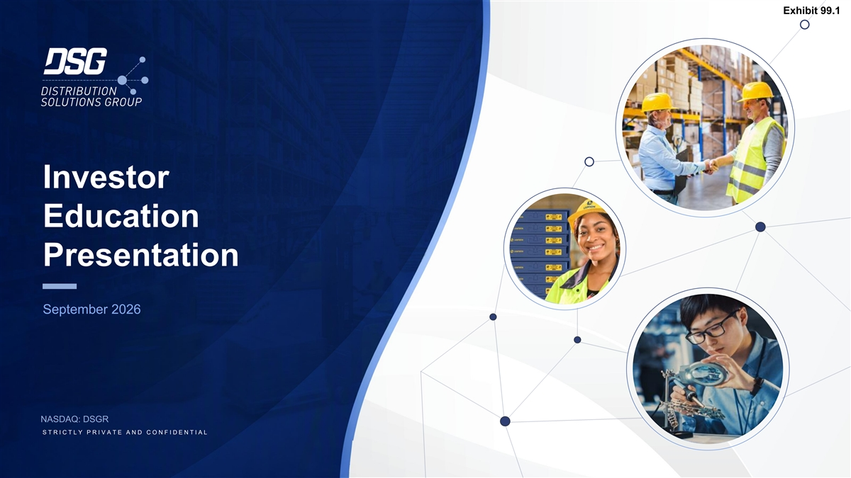
Exhibit 99.1 Investor Education Presentation September 2026 NASDAQ: DSGR S T R I C T L Y P R I V A T E A N D C O N F I D E N T I A L

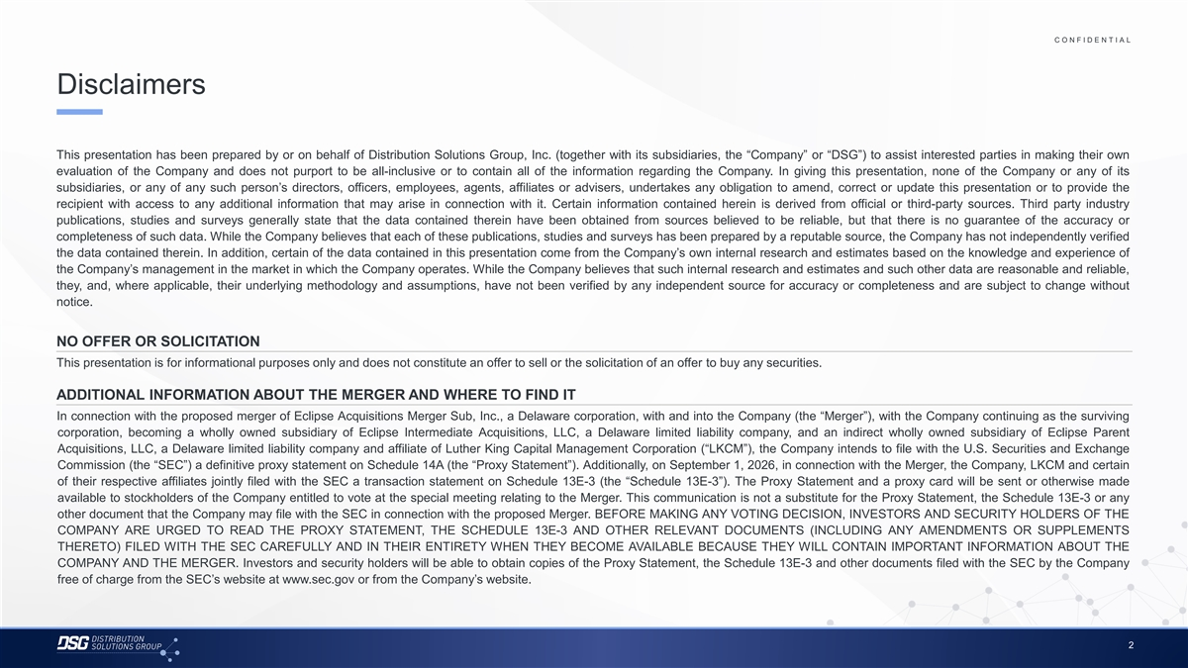
C O N F I D E N T I A L COLOR PALETTE Text 50 56 62 Disclaimers Title bar/Bullets 68 87 128 ACCENTS 2 85 This presentation has been prepared by or on behalf of Distribution Solutions Group, Inc. (together with its subsidiaries, the “Company” or “DSG”) to assist interested parties in making their own 25 141 1 70 250 evaluation of the Company and does not purport to be all-inclusive or to contain all of the information regarding the Company. In giving this presentation, none of the Company or any of its 68 173 subsidiaries, or any of any such person’s directors, officers, employees, agents, affiliates or advisers, undertakes any obligation to amend, correct or update this presentation or to provide the 87 185 2 recipient with access to any additional information that may arise in connection with it. Certain information contained herein is derived from official or third-party sources. Third party industry 128 211 publications, studies and surveys generally state that the data contained therein have been obtained from sources believed to be reliable, but that there is no guarantee of the accuracy or 142 210 169 221 3 completeness of such data. While the Company believes that each of these publications, studies and surveys has been prepared by a reputable source, the Company has not independently verified 216 239 the data contained therein. In addition, certain of the data contained in this presentation come from the Company’s own internal research and estimates based on the knowledge and experience of 255 255 196 231 the Company’s management in the market in which the Company operates. While the Company believes that such internal research and estimates and such other data are reasonable and reliable, 4 38 168 they, and, where applicable, their underlying methodology and assumptions, have not been verified by any independent source for accuracy or completeness and are subject to change without 239 249 notice. 129 205 5 35 167 213 238 213 238 NO OFFER OR SOLICITATION 6 214 239 This presentation is for informational purposes only and does not constitute an offer to sell or the solicitation of an offer to buy any securities. 30 146 124 213 Hyperlink 153 234 ADDITIONAL INFORMATION ABOUT THE MERGER AND WHERE TO FIND IT 0 98 Followed 80 205 In connection with the proposed merger of Eclipse Acquisitions Merger Sub, Inc., a Delaware corporation, with and into the Company (the “Merger”), with the Company continuing as the surviving Hyperlink 117 255 corporation, becoming a wholly owned subsidiary of Eclipse Intermediate Acquisitions, LLC, a Delaware limited liability company, and an indirect wholly owned subsidiary of Eclipse Parent TABLE Acquisitions, LLC, a Delaware limited liability company and affiliate of Luther King Capital Management Corporation (“LKCM”), the Company intends to file with the U.S. Securities and Exchange 50 Commission (the “SEC”) a definitive proxy statement on Schedule 14A (the “Proxy Statement”). Additionally, on September 1, 2026, in connection with the Merger, the Company, LKCM and certain Lines 56 62 of their respective affiliates jointly filed with the SEC a transaction statement on Schedule 13E-3 (the “Schedule 13E-3”). The Proxy Statement and a proxy card will be sent or otherwise made available to stockholders of the Company entitled to vote at the special meeting relating to the Merger. This communication is not a substitute for the Proxy Statement, the Schedule 13E-3 or any 68 Highlights 87 other document that the Company may file with the SEC in connection with the proposed Merger. BEFORE MAKING ANY VOTING DECISION, INVESTORS AND SECURITY HOLDERS OF THE 128 COMPANY ARE URGED TO READ THE PROXY STATEMENT, THE SCHEDULE 13E-3 AND OTHER RELEVANT DOCUMENTS (INCLUDING ANY AMENDMENTS OR SUPPLEMENTS THERETO) FILED WITH THE SEC CAREFULLY AND IN THEIR ENTIRETY WHEN THEY BECOME AVAILABLE BECAUSE THEY WILL CONTAIN IMPORTANT INFORMATION ABOUT THE COMPANY AND THE MERGER. Investors and security holders will be able to obtain copies of the Proxy Statement, the Schedule 13E-3 and other documents filed with the SEC by the Company free of charge from the SEC’s website at www.sec.gov or from the Company’s website. 2

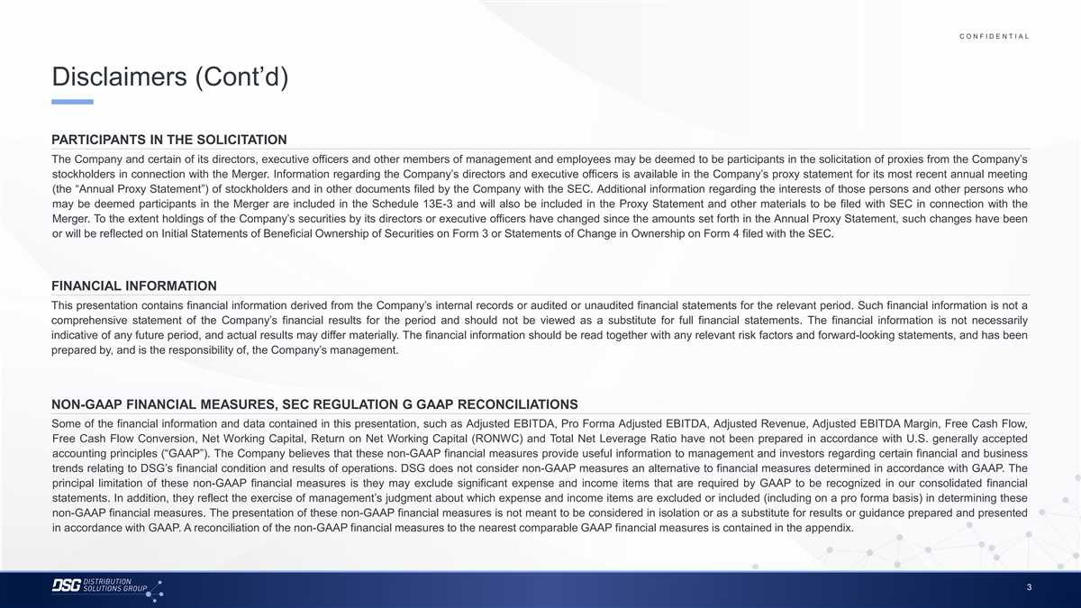
C O N F I D E N T I A L COLOR PALETTE Text 50 56 62 Disclaimers (Cont’d) Title bar/Bullets 68 87 128 ACCENTS 2 85 PARTICIPANTS IN THE SOLICITATION 25 141 1 70 250 The Company and certain of its directors, executive officers and other members of management and employees may be deemed to be participants in the solicitation of proxies from the Company’s 68 173 stockholders in connection with the Merger. Information regarding the Company’s directors and executive officers is available in the Company’s proxy statement for its most recent annual meeting 87 185 2 128 211 (the “Annual Proxy Statement”) of stockholders and in other documents filed by the Company with the SEC. Additional information regarding the interests of those persons and other persons who 142 210 may be deemed participants in the Merger are included in the Schedule 13E-3 and will also be included in the Proxy Statement and other materials to be filed with SEC in connection with the 169 221 3 Merger. To the extent holdings of the Company’s securities by its directors or executive officers have changed since the amounts set forth in the Annual Proxy Statement, such changes have been 216 239 or will be reflected on Initial Statements of Beneficial Ownership of Securities on Form 3 or Statements of Change in Ownership on Form 4 filed with the SEC. 255 255 196 231 4 38 168 239 249 129 205 5 35 167 FINANCIAL INFORMATION 213 238 This presentation contains financial information derived from the Company’s internal records or audited or unaudited financial statements for the relevant period. Such financial information is not a 213 238 6 214 239 comprehensive statement of the Company’s financial results for the period and should not be viewed as a substitute for full financial statements. The financial information is not necessarily indicative of any future period, and actual results may differ materially. The financial information should be read together with any relevant risk factors and forward-looking statements, and has been 30 146 124 213 Hyperlink prepared by, and is the responsibility of, the Company’s management. 153 234 0 98 Followed 80 205 Hyperlink 117 255 TABLE NON-GAAP FINANCIAL MEASURES, SEC REGULATION G GAAP RECONCILIATIONS 50 Some of the financial information and data contained in this presentation, such as Adjusted EBITDA, Pro Forma Adjusted EBITDA, Adjusted Revenue, Adjusted EBITDA Margin, Free Cash Flow, Lines 56 62 Free Cash Flow Conversion, Net Working Capital, Return on Net Working Capital (RONWC) and Total Net Leverage Ratio have not been prepared in accordance with U.S. generally accepted accounting principles (“GAAP”). The Company believes that these non-GAAP financial measures provide useful information to management and investors regarding certain financial and business 68 Highlights 87 trends relating to DSG’s financial condition and results of operations. DSG does not consider non-GAAP measures an alternative to financial measures determined in accordance with GAAP. The 128 principal limitation of these non-GAAP financial measures is they may exclude significant expense and income items that are required by GAAP to be recognized in our consolidated financial statements. In addition, they reflect the exercise of management’s judgment about which expense and income items are excluded or included (including on a pro forma basis) in determining these non-GAAP financial measures. The presentation of these non-GAAP financial measures is not meant to be considered in isolation or as a substitute for results or guidance prepared and presented in accordance with GAAP. A reconciliation of the non-GAAP financial measures to the nearest comparable GAAP financial measures is contained in the appendix. 3

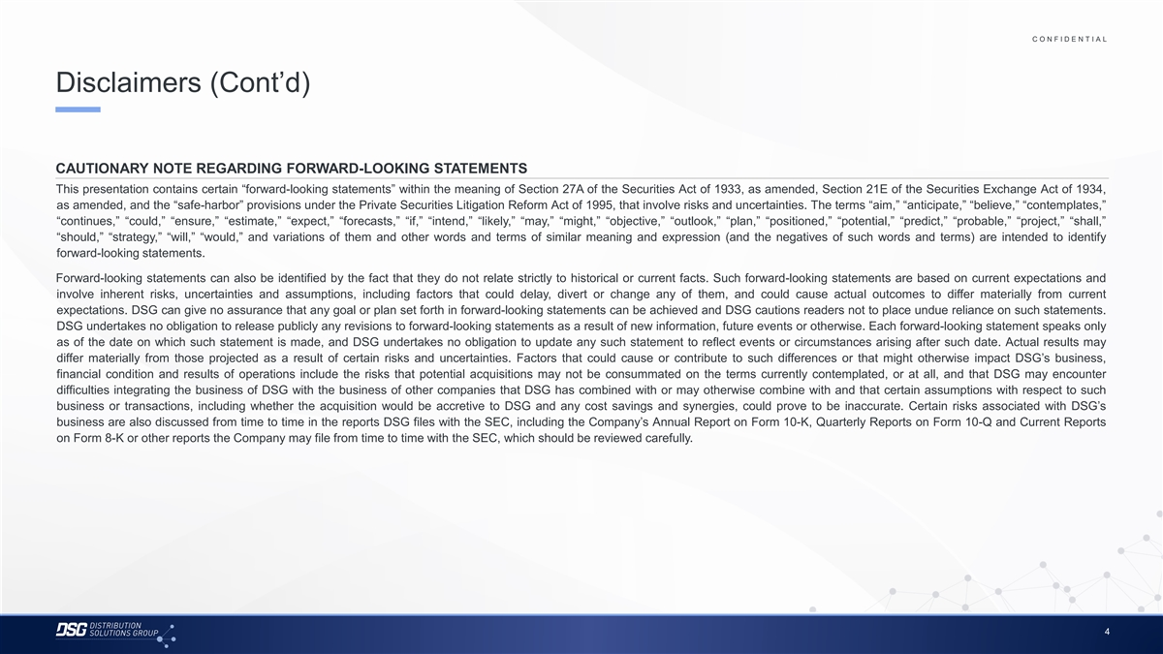
C O N F I D E N T I A L COLOR PALETTE Text 50 56 62 Disclaimers (Cont’d) Title bar/Bullets 68 87 128 ACCENTS 2 85 25 141 1 70 250 CAUTIONARY NOTE REGARDING FORWARD-LOOKING STATEMENTS 68 173 This presentation contains certain “forward-looking statements” within the meaning of Section 27A of the Securities Act of 1933, as amended, Section 21E of the Securities Exchange Act of 1934, 87 185 2 128 211 as amended, and the “safe-harbor” provisions under the Private Securities Litigation Reform Act of 1995, that involve risks and uncertainties. The terms “aim,” “anticipate,” “believe,” “contemplates,” 142 210 “continues,” “could,” “ensure,” “estimate,” “expect,” “forecasts,” “if,” “intend,” “likely,” “may,” “might,” “objective,” “outlook,” “plan,” “positioned,” “potential,” “predict,” “probable,” “project,” “shall,” 169 221 3 216 239 “should,” “strategy,” “will,” “would,” and variations of them and other words and terms of similar meaning and expression (and the negatives of such words and terms) are intended to identify forward-looking statements. 255 255 196 231 4 38 168 Forward-looking statements can also be identified by the fact that they do not relate strictly to historical or current facts. Such forward-looking statements are based on current expectations and 239 249 involve inherent risks, uncertainties and assumptions, including factors that could delay, divert or change any of them, and could cause actual outcomes to differ materially from current 129 205 5 35 167 expectations. DSG can give no assurance that any goal or plan set forth in forward-looking statements can be achieved and DSG cautions readers not to place undue reliance on such statements. 213 238 DSG undertakes no obligation to release publicly any revisions to forward-looking statements as a result of new information, future events or otherwise. Each forward-looking statement speaks only 213 238 6 as of the date on which such statement is made, and DSG undertakes no obligation to update any such statement to reflect events or circumstances arising after such date. Actual results may 214 239 differ materially from those projected as a result of certain risks and uncertainties. Factors that could cause or contribute to such differences or that might otherwise impact DSG’s business, 30 146 124 213 Hyperlink financial condition and results of operations include the risks that potential acquisitions may not be consummated on the terms currently contemplated, or at all, and that DSG may encounter 153 234 difficulties integrating the business of DSG with the business of other companies that DSG has combined with or may otherwise combine with and that certain assumptions with respect to such 0 98 Followed business or transactions, including whether the acquisition would be accretive to DSG and any cost savings and synergies, could prove to be inaccurate. Certain risks associated with DSG’s 80 205 Hyperlink 117 255 business are also discussed from time to time in the reports DSG files with the SEC, including the Company’s Annual Report on Form 10-K, Quarterly Reports on Form 10-Q and Current Reports TABLE on Form 8-K or other reports the Company may file from time to time with the SEC, which should be reviewed carefully. 50 Lines 56 62 68 Highlights 87 128 4

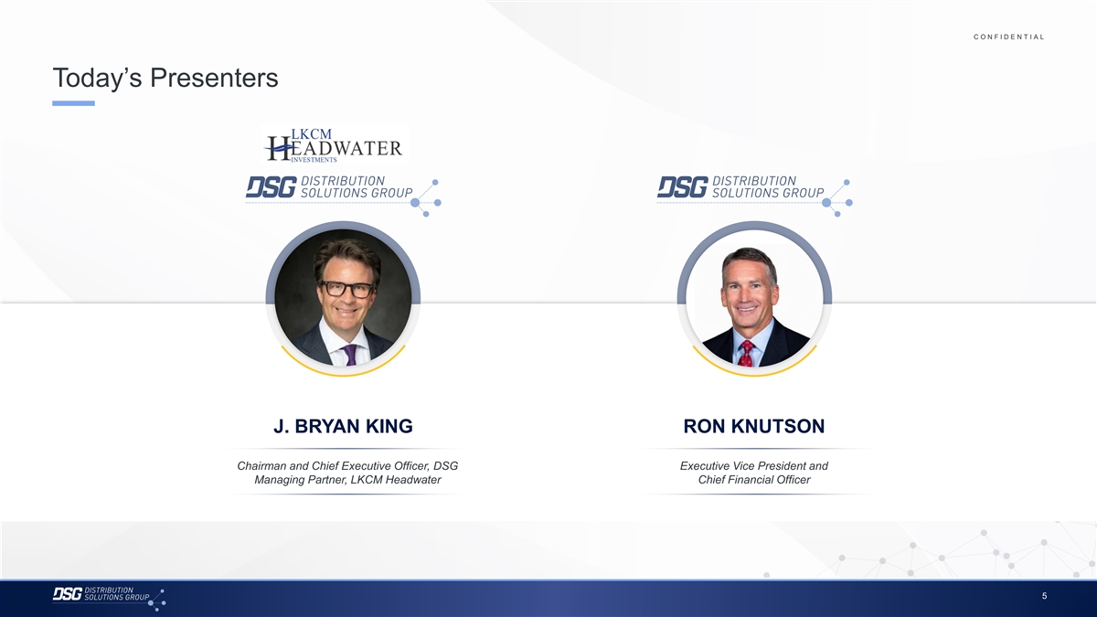
C O N F I D E N T I A L COLOR PALETTE Text 50 56 62 Today’s Presenters Title bar/Bullets 68 87 128 ACCENTS 2 85 25 141 1 70 250 68 173 87 185 2 128 211 142 210 169 221 3 216 239 255 255 196 231 4 38 168 239 249 129 205 5 35 167 213 238 213 238 6 214 239 30 146 124 213 Hyperlink 153 234 0 98 Followed 80 205 Hyperlink 117 255 TABLE 50 J. BRYAN KING RON KNUTSON Lines 56 62 68 Chairman and Chief Executive Officer, DSG Executive Vice President and Highlights 87 128 Managing Partner, LKCM Headwater Chief Financial Officer 5

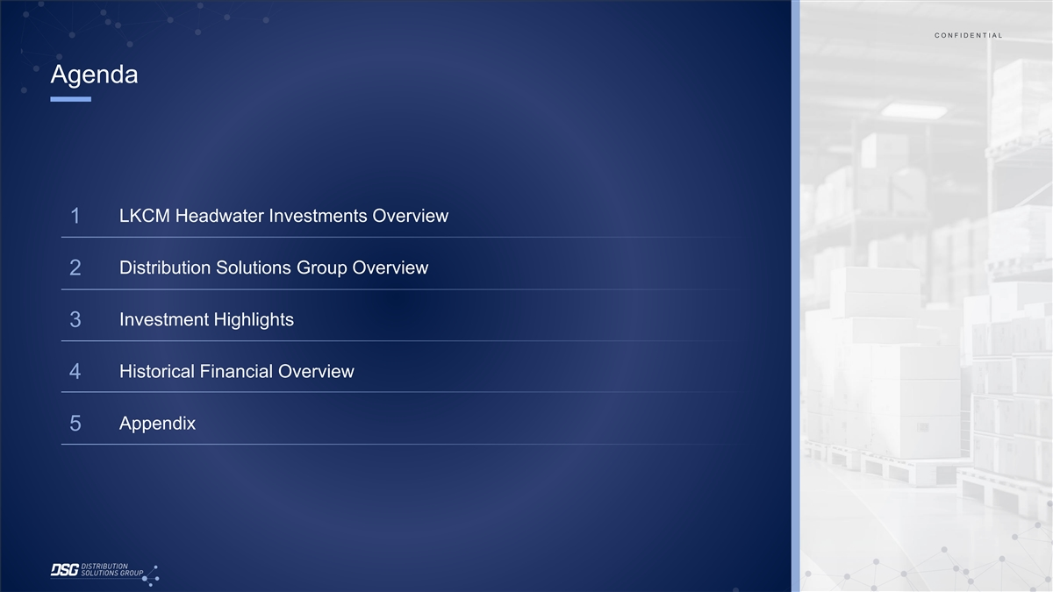
C C O O N N F F II D D E E N N T T II A A L L Agenda LKCM Headwater Investments Overview 1 Distribution Solutions Group Overview 2 Investment Highlights 3 Historical Financial Overview 4 Appendix 5

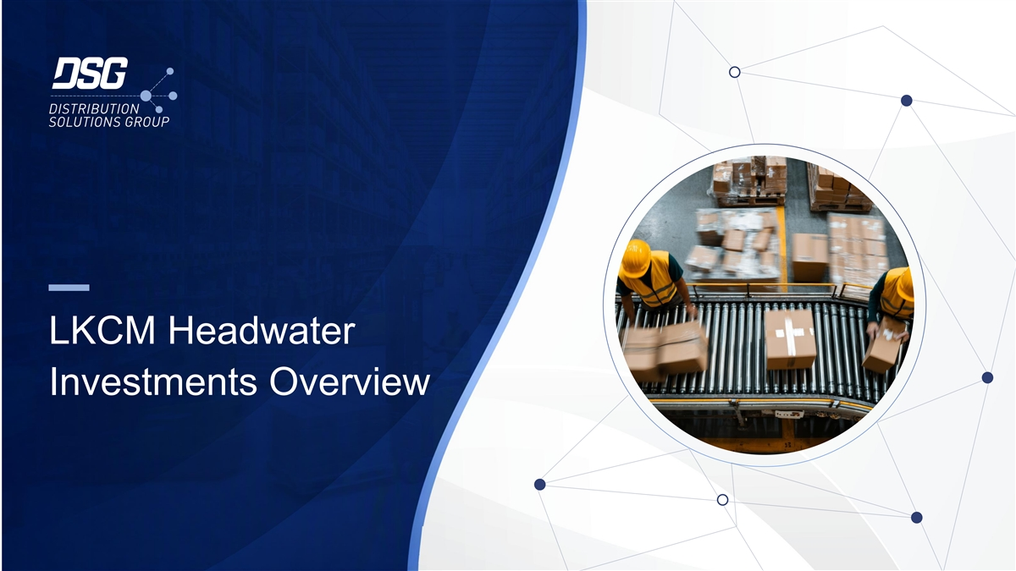
LKCM Headwater Investments Overview

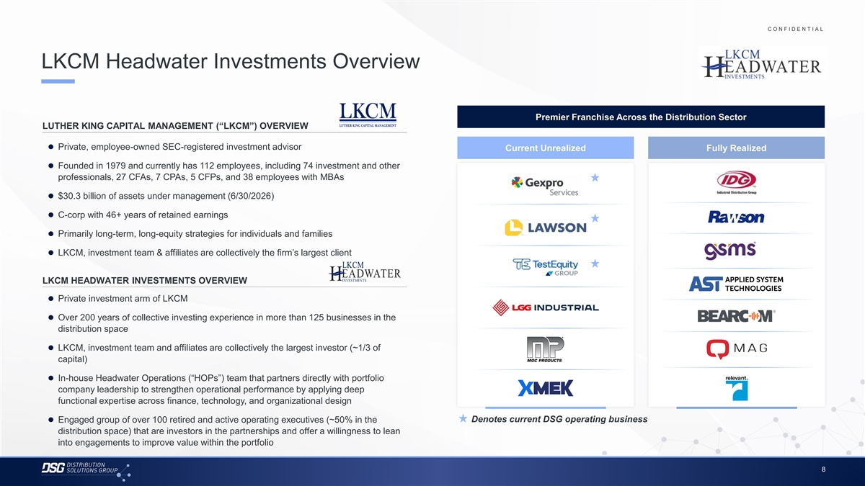
C O N F I D E N T I A L COLOR PALETTE Text 50 56 62 LKCM Headwater Investments Overview Title bar/Bullets 68 87 128 ACCENTS 2 85 25 141 Premier Franchise Across the Distribution Sector 1 70 250 LUTHER KING CAPITAL MANAGEMENT (“LKCM”) OVERVIEW 68 173 87 185 2 ⚫ Private, employee-owned SEC-registered investment advisor Current Unrealized Fully Realized 128 211 142 210 ⚫ Founded in 1979 and currently has 112 employees, including 74 investment and other 169 221 3 216 239 professionals, 27 CFAs, 7 CPAs, 5 CFPs, and 38 employees with MBAs 255 255 196 231⚫ $30.3 billion of assets under management (6/30/2026) 4 38 168 239 249⚫ C-corp with 46+ years of retained earnings 129 205 5 35 167 ⚫ Primarily long-term, long-equity strategies for individuals and families 213 238 213 238 6 ⚫ LKCM, investment team & affiliates are collectively the firm’s largest client 214 239 30 146 124 213 Hyperlink LKCM HEADWATER INVESTMENTS OVERVIEW 153 234 0 98 Followed⚫ Private investment arm of LKCM 80 205 Hyperlink 117 255 ⚫ Over 200 years of collective investing experience in more than 125 businesses in the TABLE distribution space 50 Lines 56 62⚫ LKCM, investment team and affiliates are collectively the largest investor (~1/3 of capital) 68 Highlights 87 128 ⚫ In-house Headwater Operations (“HOPs”) team that partners directly with portfolio company leadership to strengthen operational performance by applying deep functional expertise across finance, technology, and organizational design Denotes current DSG operating business ⚫ Engaged group of over 100 retired and active operating executives (~50% in the distribution space) that are investors in the partnerships and offer a willingness to lean into engagements to improve value within the portfolio 8

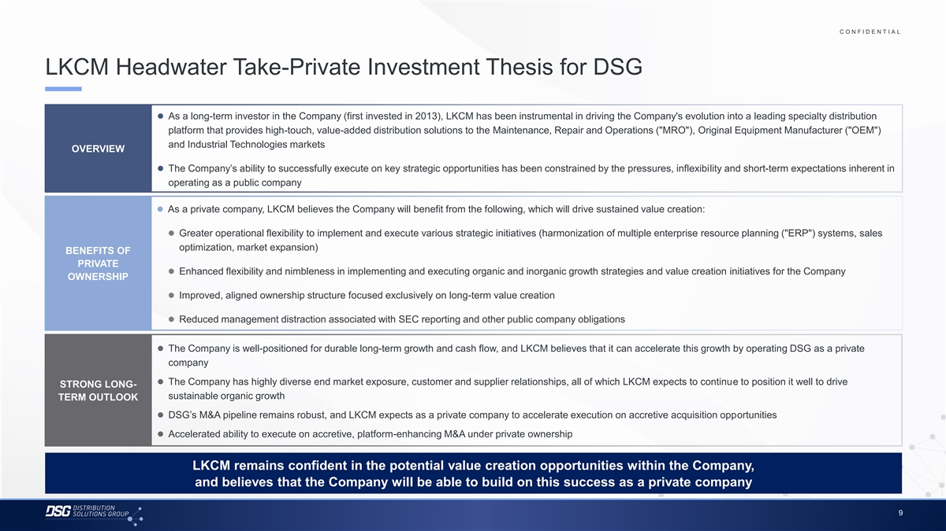
C O N F I D E N T I A L COLOR PALETTE Text 50 56 62 LKCM Headwater Take-Private Investment Thesis for DSG Title bar/Bullets 68 87 128 ACCENTS ⚫ As a long-term investor in the Company (first invested in 2013), LKCM has been instrumental in driving the Company's evolution into a leading specialty distribution 2 85 25 141 1 platform that provides high-touch, value-added distribution solutions to the Maintenance, Repair and Operations ( MRO ), Original Equipment Manufacturer ( OEM ) 70 250 and Industrial Technologies markets 68 173 OVERVIEW 87 185 2 128 211 ⚫ The Company’s ability to successfully execute on key strategic opportunities has been constrained by the pressures, inflexibility and short-term expectations inherent in 142 210 operating as a public company 169 221 3 216 239 255 255 ⚫ As a private company, LKCM believes the Company will benefit from the following, which will drive sustained value creation: 196 231 4 38 168 ⚫ Greater operational flexibility to implement and execute various strategic initiatives (harmonization of multiple enterprise resource planning ( ERP ) systems, sales 239 249 129 205 5 optimization, market expansion) 35 167 BENEFITS OF PRIVATE 213 238 ⚫ Enhanced flexibility and nimbleness in implementing and executing organic and inorganic growth strategies and value creation initiatives for the Company 213 238 6 OWNERSHIP 214 239 30 146 ⚫ Improved, aligned ownership structure focused exclusively on long-term value creation 124 213 Hyperlink 153 234 ⚫ Reduced management distraction associated with SEC reporting and other public company obligations 0 98 Followed 80 205 Hyperlink 117 255 ⚫ The Company is well-positioned for durable long-term growth and cash flow, and LKCM believes that it can accelerate this growth by operating DSG as a private TABLE company 50 Lines 56 62 ⚫ The Company has highly diverse end market exposure, customer and supplier relationships, all of which LKCM expects to continue to position it well to drive STRONG LONG- sustainable organic growth 68 TERM OUTLOOK Highlights 87 128 ⚫ DSG’s M&A pipeline remains robust, and LKCM expects as a private company to accelerate execution on accretive acquisition opportunities ⚫ Accelerated ability to execute on accretive, platform-enhancing M&A under private ownership LKCM remains confident in the potential value creation opportunities within the Company, and believes that the Company will be able to build on this success as a private company 9

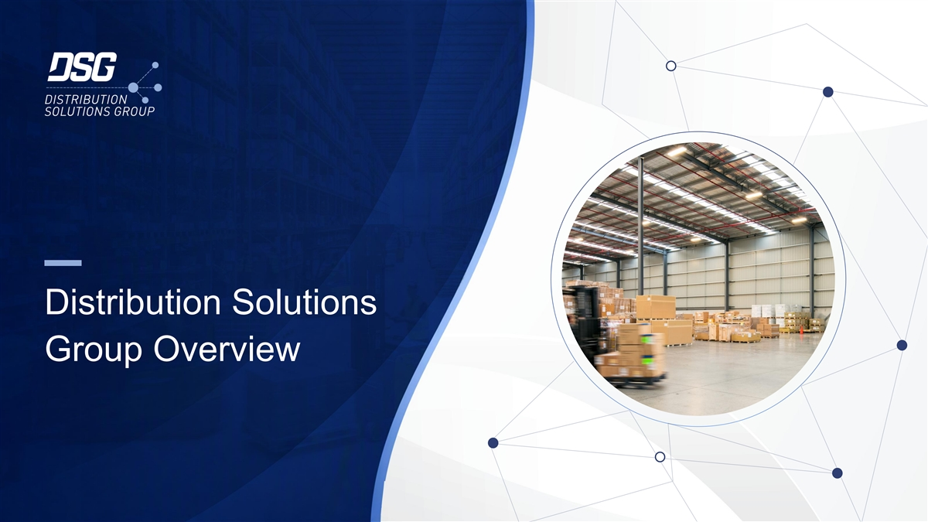
Distribution Solutions Group Overview

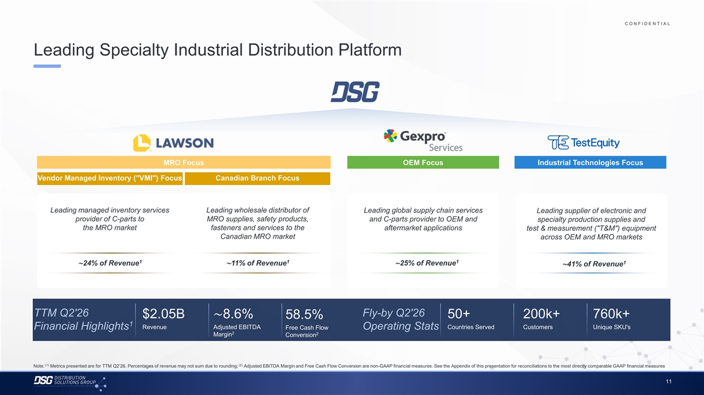
C O N F I D E N T I A L COLOR PALETTE Text 50 56 62 Leading Specialty Industrial Distribution Platform Title bar/Bullets 68 87 128 ACCENTS 2 85 25 141 1 70 250 68 173 87 185 2 128 211 142 210 169 221 3 216 239 255 255 196 231 4 MRO Focus OEM Focus Industrial Technologies Focus 38 168 239 249 Vendor Managed Inventory ( VMI ) Focus Canadian Branch Focus 129 205 5 35 167 213 238 213 238 6 214 239 Leading managed inventory services Leading wholesale distributor of Leading global supply chain services Leading supplier of electronic and 30 146 provider of C-parts to MRO supplies, safety products, and C-parts provider to OEM and specialty production supplies and 124 213 Hyperlink the MRO market fasteners and services to the aftermarket applications test & measurement ( T&M ) equipment 153 234 Canadian MRO market across OEM and MRO markets 0 98 Followed 80 205 Hyperlink 117 255 1 1 1 TABLE 1 ∼24% of Revenue∼11% of Revenue∼25% of Revenue ∼41% of Revenue 50 Lines 56 62 68 Highlights 87 128 TTM Q2'26 Fly-by Q2'26 $2.05B∼8.6% 50+ 200k+ 760k+ 58.5% 1 Revenue Adjusted EBITDA Countries Served Customers Unique SKU's Financial Highlights Free Cash Flow Operating Stats 2 2 Margin Conversion (1) (2) Note: Metrics presented are for TTM Q2’26. Percentages of revenue may not sum due to rounding; Adjusted EBITDA Margin and Free Cash Flow Conversion are non-GAAP financial measures. See the Appendix of this presentation for reconciliations to the most directly comparable GAAP financial measures 11

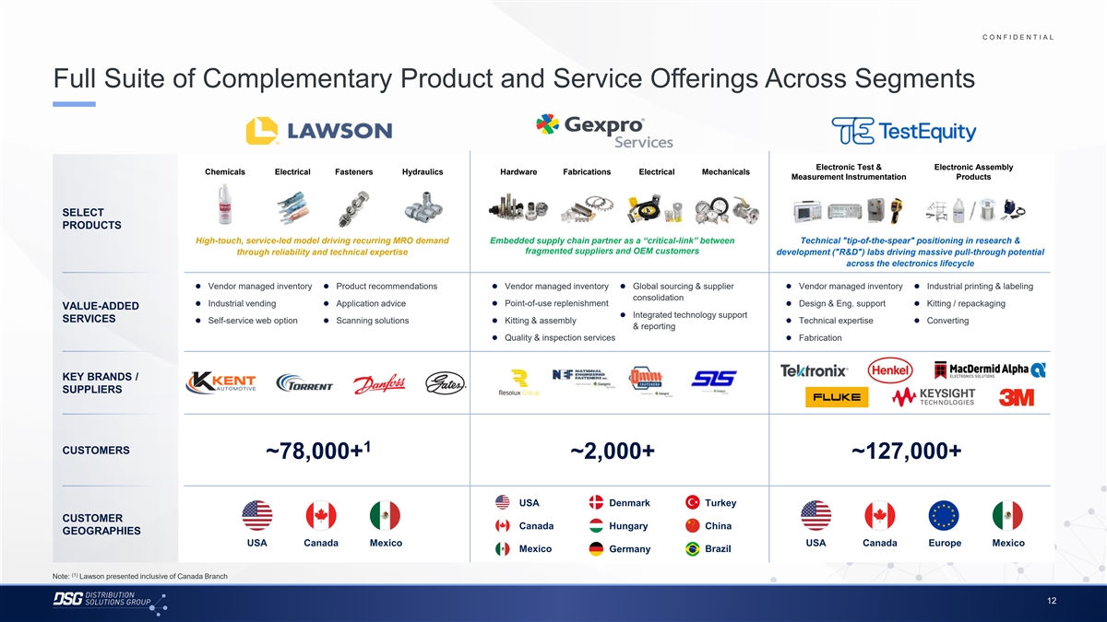
C O N F I D E N T I A L COLOR PALETTE Text 50 56 62 Full Suite of Complementary Product and Service Offerings Across Segments Title bar/Bullets 68 87 128 ACCENTS 2 85 25 141 1 70 250 Electronic Test & Electronic Assembly Chemicals Electrical Fasteners Hydraulics Hardware Fabrications Electrical Mechanicals 68 173 Measurement Instrumentation Products 87 185 2 128 211 142 210 SELECT 169 221 3 PRODUCTS​ 216 239 High-touch, service-led model driving recurring MRO demand Embedded supply chain partner as a “critical-link” between Technical tip-of-the-spear positioning in research & 255 255 196 231 fragmented suppliers and OEM customers through reliability and technical expertise development ( R&D ) labs driving massive pull-through potential 4 38 168 across the electronics lifecycle 239 249 129 205⚫ Vendor managed inventory⚫ Product recommendations⚫ Vendor managed inventory⚫ Global sourcing & supplier⚫ Vendor managed inventory⚫ Industrial printing & labeling 5 35 167 consolidation ⚫ Industrial vending⚫ Application advice⚫ Point-of-use replenishment⚫ Design & Eng. support⚫ Kitting / repackaging VALUE-ADDED 213 238 ⚫ Integrated technology support 213 238 SERVICES ⚫ Self-service web option⚫ Scanning solutions⚫ Kitting & assembly⚫ Technical expertise⚫ Converting 6 & reporting 214 239 ⚫ Quality & inspection services⚫ Fabrication 30 146 124 213 Hyperlink l 153 234 KEY BRANDS / 0 98 Followed 80 205 SUPPLIERS​ Hyperlink 117 255 TABLE 50 Lines 56 62 1 CUSTOMERS ~78,000+ ~2,000+ ~127,000+ 68 Highlights 87 128 USA Denmark Turkey CUSTOMER Canada Hungary China GEOGRAPHIES USA Canada Mexico USA Canada Europe Mexico Mexico Germany Brazil (1) Note: Lawson presented inclusive of Canada Branch 12

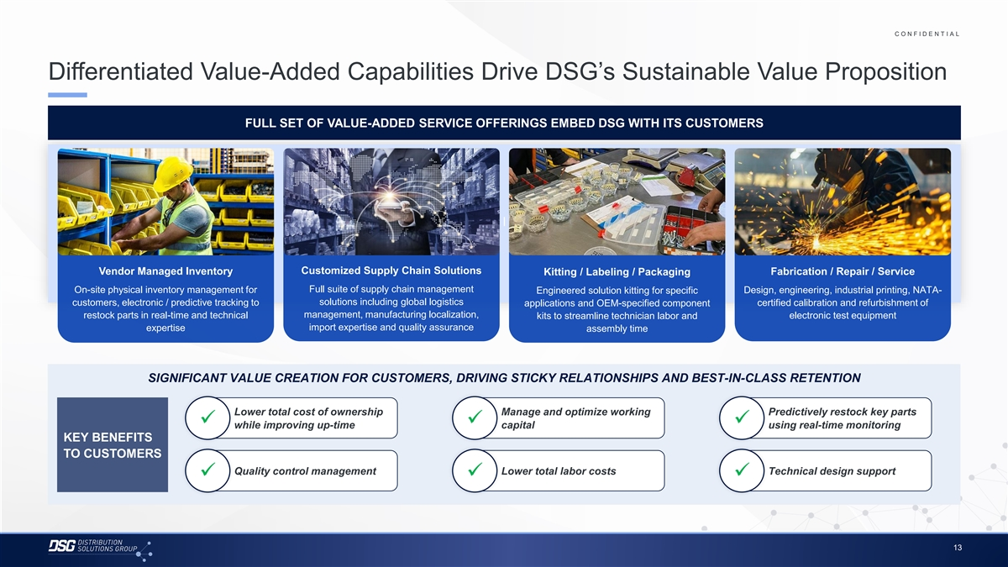
C O N F I D E N T I A L COLOR PALETTE Text 50 56 62 Differentiated Value-Added Capabilities Drive DSG’s Sustainable Value Proposition Title bar/Bullets 68 87 128 ACCENTS FULL SET OF VALUE-ADDED SERVICE OFFERINGS EMBED DSG WITH ITS CUSTOMERS 2 85 25 141 1 70 250 68 173 87 185 2 128 211 142 210 169 221 3 216 239 255 255 l 196 231 4 38 168 239 249 129 205 5 35 167 Customized Supply Chain Solutions Vendor Managed Inventory Fabrication / Repair / Service Kitting / Labeling / Packaging 213 238 Full suite of supply chain management On-site physical inventory management for Design, engineering, industrial printing, NATA- 213 238 Engineered solution kitting for specific 6 214 239 customers, electronic / predictive tracking to solutions including global logistics applications and OEM-specified component certified calibration and refurbishment of 30 146 management, manufacturing localization, restock parts in real-time and technical electronic test equipment kits to streamline technician labor and 124 213 Hyperlink expertise import expertise and quality assurance assembly time 153 234 0 98 Followed 80 205 Hyperlink 117 255 TABLE SIGNIFICANT VALUE CREATION FOR CUSTOMERS, DRIVING STICKY RELATIONSHIPS AND BEST-IN-CLASS RETENTION 50 Lines 56 62 Lower total cost of ownership Manage and optimize working Predictively restock key parts ✓✓✓ 68 while improving up-time capital using real-time monitoring Highlights 87 KEY BENEFITS 128 TO CUSTOMERS Quality control management Lower total labor costs Technical design support ✓✓✓ 13

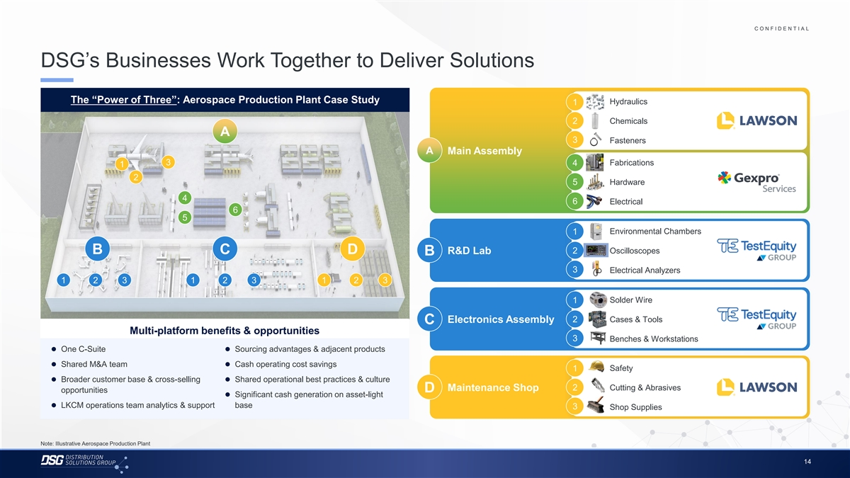
C O N F I D E N T I A L COLOR PALETTE Text 50 56 62 DSG’s Businesses Work Together to Deliver Solutions Title bar/Bullets 68 87 128 ACCENTS The “Power of Three”: Aerospace Production Plant Case Study Hydraulics 1 2 85 25 141 1 70 250 2 Chemicals A 68 173 3 Fasteners 87 185 2 128 211 A Main Assembly 142 210 3 Fabrications 4 1 169 221 3 216 239 2 5 Hardware 255 255 196 231 4 4 38 168 6 Electrical 6 239 249 5 129 205 5 35 167 Environmental Chambers 1 213 238 213 238 6 2 Oscilloscopes 214 239 B C D R&D Lab B 30 146 3 Electrical Analyzers 124 213 Hyperlink 153 234 1 2 3 1 2 3 1 2 3 0 98 Followed 80 205 Solder Wire 1 Hyperlink 117 255 TABLE 2 Cases & Tools Electronics Assembly C 50 Multi-platform benefits & opportunities Lines 56 3 Benches & Workstations 62 ⚫ One C-Suite⚫ Sourcing advantages & adjacent products 68 Highlights 87⚫ Shared M&A team⚫ Cash operating cost savings Safety 1 128 ⚫ Broader customer base & cross-selling⚫ Shared operational best practices & culture 2 Cutting & Abrasives Maintenance Shop D opportunities ⚫ Significant cash generation on asset-light ⚫ LKCM operations team analytics & support base 3 Shop Supplies Note: Illustrative Aerospace Production Plant 14

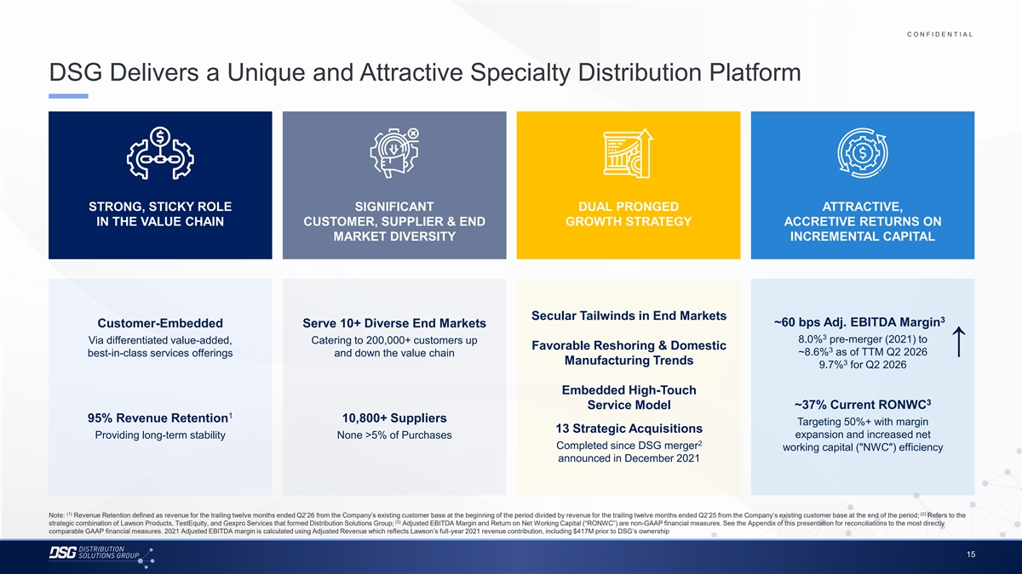
C O N F I D E N T I A L COLOR PALETTE Text 50 56 62 DSG Delivers a Unique and Attractive Specialty Distribution Platform Title bar/Bullets 68 87 128 ACCENTS 2 85 25 141 1 70 250 68 173 87 185 2 128 211 142 210 169 221 3 STRONG, STICKY ROLE SIGNIFICANT DUAL PRONGED ATTRACTIVE, 216 239 IN THE VALUE CHAIN CUSTOMER, SUPPLIER & END GROWTH STRATEGY ACCRETIVE RETURNS ON 255 255 196 231 4 MARKET DIVERSITY INCREMENTAL CAPITAL 38 168 239 249 129 205 5 35 167 213 238 213 238 6 214 239 Secular Tailwinds in End Markets 30 146 3 ~60 bps Adj. EBITDA Margin Customer-Embedded Serve 10+ Diverse End Markets 124 213 Hyperlink 153 234 3 8.0% pre-merger (2021) to Via differentiated value-added, Catering to 200,000+ customers up Favorable Reshoring & Domestic ↑ 0 98 3 ~8.6% as of TTM Q2 2026 Followed best-in-class services offerings and down the value chain 80 205 Hyperlink Manufacturing Trends 3 117 255 9.7% for Q2 2026 TABLE Embedded High-Touch 50 3 Lines 56 Service Model ~37% Current RONWC 62 1 95% Revenue Retention 10,800+ Suppliers Targeting 50%+ with margin 68 13 Strategic Acquisitions Providing long-term stability None >5% of Purchases expansion and increased net Highlights 87 2 128 Completed since DSG merger working capital ( NWC ) efficiency announced in December 2021 (1) (2) Note: Revenue Retention defined as revenue for the trailing twelve months ended Q2’26 from the Company’s existing customer base at the beginning of the period divided by revenue for the trailing twelve months ended Q2’25 from the Company’s existing customer base at the end of the period; Refers to the (3) strategic combination of Lawson Products, TestEquity, and Gexpro Services that formed Distribution Solutions Group; Adjusted EBITDA Margin and Return on Net Working Capital (“RONWC”) are non-GAAP financial measures. See the Appendix of this presentation for reconciliations to the most directly comparable GAAP financial measures. 2021 Adjusted EBITDA margin is calculated using Adjusted Revenue which reflects Lawson’s full-year 2021 revenue contribution, including $417M prior to DSG’s ownership 15

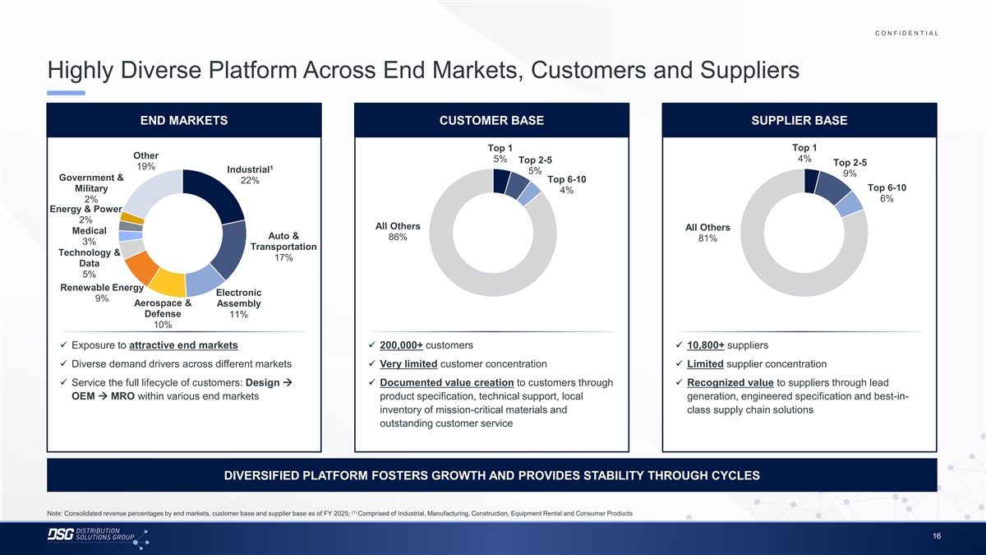
C O N F I D E N T I A L COLOR PALETTE Text 50 56 62 Highly Diverse Platform Across End Markets, Customers and Suppliers Title bar/Bullets 68 87 128 ACCENTS END MARKETS CUSTOMER BASE SUPPLIER BASE 2 85 25 141 1 70 250 Top 1 Top 1 68 173 Other 5% 4% Top 2-5 Top 2-5 87 185 2 19% 1 Industrial 5% 128 211 9% Government & Top 6-10 22% 142 210 Top 6-10 Military 4% 169 221 3 6% 2% 216 239 Energy & Power 255 255 2% 196 231 4 All Others All Others Medical 38 168 Auto & 86% 81% 3% 239 249 Transportation Technology & 129 205 5 17% 35 167 Data 5% 213 238 213 238 6 Renewable Energy 214 239 Electronic 9% Aerospace & Assembly 30 146 Defense 124 213 11% Hyperlink 153 234 10% 0 98 Followed 80 205✓ Exposure to attractive end markets✓ 200,000+ customers✓ 10,800+ suppliers Hyperlink 117 255 ✓ Diverse demand drivers across different markets✓ Very limited customer concentration✓ Limited supplier concentration TABLE 50 ✓ Service the full lifecycle of customers: Design →✓ Documented value creation to customers through✓ Recognized value to suppliers through lead Lines 56 OEM → MRO within various end markets product specification, technical support, local generation, engineered specification and best-in- 62 inventory of mission-critical materials and class supply chain solutions 68 Highlights 87 outstanding customer service 128 DIVERSIFIED PLATFORM FOSTERS GROWTH AND PROVIDES STABILITY THROUGH CYCLES (1) Note: Consolidated revenue percentages by end markets, customer base and supplier base as of FY 2025; Comprised of Industrial, Manufacturing, Construction, Equipment Rental and Consumer Products 16

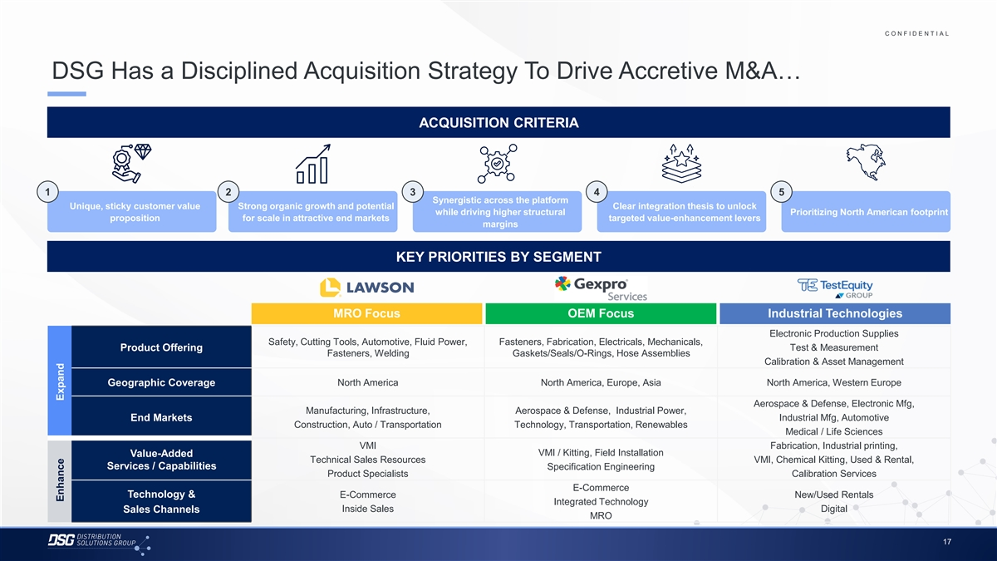
C O N F I D E N T I A L COLOR PALETTE Text 50 56 62 DSG Has a Disciplined Acquisition Strategy To Drive Accretive M&A… Title bar/Bullets 68 87 128 ACCENTS ACQUISITION CRITERIA 2 85 25 141 1 70 250 68 173 87 185 2 128 211 142 210 1 2 3 4 5 169 221 3 Synergistic across the platform 216 239 Unique, sticky customer value Strong organic growth and potential Clear integration thesis to unlock while driving higher structural Prioritizing North American footprint 255 255 proposition for scale in attractive end markets targeted value-enhancement levers margins 196 231 4 38 168 239 249 129 205 KEY PRIORITIES BY SEGMENT 5 35 167 213 238 213 238 6 214 239 30 146 MRO Focus OEM Focus Industrial Technologies 124 213 Hyperlink 153 234 Electronic Production Supplies 0 98 Safety, Cutting Tools, Automotive, Fluid Power, Fasteners, Fabrication, Electricals, Mechanicals, Followed Test & Measurement Product Offering 80 205 Hyperlink Fasteners, Welding Gaskets/Seals/O-Rings, Hose Assemblies 117 255 Calibration & Asset Management TABLE Geographic Coverage North America North America, Europe, Asia North America, Western Europe 50 Lines 56 62 Aerospace & Defense, Electronic Mfg, Manufacturing, Infrastructure, Aerospace & Defense, Industrial Power, Industrial Mfg, Automotive End Markets 68 Construction, Auto / Transportation Technology, Transportation, Renewables Highlights 87 Medical / Life Sciences 128 VMI Fabrication, Industrial printing, VMI / Kitting, Field Installation Value-Added Technical Sales Resources VMI, Chemical Kitting, Used & Rental, Services / Capabilities Specification Engineering Product Specialists Calibration Services E-Commerce Technology & E-Commerce New/Used Rentals Integrated Technology Inside Sales Digital Sales Channels MRO 17 Enhance Expand

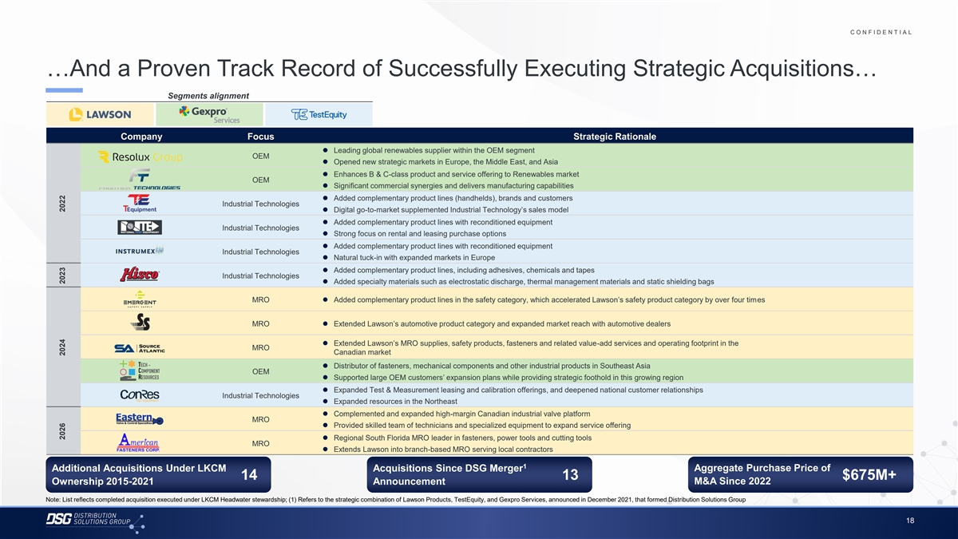
C O N F I D E N T I A L COLOR PALETTE …And a Proven Track Record of Successfully Executing Strategic Acquisitions… Text 50 56 62 …And a Proven Track Record of Successfully Executing Strategic Acquisitions… Title bar/Bullets 68 87 128 Segments alignment ACCENTS 2 85 25 141 1 70 250 Company Focus Strategic Rationale ⚫ Leading global renewables supplier within the OEM segment 68 173 OEM 87 185 2 ⚫ Opened new strategic markets in Europe, the Middle East, and Asia 128 211 ⚫ Enhances B & C-class product and service offering to Renewables market OEM 142 210 ⚫ Significant commercial synergies and delivers manufacturing capabilities 169 221 3 216 239 ⚫ Added complementary product lines (handhelds), brands and customers Industrial Technologies ⚫ Digital go-to-market supplemented Industrial Technology’s sales model 255 255 196 231 4 ⚫ Added complementary product lines with reconditioned equipment 38 168 Industrial Technologies ⚫ Strong focus on rental and leasing purchase options 239 249 ⚫ Added complementary product lines with reconditioned equipment 129 205 5 Industrial Technologies 35 167 ⚫ Natural tuck-in with expanded markets in Europe 213 238 ⚫ Added complementary product lines, including adhesives, chemicals and tapes Industrial Technologies 213 238 6 ⚫ Added specialty materials such as electrostatic discharge, thermal management materials and static shielding bags 214 239 30 146 MRO⚫ Added complementary product lines in the safety category, which accelerated Lawson’s safety product category by over four times 124 213 Hyperlink 153 234 MRO⚫ Extended Lawson’s automotive product category and expanded market reach with automotive dealers 0 98 Followed 80 205 Hyperlink 117 255⚫ Extended Lawson’s MRO supplies, safety products, fasteners and related value-add services and operating footprint in the MRO Canadian market TABLE ⚫ Distributor of fasteners, mechanical components and other industrial products in Southeast Asia 50 OEM ⚫ Supported large OEM customers’ expansion plans while providing strategic foothold in this growing region Lines 56 62 ⚫ Expanded Test & Measurement leasing and calibration offerings, and deepened national customer relationships Industrial Technologies ⚫ Expanded resources in the Northeast 68 Highlights 87 ⚫ Complemented and expanded high-margin Canadian industrial valve platform 128 MRO ⚫ Provided skilled team of technicians and specialized equipment to expand service offering ⚫ Regional South Florida MRO leader in fasteners, power tools and cutting tools MRO ⚫ Extends Lawson into branch-based MRO serving local contractors 1 Additional Acquisitions Under LKCM Acquisitions Since DSG Merger Aggregate Purchase Price of 14 13 $675M+ M&A Since 2022 Ownership 2015-2021 Announcement Note: List reflects completed acquisition executed under LKCM Headwater stewardship; (1) Refers to the strategic combination of Lawson Products, TestEquity, and Gexpro Services, announced in December 2021, that formed Distribution Solutions Group 18 2026 2024 2023 2022

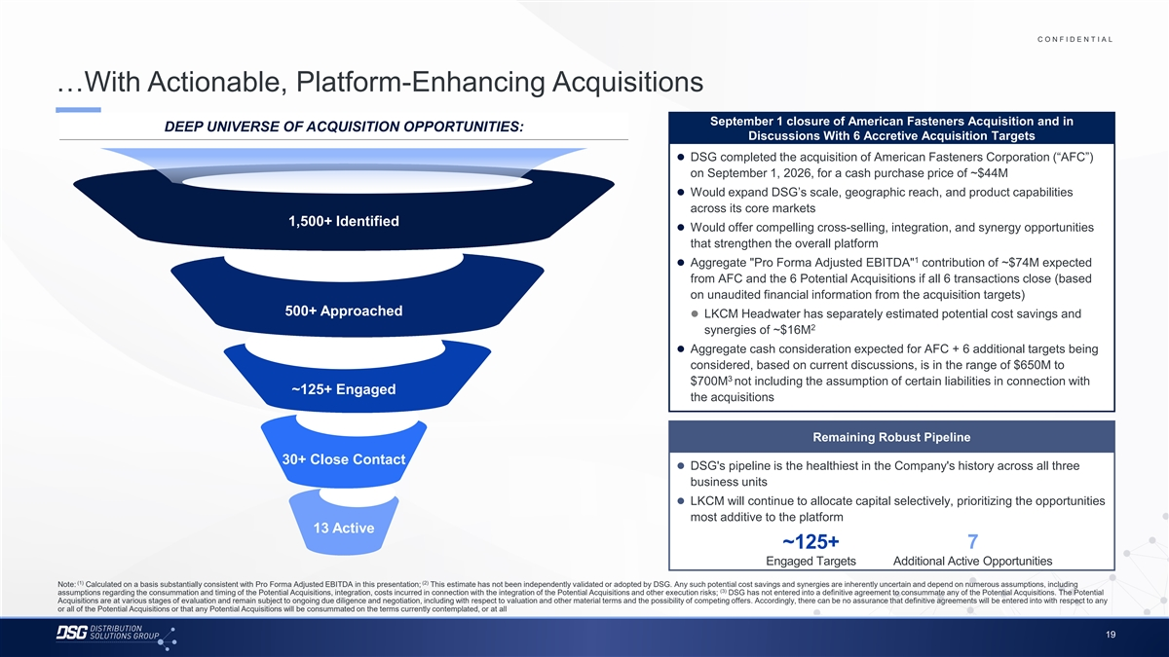
C O N F I D E N T I A L COLOR PALETTE Text 50 56 62 …With Actionable, Platform-Enhancing Acquisitions Title bar/Bullets 68 87 128 September 1 closure of American Fasteners Acquisition and in DEEP UNIVERSE OF ACQUISITION OPPORTUNITIES: ACCENTS Discussions With 6 Accretive Acquisition Targets 2 85 25 141⚫ DSG completed the acquisition of American Fasteners Corporation (“AFC”) 1 70 250 on September 1, 2026, for a cash purchase price of ~$44M 68 173 ⚫ Would expand DSG’s scale, geographic reach, and product capabilities 87 185 2 128 211 across its core markets 142 210 1,500+ Identified ⚫ Would offer compelling cross-selling, integration, and synergy opportunities 169 221 3 216 239 that strengthen the overall platform 255 255 1 ⚫ Aggregate Pro Forma Adjusted EBITDA contribution of ~$74M expected 196 231 4 38 168 from AFC and the 6 Potential Acquisitions if all 6 transactions close (based 239 249 on unaudited financial information from the acquisition targets) 129 205 5 35 167 500+ Approached ⚫ LKCM Headwater has separately estimated potential cost savings and 2 213 238 synergies of ~$16M 213 238 6 214 239 ⚫ Aggregate cash consideration expected for AFC + 6 additional targets being 30 146 considered, based on current discussions, is in the range of $650M to 124 213 Hyperlink 3 $700M not including the assumption of certain liabilities in connection with 153 234 ~125+ Engaged the acquisitions 0 98 Followed 80 205 Hyperlink 117 255 TABLE Remaining Robust Pipeline 50 30+ Close Contact Lines 56 ⚫ DSG's pipeline is the healthiest in the Company's history across all three 62 business units 68 Highlights 87⚫ LKCM will continue to allocate capital selectively, prioritizing the opportunities 128 most additive to the platform 13 Active ~125+ 7 Engaged Targets Additional Active Opportunities (1) (2) Note: Calculated on a basis substantially consistent with Pro Forma Adjusted EBITDA in this presentation; This estimate has not been independently validated or adopted by DSG. Any such potential cost savings and synergies are inherently uncertain and depend on numerous assumptions, including (3) assumptions regarding the consummation and timing of the Potential Acquisitions, integration, costs incurred in connection with the integration of the Potential Acquisitions and other execution risks; DSG has not entered into a definitive agreement to consummate any of the Potential Acquisitions. The Potential Acquisitions are at various stages of evaluation and remain subject to ongoing due diligence and negotiation, including with respect to valuation and other material terms and the possibility of competing offers. Accordingly, there can be no assurance that definitive agreements will be entered into with respect to any or all of the Potential Acquisitions or that any Potential Acquisitions will be consummated on the terms currently contemplated, or at all 19

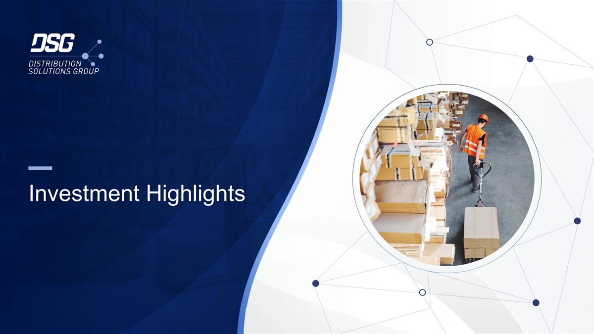
Investment Highlights

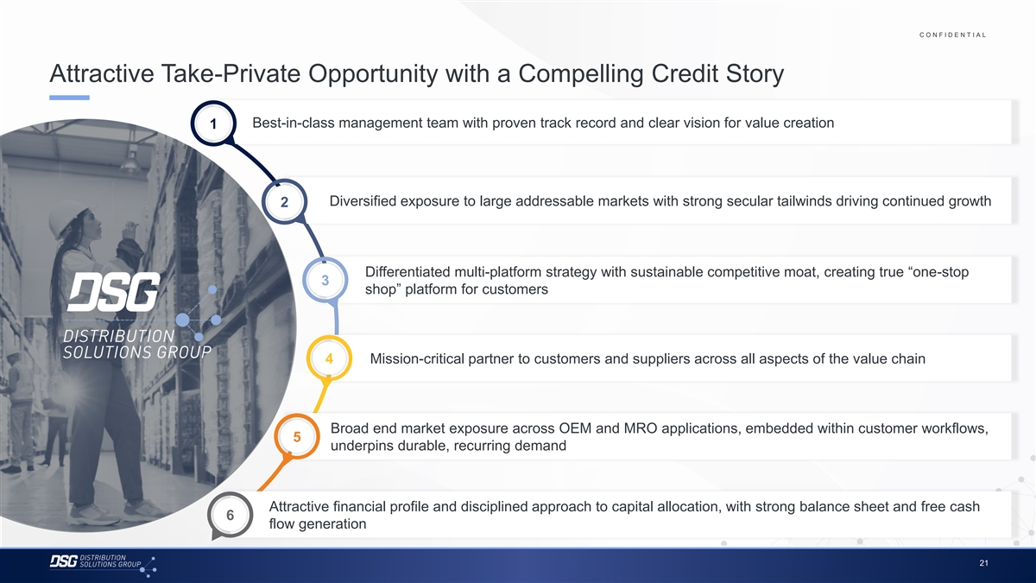
C O N F I D E N T I A L COLOR PALETTE Text 50 56 62 Attractive Take-Private Opportunity with a Compelling Credit Story Title bar/Bullets 68 87 128 ACCENTS Best-in-class management team with proven track record and clear vision for value creation 1 2 85 25 141 1 70 250 68 173 87 185 2 128 211 142 210 Diversified exposure to large addressable markets with strong secular tailwinds driving continued growth 169 221 2 3 216 239 255 255 196 231 4 38 168 239 249 129 205 5 Differentiated multi-platform strategy with sustainable competitive moat, creating true “one-stop 35 167 3 213 238 shop” platform for customers 213 238 6 214 239 30 146 124 213 Hyperlink 153 234 0 98 Followed 4 Mission-critical partner to customers and suppliers across all aspects of the value chain 80 205 Hyperlink 117 255 TABLE 50 Lines 56 62 Broad end market exposure across OEM and MRO applications, embedded within customer workflows, 68 5 Highlights 87 underpins durable, recurring demand 128 Attractive financial profile and disciplined approach to capital allocation, with strong balance sheet and free cash 6 flow generation 21

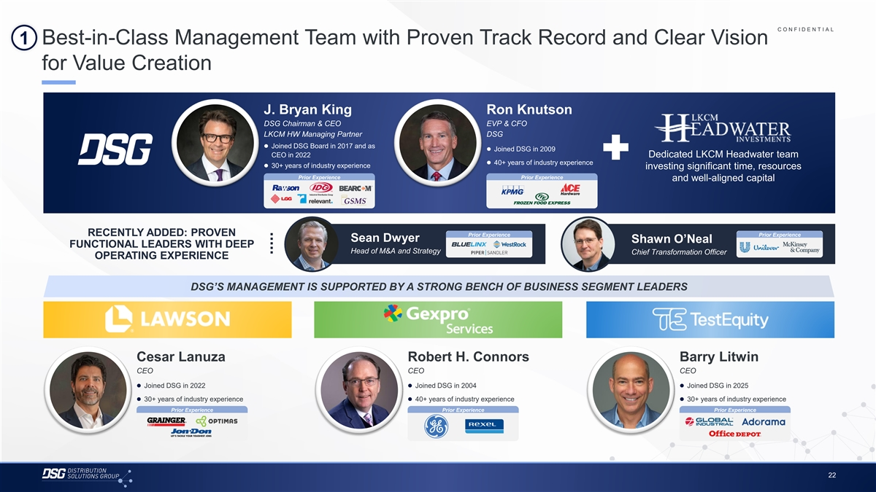
C O N F I D E N T I A L COLOR PALETTE 1 Best-in-Class Management Team with Proven Track Record and Clear Vision Text 50 56 62 for Value Creation Title bar/Bullets 68 87 128 ACCENTS 2 85 J. Bryan King Ron Knutson 25 141 1 DSG Chairman & CEO EVP & CFO 70 250 LKCM HW Managing Partner DSG 68 173 87 185⚫ Joined DSG Board in 2017 and as 2 ⚫ Joined DSG in 2009 128 211 CEO in 2022 Dedicated LKCM Headwater team ⚫ 40+ years of industry experience 142 210⚫ 30+ years of industry experience investing significant time, resources 169 221 3 Prior Experience Prior Experience 216 239 and well-aligned capital 255 255 196 231 4 38 168 239 249 129 205 5 35 167 RECENTLY ADDED: PROVEN Prior Experience Prior Experience Sean Dwyer Shawn O’Neal FUNCTIONAL LEADERS WITH DEEP 213 238 Head of M&A and Strategy Chief Transformation Officer 213 238 6 OPERATING EXPERIENCE 214 239 30 146 124 213 Hyperlink 153 234 DSG’S MANAGEMENT IS SUPPORTED BY A STRONG BENCH OF BUSINESS SEGMENT LEADERS 0 98 Followed 80 205 Hyperlink 117 255 TABLE 50 Lines 56 62 Cesar Lanuza Robert H. Connors Barry Litwin 68 CEO CEO CEO Highlights 87 128 ⚫ Joined DSG in 2022⚫ Joined DSG in 2004⚫ Joined DSG in 2025 ⚫ 30+ years of industry experience⚫ 40+ years of industry experience⚫ 30+ years of industry experience Prior Experience Prior Experience Prior Experience 22

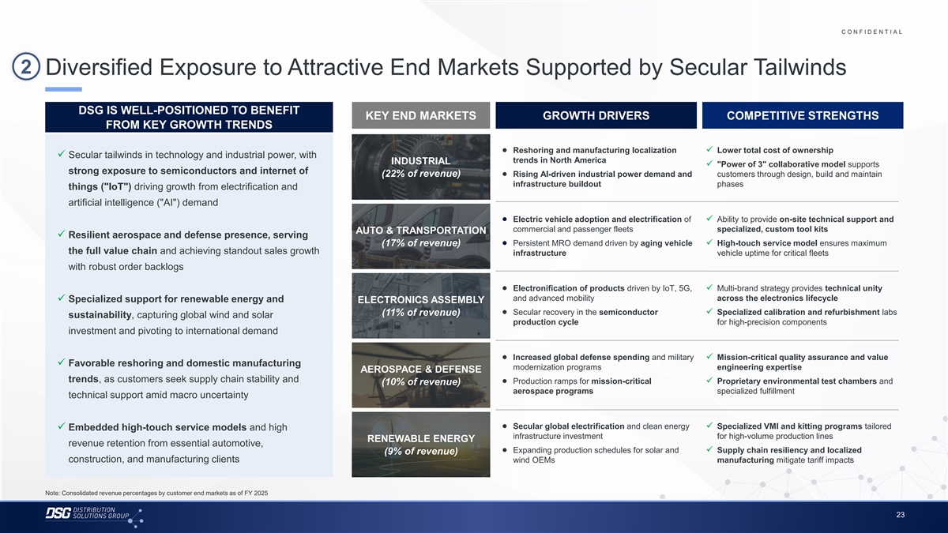
C O N F I D E N T I A L COLOR PALETTE Text 50 56 62 2 Diversified Exposure to Attractive End Markets Supported by Secular Tailwinds Title bar/Bullets 68 87 128 ACCENTS DSG IS WELL-POSITIONED TO BENEFIT KEY END MARKETS GROWTH DRIVERS COMPETITIVE STRENGTHS 2 85 FROM KEY GROWTH TRENDS 25 141 1 70 250 68 173 ● Reshoring and manufacturing localization✓ Lower total cost of ownership ✓ Secular tailwinds in technology and industrial power, with 87 185 2 trends in North America INDUSTRIAL ✓ Power of 3 collaborative model supports 128 211 strong exposure to semiconductors and internet of (22% of revenue) ● Rising AI-driven industrial power demand and customers through design, build and maintain 142 210 infrastructure buildout phases 169 221 things ( IoT ) driving growth from electrification and 3 216 239 artificial intelligence ( AI ) demand 255 255 196 231 4 ● Electric vehicle adoption and electrification of✓ Ability to provide on-site technical support and 38 168 commercial and passenger fleets specialized, custom tool kits AUTO & TRANSPORTATION ✓ Resilient aerospace and defense presence, serving 239 249 (17% of revenue) ● Persistent MRO demand driven by aging vehicle✓ High-touch service model ensures maximum 129 205 5 the full value chain and achieving standout sales growth 35 167 infrastructure vehicle uptime for critical fleets 213 238 with robust order backlogs 213 238 6 214 239 ● Electronification of products driven by IoT, 5G,✓ Multi-brand strategy provides technical unity 30 146 and advanced mobility across the electronics lifecycle ✓ Specialized support for renewable energy and ELECTRONICS ASSEMBLY 124 213 Hyperlink 153 234 ● Secular recovery in the semiconductor✓ Specialized calibration and refurbishment labs (11% of revenue) sustainability, capturing global wind and solar production cycle for high-precision components 0 98 Followed investment and pivoting to international demand 80 205 Hyperlink 117 255 TABLE ● Increased global defense spending and military✓ Mission-critical quality assurance and value ✓ Favorable reshoring and domestic manufacturing 50 modernization programs engineering expertise AEROSPACE & DEFENSE Lines 56 trends, as customers seek supply chain stability and ● Production ramps for mission-critical✓ Proprietary environmental test chambers and 62 (10% of revenue) aerospace programs specialized fulfillment technical support amid macro uncertainty 68 Highlights 87 128 ● Secular global electrification and clean energy✓ Specialized VMI and kitting programs tailored ✓ Embedded high-touch service models and high infrastructure investment for high-volume production lines RENEWABLE ENERGY revenue retention from essential automotive, ● Expanding production schedules for solar and✓ Supply chain resiliency and localized (9% of revenue) construction, and manufacturing clients wind OEMs manufacturing mitigate tariff impacts Note: Consolidated revenue percentages by customer end markets as of FY 2025 23

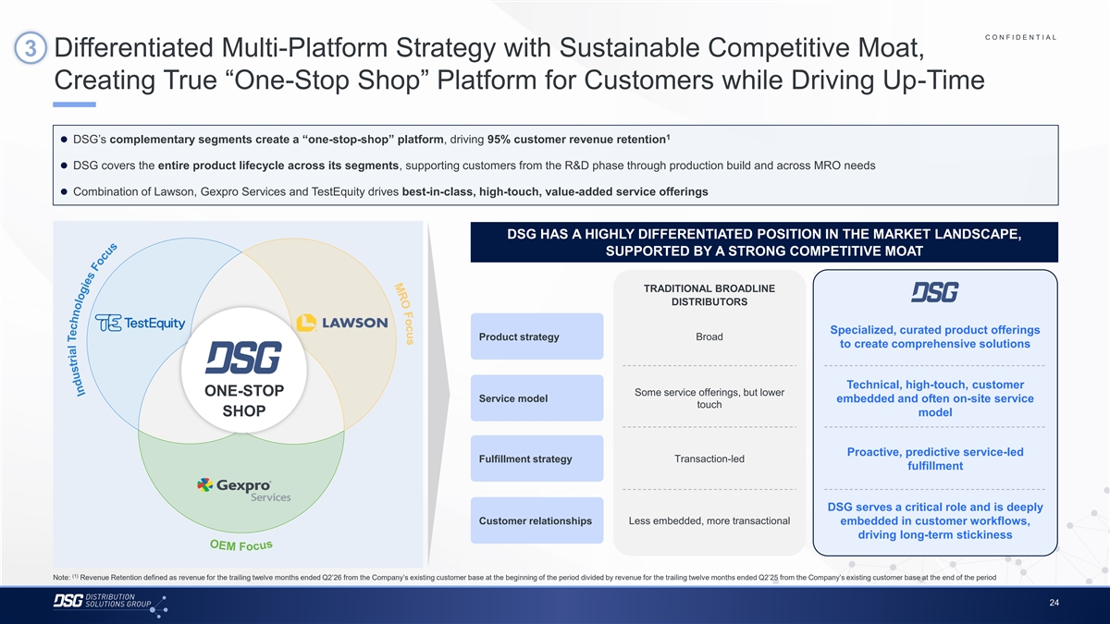
s u c o F O R M O E M C O N F I D E N T I A L COLOR PALETTE 3 Differentiated Multi-Platform Strategy with Sustainable Competitive Moat, Text 50 56 62 Creating True “One-Stop Shop” Platform for Customers while Driving Up-Time Title bar/Bullets 68 87 128 ACCENTS 1 ⚫ DSG’s complementary segments create a “one-stop-shop” platform, driving 95% customer revenue retention 2 85 25 141 1 70 250 ⚫ DSG covers the entire product lifecycle across its segments, supporting customers from the R&D phase through production build and across MRO needs 68 173 87 185 2 ⚫ Combination of Lawson, Gexpro Services and TestEquity drives best-in-class, high-touch, value-added service offerings 128 211 142 210 169 221 3 216 239 DSG HAS A HIGHLY DIFFERENTIATED POSITION IN THE MARKET LANDSCAPE, 255 255 196 231 SUPPORTED BY A STRONG COMPETITIVE MOAT 4 38 168 239 249 129 205 5 TRADITIONAL BROADLINE 35 167 DISTRIBUTORS 213 238 213 238 6 214 239 Specialized, curated product offerings Broad Product strategy to create comprehensive solutions 30 146 124 213 Hyperlink 153 234 0 98 Followed Technical, high-touch, customer 80 205 ONE-STOP Some service offerings, but lower Hyperlink 117 255 Service model embedded and often on-site service touch SHOP model TABLE 50 Lines 56 62 Proactive, predictive service-led Fulfillment strategy Transaction-led 68 fulfillment Highlights 87 128 DSG serves a critical role and is deeply Customer relationships Less embedded, more transactional embedded in customer workflows, driving long-term stickiness (1) Note: Revenue Retention defined as revenue for the trailing twelve months ended Q2’26 from the Company’s existing customer base at the beginning of the period divided by revenue for the trailing twelve months ended Q2’25 from the Company’s existing customer base at the end of the period 24 F o c u s s u c o F s e i g o l o n h c e T l a i r t s u d n I

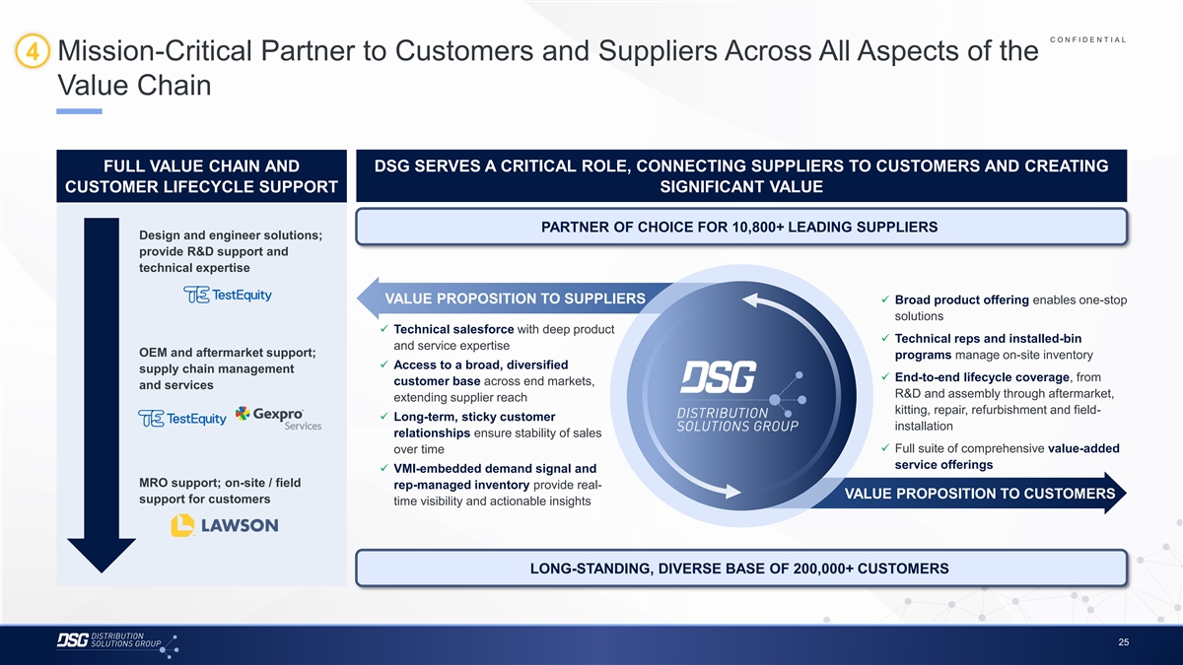
C O N F I D E N T I A L COLOR PALETTE 4 Mission-Critical Partner to Customers and Suppliers Across All Aspects of the Text 50 56 62 Value Chain Title bar/Bullets 68 87 128 ACCENTS 2 85 25 141 1 FULL VALUE CHAIN AND DSG SERVES A CRITICAL ROLE, CONNECTING SUPPLIERS TO CUSTOMERS AND CREATING 70 250 68 173 CUSTOMER LIFECYCLE SUPPORT SIGNIFICANT VALUE 87 185 2 128 211 142 210 PARTNER OF CHOICE FOR 10,800+ LEADING SUPPLIERS 169 221 3 Design and engineer solutions; 216 239 provide R&D support and 255 255 196 231 technical expertise 4 38 168 239 249 VALUE PROPOSITION TO SUPPLIERS✓ Broad product offering enables one-stop 129 205 5 35 167 solutions ✓ Technical salesforce with deep product 213 238 ✓ Technical reps and installed-bin 213 238 6 and service expertise 214 239 OEM and aftermarket support; programs manage on-site inventory ✓ Access to a broad, diversified 30 146 supply chain management 124 213 Hyperlink✓ End-to-end lifecycle coverage, from customer base across end markets, and services 153 234 R&D and assembly through aftermarket, extending supplier reach 0 98 Followed kitting, repair, refurbishment and field- 80 205 ✓ Long-term, sticky customer Hyperlink 117 255 installation relationships ensure stability of sales TABLE ✓ Full suite of comprehensive value-added over time 50 service offerings Lines 56 ✓ VMI-embedded demand signal and 62 MRO support; on-site / field rep-managed inventory provide real- VALUE PROPOSITION TO CUSTOMERS 68 support for customers time visibility and actionable insights Highlights 87 128 LONG-STANDING, DIVERSE BASE OF 200,000+ CUSTOMERS 25

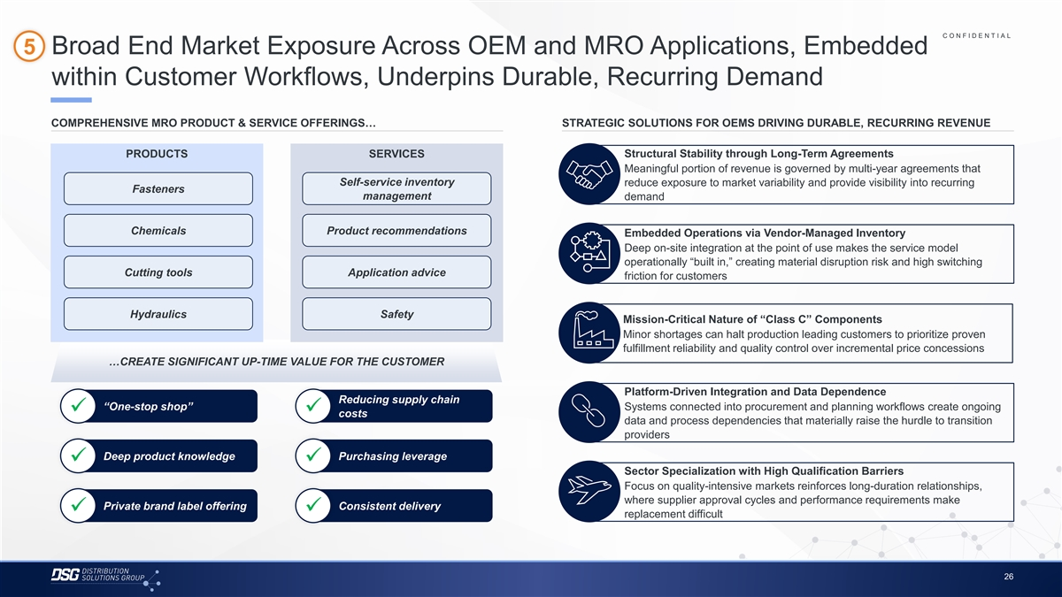
C O N F I D E N T I A L COLOR PALETTE 5 Broad End Market Exposure Across OEM and MRO Applications, Embedded Text 50 56 62 within Customer Workflows, Underpins Durable, Recurring Demand Title bar/Bullets 68 87 128 ACCENTS COMPREHENSIVE MRO PRODUCT & SERVICE OFFERINGS… STRATEGIC SOLUTIONS FOR OEMS DRIVING DURABLE, RECURRING REVENUE 2 85 25 141 1 70 250 PRODUCTS SERVICES Structural Stability through Long-Term Agreements 68 173 Meaningful portion of revenue is governed by multi-year agreements that 87 185 2 Self-service inventory reduce exposure to market variability and provide visibility into recurring 128 211 Fasteners management demand 142 210 169 221 3 216 239 Chemicals Product recommendations 255 255 Embedded Operations via Vendor-Managed Inventory 196 231 4 Deep on-site integration at the point of use makes the service model 38 168 operationally “built in,” creating material disruption risk and high switching 239 249 Cutting tools Application advice 129 205 5 friction for customers 35 167 213 238 213 238 6 214 239 Hydraulics Safety Mission-Critical Nature of “Class C” Components 30 146 Minor shortages can halt production leading customers to prioritize proven 124 213 Hyperlink 153 234 fulfillment reliability and quality control over incremental price concessions 0 98 …CREATE SIGNIFICANT UP-TIME VALUE FOR THE CUSTOMER Followed 80 205 Hyperlink 117 255 Platform-Driven Integration and Data Dependence TABLE Reducing supply chain “One-stop shop” Systems connected into procurement and planning workflows create ongoing 50 ✓✓ costs Lines 56 data and process dependencies that materially raise the hurdle to transition 62 providers 68 Highlights 87 Deep product knowledge Purchasing leverage ✓✓ 128 Sector Specialization with High Qualification Barriers Focus on quality-intensive markets reinforces long-duration relationships, where supplier approval cycles and performance requirements make Private brand label offering Consistent delivery ✓✓ replacement difficult 26

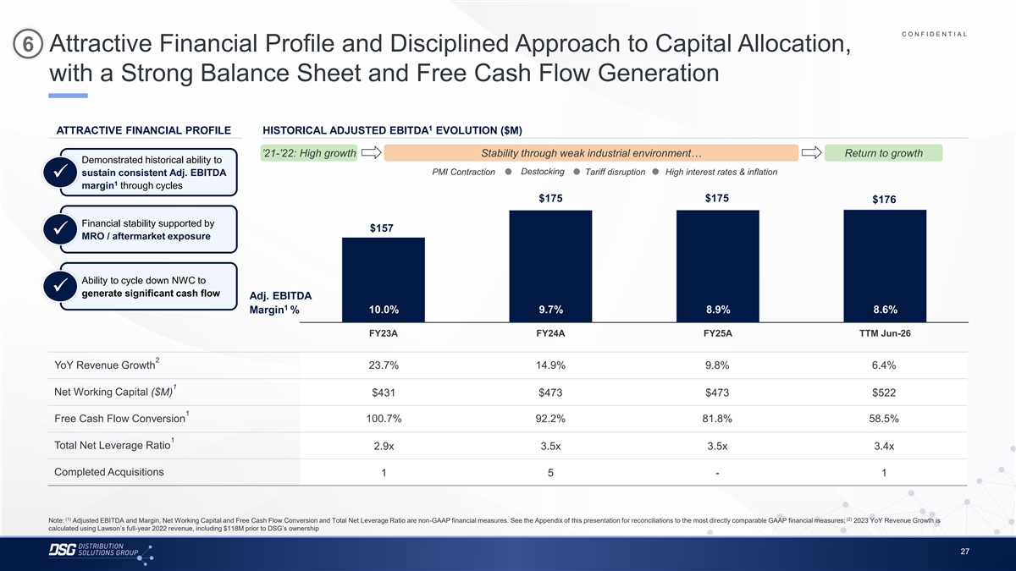
C O N F I D E N T I A L COLOR PALETTE 6 Attractive Financial Profile and Disciplined Approach to Capital Allocation, Text 50 56 62 with a Strong Balance Sheet and Free Cash Flow Generation Title bar/Bullets 68 87 128 ACCENTS 1 2 85 ATTRACTIVE FINANCIAL PROFILE HISTORICAL ADJUSTED EBITDA EVOLUTION ($M) 25 141 1 70 250 ’21-’22: High growth Stability through weak industrial environment… Return to growth 68 173 Demonstrated historical ability to 87 185 2 Destocking PMI Contraction Tariff disruption High interest rates & inflation sustain consistent Adj. EBITDA 128 211✓ 1 margin through cycles 142 210 $175 $175 169 221 $176 3 216 239 255 255 Financial stability supported by $157 196 231 4 ✓ MRO / aftermarket exposure 38 168 239 249 129 205 5 35 167 Ability to cycle down NWC to 213 238 ✓ 213 238 generate significant cash flow 6 Adj. EBITDA 214 239 1 10.0% 9.7% 8.9% 8.6% Margin % 30 146 124 213 Hyperlink 153 234 FY23A FY24A FY25A TTM Jun-26 0 98 Followed 80 205 2 Hyperlink 117 255 YoY Revenue Growth 23.7% 14.9% 9.8% 6.4% TABLE 1 50 Net Working Capital ($M) $431 $473 $473 $522 Lines 56 62 1 Free Cash Flow Conversion 100.7% 92.2% 81.8% 58.5% 68 Highlights 87 1 128 Total Net Leverage Ratio 2.9x 3.5x 3.5x 3.4x Completed Acquisitions 1 5 - 1 (1) (2) Note: Adjusted EBITDA and Margin, Net Working Capital and Free Cash Flow Conversion and Total Net Leverage Ratio are non-GAAP financial measures. See the Appendix of this presentation for reconciliations to the most directly comparable GAAP financial measures; 2023 YoY Revenue Growth is calculated using Lawson’s full-year 2022 revenue, including $118M prior to DSG’s ownership 27

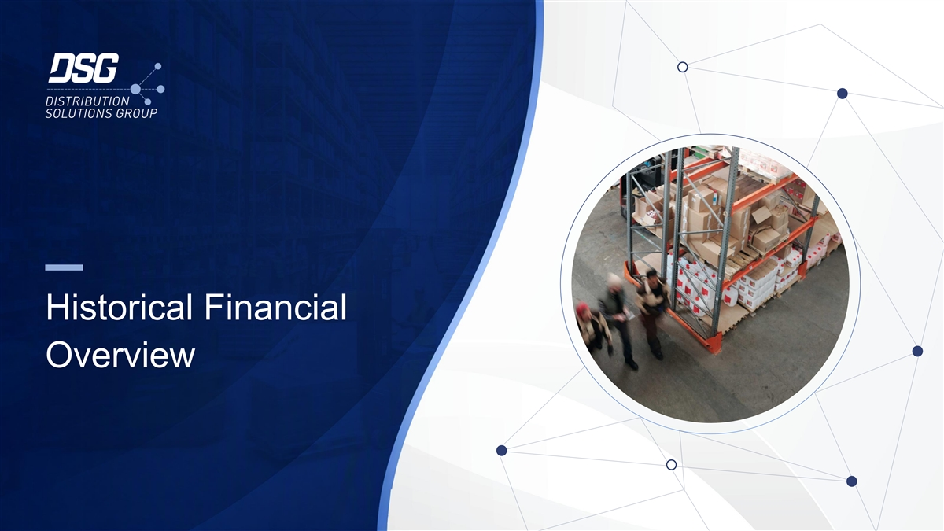
Historical Financial Overview

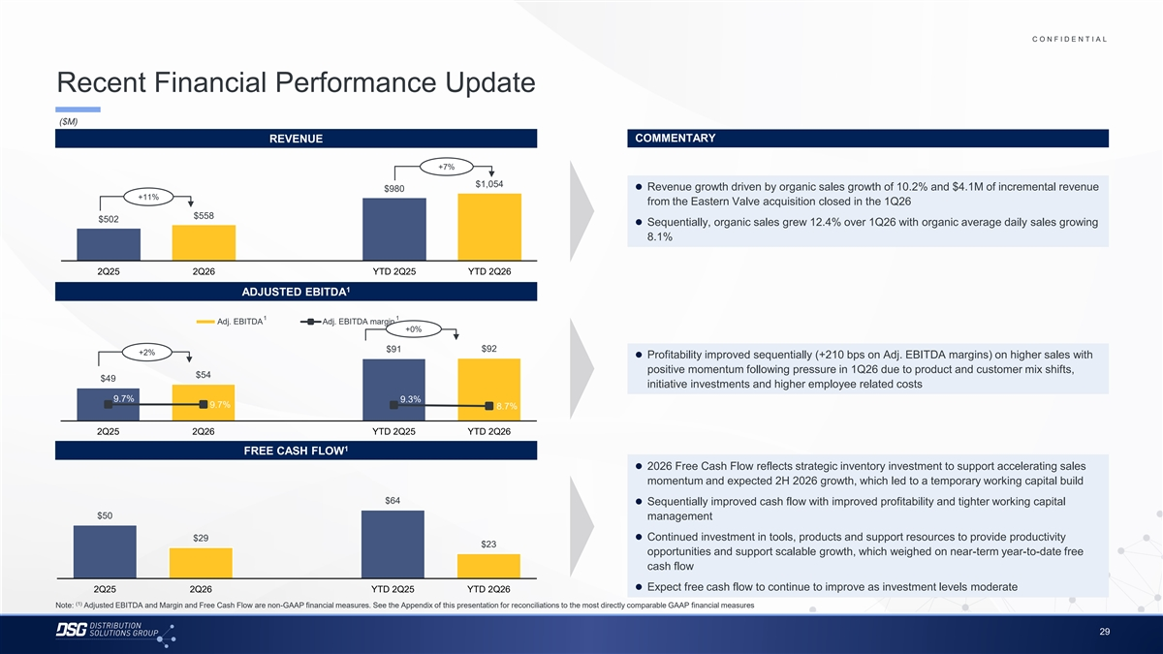
C O N F I D E N T I A L COLOR PALETTE Text 50 56 62 Recent Financial Performance Update Title bar/Bullets 68 87 128 ($M) ACCENTS REVENUE COMMENTARY 2 85 25 141 1 70 250 +7% 68 173 $1,054 ⚫ Revenue growth driven by organic sales growth of 10.2% and $4.1M of incremental revenue $980 87 185 2 +11% from the Eastern Valve acquisition closed in the 1Q26 128 211 $558 $502 142 210 ⚫ Sequentially, organic sales grew 12.4% over 1Q26 with organic average daily sales growing 169 221 3 8.1% 216 239 255 255 196 231 4 2Q25 2Q26 YTD 2Q25 YTD 2Q26 38 168 1 239 249 ADJUSTED EBITDA 129 205 5 35 167 1 1 Adj. EBITDA Adj. EBITDA margin 213 238 +0% 213 238 6 214 239 $91 $92 +2% ⚫ Profitability improved sequentially (+210 bps on Adj. EBITDA margins) on higher sales with 30 146 positive momentum following pressure in 1Q26 due to product and customer mix shifts, 124 213 Hyperlink $54 $49 153 234 initiative investments and higher employee related costs 0 98 9.7% 9.3% Followed 9.7% 8.7% 80 205 Hyperlink 117 255 2Q25 2Q26 YTD 2Q25 YTD 2Q26 TABLE 1 50 FREE CASH FLOW Lines 56 ⚫ 2026 Free Cash Flow reflects strategic inventory investment to support accelerating sales 62 momentum and expected 2H 2026 growth, which led to a temporary working capital build 68 Highlights 87 $64 ⚫ Sequentially improved cash flow with improved profitability and tighter working capital 128 $50 management $29⚫ Continued investment in tools, products and support resources to provide productivity $23 opportunities and support scalable growth, which weighed on near-term year-to-date free cash flow ⚫ Expect free cash flow to continue to improve as investment levels moderate 2Q25 2Q26 YTD 2Q25 YTD 2Q26 (1) Note: Adjusted EBITDA and Margin and Free Cash Flow are non-GAAP financial measures. See the Appendix of this presentation for reconciliations to the most directly comparable GAAP financial measures 29

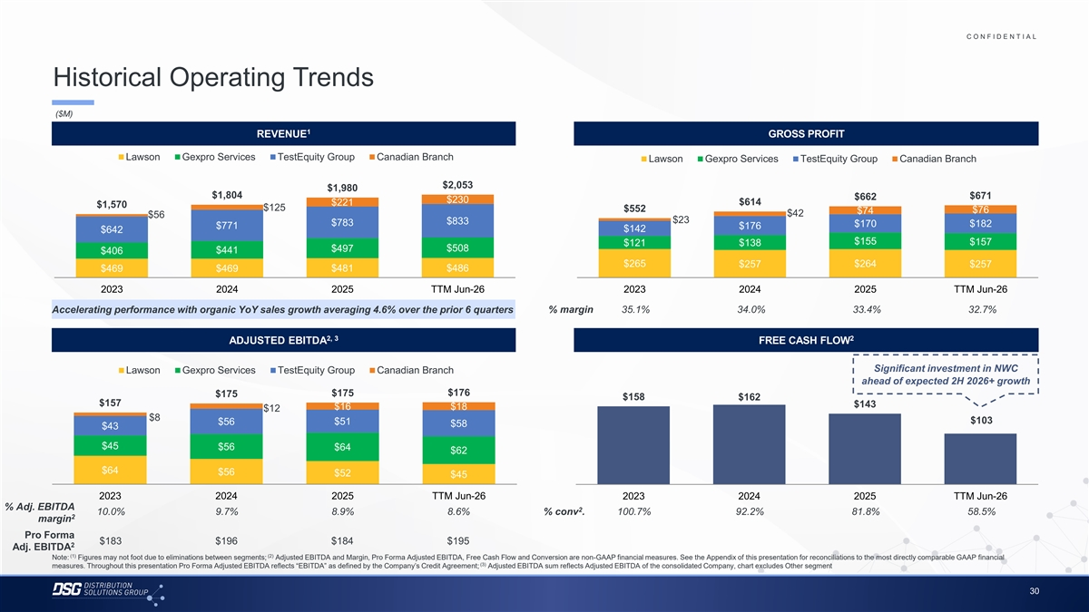
C O N F I D E N T I A L COLOR PALETTE Text 50 56 62 Historical Operating Trends Title bar/Bullets 68 87 128 ($M) ACCENTS 1 REVENUE GROSS PROFIT 2 85 25 141 1 70 250 Lawson Gexpro Services TestEquity Group Canadian Branch Lawson Gexpro Services TestEquity Group Canadian Branch 68 173 87 185 2 $2,053 $1,980 128 211 $1,804 $671 $662 $230 $614 $221 $1,570 142 210 $125 $552 $76 $74 $42 169 221 $56 3 $23 $833 216 239 $783 $170 $182 $771 $176 $142 $642 255 255 $155 $157 $121 $138 196 231 $508 4 $497 $441 $406 38 168 $265 $257 $264 $257 $469 $469 $481 $486 239 249 129 205 5 35 167 2023 2024 2025 TTM Jun-26 2023 2024 2025 TTM Jun-26 213 238 % margin 35.1% 34.0% 33.4% 32.7% Accelerating performance with organic YoY sales growth averaging 4.6% over the prior 6 quarters 213 238 6 214 239 2, 3 2 30 146 ADJUSTED EBITDA FREE CASH FLOW 124 213 Hyperlink 153 234 Significant investment in NWC Lawson Gexpro Services TestEquity Group Canadian Branch 0 98 Followed 80 205 ahead of expected 2H 2026+ growth Hyperlink 117 255 $176 $175 $175 $158 $162 $157 $143 TABLE $16 $18 $12 $8 50 $103 $56 $51 $58 $43 Lines 56 62 $45 $56 $64 $62 68 Highlights 87 $64 $56 $52 $45 128 2023 2024 2025 TTM Jun-26 2023 2024 2025 TTM Jun-26 % Adj. EBITDA 2 10.0% 9.7% 8.9% 8.6% % conv . 100.7% 92.2% 81.8% 58.5% 2 margin Pro Forma $183 $196 $184 $195 2 Adj. EBITDA (1) (2) Note: Figures may not foot due to eliminations between segments; Adjusted EBITDA and Margin, Pro Forma Adjusted EBITDA, Free Cash Flow and Conversion are non-GAAP financial measures. See the Appendix of this presentation for reconciliations to the most directly comparable GAAP financial (3) measures. Throughout this presentation Pro Forma Adjusted EBITDA reflects “EBITDA” as defined by the Company’s Credit Agreement; Adjusted EBITDA sum reflects Adjusted EBITDA of the consolidated Company, chart excludes Other segment 30

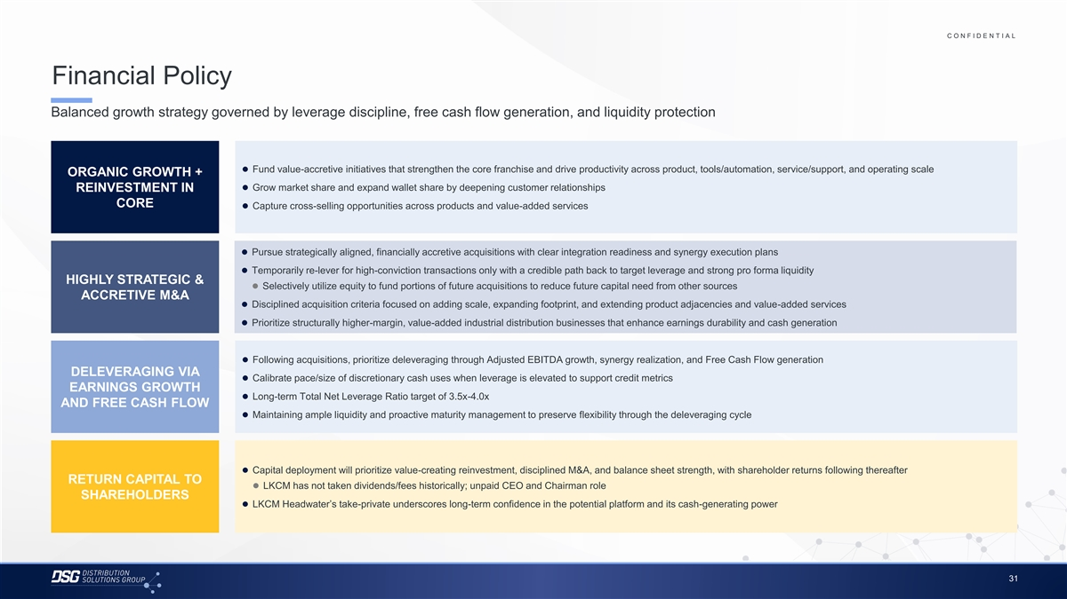
C O N F I D E N T I A L COLOR PALETTE Text 50 56 62 Financial Policy Title bar/Bullets 68 87 128 Balanced growth strategy governed by leverage discipline, free cash flow generation, and liquidity protection ACCENTS 2 85 25 141 1 70 250 68 173 ⚫ Fund value-accretive initiatives that strengthen the core franchise and drive productivity across product, tools/automation, service/support, and operating scale ORGANIC GROWTH + 87 185 2 128 211 ⚫ Grow market share and expand wallet share by deepening customer relationships REINVESTMENT IN 142 210 CORE ⚫ Capture cross-selling opportunities across products and value-added services 169 221 3 216 239 255 255 196 231 4 38 168 ⚫ Pursue strategically aligned, financially accretive acquisitions with clear integration readiness and synergy execution plans 239 249 ⚫ Temporarily re-lever for high-conviction transactions only with a credible path back to target leverage and strong pro forma liquidity 129 205 5 HIGHLY STRATEGIC & 35 167 ⚫ Selectively utilize equity to fund portions of future acquisitions to reduce future capital need from other sources ACCRETIVE M&A 213 238 ⚫ Disciplined acquisition criteria focused on adding scale, expanding footprint, and extending product adjacencies and value-added services 213 238 6 214 239 ⚫ Prioritize structurally higher-margin, value-added industrial distribution businesses that enhance earnings durability and cash generation 30 146 124 213 Hyperlink 153 234 ⚫ Following acquisitions, prioritize deleveraging through Adjusted EBITDA growth, synergy realization, and Free Cash Flow generation 0 98 Followed 80 205 DELEVERAGING VIA Hyperlink ⚫ Calibrate pace/size of discretionary cash uses when leverage is elevated to support credit metrics 117 255 EARNINGS GROWTH ⚫ Long-term Total Net Leverage Ratio target of 3.5x-4.0x TABLE AND FREE CASH FLOW 50 ⚫ Maintaining ample liquidity and proactive maturity management to preserve flexibility through the deleveraging cycle Lines 56 62 68 Highlights 87 128 ⚫ Capital deployment will prioritize value-creating reinvestment, disciplined M&A, and balance sheet strength, with shareholder returns following thereafter RETURN CAPITAL TO ⚫ LKCM has not taken dividends/fees historically; unpaid CEO and Chairman role SHAREHOLDERS ⚫ LKCM Headwater’s take-private underscores long-term confidence in the potential platform and its cash-generating power 31

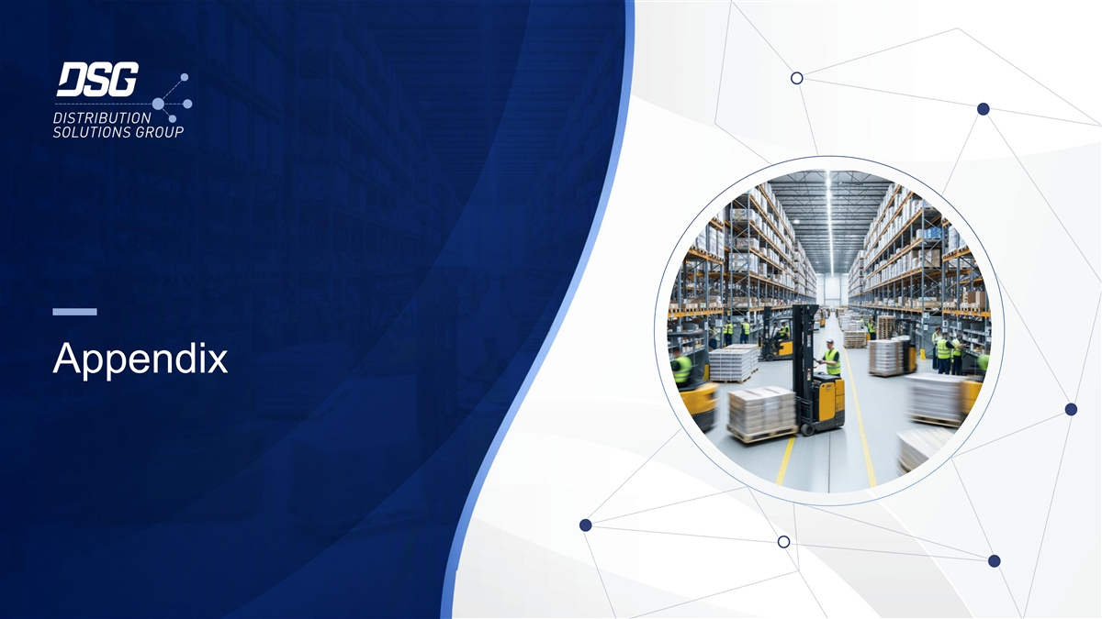
Appendix

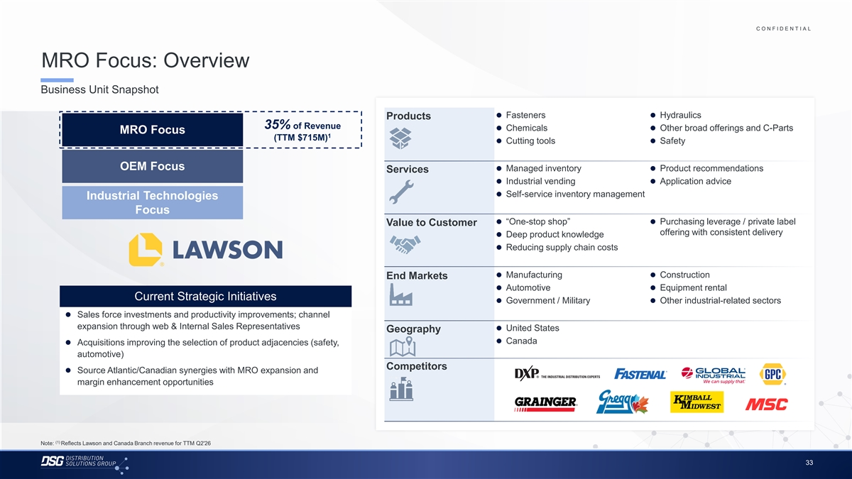
C O N F I D E N T I A L COLOR PALETTE Text 50 56 62 MRO Focus: Overview Title bar/Bullets 68 87 128 Business Unit Snapshot ACCENTS 2 85 25 141 ⚫ Fasteners⚫ Hydraulics 1 Products 70 250 35% of Revenue ⚫ Chemicals⚫ Other broad offerings and C-Parts MRO Focus 68 173 1 (TTM $715M) 87 185⚫ Cutting tools⚫ Safety 2 128 211 142 210 169 221 OEM Focus 3⚫ Managed inventory⚫ Product recommendations Services 216 239 ⚫ Industrial vending⚫ Application advice 255 255 196 231 4⚫ Self-service inventory management Industrial Technologies 38 168 Focus 239 249 129 205 5 ⚫ “One-stop shop”⚫ Purchasing leverage / private label Value to Customer 35 167 offering with consistent delivery ⚫ Deep product knowledge 213 238 213 238 6 ⚫ Reducing supply chain costs 214 239 30 146 124 213 Hyperlink ⚫ Manufacturing⚫ Construction End Markets 153 234 ⚫ Automotive⚫ Equipment rental 0 98 Followed Current Strategic Initiatives 80 205 ⚫ Government / Military⚫ Other industrial-related sectors Hyperlink 117 255 ⚫ Sales force investments and productivity improvements; channel TABLE expansion through web & Internal Sales Representatives ⚫ United States 50 Geography Lines 56 ⚫ Canada ⚫ Acquisitions improving the selection of product adjacencies (safety, 62 automotive) 68 Highlights 87 Competitors ⚫ Source Atlantic/Canadian synergies with MRO expansion and 128 margin enhancement opportunities (1) Note: Reflects Lawson and Canada Branch revenue for TTM Q2'26 33

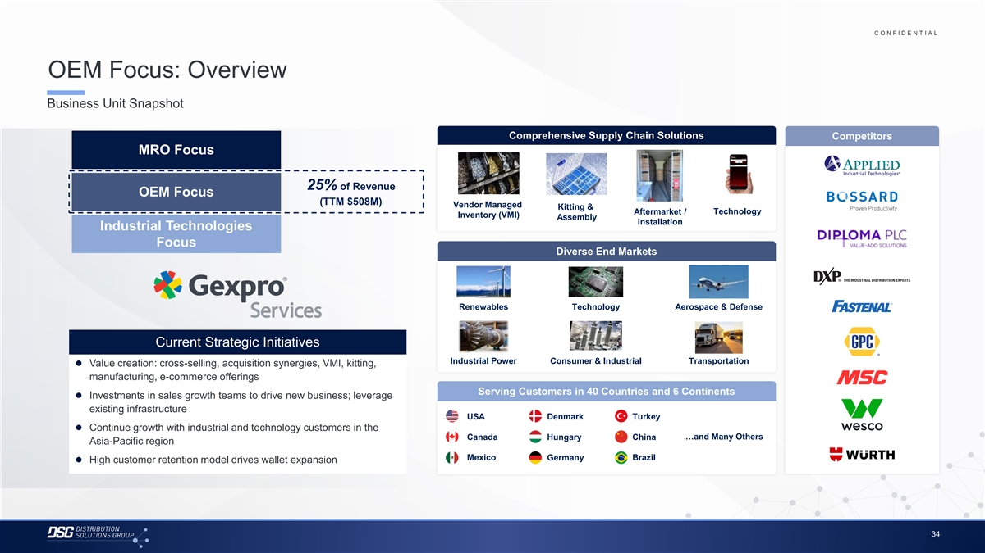
C O N F I D E N T I A L COLOR PALETTE Text 50 56 62 OEM Focus: Overview Title bar/Bullets 68 87 128 Business Unit Snapshot ACCENTS 2 85 25 141 1 Comprehensive Supply Chain Solutions Competitors 70 250 MRO Focus 68 173 87 185 2 128 211 142 210 25% of Revenue 169 221 OEM Focus 3 216 239 (TTM $508M) Vendor Managed Kitting & Aftermarket / Technology Inventory (VMI) 255 255 Assembly Installation 196 231 4 Industrial Technologies 38 168 Focus 239 249 Diverse End Markets 129 205 5 35 167 213 238 213 238 6 214 239 30 146 Renewables Technology Aerospace & Defense 124 213 Hyperlink 153 234 0 98 Followed Current Strategic Initiatives 80 205 Hyperlink 117 255 Industrial Power Consumer & Industrial Transportation ⚫ Value creation: cross-selling, acquisition synergies, VMI, kitting, TABLE manufacturing, e-commerce offerings 50 Lines 56 Serving Customers in 40 Countries and 6 Continents ⚫ Investments in sales growth teams to drive new business; leverage 62 existing infrastructure 68 USA Denmark Turkey Highlights 87 ⚫ Continue growth with industrial and technology customers in the 128 …and Many Others Canada Hungary China Asia-Pacific region Mexico Brazil Germany ⚫ High customer retention model drives wallet expansion 34

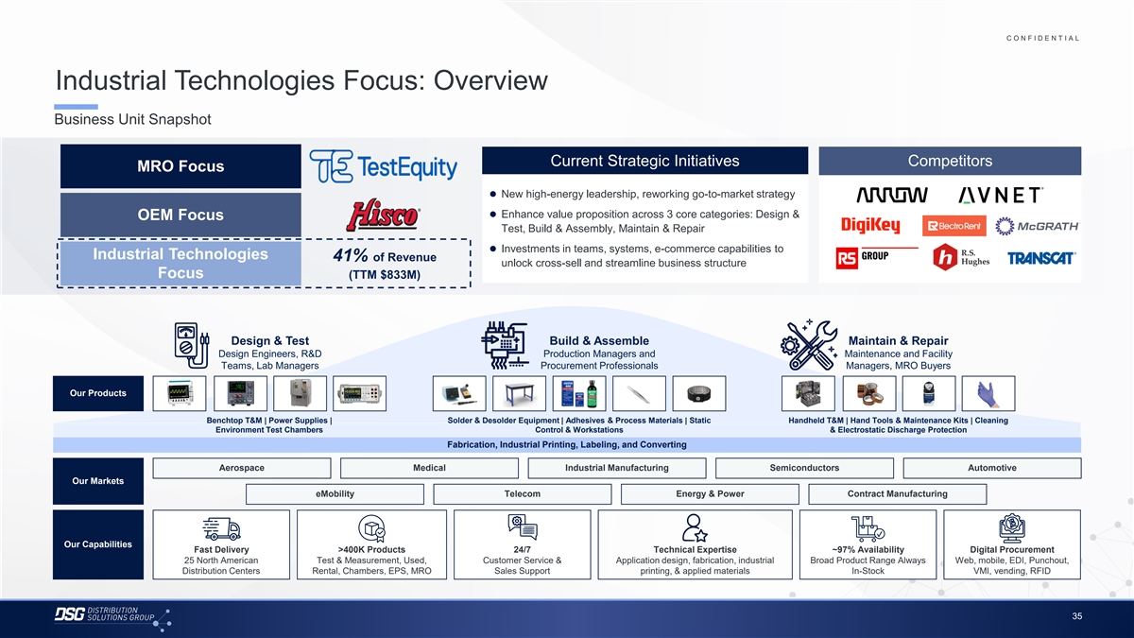
C O N F I D E N T I A L COLOR PALETTE Text 50 56 62 Industrial Technologies Focus: Overview Title bar/Bullets 68 87 128 Business Unit Snapshot ACCENTS 2 85 25 141 1 70 250 Current Strategic Initiatives Competitors MRO Focus 68 173 87 185 2 ⚫ New high-energy leadership, reworking go-to-market strategy 128 211 142 210⚫ Enhance value proposition across 3 core categories: Design & OEM Focus 169 221 3 Test, Build & Assembly, Maintain & Repair 216 239 255 255⚫ Investments in teams, systems, e-commerce capabilities to Industrial Technologies 196 231 41% of Revenue 4 unlock cross-sell and streamline business structure 38 168 Focus (TTM $833M) 239 249 129 205 5 35 167 213 238 213 238 6 214 239 Design & Test Build & Assemble Maintain & Repair 30 146 Design Engineers, R&D Production Managers and Maintenance and Facility 124 213 Hyperlink Teams, Lab Managers Procurement Professionals Managers, MRO Buyers 153 234 0 98 Followed Our Products 80 205 Hyperlink 117 255 Benchtop T&M | Power Supplies | Solder & Desolder Equipment | Adhesives & Process Materials | Static Handheld T&M | Hand Tools & Maintenance Kits | Cleaning TABLE Environment Test Chambers Control & Workstations & Electrostatic Discharge Protection 50 Fabrication, Industrial Printing, Labeling, and Converting Lines 56 62 Aerospace Medical Industrial Manufacturing Semiconductors Automotive 68 Our Markets Highlights 87 eMobility Telecom Energy & Power Contract Manufacturing 128 Our Capabilities Fast Delivery >400K Products 24/7 Technical Expertise ~97% Availability Digital Procurement 25 North American Test & Measurement, Used, Customer Service & Application design, fabrication, industrial Broad Product Range Always Web, mobile, EDI, Punchout, Distribution Centers Rental, Chambers, EPS, MRO Sales Support printing, & applied materials In-Stock VMI, vending, RFID 35

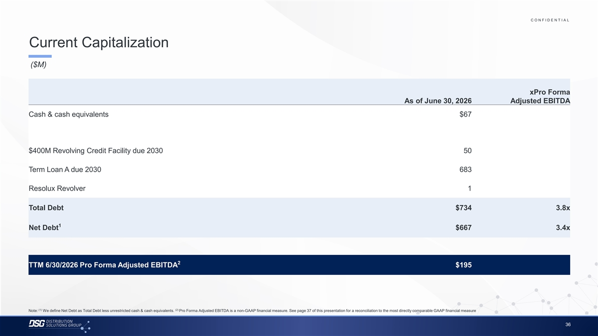
C O N F I D E N T I A L COLOR PALETTE Text 50 56 62 Current Capitalization Title bar/Bullets 68 87 128 ($M) ACCENTS 2 85 25 141 1 70 250 xPro Forma 68 173 87 185 2 As of June 30, 2026 Adjusted EBITDA 128 211 142 210 Cash & cash equivalents $67 169 221 3 216 239 255 255 196 231 4 38 168 239 249 $400M Revolving Credit Facility due 2030 50 129 205 5 35 167 213 238 Term Loan A due 2030 683 213 238 6 214 239 30 146 Resolux Revolver 1 124 213 Hyperlink 153 234 0 98 Followed Total Debt $734 3.8x 80 205 Hyperlink 117 255 TABLE 1 Net Debt $667 3.4x 50 Lines 56 62 68 Highlights 87 128 2 TTM 6/30/2026 Pro Forma Adjusted EBITDA $195 (1) (2) Note: We define Net Debt as Total Debt less unrestricted cash & cash equivalents. Pro Forma Adjusted EBITDA is a non-GAAP financial measure. See page 37 of this presentation for a reconciliation to the most directly comparable GAAP financial measure 36

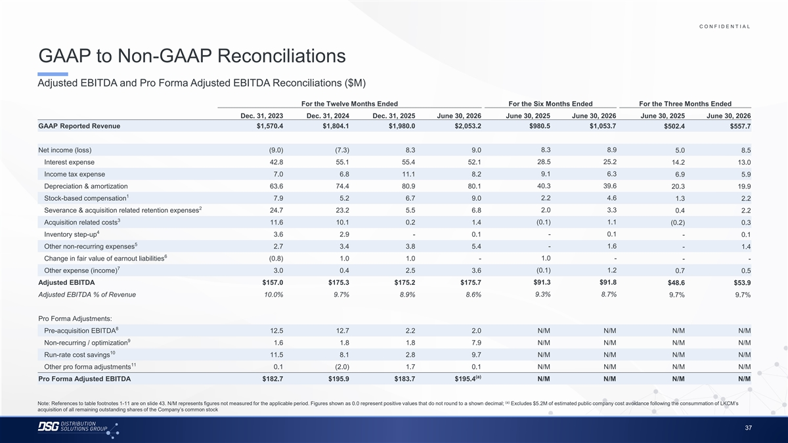
C O N F I D E N T I A L COLOR PALETTE Text 50 56 62 GAAP to Non-GAAP Reconciliations Title bar/Bullets 68 87 128 Adjusted EBITDA and Pro Forma Adjusted EBITDA Reconciliations ($M) ACCENTS 2 85 For the Twelve Months Ended For the Six Months Ended For the Three Months Ended 25 141 1 70 250 Dec. 31, 2023 Dec. 31, 2024 Dec. 31, 2025 June 30, 2026 June 30, 2025 June 30, 2026 June 30, 2025 June 30, 2026 68 173 GAAP Reported Revenue $1,570.4 $1,804.1 $1,980.0 $2,053.2 $980.5 $1,053.7 $502.4 $557.7 87 185 2 128 211 142 210 Net income (loss) (9.0) (7.3) 8.3 9.0 8.3 8.9 5.0 8.5 169 221 3 216 239 28.5 25.2 Interest expense 42.8 55.1 55.4 52.1 14.2 13.0 255 255 Income tax expense 7.0 6.8 11.1 8.2 9.1 6.3 6.9 5.9 196 231 4 38 168 40.3 39.6 Depreciation & amortization 63.6 74.4 80.9 80.1 20.3 19.9 1 239 249 Stock-based compensation 7.9 5.2 6.7 9.0 2.2 4.6 1.3 2.2 129 205 5 2 35 167 Severance & acquisition related retention expenses 24.7 23.2 5.5 6.8 2.0 3.3 0.4 2.2 3 213 238 (0.1) 1.1 Acquisition related costs 11.6 10.1 0.2 1.4 (0.2) 0.3 213 238 6 4 214 239 Inventory step-up 3.6 2.9 - 0.1 - 0.1 - 0.1 5 30 146 Other non-recurring expenses 2.7 3.4 3.8 5.4 - 1.6 - 1.4 124 213 Hyperlink 6 153 234 1.0 - Change in fair value of earnout liabilities (0.8) 1.0 1.0 - - - 7 0 98 Other expense (income) 3.0 0.4 2.5 3.6 (0.1) 1.2 0.7 0.5 Followed 80 205 Hyperlink 117 255 $91.3 $91.8 Adjusted EBITDA $157.0 $175.3 $175.2 $175.7 $48.6 $53.9 TABLE Adjusted EBITDA % of Revenue 10.0% 9.7% 8.9% 8.6% 9.3% 8.7% 9.7% 9.7% 50 Lines 56 62 Pro Forma Adjustments: 8 Pre-acquisition EBITDA 12.5 12.7 2.2 2.0 N/M N/M N/M N/M 68 Highlights 87 9 Non-recurring / optimization 1.6 1.8 1.8 7.9 N/M N/M N/M N/M 128 10 Run-rate cost savings 11.5 8.1 2.8 9.7 N/M N/M N/M N/M 11 Other pro forma adjustments 0.1 (2.0) 1.7 0.1 N/M N/M N/M N/M (a) Pro Forma Adjusted EBITDA $182.7 $195.9 $183.7 $195.4 N/M N/M N/M N/M (a) Note: References to table footnotes 1-11 are on slide 43. N/M represents figures not measured for the applicable period. Figures shown as 0.0 represent positive values that do not round to a shown decimal; Excludes $5.2M of estimated public company cost avoidance following the consummation of LKCM’s acquisition of all remaining outstanding shares of the Company’s common stock 37

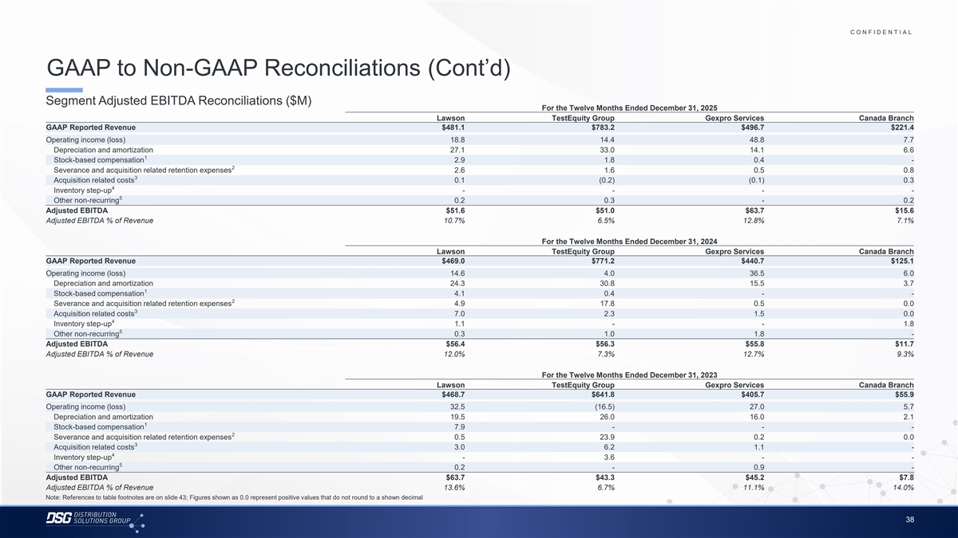
C O N F I D E N T I A L COLOR PALETTE Text 50 56 62 GAAP to Non-GAAP Reconciliations (Cont’d) Title bar/Bullets 68 87 128 Segment Adjusted EBITDA Reconciliations ($M) For the Twelve Months Ended December 31, 2025 ACCENTS Lawson TestEquity Group Gexpro Services Canada Branch 2 85 GAAP Reported Revenue $481.1 $783.2 $496.7 $221.4 25 141 1 70 250 Operating income (loss) 18.8 14.4 48.8 7.7 Depreciation and amortization 27.1 33.0 14.1 6.6 68 173 1 87 185 2 Stock-based compensation 2.9 1.8 0.4 - 128 211 2 Severance and acquisition related retention expenses 2.6 1.6 0.5 0.8 3 Acquisition related costs 0.1 (0.2) (0.1) 0.3 142 210 4 169 221 3 Inventory step-up - - - - 216 239 5 Other non-recurring 0.2 0.3 - 0.2 255 255 Adjusted EBITDA $51.6 $51.0 $63.7 $15.6 196 231 4 Adjusted EBITDA % of Revenue 10.7% 6.5% 12.8% 7.1% 38 168 239 249 For the Twelve Months Ended December 31, 2024 129 205 5 Lawson TestEquity Group Gexpro Services Canada Branch 35 167 GAAP Reported Revenue $469.0 $771.2 $440.7 $125.1 213 238 Operating income (loss) 14.6 4.0 36.5 6.0 213 238 6 Depreciation and amortization 24.3 30.8 15.5 3.7 214 239 1 Stock-based compensation 4.1 0.4 - - 30 146 2 Severance and acquisition related retention expenses 4.9 17.8 0.5 0.0 124 213 Hyperlink 3 153 234 Acquisition related costs 7.0 2.3 1.5 0.0 4 Inventory step-up 1.1 - - 1.8 0 98 5 Followed Other non-recurring 0.3 1.0 1.8 - 80 205 Hyperlink 117 255 Adjusted EBITDA $56.4 $56.3 $55.8 $11.7 Adjusted EBITDA % of Revenue 12.0% 7.3% 12.7% 9.3% TABLE 50 For the Twelve Months Ended December 31, 2023 Lines 56 Lawson TestEquity Group Gexpro Services Canada Branch 62 GAAP Reported Revenue $468.7 $641.8 $405.7 $55.9 68 Operating income (loss) 32.5 (16.5) 27.0 5.7 Highlights 87 Depreciation and amortization 19.5 26.0 16.0 2.1 128 1 Stock-based compensation 7.9 - - - 2 Severance and acquisition related retention expenses 0.5 23.9 0.2 0.0 3 Acquisition related costs 3.0 6.2 1.1 - 4 Inventory step-up - 3.6 - - 5 Other non-recurring 0.2 - 0.9 - Adjusted EBITDA $63.7 $43.3 $45.2 $7.8 Adjusted EBITDA % of Revenue 13.6% 6.7% 11.1% 14.0% Note: References to table footnotes are on slide 43; Figures shown as 0.0 represent positive values that do not round to a shown decimal 38

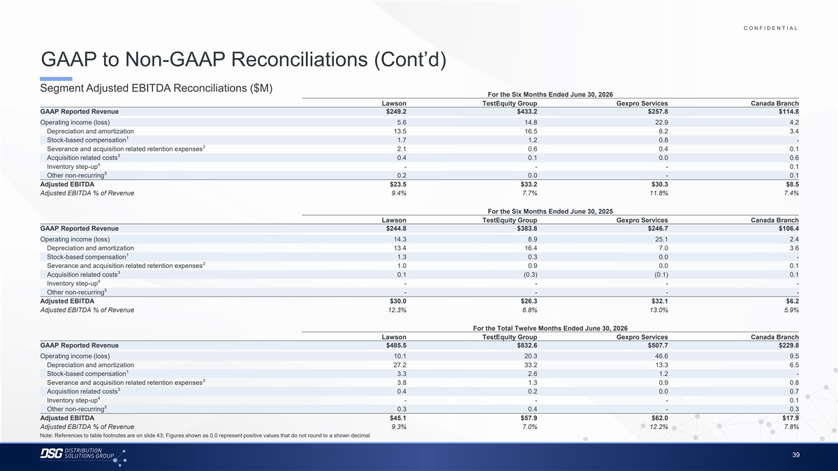
C O N F I D E N T I A L COLOR PALETTE Text 50 56 62 GAAP to Non-GAAP Reconciliations (Cont’d) Title bar/Bullets 68 87 128 Segment Adjusted EBITDA Reconciliations ($M) For the Six Months Ended June 30, 2026 ACCENTS Lawson TestEquity Group Gexpro Services Canada Branch 2 85 GAAP Reported Revenue $249.2 $433.2 $257.8 $114.8 25 141 1 70 250 Operating income (loss) 5.6 14.8 22.9 4.2 Depreciation and amortization 13.5 16.5 6.2 3.4 68 173 1 87 185 2 Stock-based compensation 1.7 1.2 0.8 - 128 211 2 Severance and acquisition related retention expenses 2.1 0.6 0.4 0.1 3 Acquisition related costs 0.4 0.1 0.0 0.6 142 210 4 169 221 3 Inventory step-up - - - 0.1 216 239 5 Other non-recurring 0.2 0.0 - 0.1 255 255 Adjusted EBITDA $23.5 $33.2 $30.3 $8.5 196 231 4 Adjusted EBITDA % of Revenue 9.4% 7.7% 11.8% 7.4% 38 168 239 249 For the Six Months Ended June 30, 2025 129 205 5 Lawson TestEquity Group Gexpro Services Canada Branch 35 167 GAAP Reported Revenue $244.8 $383.8 $246.7 $106.4 213 238 Operating income (loss) 14.3 8.9 25.1 2.4 213 238 6 Depreciation and amortization 13.4 16.4 7.0 3.6 214 239 1 Stock-based compensation 1.3 0.3 0.0 - 30 146 2 Severance and acquisition related retention expenses 1.0 0.9 0.0 0.1 124 213 Hyperlink 3 153 234 Acquisition related costs 0.1 (0.3) (0.1) 0.1 4 Inventory step-up - - - - 0 98 5 Followed Other non-recurring - - - - 80 205 Hyperlink 117 255 Adjusted EBITDA $30.0 $26.3 $32.1 $6.2 Adjusted EBITDA % of Revenue 12.3% 6.8% 13.0% 5.9% TABLE 50 For the Total Twelve Months Ended June 30, 2026 Lines 56 Lawson TestEquity Group Gexpro Services Canada Branch 62 GAAP Reported Revenue $485.5 $832.6 $507.7 $229.8 68 Operating income (loss) 10.1 20.3 46.6 9.5 Highlights 87 Depreciation and amortization 27.2 33.2 13.3 6.5 128 1 Stock-based compensation 3.3 2.6 1.2 - 2 Severance and acquisition related retention expenses 3.8 1.3 0.9 0.8 3 Acquisition related costs 0.4 0.2 0.0 0.7 4 Inventory step-up - - - 0.1 5 Other non-recurring 0.3 0.4 - 0.3 Adjusted EBITDA $45.1 $57.9 $62.0 $17.9 Adjusted EBITDA % of Revenue 9.3% 7.0% 12.2% 7.8% Note: References to table footnotes are on slide 43; Figures shown as 0.0 represent positive values that do not round to a shown decimal 39

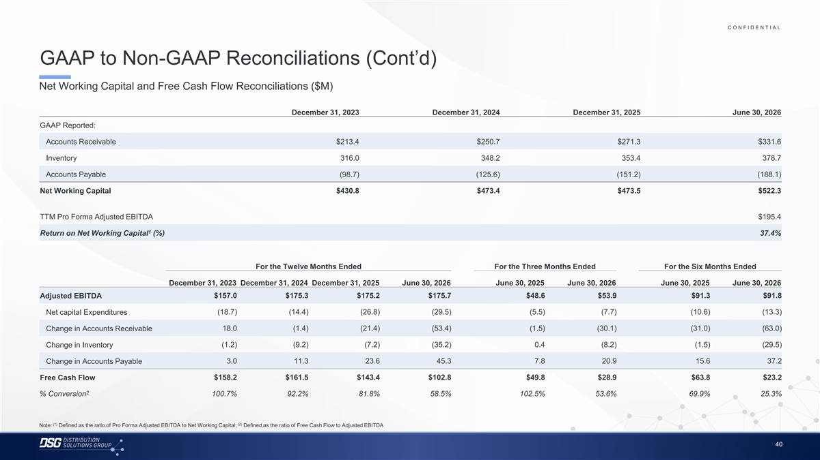
C O N F I D E N T I A L COLOR PALETTE Text 50 56 62 GAAP to Non-GAAP Reconciliations (Cont’d) Title bar/Bullets 68 87 128 Net Working Capital and Free Cash Flow Reconciliations ($M) ACCENTS 2 85 25 141 1 December 31, 2023 December 31, 2024 December 31, 2025 June 30, 2026 70 250 GAAP Reported: 68 173 87 185 2 Accounts Receivable $213.4 $250.7 $271.3 $331.6 128 211 142 210 Inventory 316.0 348.2 353.4 378.7 169 221 3 216 239 Accounts Payable (98.7) (125.6) (151.2) (188.1) 255 255 196 231 4 Net Working Capital $430.8 $473.4 $473.5 $522.3 38 168 239 249 129 205 5 TTM Pro Forma Adjusted EBITDA $195.4 35 167 213 238 1 Return on Net Working Capital (%) 37.4% 213 238 6 214 239 30 146 124 213 Hyperlink For the Twelve Months Ended For the Three Months Ended For the Six Months Ended 153 234 0 98 Followed December 31, 2023 December 31, 2024 December 31, 2025 June 30, 2026 June 30, 2025 June 30, 2026 June 30, 2025 June 30, 2026 80 205 Hyperlink 117 255 Adjusted EBITDA $157.0 $175.3 $175.2 $175.7 $48.6 $53.9 $91.3 $91.8 TABLE Net capital Expenditures (18.7) (14.4) (26.8) (29.5) (5.5) (7.7) (10.6) (13.3) 50 Lines 56 18.0 (1.4) (21.4) (53.4) (1.5) (30.1) (31.0) (63.0) Change in Accounts Receivable 62 68 (1.2) (9.2) (7.2) (35.2) 0.4 (8.2) (1.5) (29.5) Change in Inventory Highlights 87 128 3.0 11.3 23.6 45.3 7.8 20.9 15.6 37.2 Change in Accounts Payable $158.2 $161.5 $143.4 $102.8 $49.8 $28.9 $63.8 $23.2 Free Cash Flow 2 % Conversion 100.7% 92.2% 81.8% 58.5% 102.5% 53.6% 69.9% 25.3% (1) (2) Note: Defined as the ratio of Pro Forma Adjusted EBITDA to Net Working Capital; Defined as the ratio of Free Cash Flow to Adjusted EBITDA 40

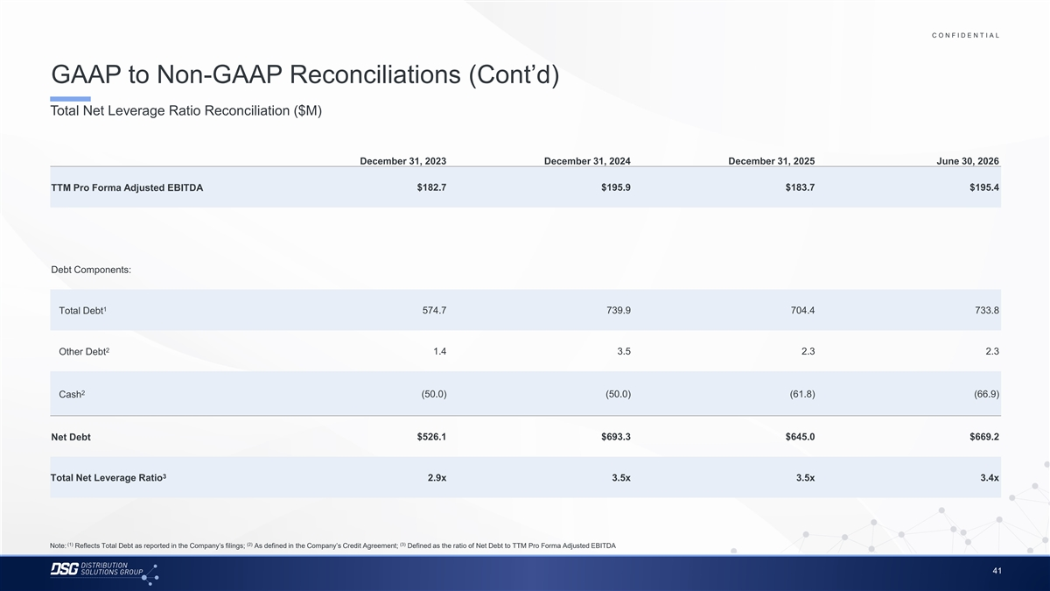
C O N F I D E N T I A L COLOR PALETTE Text 50 56 62 GAAP to Non-GAAP Reconciliations (Cont’d) Title bar/Bullets 68 87 128 Total Net Leverage Ratio Reconciliation ($M) ACCENTS 2 85 25 141 1 70 250 December 31, 2023 December 31, 2024 December 31, 2025 June 30, 2026 68 173 87 185 2 128 211 TTM Pro Forma Adjusted EBITDA $182.7 $195.9 $183.7 $195.4 142 210 169 221 3 216 239 255 255 196 231 4 38 168 239 249 Debt Components: 129 205 5 35 167 213 238 213 238 6 1 Total Debt 574.7 739.9 704.4 733.8 214 239 30 146 124 213 Hyperlink 153 234 2 Other Debt 1.4 3.5 2.3 2.3 0 98 Followed 80 205 Hyperlink 117 255 2 TABLE Cash (50.0) (50.0) (61.8) (66.9) 50 Lines 56 62 Net Debt $526.1 $693.3 $645.0 $669.2 68 Highlights 87 128 3 Total Net Leverage Ratio 2.9x 3.5x 3.5x 3.4x (1) (2) (3) Note: Reflects Total Debt as reported in the Company’s filings; As defined in the Company’s Credit Agreement; Defined as the ratio of Net Debt to TTM Pro Forma Adjusted EBITDA 41

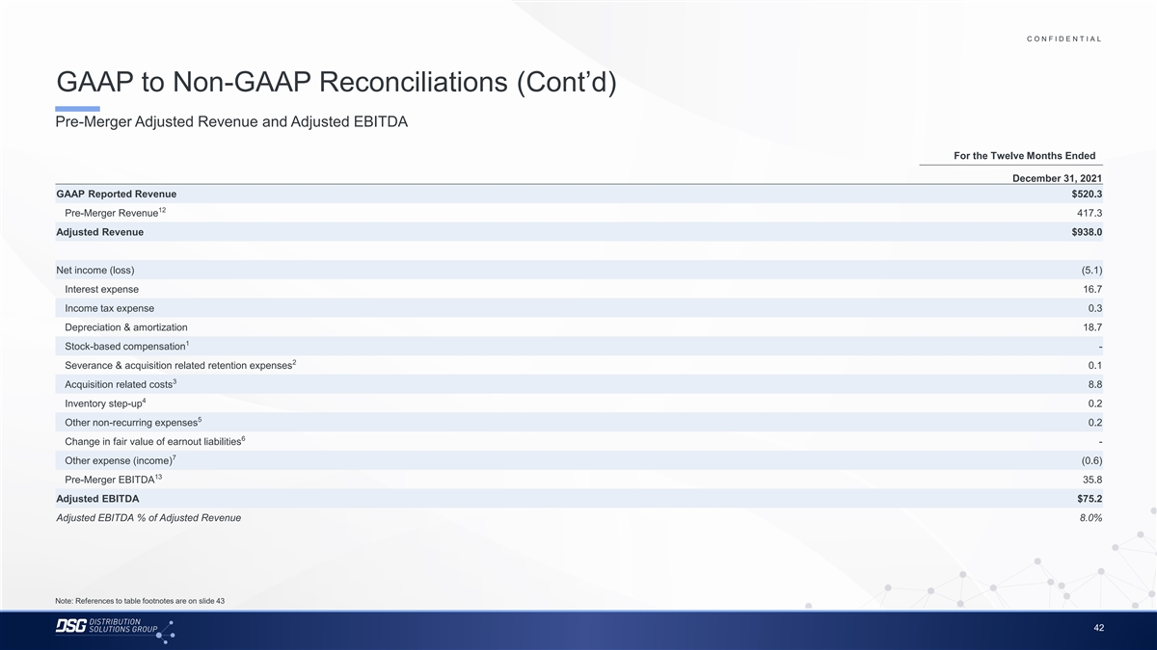
C O N F I D E N T I A L COLOR PALETTE Text 50 56 62 GAAP to Non-GAAP Reconciliations (Cont’d) Title bar/Bullets 68 87 128 Pre-Merger Adjusted Revenue and Adjusted EBITDA ACCENTS 2 85 25 141 For the Twelve Months Ended 1 70 250 December 31, 2021 68 173 87 185 2 GAAP Reported Revenue $520.3 128 211 12 Pre-Merger Revenue 417.3 142 210 169 221 3 Adjusted Revenue $938.0 216 239 255 255 196 231 4 Net income (loss) (5.1) 38 168 239 249 Interest expense 16.7 129 205 5 35 167 Income tax expense 0.3 213 238 Depreciation & amortization 18.7 213 238 6 214 239 1 Stock-based compensation - 30 146 2 Severance & acquisition related retention expenses 0.1 124 213 Hyperlink 153 234 3 Acquisition related costs 8.8 0 98 Followed 4 Inventory step-up 0.2 80 205 Hyperlink 117 255 5 Other non-recurring expenses 0.2 TABLE 6 Change in fair value of earnout liabilities - 50 Lines 56 7 Other expense (income) (0.6) 62 13 Pre-Merger EBITDA 35.8 68 Highlights 87 Adjusted EBITDA $75.2 128 Adjusted EBITDA % of Adjusted Revenue 8.0% Note: References to table footnotes are on slide 43 42

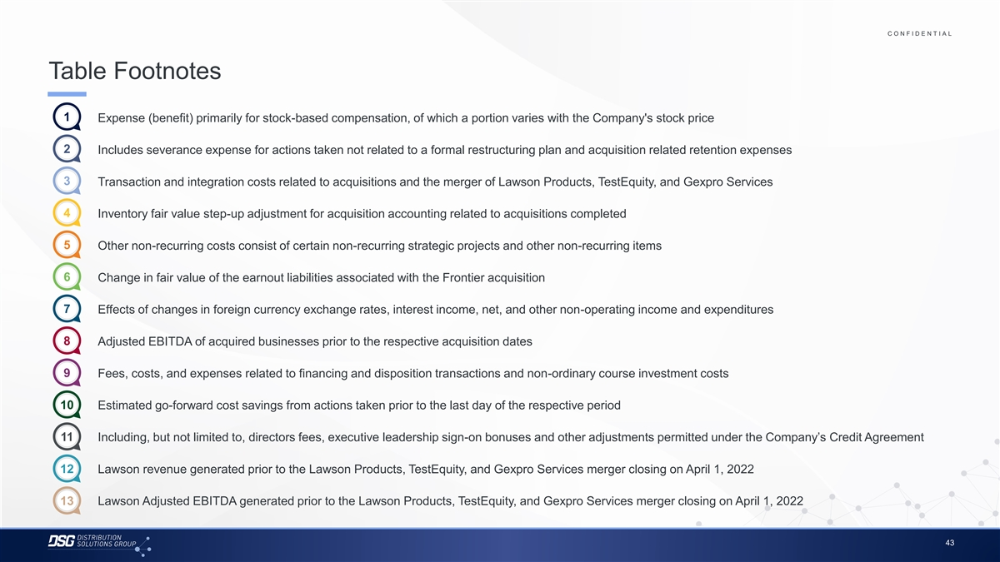
C O N F I D E N T I A L COLOR PALETTE Text 50 56 62 Table Footnotes Title bar/Bullets 68 87 128 ACCENTS 1 1. Expense (benefit) primarily for stock-based compensation, of which a portion varies with the Company's stock price 2 85 25 141 1 70 250 2 2. Includes severance expense for actions taken not related to a formal restructuring plan and acquisition related retention expenses 68 173 87 185 2 128 211 3 3. Transaction and integration costs related to acquisitions and the merger of Lawson Products, TestEquity, and Gexpro Services 142 210 169 221 3 216 239 4 4. Inventory fair value step-up adjustment for acquisition accounting related to acquisitions completed 255 255 196 231 4 38 168 5 5. Other non-recurring costs consist of certain non-recurring strategic projects and other non-recurring items 239 249 129 205 5 35 167 6 6. Change in fair value of the earnout liabilities associated with the Frontier acquisition 213 238 213 238 6 214 239 7 30 146 7. Effects of changes in foreign currency exchange rates, interest income, net, and other non-operating income and expenditures 124 213 Hyperlink 153 234 0 98 8. 8 Adjusted EBITDA of acquired businesses prior to the respective acquisition dates Followed 80 205 Hyperlink 117 255 TABLE 9. 9 Fees, costs, and expenses related to financing and disposition transactions and non-ordinary course investment costs 50 Lines 56 62 10 10. Estimated go-forward cost savings from actions taken prior to the last day of the respective period 68 Highlights 87 128 11 11. Including, but not limited to, directors fees, executive leadership sign-on bonuses and other adjustments permitted under the Company’s Credit Agreement 12 12. Lawson revenue generated prior to the Lawson Products, TestEquity, and Gexpro Services merger closing on April 1, 2022 13 13. Lawson Adjusted EBITDA generated prior to the Lawson Products, TestEquity, and Gexpro Services merger closing on April 1, 2022 43

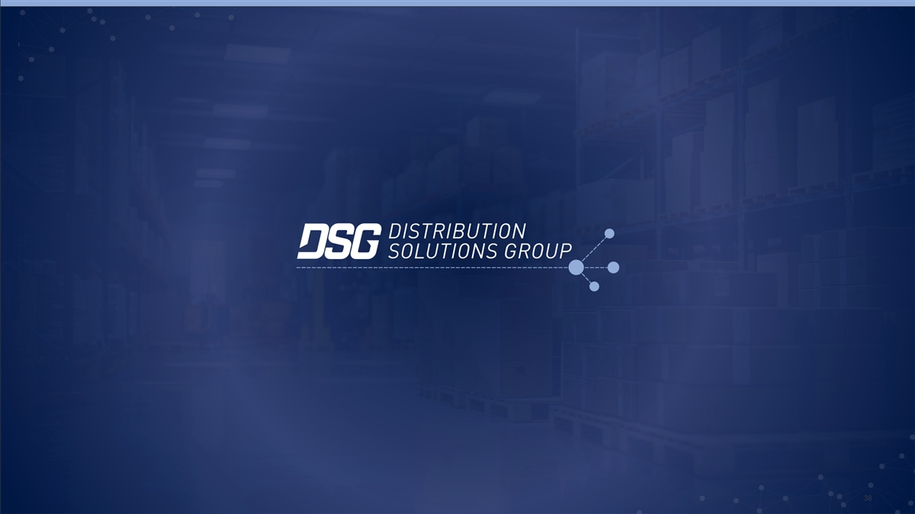
44 38

